
How to Submit Census in Banner 9 Faculty Services (Cougar Tracks)
- Log into MyTC (upper right-hand corner of the TC homepage). If you need to reset your password, please contact A&R at 7741.


- Click on the Faculty Services (Cougar Tracks) icon
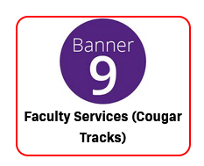
- Click on “Web-Enabled Drop Roster”
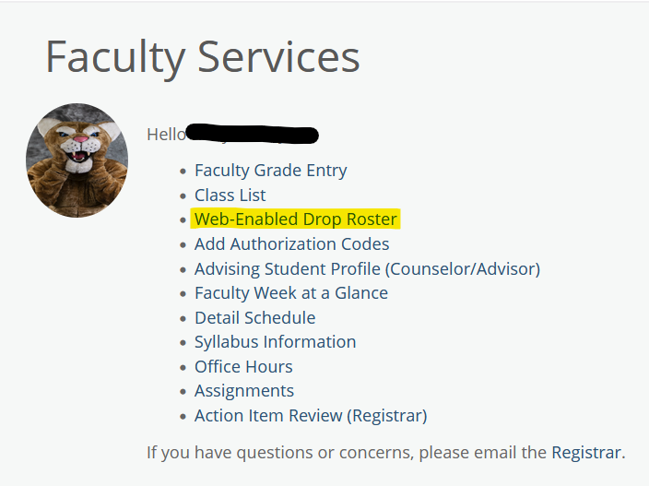
- Select the appropriate term from the drop-down menu and double click on the line for the course. Double click anywhere within the line besides the hyperlinked items.
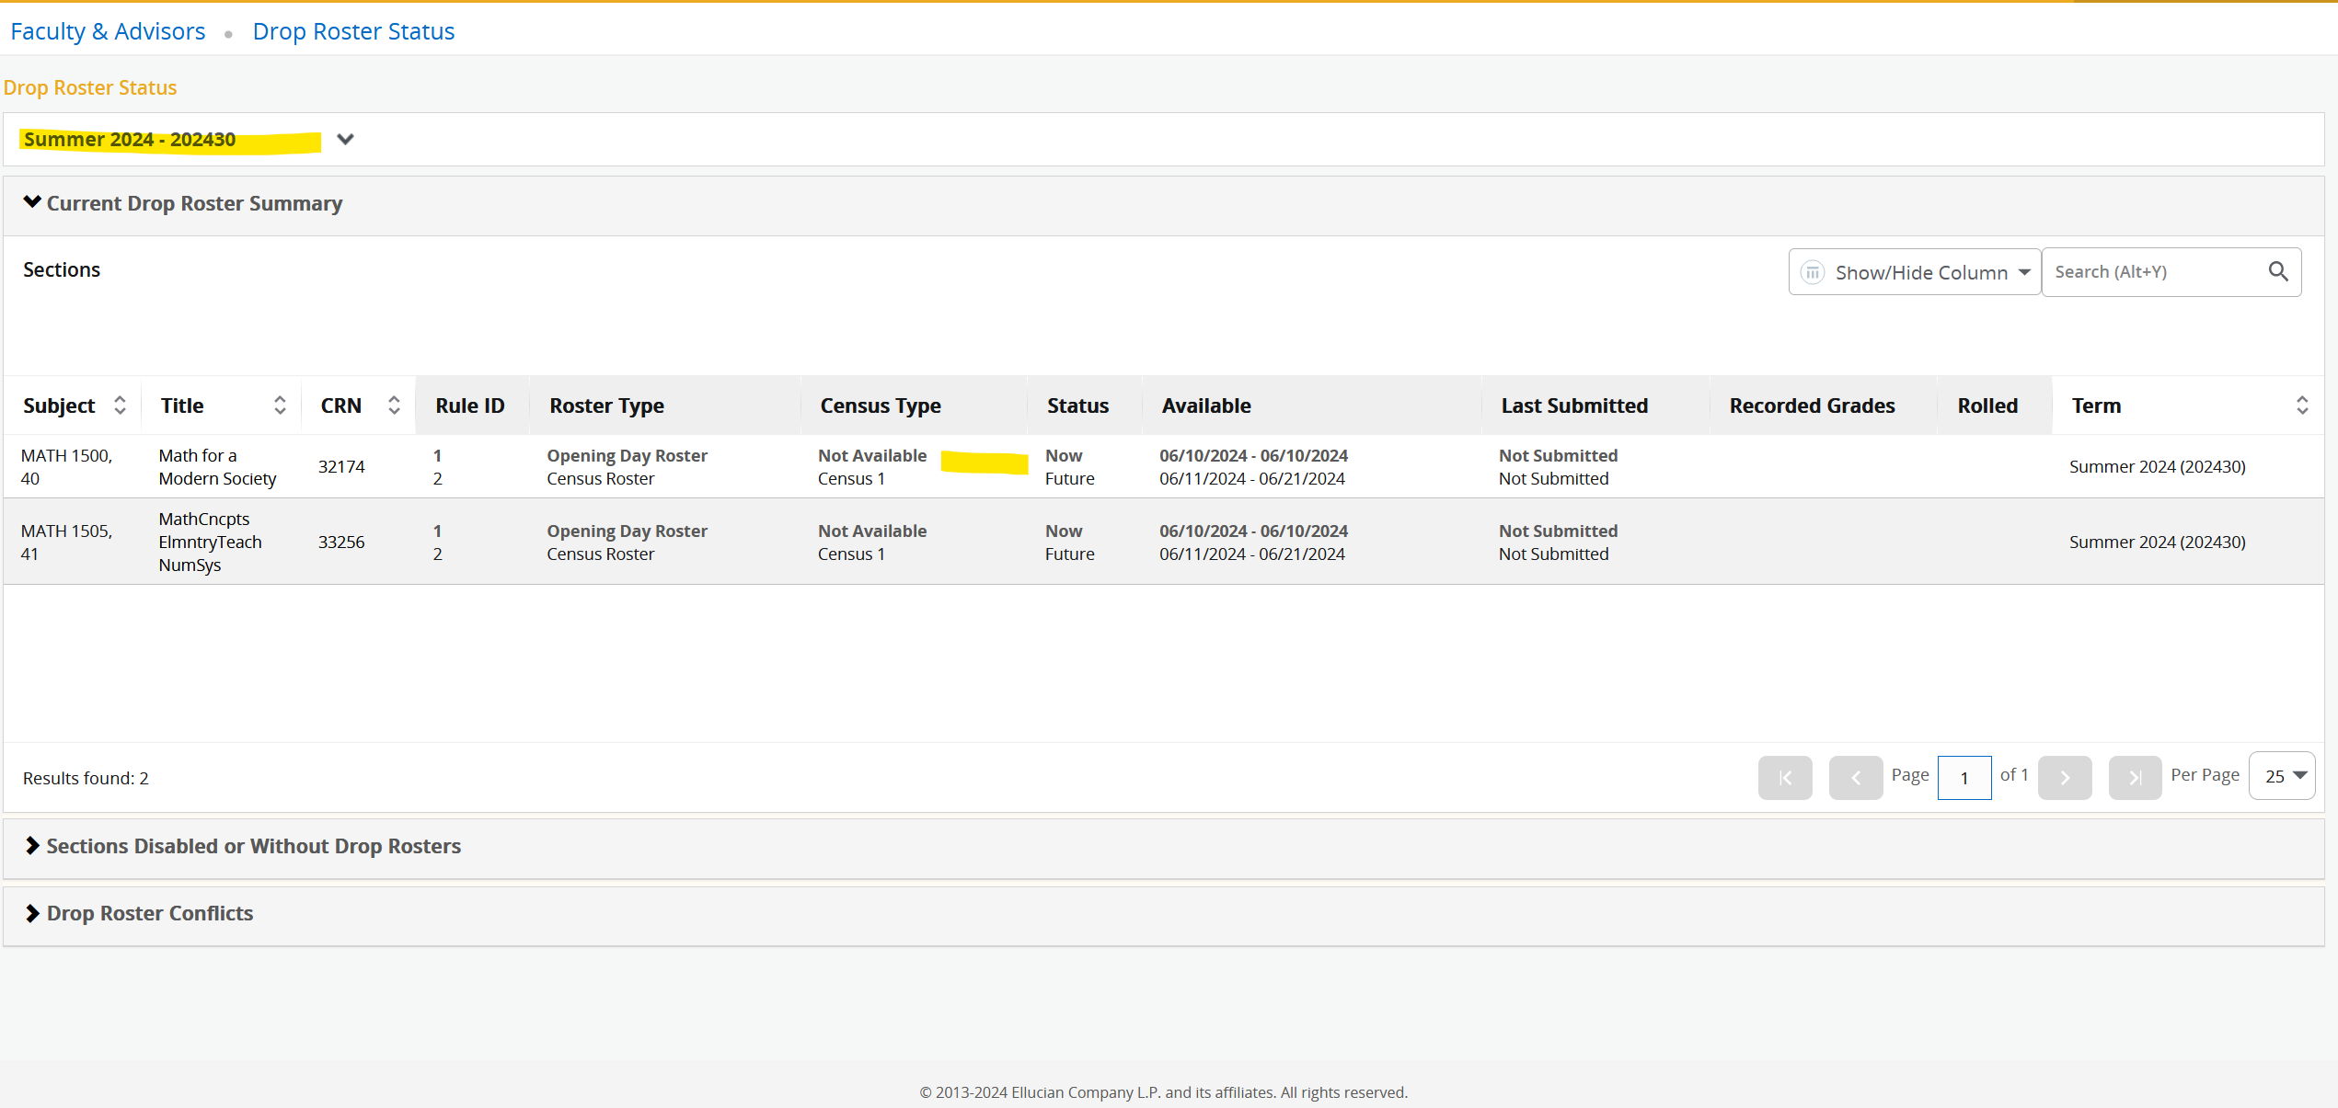
- The screen below is what you will see for your course. Please make sure you are completing the correct census by checking the highlighted areas. This example shows an opening day roster but most of you will be completing the “Census 1” roster which is set for a future date in the screenshot above.
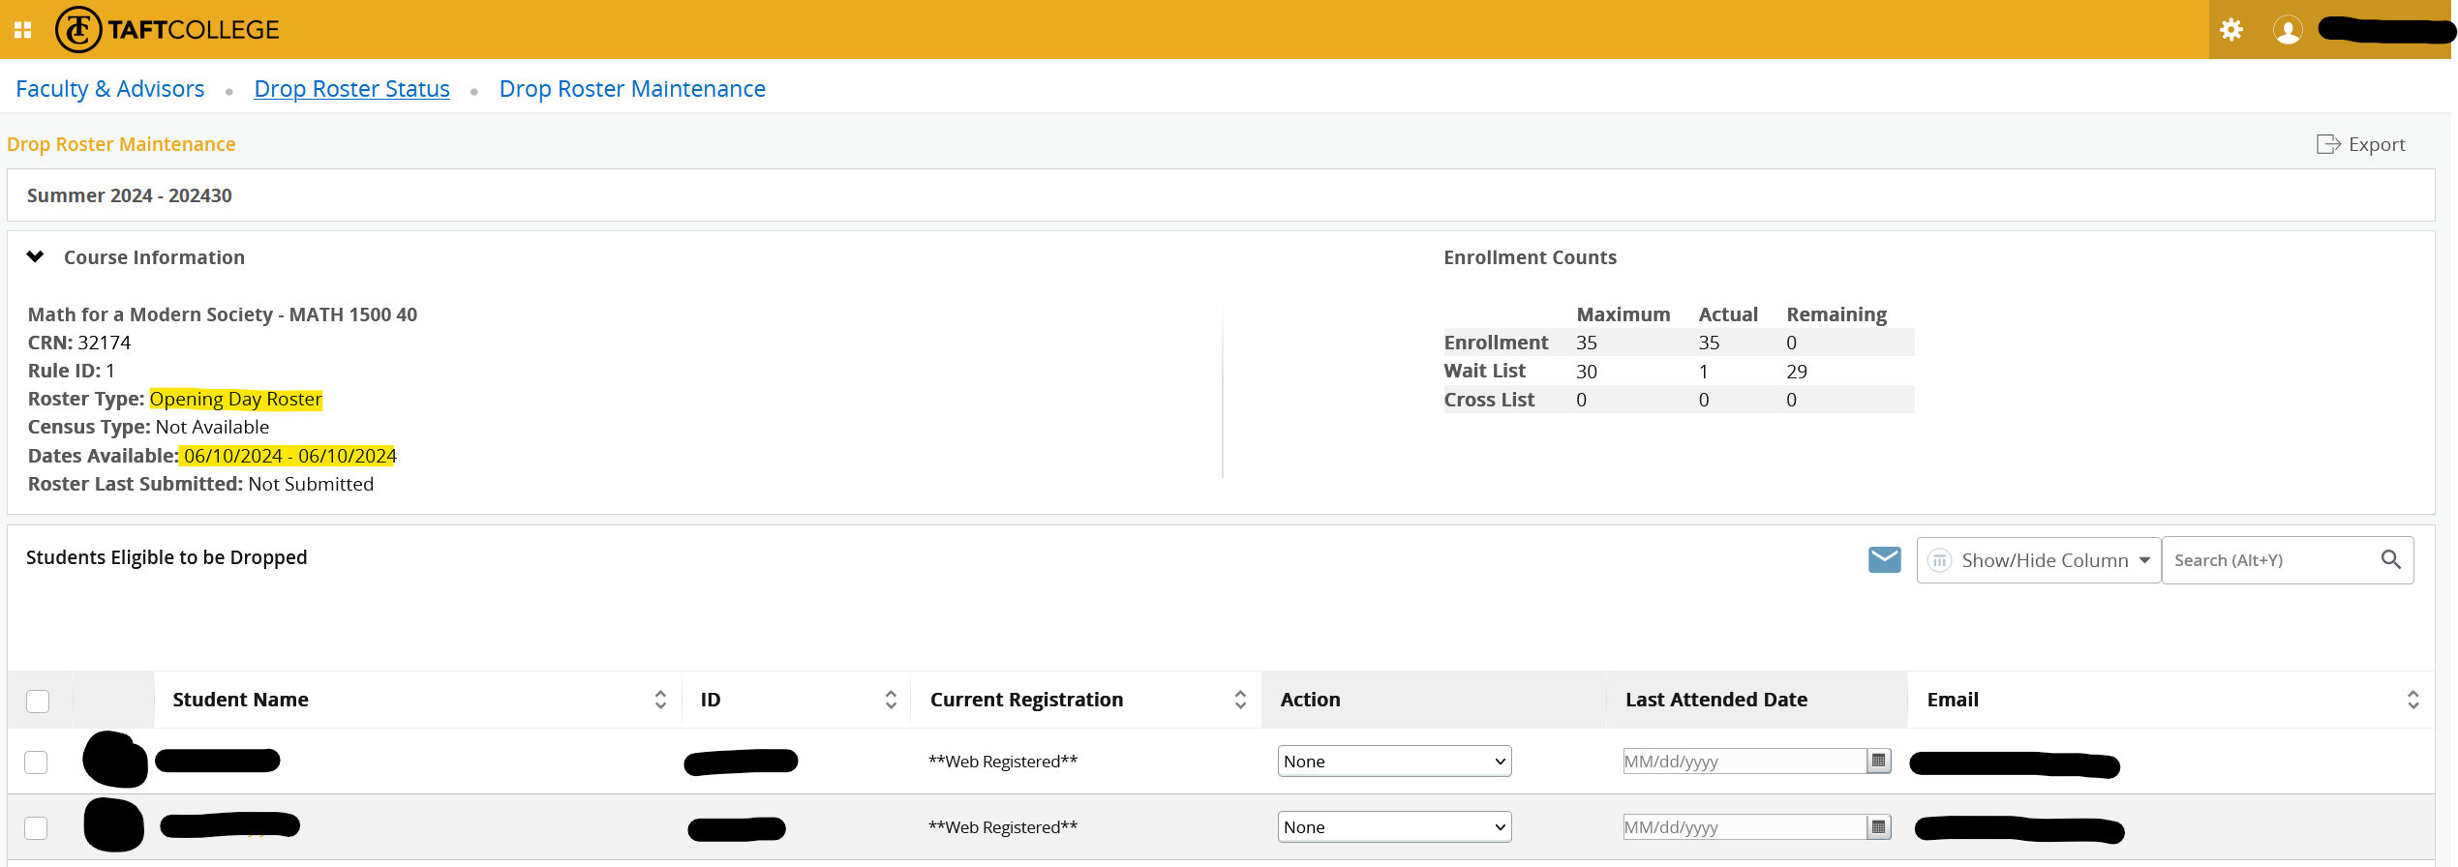
- Select the appropriate “Action” from the drop-down menu for the students who you are dropping.
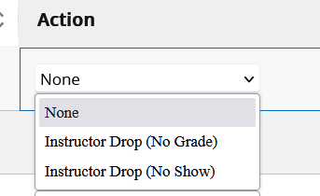
- Click “Submit” at the bottom right-hand corner of the screen. If you see a message saying less students were processed than you submitted, one of your students most likely has a registration prevention on their account due to academic standing and you will need to contact us to drop them.
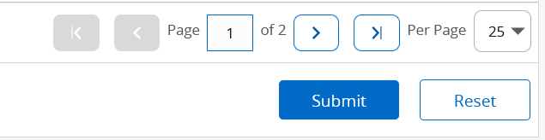

Important things to remember:
- Dropping students on your census date will result in the student receiving a “W”. Remember, the census date is the FIRST date to receive a “W” grade. Please drop your students the day before your census date to not issue a “W”. Your calendar reminder from A&R will be set up for the day before.
- You will need to confirm your roster regardless of if you are dropping students.
- If you miss the deadline to submit your Web-Enabled Drop Roster, you will be required to submit a paper roster. Please use the process online, it is way more work on you and us if you miss the deadline and are required to do a paper roster.
- If you do not drop a student from your course using your census or the online drop submission form, you cannot issue a student a “FW” grade with a last date of attendance that is before census. Those students are required to be dropped at census and we will get an audit finding if you issue a last date of attendance prior to census since we are collecting apportionment based on census date attendance. This is very important.
- Please track the number of students you are dropping and if the message after you click submit does not reflect the number of students you dropped, one or more of your students has a registration prevention based on their academic standing and we will need to help drop those students.

