Minutes of the Strategic Planning Committee
January 8, 2026
2:00 p.m. – 3:30 p.m.
Cougar Room
Present: Amar Abbott, Heather Cash, Xiaohong Li, Greg Bormann, Vicki Jacobi, Candace Duron
Absent: Mike Giacomini Adam Bledsoe, Jennifer Altenhofel and Rashitta Brown-Elize
Guests: Sharyn Eveland
Approve the Minutes from December 11, 2025 (Action)
The minutes were approved unanimously.

Planning Guide – Review and Update
The Planning Guide has been updated and unanimously approved with the following:
- Page 4 – Update the title of the Five-Year Technology Plan
- Page 7 – Update Accreditation Standards 2025
- Add “Steps” to all plans instead of months and “See Summary Table on Page 18”
- Page 12 – Add language concerning “consulting agency”.
- Page 18 - Add a column to the table for the specific semester to start Step 1

Comprehensive Program Review – Status Update
There is a new SLO Dashboard for data extracted from eLumen Insights. A demonstration will be given during the spring inservice Program Review Overview meeting.

Accreditation Steering Task Force
The Accreditation Steering Task force (ASTF) will have their first meeting in January 2026 to discuss the ISER timeline and the standards. They will meet quarterly for the first year and then monthly until the completion of the ISER.
The ASTF membership:
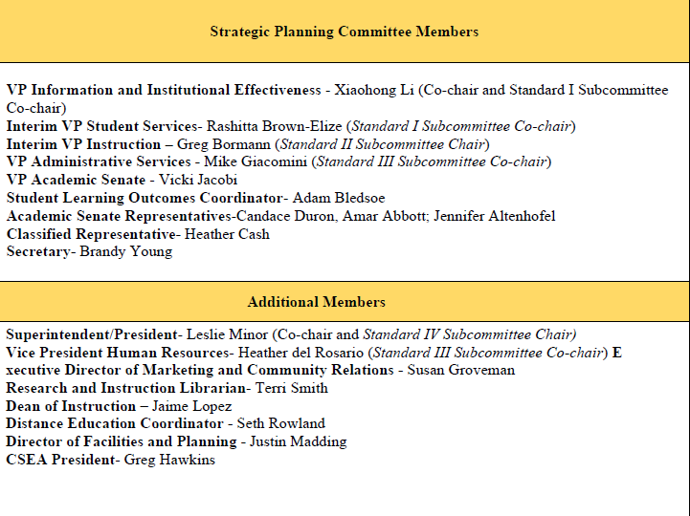
New Strategic Action Plan Activities – Discussion
A handout created from the Educational Master Plan development exercise was shared with the committee. The handout listed many activities, categorized by focus area, that may be implemented in the Strategic Action Plan. Much discussion was had on how to engage committees, division chairs and leadership in the activity development process. The focus area hand out, along with activities developed in the VAR process will be shared with those groups to provide a starting point. The IR Office will work with individuals and committees to establish the activities that will be reviewed by the SPC and added to the Strategic Action Plan for implementation.

Next Meeting: Thursday, February 5, 2026, at 2:10 p.m. in Cougar Room

Respectfully submitted by Brandy Young

