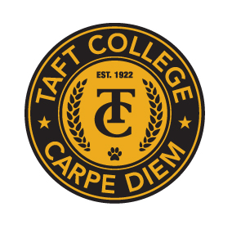
TAFT COLLEGE
Governance Council
Special Meeting
September 12, 2025
10:10 a.m. – 12:00 p.m.
Cougar Room

AGENDA

Welcome and Introductions

Presentation by Ed Knudson, President Emeritus, Antelope Valley College

Governance Council Refresh
- Participatory Governance
- AP/BP Process
- 10+1
- Brown Act

Next Meeting: Friday, October 10, 2025, at 10:10 a.m. in the Cougar Room

