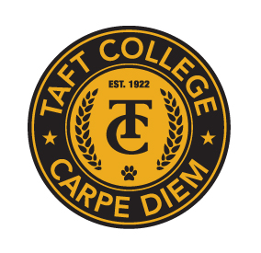**TAFT COLLEGE**

**Governance Council**

**May 15, 2025**

**10:10 a.m. – 12:00 p.m.   
Cougar Room**

# **AGENDA**

**Facilitator: Leslie Minor**

**Timekeeper: Justin Madding**

**Recorder/Minutes: Brandy Young**

1. Approval of Minutes – April 11, 2025 **(Action Item)**  5 Minutes

1. Committee Reports 35 Minutes
   1. Strategic Enrollment Committee (SEMCOM) (Leslie Minor)
   2. Budget Committee (Mike Giacomini)
   3. Strategic Planning Committee (Xiaohong Li)
   4. Campus Safety and Security Committee (Heather del Rosario)
   5. Information Technology Committee (Xiaohong Li)
   6. DEIAA Committee (Leslie Minor)
   7. Academic Senate (Candace Duron)
2. Board Policies and Administrative Procedures 5 Minutes  
    a. AP 7120 and AP 7121
3. Strategic Action Plan 2023-2024 Data Update (Xiaohong Li) **(Action)** 15 Minutes
4. Institution Set Standards (Xiaohong Li) **(Action)** 15 Minutes
5. Program Review Goals - Final Ranking Results (Xiaohong Li) 10 Minutes
6. Program Review – List of Programs and Contacts (Xiaohong Li) **(Action)**  10 Minutes
7. Proposal for Enhancements to Comp PR Process (Xiaohong Li) **(Action)** 10 Minutes
8. Mid-Term Report Update (Xiaohong Li) 5 Minutes
9. OER Plan Update (Michelle Oja) 10 Minutes
10. Other

**Next Meeting: TBD**