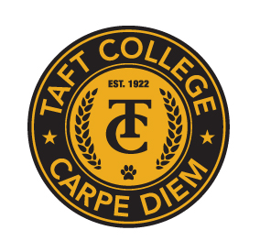
TAFT COLLEGE
Governance Council
November 14, 2025
10:10 a.m. – 12:00 p.m.
Cougar Room

AGENDA

Facilitator: Rashita Brown-Elize
Timekeeper: Heather del Rosario
Recorder/Minutes: Brandy Young

- Approval of Minutes – October 10, 2025 (Action Item) 5 Minutes

- Committee Reports 35 Minutes
  - Strategic Enrollment Committee (SEMCOM) (Greg Bormann)
  - Budget Committee (Mike Giacomini)
  - Strategic Planning Committee (TBD)
  - Campus Safety and Security Committee (Heather del Rosario)
  - Information Technology Committee (TBD)
  - DEIAA Workgroup (Rashita Brown-Elize)
  - Academic Senate (Candace Duron)

- Budget Development Calendar (Mike Giacomini) (Action Item) 15 Minutes

- ACCJC Institutional Self Evaluation Workshop – Re-Cap (Leslie Minor) 10 Minutes

- Governance Council Sub-Committee Charters and Self-Evaluations (Action Item) 35 Minutes
Home Link to Charters and Self-Evaluations

- Other

Next Meeting: Friday, December 12, 2025, at 10:10 a.m. in the Cougar Room

