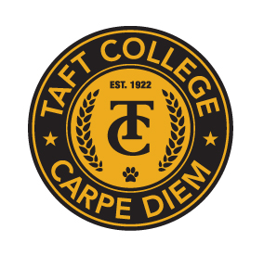
TAFT COLLEGE
Governance Council
October 10, 2025
10:10 a.m. – 11:00 a.m.
Cougar Room

AGENDA

Facilitator: TBD
Timekeeper: TBD
Recorder/Minutes: Brandy Young

- Approval of Minutes – May 15, 2025 (Action Item) 5 Minutes

- 2025-26 Governance Council Charter (Co-Chairs) (Action Item) 15 Minutes
- Comprehensive Program Review (Action) 15 Minutes
a. Three-Year Cycle

- Board Policies and Administrative Procedures (Co-Chairs) (Potential Action Item)
a. The role of Governance Council 10 Minutes

- Committee Reports (Time permitting)
  - Strategic Enrollment Committee (SEMCOM) (Greg Bormann)
  - Budget Committee (Mike Giacomini)
  - Strategic Planning Committee (Xiaohong Li)
  - Campus Safety and Security Committee (Heather del Rosario)
  - Information Technology Committee (Xiaohong Li)
  - DEIAA Committee (Leslie Minor)
  - Academic Senate (Candace Duron) f
- Other

Next Meeting: Friday, November 14, 2025, at 10:10 a.m. in the Cougar Room

