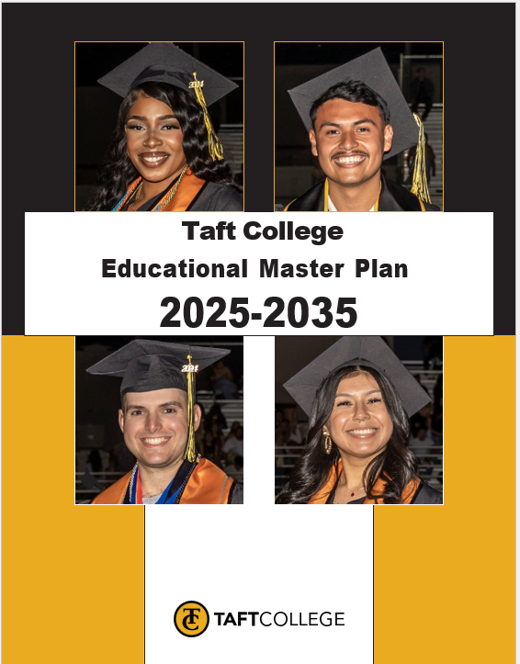
Contents
Acknowledgments 4
Educational Master Plan Committee (EMPC) 4
Executive Summary 5
President’s Message 6
Educational Master Plan Development Process 7
Phase I: Discovery Phase: Data Collection, Analysis, and Synthesis 7
Phase II: Portfolio Development and Planning Assumptions 7
Phase III: Goal-Setting and Recommendations 8
College Profile 9
History 9
Mission 10
Vision 10
Values 10
Native Land Acknowledgement 10
Distinctive Partnerships 11
College Fast Facts 11
Taft College Community, Student, and Outcomes Summary Data 12
State Context 13
Role of California Community Colleges: Meeting the Needs of Students, Communities, and Workforce Development 13
Participation in Local Decision-Making (AB 1725) 13
Vision 2030 Foundations 13
New State Initiatives 15
Taft College Planning 15
Integrated Planning 15
Program Review Process 16
Student Equity Plan 18
Guided Pathways 19
Current Planning Efforts in Progress 20
Educational Master Plan Alignment with Other Planning Efforts 20
Trends and Planning Assumptions 21
National Trends 21
State Trends 22
Regional Trends 23
District/College Enrollment Trends and Planning Assumptions 24
Educational Master Plan Framework and Educational Master Plan Goals and Objectives 26
Goal 1: Increase student enrollment. 26
Goal 2: Improve Retention and Success Rates Including Program Completion, Transfer, and Graduation 26
Goal 3: Diversify Instructional Programs and Opportunities & Enhance Community and Industry Partnerships to Support Workforce Development 27
Goal 4: Position Taft College for Long-Term Sustainability and Future Growth 27
Goal 5: Strengthen a Culture of Innovation, Equity, and Institutional Excellence 28
Next Steps and Recommendations 28
Educational Master Plan Roll-Out Process 28
Plan Implementation 28
Plan Design, Timelines, and Alignment Recommendations 29
Accountability and Monitoring Process 29
Appendix A: External Scan 30
West Kern Community College District Service Area 30
Kern County K-12 Trends 37
Labor Market Information 40
Appendix B: Internal Scan 44
Enrollment 44
Students 50
Student Outcomes: Degree/Transfer Students (primarily Taft campus) 65
Student Outcomes: Short-Term Career Students (primarily WESTEC) 75
Career Education Wage Outcomes by Program 80
Student Outcomes: Undecided/Other Students 81
Student Surveys 81
Listening Sessions and Emergent Themes 83

Acknowledgments
Taft College would like to express its sincere appreciation to all those who contributed to the development of the Educational Master Plan (EMP). This collaborative effort would not have been possible without the dedication and input from our faculty, staff, students, administrators, and community members. We are especially grateful to the members of the Educational Master Plan Committee, whose leadership and commitment guided the process. A special thanks also goes to the Academic Senate, Classified Senate, and the Associated Students of Taft College for their active involvement and valuable perspectives.
The success of this plan reflects the collective vision of our campus and community. Your contributions have shaped a thoughtful, inclusive, and forward-looking roadmap that will help guide Taft College in its mission to foster equity, enhance student success, and promote innovation in education. Together, we are building a future that prioritizes student achievement and strengthens our commitment to excellence in teaching, learning, and community engagement. We are grateful for everyone’s participation in shaping this important plan and for your ongoing support in helping Taft College continue to thrive.

Educational Master Plan Committee (EMPC)
While many voices are reflected in the development of this plan, a special acknowledgment goes to the Taft College Educational Master Plan Committee members listed below (in alphabetical order) who served on the committee in the 2024-25 Academic Years and others who substantive added to the development of this plan.

Krystal Allikas Educational Data Equity Specialist
Kanoe Bandy Division Chair, Allied Health and Applied Technology
Trudi Blanco Confidential Representative, Executive Assistant, Administrative Services
Adam Bledsoe Division Chair, Business, Arts, and Humanities
Heather del Rosario Vice President, Human Resources
Bill Devine Division Chair, English Language Arts
Candace Duron Academic Senate President
Renae Ginther Classified Representative, Tutor
Luz Gonzalez Associated Student Organization (ASO) Representative
Dr. Todd Hampton Vice President, Admin. Services
Giselle Hovind Classified Representative, Cougar Support Center
Dr. Xiaohong Li Vice President, Information and Institutional Effectiveness
Justin Madding Management Representative, Director Facilities and Planning
Mike Mayfield Division Chair, Math and Science
Tina Mendoza Division Chair, Social Sciences
Dr. Leslie Minor Interim Superintendent/President, Vice President, Instruction
Juana Rangel-Escobedo Division Chair, Learning Support
Debbie Rios Classified Representative, Transition to Independent Living (TIL) Senior Secretary
Brandy Young Executive Assistant, Institutional Effectiveness
Dr. Vicki Jacobi Academic Senate Vice President, Articulation Officer, Counselor

Executive Summary
The Taft College Educational Master Plan 2025-2035 is a comprehensive document that will help guide the institution over the next ten years as it works to fulfill its mission and vision and meet the needs of its students and community.
The Educational Master Plan (EMP) aligns with districtwide strategic directions and the California Community College Chancellor’s Office (CCCCO) Vision for Success and Vision 2030 goals. Developed through a collegial and collaborative process, this plan articulates collegewide goals and supporting objectives that will help guide Taft College in establishing priorities, planning for future needs, developing new programs, and guiding resource allocation as it focuses on strengthening student access and success, and achieving equitable outcomes.
Taft College’s EMP provides the overarching structure for all institutional planning. It is central to both the College’s Strategic Enrollment Management Plan under development and the integrated planning model, which includes the Strategic Action Plan, Student Equity Plan, Technology Master Plan, Facilities Master Plan, and Program Review.
The Educational Master Plan was developed through a collegewide planning process that included extensive internal and external data analysis and input from diverse constituent groups and community partners (faculty, staff, students, administrators, and community leaders) prior to adoption by the Board of Trustees. The following goals are adopted to guide the direction of Taft College over the next ten years:

Goal 1: Increase student enrollment.
Goal 2: Improve retention and success rates including program completion, transfer, and graduation.
Goal 3: Diversify instructional programs and opportunities and enhance community and industry partnerships to support workforce development.
Goal 4: Position Taft College for long-term sustainability and future growth.
Goal 5: Strengthen a culture of innovation, equity, and institutional excellence.

President’s Message

Dear Colleagues,
On behalf of the West Kern Community College District (WKCCD), I am pleased to present the Taft College Educational Master Plan (EMP) 2025-2035. After celebrating successful service to more than one million students over 100 years in 2022 and navigating through the devastating, global COVID-19 pandemic in 2023, Taft College has reflected deeply on a myriad of important ideas, metrics, processes, and procedures to develop this 10-year plan over the 2024-25 academic year. It is the direct synthesis of painstaking efforts by faculty, staff, and students, members of our local community, and partners in community college integrated planning. The importance of this document cannot be overstated—it is the road map by which Taft College will set itself up for continued student learning and success and to capitalize on the momentum of enrollment gains in Spring Semester 2025.

While the pandemic showed us that faculty, staff, and students are capable of resiliency while enduring constant change, learning new modalities, and trying to stay safe, it further exposed the vulnerability of our historically underserved and marginalized students, as well as the digital divide. To confront these inequities, the College will further endeavor to close historic equity gaps in service to a student body with diverse experiences, backgrounds, and educational goals. Taft College is committed to building back better and stronger by ensuring all students receive an equal educational opportunity that meets their goals, providing in-demand educational programs leading to higher earnings, and expanding our high-quality student support services for which our College is widely known.

Sincere thanks to the various contributors on this important undertaking, especially the EMP Committee for their many hours dedicated to getting this document over the finish line. Committee members and key campus stakeholders thoroughly examined college and regional data gathered through an internal and external environmental scan, identified needs of business, industry, and the community, and formulated goals, objectives, and initiatives to drive Taft College forward.

This Taft College EMP provides the foundation on which all other planning documents will rely and is the central reference point for comprehensive program review, student learning outcomes, and resource allocation over the next decade. Taft College plans to increase enrollment, improve outcomes for key student populations, and measure our progress along the way.

Again, my gratitude goes out to faculty, classified staff, managers, administrators, and students who shepherded this plan through its many stages of creation, review, and revision. By asking students to participate in this process, Taft College incorporated student voices and perspectives and made this planning process collaborative, inclusive, and best of all, student-centered.

Sincerely,
Dr. Leslie Minor
Interim Superintendent/President

Educational Master Plan Development Process
The Taft College Governance Council (GC) is primarily responsible for setting the vision, mission, and long-term goals of the entire college, as well as identifying college-level outcomes as measurements toward those goals. In all its actions, the Council places the highest value on building communication and trust with the entire college community and uses consensus to reach its decisions. The GC is a cross-functional group comprising the Superintendent/President and faculty, classified, and management across instruction, student services, and administrative services areas, as well as student representatives. The Superintendent/President and Faculty Academic Senate President co-chair the GC. The GC served as the Educational Master Plan Committee (EMPC) as the College embarked upon the development of the ten-year Educational Master Plan (EMP). With the technical support of a national community college educational consulting firm, the College began a ten-month, three-phase project for plan development, as listed below.
- Phase I: Discovery Phase: Data Collection, Analysis, and Synthesis
- Phase II: Portfolio Development and Planning Assumptions
- Phase III: Goal-Setting and Recommendations

Phase I: Discovery Phase: Data Collection, Analysis, and Synthesis
Extensive quantitative and qualitative data were gathered, analyzed, and synthesized during this first phase of development of the EMP. Document review included examining program review results, reviewing minutes from meetings and correspondence from accreditation reports and visits, and studying current planning efforts underway at the College. Both internal data on the College and its students and external data on the region and workforce were examined. Interviews and listening sessions were held internally with students and constituent groups, and externally with educational and other partners and stakeholders. A review of national, state, and regional trends was conducted, and local and regional workforce data and information were examined. The following infographic summarizes the four data sources for the Discovery Phase.

The analysis and synthesis of quantitative data revealed trends and planning assumptions for plan development. Qualitative data garnered from interviews and listening sessions were reviewed, and emerging themes were identified.

Phase II: Portfolio Development and Planning Assumptions
In Phase II, the results from Phase I formed the Data Portfolio and framed planning assumptions for plan development. A high-level Strengths, Opportunities, Aspirations, and Results (SOAR) analysis was conducted to identify challenges and opportunities for Taft College for the next ten years, and to lay the foundation for goal-setting in Phase III.

Phase III: Goal-Setting and Recommendations
The activities from Phases I and II provided a framework for dialogue among EMPC members for the Phase III goal-setting session. The committee met for a six-hour goal-setting session to draft a set of goals and objectives to provide direction for the College for the next ten years. The framework of goals and objectives was added to the draft Educational Master Plan along with recommendations for the next steps for plan implementation, monitoring, and evaluation.
Upon completion of the three phases of plan development, the draft Taft College Educational Master Plan 2025-2035 was shared with college constituents for review and feedback. The Governance Council then provided recommendations to the Superintendent/President, and the resulting document was provided to the Board of Trustees for its consideration for adoption.

College Profile

History
Taft College was founded on August 30, 1922, as Taft Junior College. Approved for creation by the Taft Union High School Board, which was formed in 1920, the new junior college was deemed necessary to keep up with the demands of a dramatically increasing population in Taft, California. In eight years, the population had grown from 1,650 to 4,000.
Approximately 12 Taft Junior College students took classes on the high school’s property in the first year. In October of 1947, the Taft Union High School District Board purchased and renovated buildings left over from the United States Army Corps World War II training facility at the defunct Gardner and Minter Fields. Taft Junior College moved to this new location the following year.
With the local population swelling to 16,000 by 1954 and Taft Junior College enrollment increasing, the Taft Union High School District Board approved preliminary plans for a new campus in July 1954 and officially changed the school’s name to Taft College. On September 11, 1956, the new campus opened at 29 Emmons Park Drive in Taft, California. The address was later changed to 29 Cougar Court.
When local voters overwhelmingly approved Taft Junior College District, the college separated completely from Taft Union High School District in 1962. Taft Junior College District became West Kern Junior College District in 1963 and was renamed West Kern Community College District (WKCCD) in 1971.
Student residence hall construction began in 1962. One year later, Taft College became one of very few California Community Colleges to have on-campus residence halls. Campus development continued. The new Science Building opened in 1966 and was followed by the Technical Arts Building the following year. The Vocational Technologies Building and Library Annex were completed in 1969 and 1970, respectively. The new Cougar Sports Center was added in 1981. The Dental Hygiene Program opened in 1993 and still operates a dental hygiene clinic open to the public.
In 2004, voters approved a $39.8 million, 30-year bond to finance the renovation of existing facilities and expansion of the college. The West Kern Community College District Board of Trustees approved the formation of a Bond Oversight Committee in May 2024 to keep the public informed of expenditures. In addition to modernizing the Science Building, Technical Arts Building, Courtyard, and Residence Halls, new structures included the Children’s Center, Library, Learning Resource Center, STEM Building, Student Services Administration Building, Maintenance and Operations Facility, and the Center for Independent Living (CIL). The last bond-financed project, the award-winning Student Center, was completed in 2021.Since 1976, Taft College has offered programs and special classes serving individuals with developmental or intellectual disabilities. In 1995, with funding from Kern Regional Center, Taft College began its Transition to Independent Living (TIL) Program, a post-secondary educational experience for young adults with developmental disabilities that also offers a residential experience, where they receive training to handle living on their own.
Taft College welcomed more than 6,000 enrolled students in 2011. By 2024, it offered more than 85 degree and certificate programs, including a Baccalaureate degree in Dental Hygiene Administration. These innovative programs are available at a fraction of the cost of state and private colleges and universities. Interest continues to grow for remote learning options, and by 2024, hundreds of students seeking flexibility took advantage of Taft College’s Distance Education for online and offline classes.
With a Transfer Admission Guarantee agreements, students awarded a degree for transfer are guaranteed admission to the California State University (CSU) system, more than 20 Historically Black Colleges and Universities (HBCU), the University of La Verne, and select campuses and programs of the University of California (UC).
Taft College has been a designated Hispanic Serving Institution since 2003 and was recognized as a Military Friendly School in 2023. The College is accredited by the Accrediting Commission for Community and Junior Colleges (ACCJC) of the Western Association of Schools and Colleges (WASC). ACCJC reaffirmed Taft College’s accreditation in January 2022, and its next Midterm Report is due on October 15, 2025. The institution’s next comprehensive review will begin with a Team ISER Review in Spring 2028 and conclude with a Focused Site Visit in the Fall term of 2028.
In 2022, Taft College celebrated its 100th year of serving students. The college's rich history and celebratory events were captured in a Centennial History Coffee Table Book and a year-end summary video.

Mission
Taft College is committed to creating a community of learners by enriching the lives of all students we serve through career technical education, transfer programs, foundational programs, baccalaureate programs, and student support services. Taft College provides an equitable learning environment defined by applied knowledge leading to students’ achievement of their educational goals.

Vision
Taft College instills a passion for learning, leading to success for all.

Values
- Students and their success
- A learning community with teaching excellence
- An environment conducive to learning, fairness, dialogue, and continuous improvement
- A communicative, collaborative, collegial, and respectful culture
- A partnership of students, faculty, support services, and community
- Innovation, diversity, creativity, and critical thinking
- Academic, financial, personal, and professional integrity
- Employees and their professional development
- A transparent, accessible, participative governance structure

Native Land Acknowledgement
Taft College is part of the California Community College System, which currently comprises 73 districts and 116 colleges. The California Community Colleges and California Tribal Chairpersons’ Association collaborated to create a systemwide land acknowledgment that recognizes and respects the Indigenous peoples as traditional stewards of all California land. The Land Acknowledge Statement recognizes that all 116 colleges throughout the state are located in the unceded territories of the 109 federally recognized tribes and other tribes seeking recognition. Relationships between California’s community colleges and tribal nations, such as the relationship between Taft College and the Tejon Indian Tribe in Kern County, are of great importance. The Tejon Indian Tribe is a federally recognized tribe comprising the Kitanemuk, Yokuts, Paiute, and Chumash indigenous people of California, and Taft College will respond to workforce needs of the tribe as they arise.
The California Community Colleges’ systemwide land acknowledgment, developed in partnership with the California Tribal Chairpersons’ Association https://www.cccco.edu/About-Us/land-acknowledgement, is as follows:
California Community Colleges honors and acknowledges that our 116 campuses throughout the state of California are located in the unceded territories of the 109 federally recognized tribes and the dozens of tribes throughout the state who are seeking recognition. We are committed to supporting the ongoing relationships between these tribes, their ancestral territories and the resilience, strength and sovereignty that continues to be demonstrated by California’s first peoples. We affirm our intentions for ongoing relationships with American Indian Tribal Nations and communities whose ancestral lands we occupy and students we educate. A land acknowledgement is a critical step towards working with Native communities to secure meaningful partnership and inclusion in the stewardship and protection of their cultural resources and homelands. Our institutions were founded upon exclusions and erasures of Indigenous peoples. We honor and are grateful for the land we occupy and recognize the ongoing damage of settler colonialism.
We commit to pursuing continuous collaborations with the Tribal Nations of California. We strive to strengthen our awareness of historical and contemporary issues in California to reckon with our institutional legacy and its impact on the people, lands, waters of this place, which are, and always will be, inextricable.

Distinctive Partnerships
Kern Regional Center and the Transitions to Independent Living (TIL) Program
Since 1976, Taft College has collaborated with the Kern Regional Center (KRC) to obtain support for educational services and resources for individuals with developmental and intellectual disabilities. KRC, one of 21 private, nonprofit regional centers contracted by the State of California through the Department of Developmental Services (DDS), provides funding for the Transitions to Independent Living (TIL) program and Taft College serves as the sponsoring agency.
The TIL program is a post-secondary educational and residential experience for students that offers instruction, training, and support on the college campus. It is based on a comprehensive curriculum that promotes the acquisition of functional, social, and career skills necessary for students to live productive and normalized lifestyles. At the conclusion of the two-year program, students are eligible for graduation after completing required coursework and demonstrating learned skills independently. The TIL transition team staff then help graduates transition to independent living in their home community.
WESTEC Incorporated
The Westside Energy Services and Training Center (WESTEC) is a non-profit educational cooperative that has been continuously operating since 1982. WESTEC partners with local employers and community colleges, such as Taft College, to fund programs and provide students with college credit upon completion of classes. Located in Shafter, California, WESTEC offers short and long-term career and job training programs at the North Kern Training Center. Programs and courses cover topics such as safety, law enforcement, and court reporting. The future of WESTEC is uncertain at this time.

College Fast Facts
The chart below provides a synopsis of Fast Facts about Taft College today. It outlines data about the community, students, and outcomes for the County, the College, and its student body.

Taft College Community, Student, and Outcomes Summary Data
Community | Students | Outcomes
Kern County  Population (909,235 in 2022)  - Modest growth projected  - Most pronounced growth in Bakersfield and larger towns  - Low population in close proximity to the campus in Taft  Educational Attainment  - Low; 73% have less than an Associate degree  - Rates are even lower in West Kern County, where 78% have less than an Associate degree, and in the city of Taft where the percentage is 85%  Age Distribution  - Slightly younger population  Ethnicity  - Majority Latino (57%) followed by White (30%), Black (6%) and Asian (6%)  Origin of Birth  - Nearly one fifth foreign born  - Nearly half speak a language other than English at home  High Schools  - Modest growth projected  - Majority Latino  - Vast majority of English Language Learners speak Spanish  - Very low college-going rates  Socioeconomic Status  - Lower income, higher poverty, especially in Taft/West Kern County  Labor Market  - Regionally, numerous opportunities to expand college programs leading to in-demand and higher wage jobs, with the largest potential gaps in workforce supply in Health, Business & Entrepreneurship, and Energy, Construction & Utilities  - Nationally, 20% of workers do remote work, and 16% of companies are fully remote, with the largest online industries being Computer/IT, Accounting, and Marketing | Taft College Overall (2023-2024)  Headcount 8,414  FTES 2,096  Taft Campus  Students  Headcount 3,414  FTES 1,915  Gender  Female 66.6%  Male 31.7%  Other/Unknown 1.7%  Ethnicity  Black 4.3%  Am Indian/AK Native 0.5%  Asian 3.0%  Latino 59.3%  International 0.2%  Multi Ethnicity 4.1%  HI/Pacific Islander 0.2%  White 26.6%  Unknown 1.9%  Age Group  Less than 18 16.4%  18-24 48.4%  25-34 23.3%  35-49 9.4%  50+ 2.5%  WESTEC  Students Fall 2023  Headcount 5,000  FTES 181  Gender  Female 22.2%  Male 77.7%  Other/Unknown 0.1%  Ethnicity  Black 2.6%  Am Indian/AK Native 0.2%  Asian 0.6%  Latino 72.8%  Multi Ethnicity 0.9%  White 8.3%  Unknown 14.5%  Age Group  Less than 18 13.0%  18-24 18.7%  25-34 27.7%  35-49 27.8%  50+ 12.9% | Student Outcomes  Awards 2023-2024  Associate Degree for Transfer 121  AA/AS (local) 351  Certificates 252  Transfer 2022-2023  Total 118  Public 103  Private 15  Degree/Transfer Students (primarily Taft campus)  - Degree completion rates are higher than the region or state  - Transfer Rates are higher for students earning an Associate Degree for Transfer (ADT) than for those earning a local AA/AS  - Acceptance rates at UC and CSU are lower than average  - Lower rates of completion of math and English in Year 1  - Lower fall-to-spring persistence rates  Career Education (primarily WESTEC)  - Higher course success rates  - Higher average wage gains after courses/training  - Higher rates of attaining the regional Living Wage  Top Degrees 2023-2024  AA Liberal Arts, Math & Science  AA Liberal Arts, Allied Health  AS Life Science  AA Liberal Arts, Communication  Psychology for Transfer (ADT)  Top Certificates 2023-2024  CSU GE Certificate  Associate Teacher ECE  Teacher in ECEF  Structural Code Welding  IGETC Certificate  Top Transfer Destinations (5-yr)  CSU Bakersfield  CSU Fresno  Arizona State University  Fresno Pacific  Western Governors
Note: More detailed data are included elsewhere in this report, including in the Appendix.
Sources: US Census, California Department of Labor, California Department of Education, CCCCO DataVista, California Community College Career & Technical Education Outcomes Survey, Internal Taft Data provided by Institutional Research

State Context
The West Kern Community College District (“Taft College”) operates as one of 73 community college districts in the State of California under the California Community Colleges Chancellor’s Office. The California Community Colleges have a long-standing history of working to meet the needs of their students and communities, while partnering with businesses and industries to deliver a prepared workforce.
Today, the California Community College system of higher education consists of 116 colleges within those 73 districts, with each governed by a locally elected Board of Trustees. Collectively, these institutions serve over 1.9 million students. The state context is important to the development of Taft College’s Educational Master Plan in order to ensure alignment with the collective vision of the California Community Colleges system for providing community college services to the state as a whole. Additionally, California state laws and regulations govern all community colleges in the state, and Taft College receives state apportionment dollars to conduct its work within these laws and the state vision. In the sections that follow, a brief overview of four key areas is provided to frame this Educational Master Plan: Role of California Community Colleges, Participation in Local Decision Making (AB 1725), Vision 2030, and New State Initiatives. More information can be found on the California Community Colleges Chancellor’s Office website.

Role of California Community Colleges: Meeting the Needs of Students, Communities, and Workforce Development
The California Community Colleges (CCC) system is the largest higher education system in the nation. California community colleges remain dedicated to advancing the state's economic growth and global competitiveness through education, training, and services that enhance workforce development. California’s community colleges are also notable for attracting the most diverse student body in public higher education. As cited on the California Community Colleges Chancellor’s Office website, 70% of students representing varied ethnic backgrounds. Furthermore, 51% of California State University graduates and 29% of University of California graduates embarked on their academic journey at a community college. The system is pivotal in fostering economic growth, global competitiveness, and equity in education.

Participation in Local Decision-Making (AB 1725)
Passed in 1988, AB 1725 mandates participatory governance, ensuring faculty, staff, and students have roles in decision-making processes. The role for each is as follows:
- Academic Senate (Title 5, Section 53200) – Mandates that Academic senates advise on academic and professional matters, such as curriculum, grading policies, program development, etc. through the "10+1" framework.
- Staff Participation (Title 5, Section 51023.5) – Provides district and college staff (classified, managerial, non-represented, etc.) the opportunity to participate effectively in district and college governance.
- Student Involvement (Title 5, Section 51023.7) – Guarantees that students have a voice in shaping policies and procedures that affect them, such as policies on grading, conduct, services, etc.

Vision 2030 Foundations
In 2017, State Chancellor Eloy Oakley launched Vision for Success – an initiative focused on a commitment to ensure that students from all backgrounds succeed in reaching their goals and improving their families and communities to eliminate gaps once and for all. Goals and targets were set, and a comprehensive framework was provided to ensure its success. Three key elements were emphasized:
- Guided Pathways – Four pillars to support the student’s journey from the point of entry through completion: Clarify the path, Enter the path, Stay on the path, and Ensure learning. Collaboration both across disciplines within fields of study, and between instructional and student support services is essential to the process; student access, retention, persistence, and completion are intended milestones.
- Student Equity and Achievement – Emphasizes equity in access, success, and support by examining disaggregated data and focuses actions to identify and eliminate disproportionate gaps among various student population subsets (age, gender, ethnicity, etc.).
- Student Centered Funding Formula (SCFF) – Included in the 2018-19 state budget as an innovative method to allocate funding to community college districts using a formula designed to support the goals and commitment set by the Vision for Success plan and is aligned with the Guided Pathways student success metrics. The SCFF is based on three primary calculations: (1) A base allocation which largely reflects enrollment; (2) a supplemental allocation based on the number of students receiving financial aid; and (3) a student success allocation based on success outcomes for the Vision for Success metrics.
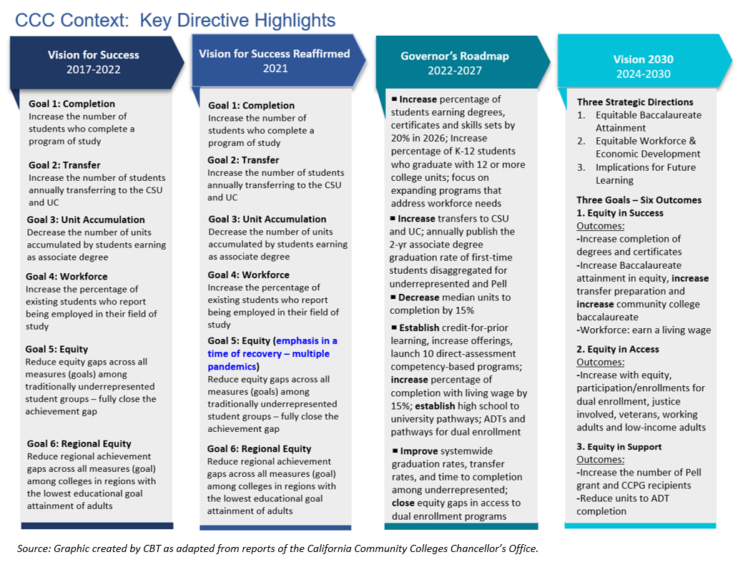
Following the COVID-19 pandemic of 2020-2021, the Vision for Success Reaffirmed (2021), the Governor’s Roadmap (2022-2027), and the new State Chancellor, Dr. Sonya Christian’s Vision 2030 (2024-2030) have continued to reaffirm the commitment to the three cornerstones of Equity in Student Access, Equity in Success, and Equity in Support. From 2017 to today, the goals of each of these statewide frameworks have remained consistent, as reflected in the below infographic.

New State Initiatives
As Taft College embarks on its new ten-year Educational Master Plan, the tenets of Vision 2030 continue to frame the work of the College. Additional new initiatives have been developing as well, including the following:
- Refinement of the California community college baccalaureate degree
- Collaborative work to streamline transfer among California’s three public systems of higher education (UC, CSU, and the CCCs).
- California’s emerging higher education priorities and technologies, including the evolving Master Plan for Career Education and Artificial Intelligence (AI)
More information on these, other new initiatives, and legislative agenda on the horizon can be found on the California Community Colleges Chancellor’s Office website.

Taft College Planning

Integrated Planning
Taft College’s institutional planning uses a data-informed, multi-layered, integrated approach, combining institution-level and department-level plans to guide activities across the college. Institution-level plans, such as the Educational Master Plan (EMP) and Strategic Action Plan (SAP), set long-term goals and strategic directions. Supporting these are the Technology Plan, Facilities Plan, and Student Equity Plan (SEP), each aligned with the SAP to advance specific college areas in alignment with the goals of the long-range EMP.
Area plans, informed by program reviews, include operational goals, budgets, and actionable items to improve college effectiveness. Regular assessments ensure these plans remain relevant, with new plans added as needed, such the Strategic Enrollment Management (SEM) Plan currently under development.
Action plans, developed from data-informed program reviews, outline steps for enhancing program effectiveness and resource needs, bringing a bottom-up perspective to the planning process through the college’s committee structures.
The Taft College Planning Guide Manual of Institutional Plans provides users with information on each plan and the integrated planning process. The manual is updated on a regular basis. It is currently being updated with the below infographic reflecting the new three-year comprehensive program review process, which is described in the next section.

Taft College Integrated Planning Model, 2024
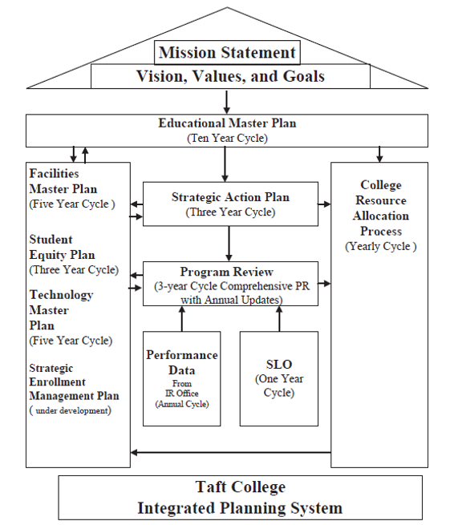

Program Review Process
At Taft College, program review plays an integral role in strategic planning, directly linking to budgeting and resource allocation. Program Review (PR) is a systematic process in which campus programs and departments evaluate their achievements and challenges, aiming to identify strategies to enhance goal achievement. This comprehensive review applies to all programs — whether instructional, support-focused, or a blend of both —assessing their effectiveness in meeting college standards and advancing the College’s mission.
Program review documents and facilitates meaningful discussions and planning around improving student success and program effectiveness, ensuring that these insights are shared with the college community. Additionally, resource allocation decisions are aligned with program goals, assessing the impact of these resources on overall effectiveness.
Beginning in 2022-2023, the College adopted a new three-year cycle comprehensive program review process with annual updates to improve efficiency and better support strategic decision making. Tailored templates and customized datasets are provided for instructional and non-instructional programs, ensuring relevance to each area’s unique needs. Resource requests are also included in the process to support the alignment of the budget allocation process. Additionally, the Office of Institutional Research and Planning meets regularly with each program to provide guidance and support throughout the review process, and user feedback serves to continuously improve the templates and process. The Taft College Program Review Planning Cycle is displayed in the infographic that follows.
Taft College Program Review Planning Cycle
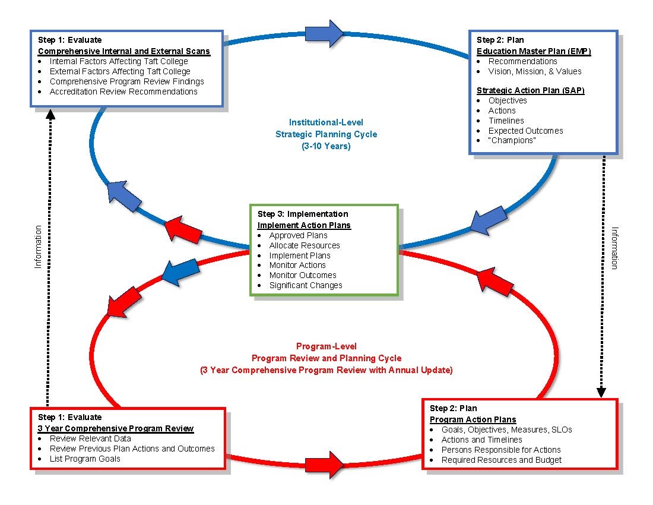

Additional information regarding the Three-Year Comprehensive Program Review process and timeline follows.
Timeline – Annual Updates and Comprehensive 3-Year | Action – Current
August | IR – program review website updated with current cycle documents and data  Program Review Overview during in-service  Programs begin updating/drafting reports and goal forms
August – January | Program contacts – guide program review analysis and writing process; submit Program Review Reports, and Program Goals; submit evaluation of the program review process
February | Budget Committee review potential funding sources for non-personnel resource allocation  SPC (Strategic Planning Committee) review the comprehensive program review reports and provide feedback  IR – compile program review goals, and distribute prioritization worksheet to GC members
March | GC – Review & Rank non-personnel goals  Classified Committee: Review & Rank classified staff goals
May | GC – Review list of programs for accuracy in preparation for next Program Review cycle  Superintendent/president receives final rankings of program review goals
April - July | IR – edits based on the feedback and posts program reviews on IR website  goals and sends to appropriate committees: GC, AC, Budget Committee, CSEA

To enhance the Program Review process, Taft College could explore additional strategies to further facilitate data-informed decision-making for the institution. These strategies may include:
- Providing detailed disaggregated data (e.g., course success, completion, etc.) at the individual course level to identify any disproportionate impact on specific students.
- Integrating feedback and participation from CTE program Advisory Committees to ensure programs reflect current industry standards and expectations.
- Developing mechanisms to address recommended improvement actions, including benchmarks, timelines, and anticipated outcomes.
- Designing a comprehensive rubric for program assessment to evaluate program vitality and viability effectively.
- Conducting long-term studies of degree and certificate completers to gain insights into program effectiveness and institutional offerings.

Student Equity Plan
The Taft College Student Equity Plan (SEP) is designed to advance the college’s mission of providing exceptional comprehensive educational programs and services that foster student learning and success in collaboration with our diverse communities. The primary goal is to provide diverse student groups with the tools and opportunities they need to accomplish their objectives, which is essential to Taft College’s mission. The Student Equity Plan supports basic skills completion, degree and certificate attainment, career and technical education, and transfer opportunities for all students. The SEP plan helps the College ensure its diverse students have equal opportunities to achieve their goals by providing the necessary tools.

Before the creation of the current 2022-2025 SEP, a Student Equity and Achievement Steering Workgroup (SEASW) was assembled. This group consisted of faculty, staff, administrators, and a student representative with the objective to evaluate the effectiveness of the 2019-2022 Student Equity Plan. They sought to identify both successful initiatives in reducing achievement gaps for Disproportionately Impacted (DI) student groups and areas needing improvement. The SEASW set working norms based on authenticity, collegiality, and self-awareness to establish an equitable learning environment. These norms guided discussions around student equity work and formed the basis for the 2022-2025 Student Equity Plan (SEAP), which was developed using a post-pandemic "Equity First" framework.

The SEASW was charged with the following responsibilities:
- Review and evaluate successes and areas of growth from the 2019-2022 Student Equity Plan.
- Collect and review data that identified achievement gaps of students identified in DI groups.
- Develop and create a 2022-2025 Student Equity Plan
- Establish a standing Student Equity and Achievement Committee to implement and evaluate goals and activities identified in the plan to close achievement gaps.

The 2022-2025 Student Equity Plan was developed to ensure the integration of all goals, with a focus on prioritizing equity. The college utilizes data analysis to address achievement gaps, which is in line with its mission, vision, and Strategic Action Plan. Taft College is also using the Guided Pathways framework to enhance existing programs, minimize redundancy, bolster resources, and foster new opportunities for students while strengthening collaboration across programs.
The main goal of the Student Equity Plan is to recognize student groups that are disproportionately affected in meeting the success metrics of the California Community College Chancellor’s Office. The plan aims to reduce and ultimately eliminate the achievement gap for these identified groups as outlined by the state Chancellor’s Office. A secondary goal is to focus on additional groups identified by Taft College as those who could benefit from the “Equity First” activities, including historically racially minoritized students of color. An evaluation process was also created with defined metrics to achieve the goals.
The Student Equity Plan (SEP) undergoes continuous updates to ensure it remains current and provides enhancements. In addition to Taft College’s SEP plan, a commitment to student equity is demonstrated through the development of its Diversity, Inclusion, Equity, Accessibility, and Anti-Racism (DEIAA) committee. The committee hosts events such as Hispanic Awareness, Black History Month, and a Male Summit for high school seniors. It also collaborates with the Associated Student Organization (ASO) on various DEIAA projects.

Guided Pathways
Taft College implemented Guided Pathways as an initiative that began in conjunction with the Vision for Success, launched in 2017, and is discussed further in this document under the section State Context. More information can be found on the Taft College website for Guided Pathways. Taft College has identified the below seven meta majors to assist students in pursuing their educational goals. The work is ongoing as the College continues its focus on student access and success and aligning College curriculum, programs, and student support services with the Guided Pathways model. The State Chancellor’s Office requires a Scale of Adoption Assessment (SOAA) report annually from community colleges on their progress in implementing the four pillars of the model as a component of the Vision for Success and Vision 2030.

TAFT COLLEGE GUIDED PATHWAYS - META MAJORS
Arts, Humanities, and Communications
Early Childhood and Elementary Education
Science, Technology, Engineering, and Mathematics (STEM)
Health Science and Kinesiology
Business and Finance
Industrial Technology
Social Sciences, Law Enforcement, and Public Service

Current Planning Efforts in Progress
As the Taft College Educational Master Plan 2025-2035 was being developed, two key planning efforts underway at the College included the Strategic Enrollment Management (SEM) Plan and new program planning aligned with local workforce needs. These efforts are discussed below.
Strategic Enrollment Management (SEM) Plan
Initial work has begun on the development of a SEM Plan for Taft College. The effort is being led by a tri-chair group comprised of the Vice President of Instruction, the Vice President of Student Services, and an experienced, tenured faculty member appointed by the Academic Senate. The need for the plan was recognized based partly on several changes in the West Kern region, including the impact of the 2020-2023 COVID-19 pandemic, economic changes in the region from the changing dynamics of the oil industry, demographic changes in the West Kern/Taft area, increasing health care needs, and changes in student participation preferences, to name a few. The SEM Plan project is on hold and will be finalized in conjunction with the adoption of the new Educational Master Plan, which provides a framework for the project’s planning effort.
New Program Planning
Due to the changing workforce needs of the region, efforts are underway by Taft College to expand Career Technical Education (CTE) to serve the region. There are several areas under exploration and development. Work is underway to address workforce needs in allied health areas, including potentially adding an Associate Degree in Nursing, a Medical Assisting certificate program, and Paramedic training. The College has launched a Bachelor’s Degree in Dental Hygiene Administration, with the first student cohort in the 2024-2025 Academic Year.
A newer area of focus is planning for noncredit courses aligning with Vision 2030, with emphases on short-term vocational programs, workforce preparation, and elementary and secondary basic skills. Instruction for short-term workforce training continues for both entry-level and advanced training needs through a partnership with the Westside Energy Services and Training Education Center (WESTEC). As current workforce data is analyzed in conjunction with EMP development, additional new program areas will continue to be explored.

Educational Master Plan Alignment with Other Planning Efforts
Planning at Taft College exists in a variety of interconnected processes and documents. Accreditation self-evaluation reports, department and unit plans, program reviews, and campus-wide plans come together to inform the work done at the college. As described earlier in this document, the Taft College Integrated Planning System refers to three inter-related and dynamic planning documents and processes:
- Educational Master Plan (EMP): The long-range primary planning document of the College; it outlines broad ten-year goals and College-wide objectives across multiple departments to fulfill those goals.
- Strategic Action Plan (SAP): The shorter-term planning document providing a roadmap to success in achieving EMP goals. It helps prioritize goals, maximize resources, and make data-driven decisions over the span of three years.
- Comprehensive Program Reviews: A three-year in-depth reporting and planning document aligned with SAP objectives. Instructional and non-instructional (student and administrative services) program reviews are conducted in all areas to evaluate vitality, viability, strengths, and resource needs (fiscal, personnel, facility, and technology) for existing programs. Program plans are derived from the reviews.
  - Annual Program Review Update: Progress updates to track performance in achieving SAP goals.
- Strategic Enrollment Management (SEM): A five-year Plan guiding recruiting, enrollment, persistency, retention, and completion efforts aligned with Educational Planning at Taft College.

Trends and Planning Assumptions
The trends and planning assumptions are based on internal and external scans, including phases I and II’s listening sessions (Appendix B:Listening Sessions and Emergent Themes), student success data, Student survey results (Appendix B: Student Surveys) , and a regional labor market analysis. These assumptions are provided at the national, state, regional, and District/Taft College levels, along with a Taft College Fast Facts infographic summarizing community, student, and outcome data. Supporting data can be found in the Appendix, with additional resources available from the Office of Research and Planning.

National Trends
Enrollment
The COVID-19 pandemic prompted many changes, including those at two-year colleges, where enrollment decreased and teaching and learning rapidly shifted to online.
Nationally, the overall college-going rate decreased from 41% to 38% between 2010 and 2021, driven specifically by the decrease in the college enrollment rate at 2-year institutions, which fell from 13% to 8% in the same time period (National Center for Education Statistics).
College enrollment continued to decline during the COVID-19 pandemic but began to rebound in 2023. According to the Research Center at the National Student Clearinghouse (reported October 26, 2023) students are gravitating to shorter-term credentials rather than longer-term degrees. Enrollment growth is attributed to increased dual enrollment and increased enrollment by Black, Latinx, and Asian students. White student enrollment continues to decrease.
In fall 2023, undergraduate enrollment grew by 1.2%, the first increase since the COVID-19 pandemic, with two-year colleges posting the highest growth at 2.6% (reported January 24, 2024).

Trends Impacting Teaching and Learning
EDUCAUSE, whose mission is to advance higher education focusing on technology, has identified national trends impacting teaching and learning in their 2024 Horizon Report: Teaching and Learning. Highlights from EDUCAUSE and that report include:

Social
- Public perception of the value of higher education is declining.
- Student demographics are changing.
- Students are increasingly demanding access to learning anytime, anywhere.
Technological
- Concerns about cybersecurity and privacy are increasing.
- The use of learning analytics continues to rise.
- The digital divide persists.
Economic
- The demand for and focus on workforce skills is growing.
- Challenges for employee retention are increasing.
- Student debt is increasingly impacting students’ enrollment decisions.
Environmental
- Higher ed institutions are increasing their commitment to sustainability.
- Concerns about the impact of big data tools on the environment are rising.
- The demand for green skills in the workforce is increasing.
Political
- Political polarization in the United States continues to impact higher education.
- Government policy is increasingly influencing education.
- The need is growing for policies that address emerging technologies.
Honorary AI Trends
- AI is changing the way we communicate.
- AI tools have growing potential to reshape pedagogy and student experiences.
- AI is increasingly having an impact on the economy and workforce.
- AI is increasingly being used to address climate change and sustainability issues.
- The potential for the use of AI in politics is growing.

State Trends
Enrollment and Program Development
- Statewide, enrollment in California Community Colleges dropped during the COVID-19 pandemic but began to rebound in the 2022-2023 academic year.
- Career and Technical Education (CTE) is playing an increasingly significant role in California community college education, focusing on training for jobs that lead to a Living Wage.
- Statewide and regionally, community colleges are focusing on developing credit and noncredit short-term certificates tied to local workforce opportunities. This trend will have a significant impact on student demand.
Policy and Initiatives
- The success of California community college students will remain a top priority of statewide policy makers, and the California Community Colleges Chancellor’s Office (CCCCO) is supporting this agenda by funding incentives with mandated reporting, including student success data posted publicly on the CCCCO DataVista.
- Across the California Community College system, decreasing the cost of education and the time to completion of a certificate and/or degree will continue to be a top priority with students, families, and policymakers. Providing various student services and basic needs support will also continue to be essential.
- Meeting the California Community Colleges' Vision for Success and Vision 2030 goals will continue to be important, and community colleges will be expected to build on their success and accelerate the pace of improvement. Work will continue with prioritizing diversity, equity, inclusion, and accessibility (DEIA) and its impact on Vision 2030 goals, Guided Pathways, and faculty and staff diversification efforts.
- The California Community College system is also increasing its emphasis on career education, streamlining transfer, and the impact of AI on its colleges and teaching and learning. For more detail on statewide initiatives, review the State Context section of this report.
Community College Funding
- Funding for student support and success measures will continue to be included in the state budget and assigned to specific activities to support student success goals.
- Hold harmless for the Student Centered Funding Formula (SCFF) metrics will end in 2025. It will be necessary for the College to increase outcomes in all three components: regular enrollment; students receiving a College Promise grant, Pell grant, or covered by AB 540; and student success (degree/certificate completion).
- The state of California is increasingly relying on local districts to fund new educational facilities rather than depending on statewide educational bonds.
Sources: CCCCO DataMart and CCCCO website.

Regional Trends
Demographic Trends
- The population of Kern County is expected to increase slightly in the next 30 years, with the growth likely to continue in Bakersfield and larger towns.
- Population within West Kern Community College District and near the Taft College campus is low and decreasing.
- Enrollment in local K-12 school districts has been trending slightly upward over the past six years, but college-going rates are much lower than the state average, and fewer students have met UC/CSU requirements upon graduation.
- Approximately 73% of the population of Kern County has less than “some college or Associate Degree” which provides a large pool of potential students.
- Kern County is ethnically diverse, with a slight majority of Latinos, but the town of Taft and West Kern County maintain a majority of White residents. Overall, the population of Taft and West Kern County show lower levels of socioeconomic status and income levels than Kern County or the state and nation.
Source: US Census and California Department of Education.

Labor Market
The following ten sectors, listed here in declining order of annual openings, are projected to offer more than 80,000 jobs annually in the Southern Central Valley/South Mother Lode region.
- Health
- Business & Entrepreneurship
- Energy, Construction & Utilities
- Retail, Hospitality & Tourism
- Advanced Transportation & Logistics
- Agriculture, Water & Environmental Technologies
- Education
- ICT/Digital Media
- Advanced Manufacturing
- Public Safety
Source: Centers of Excellence for Labor Market Research for the California Community Colleges.

Remote Jobs
The COVID-19 pandemic caused both work and school to shift to online platforms. Since then, work and school have maintained more of an online presence than before the Pandemic.
Citing census data and the US Bureau of Labor Statistics and other sources, Forbes Advisor (updated June 12, 2023) identified the following key remote work statistics:
- One in five workers nationally is working remotely.
- 16% of companies are fully remote, operating without a physical office.
- The highest percentage of remote workers is aged 24 to 35 – within this age group, 39% work remotely full-time and 25% do so part time.
- The top industries for remote work are Computer and IT, Accounting and Finance, Marketing, Medical and Health, Project Management, Customer Service, Sales, Administrative, Human Resources and Recruiting, and Operations.
- The top remote job titles are Accountant, Executive Assistant, Financial Analyst, Product Manager, Customer Service Rep, Software Engineer, Customer Success Manager, Accounting Manager, Product Designer, and Writer.
Source: US Census and other data quoted in Forbes.

Industry Clusters for Development
Consistent with the labor market and remote jobs cited above, the Kern County Comprehensive Economic Development Strategy (October 2021) prioritizes the following industry clusters for development:
- Value-Added Agriculture
- Transportation and Logistics
- Energy and Natural Resources
- Aerospace and Defense
- Tourism, Recreation and Entertainment
- Healthcare Services

District/College Enrollment Trends and Planning Assumptions
Students
- In recent years, enrollment dipped due to the COVID-19 pandemic but began rebounding in 2022.
- The ethnic composition of the student population has shifted from majority White in the 1990s to majority Latino in 2010. In Fall 2023, two-thirds (66.4%) of Taft College students were Latino.
- The preponderance of Taft College students are from Bakersfield. The second largest student group by town is from Taft, followed by Shafter, Wasco and Arvin.
- The high school sending the greatest number of students to Taft College is Taft Union High School, followed by Ridgeview, Stockdale and Shafter high schools.

Special Populations
- Nearly one-third of students are First-Generation students, meaning neither parent/guardian has completed a bachelor’s degree.
- One in six (16.5%) Taft College students is Special Admit, meaning they are concurrently enrolled in high school.
- One in seven (14.6%) Taft College students receives Basic Needs support.
- In 2023-2024, 30.0% of Taft College students received the California Promise Grant, 15.3% received a Pell Grant, and 1.5% were AB540 students. These rates are somewhat lower than the state rates.
Taft College (Excluding WESTEC)
- In recent years, Taft College has accounted for 40% of the overall Taft College headcount and 90% of total Taft College FTES.
- Prior to the COVID-19 pandemic, the Taft campus enrolled approximately 4,500 students annually. That number declined in the Pandemic but rose to 3,414 in the 2023-24 academic year.
- In 2023-2024, the majority (55%) of students at the Taft campus had Degree/Transfer as their educational goal, and an additional 31% were undecided. In recent years, the vast majority of students at the Taft campus have had Degree/Transfer as their educational goal.
- Taft campus students in 2023-2024 were 66.6% female, 59.3% Latino, and 26.6% White. The majority of students at the Taft campus are traditionally aged college students – 64.8% were 24 or younger in 2023-2024.
- Compared to statewide, the Taft campus posts higher than average rates of First-Time Students, and higher than average rates of First-Time Transfer students. Conversely, the campus shows lower than average rates of continuing students.
- Online enrollments were relatively high at Taft College prior to the COVID-19 pandemic and they have remained high, with more sections taught online than in person. Success rates continue to be higher in face-to-face classes, which is true statewide.
WESTEC
- WESTEC has accounted for 60% of the overall Taft College headcount and around 10% of total Taft College FTES.
- In 2023-2024, the vast majority of WESTEC students (98%) had Short-Term Career Education as their educational goal.
- WESTEC students, in 2023-2024, were 77.7% male, 72.8% Latino, and 8.8% White.
- The majority of WESTEC students are non-traditionally aged; 55.5% are aged 35 or older.

Student Outcomes
- Degree/Transfer students (primarily at the Taft campus), when compared to their regional and state counterparts, post higher rates of:
  - Completion (earning a degree or certificate)
  - Earning a degree with fewer units accumulated
- Conversely, Taft Degree/Transfer students post lower rates of:
  - Completing transfer level English and Math in their first year
  - Persisting from Fall to Spring
  - Transferring to a 4-year institution
- UC and, to a lesser extent, CSU admissions rates are lower for Taft College transfer students, but a higher percentage of the admitted students enroll in courses at a UC or CSU.
- The transfer rate for Taft College students earning an Associate Degree for Transfer (ADT) is much higher than the rate for students earning local Associate Degree (which is awarded with far more frequency).
- Short-Term Career Education students (primarily at WESTEC), when compared to their regional and state counterparts, post higher rates of:
  - Successful course completion
  - Post-training earnings
  - Earning the regional minimum wage
- The top five Taft College CTE programs (as measured by resulting increases in student wages) are Dental Hygiene, Energy Technology, Management, Business Administration, and Early Care, Education & Family Studies.
- Skills Builders, or non-completing Career Education students (completed 9+ CTE units, but did not earn a degree or certificate) show a wage increase of 45% after their courses and training.
Source: CCCCO DataVista, UCOP InfoCenter, CSU Data Analytics, Taft College Office of Institutional Research, and CTEOS – detailed information is included in the Appendix.

Educational Master Plan Framework and Educational Master Plan Goals and Objectives
In February 2025, the Educational Master Plan Committee (EMPC) engaged in a facilitated, interactive six-hour session to complete Phase III: Goal Setting. The EMPC reviewed data, trends, listening session themes, and planning assumptions, as well as the challenges and opportunities that were identified through the SOAR analysis. The session was well-attended, and the EMPC members worked diligently throughout the session to identify broad goals and a set of districtwide objectives for each goal to provide a framework for the new ten-year Educational Master Plan.

It is important to note that ongoing planning efforts at the College were incorporated into the development of the ten-year goals and objectives. Examples of these efforts include ACCJC Accreditation plans from the Institutional Self-Evaluation Report (ISER), Student Equity Plans, Guided Pathways Scale of Adoption Assessment (SOAA), the Strategic Enrollment Management (SEM) Plan under development, and collaborative efforts in progress with educational, community, and workforce partners. The resulting Educational Master Plan serves as an integrated, overarching document for the many planning efforts at Taft College and also provides direction for facility and technology planning for the College. Its long-range goals and supporting objectives are delineated in the next section and are in alignment with both the College’s mission, vision, and values, and the State’s Vision for Success and Vision 2030.

Goal 1: Increase student enrollment.
To grow student enrollment, Taft college will implement strategies aimed at enhancing course accessibility and outreach.

Objective 1.1
Increase the number of online courses with CVC badging, offering students greater flexibility in course selection and attracting enrollments from other colleges
Objective 1.2:
Expand the availability of ZTC (Zero Textbook Cost) textbooks, to reduce financial barriers and making courses more accessible and attractive to a wider student audience.
Objective 1.3:
Complete a Strategic Enrollment Management (SEM) Plan, establishing a structured approach to improving recruitment, retention, and enrollment strategies.
Objective 1.4:
Strengthen outreach efforts within the Taft community, to motivate more local students to enroll and contribute to population growth.
Objective 1.5:
Actively promoting programs and resources to students in outlying areas, to broaden the college's reach and attracting students from diverse geographic regions.

Goal 2: Improve Retention and Success Rates Including Program Completion, Transfer, and Graduation
Retention and student success are rooted in a supportive learning environment, access to resources, and structured academic pathways from admission through completion of Taft College programs.
Objective 2.1:
Enhance mentoring and tutoring programs, offering students additional academic support, boosting retention rates and graduation rates.
Objective 2.2:
Expand mental health services, to support student well-being, a critical factor in maintaining engagement and academic persistence.
Objective 2.3:
Develop student engagement strategies, to cultivate a strong sense of belonging and motivation to persist in their studies.
Objective 2.4:
Optimize Guided Pathways, to provide clearer academic and career roadmaps, reducing confusion and increasing completion rates.
Objective 2.5:
Strengthen certificate scaffolding, to create more structured pathways for earning stackable credentials, improving workforce readiness.
Objective 2.6:
Strengthen transfer support services and connections to ease the process for students transferring to universities and specialized programs, such as Dental Hygiene.

Goal 3: Diversify Instructional Programs and Opportunities & Enhance Community and Industry Partnerships to Support Workforce Development
Expanding instructional programs and industry partnerships will align education with workforce demands and provide students with career-ready skills.
Objective 3.1:
Increase non-credit, CPL (Credit for Prior Learning), CTE (Career & Technical Education), and Dual Enrollment offerings, to deliver flexible learning options and career pathways for a diverse student body.
Objective 3.2:
Expand and diversifying programs that align with labor market needs, to ensure students acquire relevant, in-demand skills.
Objective 3.4:
Create internship, externship, and apprenticeship opportunities, to enhance students’ real-world experience and job readiness.

Goal 4: Position Taft College for Long-Term Sustainability and Future Growth
To ensure long-term success, Taft College must focus on financial stability, infrastructure planning, and technological advancement.
Objective 4.1:
Develop a fiscally responsible budget each year, to ensure financial stability and strategic resource allocation.
Objective 4.2:
Optimize grant opportunities, to obtain additional funding for institutional priorities.
Objective 4.3:
Modernize the facilities plan, to support campus infrastructure in accommodating projected growth.
Objective 4.4:
Secure additional funding sources, to facilitate the successful execution of the facilities plan as needed.
Objective 4.5:
Implement technological innovations, to enhance student success, streamline operations, and improve cybersecurity.
Objective 4.6:
Maintain compliance with accessibility and ADA standards, to guarantee equitable access for all students.
Objective 4.7:
Expand dual enrollment and non-credit programs, to contribute to FTES (Full-Time Equivalent Student) growth.
Objective 4.8:
Conduct annual evaluations of strengths and weaknesses, to mitigate external threats and identify growth opportunities.
Objective 4.9:
Develop a leadership and management succession plan, to promote continuity and institutional stability.

Goal 5: Strengthen a Culture of Innovation, Equity, and Institutional Excellence
Fostering an inclusive, innovative, and collaborative campus culture will enhance student and staff experiences while strengthening community connections.
Objective 5.1:
Align DEIAA (Diversity, Equity, Inclusion, Accessibility, and Anti-Racism) initiatives with student resource expansion, to ensure equitable access and support for special populations.
Objective 5.2:
Expand professional development opportunities for all employees and students, to build institutional capacity and expertise.
Objective 5.3:
Educate the community about degree and non-traditional programs, to promote lifelong learning and workforce readiness.
Objective 5.4:
Increase on-campus activities and events, to foster engagement and strengthen campus life.
Objective 5.5:
Strengthen internal and external partnerships, to enhance collaboration, student support, and institutional growth.

Next Steps and Recommendations
The next steps described below are recommended after final review and approval by the College and District Board of Trustees.

Educational Master Plan Roll-Out Process
Production of the final Educational Master Plan will include electronic and hard-copy documents. Condensed versions may also be developed for offices across campus and used in meetings with the College’s educational, business, industry, and community partners. An intentional internal roll-out process for Fall 2025 with all internal constituents is critical to increase awareness and provide a unified direction for all departments at Taft College as they engage in program review and their annual planning processes.

Plan Implementation
The success of any Educational Master Plan is dependent upon it being effectively operationalized. As each academic year begins, the College’s implementation plan will translate the Objectives of the Taft College Educational Master Plan 2025-2035 into actionable steps aligned with its goals. These implementation/action plans will include the tasks, timelines, measurable outcomes, responsible individuals and groups, and resources needed to enact that year’s priorities in the plan. The detailed action plans will provide individuals with a step-by-step approach to advancing the College’s agenda, and they are also valuable for other annual planning processes, such as curriculum and instructional design, budget development, staffing needs, facilities, and technology planning.

As part of the implementation process, an examination of planning timelines and their alignment for today’s rapidly changing world, as well as resource alignment (staffing, facilities, technology, etc.), is warranted for planning to be dynamic, relevant, and impactful. These areas are discussed in the next section.

Plan Design, Timelines, and Alignment Recommendations
Following adoption of the new ten-year EMP and development of the Implementation Plan:
- Realign other plan timelines with the EMP.
- Increase use of SAP indicators and program review dashboards to measure progress and redirect annual plans.
- Continue using internal and external data for a stronger decision-making process regarding program expansion, contraction, consolidation, elimination, and new program development within Pathway meta majors and with community, educational, and workforce partners.
- Realign resources (staffing, facilities, and technology) with planning as needed.

Accountability and Monitoring Process
Accountability plays a crucial role in the successful execution of the Educational Master Plan (EMP). Annual reporting of EMP goal achievement status to primary stakeholders ensures transparency and fosters trust in the process. This accountability is primarily maintained through Strategic Action Plan that align with the EMP’s goals and objectives. By continuously engaging stakeholders and providing clear progress updates, the plan holds all parties involved responsible for meeting set goals. Program review also serves as a tool for evaluating performance, identifying areas that require adjustment, and ensuring that resources are being used effectively to reach desired outcomes.
In addition, an ongoing monitoring process, on a regular cycle, is critical to assess and ensure progress on the Goals and Objectives of the EMP. An ongoing, annual monitoring process will provide opportunities to redirect work as needed, provide additional attention and support to achieve desired outcomes, set targets, and provide focus for grant opportunities.

Appendix A: External Scan

West Kern Community College District Service Area
District Map

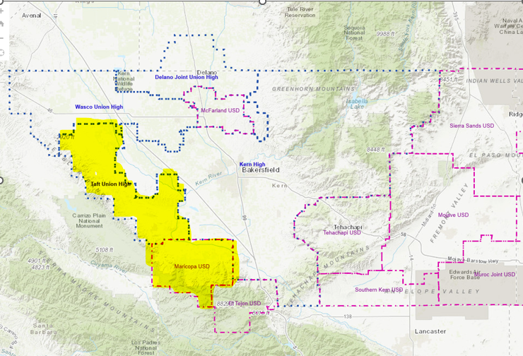
Map Source: KCSOS (with highlighting added)

The West Kern County Community College District comprises the areas serviced by the Taft Union High and Maricopa Unified School Districts, in West Kern County, shown in yellow highlight on this map.

Population Proximity to Taft College

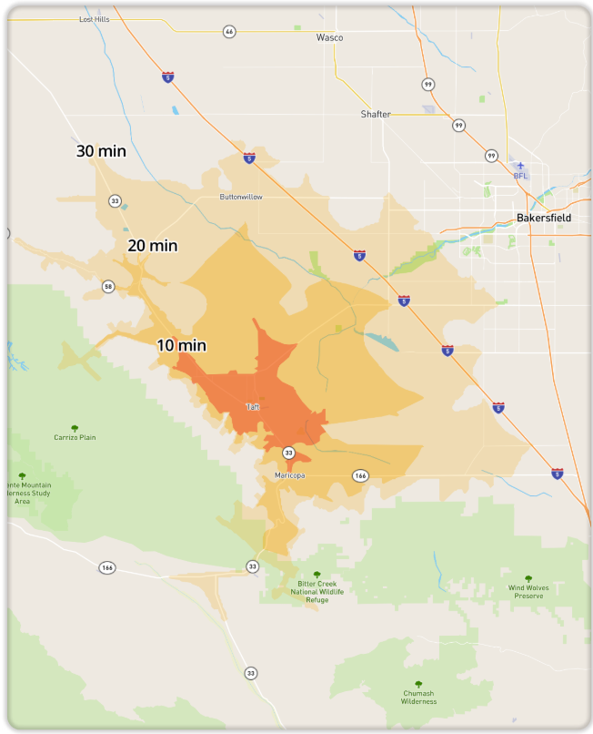
The City of Taft provides this map showing commute times to Taft from the region.
While the preponderance of Taft College students resides in Bakersfield, only west Bakersfield is within a 30-minute commute time.
In 2020, according to the City of Taft, 18,739 people lived within a ten-minute drive of Taft, 23,807 within a 20-minute drive, and 29,185 within a 30-minute drive.

Kern County Population

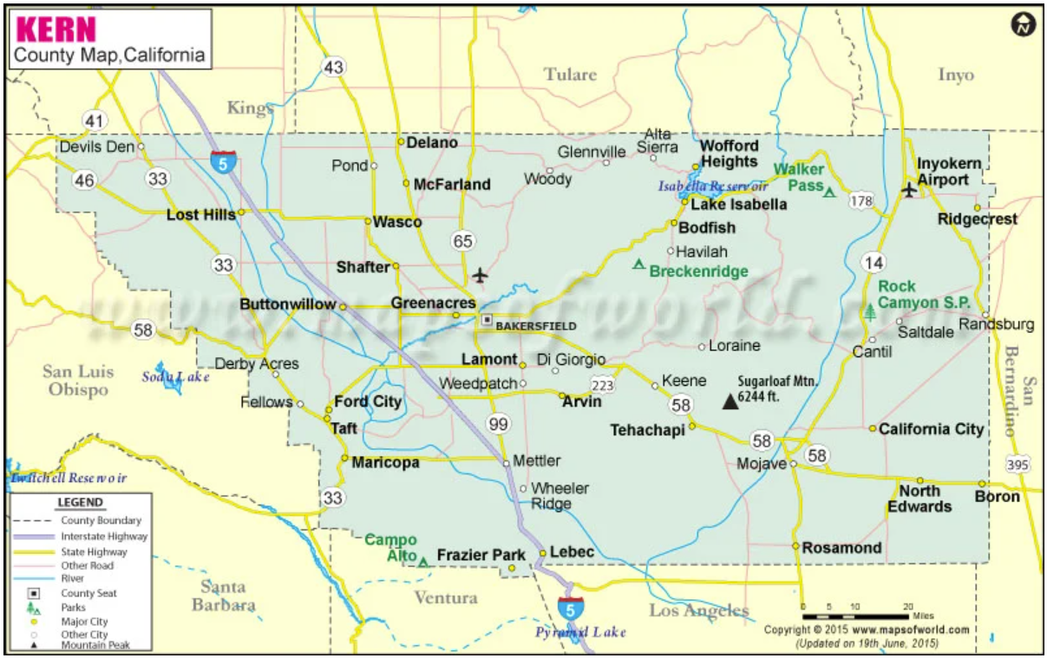
Map source:
https://www.mapsofworld.com/usa/county-maps/california/kern-county-map.html#google_vignette

Nearly one million people (909,235) live in Kern County. One-third (33.9%) of the population of Kern County lives in unincorporated areas. Bakersfield is by far the largest city in Kern County, where 44.3% of the population resides. Taft and Maricopa are the two smallest incorporated towns in the County, accounting for 1.1% of the population.
City/Town/Area | Population in 2020 | % of County Population
Bakersfield | 402,857 | 44.3%
Unincorporated | 308,220 | 33.9%
Delano | 51,577 | 5.7%
Ridgecrest | 27,850 | 3.1%
Wasco | 27,116 | 3.0%
Shafter | 19,890 | 2.2%
Arvin | 19,749 | 2.2%
California City | 15,014 | 1.7%
McFarland | 14,178 | 1.6%
Tehachapi | 13,062 | 1.4%
Taft | 8,697 | 1.0%
Maricopa | 1,025 | 0.1%
Total County Population | 909,235 | 100.0%
Source: US Census.
Historic Population of Kern County Incorporated Towns/Cities

Source: CA Department of Finance.
The population of Kern County increased dramatically in the late 1900s, with most of the growth occurring in Bakersfield, Delano, Ridgecrest, Wasco and Shafter. Maricopa shows little growth over the past century, while Taft more than doubled in size but remains the second smallest town in the county.

Kern County Population Changes 2020-2023

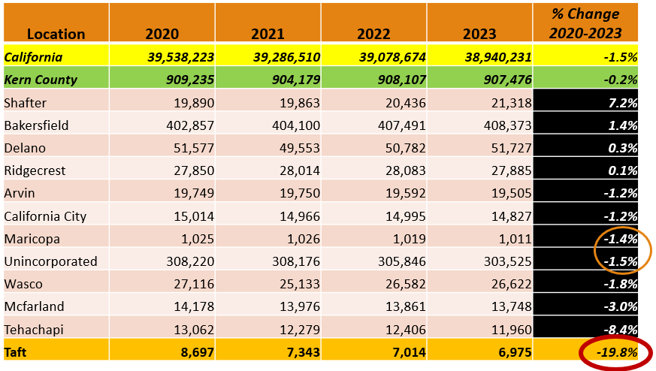
Source: CA Department of Finance.
Note: “Taft” does not include South Taft, Fellows, Ford City, or other unincorporated areas.
Both Kern County and the State of California experienced a slight population decrease from 2020-2023 (-1.5% and -.02% respectively).
Shafter was the only town/city in Kern County that experienced significant growth between 2020 and 2023 (7.2%).
In that same time period, Taft experienced a significant decrease in population (-19/8%).

Kern County Population Projections, by Ethnicity, 2020-2060
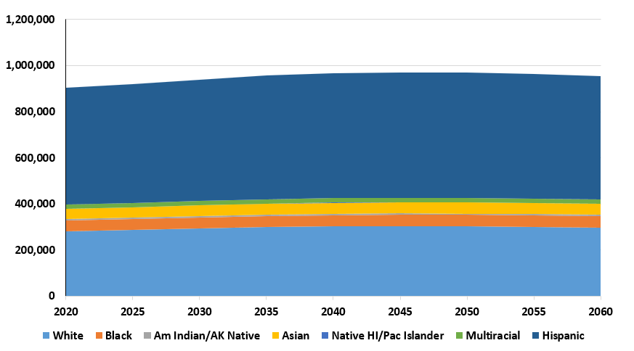
Source: California Department of Finance.

The population of Kern County is projected to increase slightly in the next 30 years, and then slightly decrease.

The proportion of ethnic/racial groups is projected to remain the same, with Latinos in the majority, followed by Whites.

Kern County Population by Ethnicity, 2022

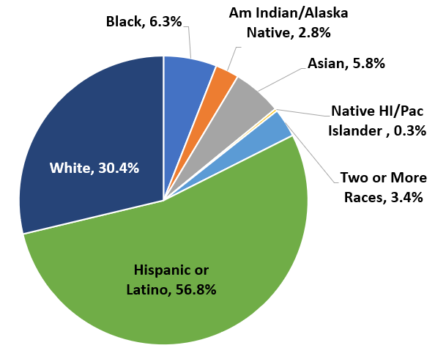
Source: US Census.

Kern County is ethnically diverse, with a slight majority of Latino residents (56.8%), followed by White (30.4%).

Kern County Population Demographics Compared: Ethnicity, Nativity and Language

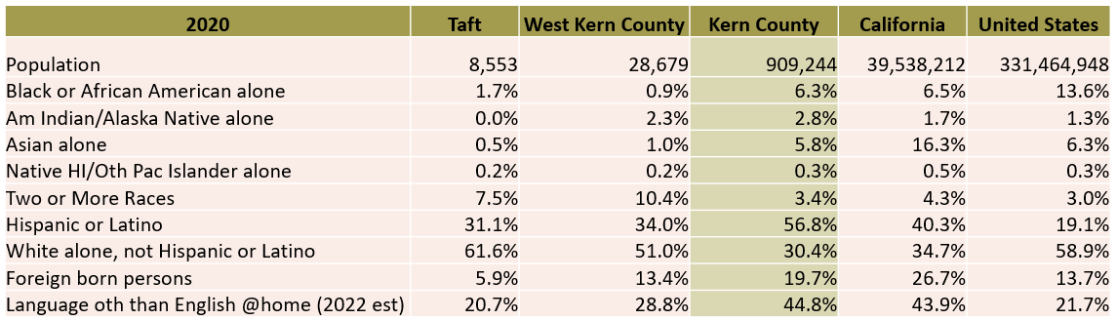
Source: US Census.

Kern County is more ethnically diverse (non-White) than West Kern County or Taft.

The proportion of foreign-born persons is higher in Kern County than in West Kern, or Taft.

One-fifth (20.7%) of residents of Taft speak a language other than English at home; this rate is lower than the county average of 44.8%.

Kern County Population Demographics Compared: Age, Socioeconomic Status
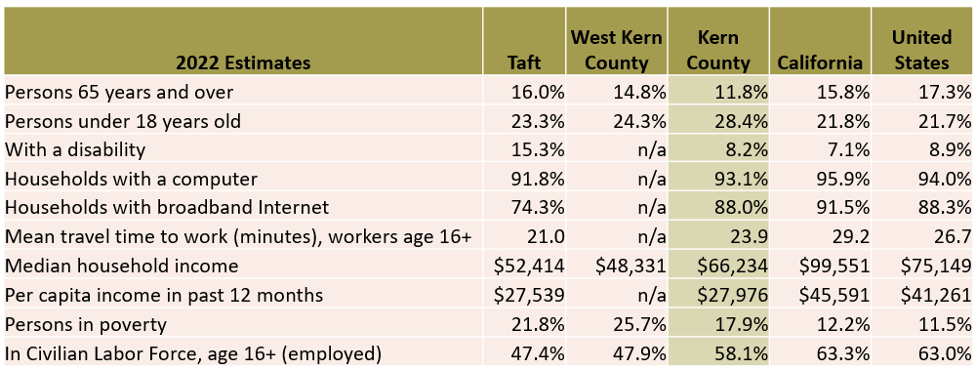
Source: US Census.
Overall, the population of Taft and of West Kern County show lower levels of socioeconomic status compared to the state and the nation.

The population of Taft is older on average than the population of West Kern County, Kern County, and California.

Taft residents are much more likely to have a disability and less likely to have broadband internet at home than West Kern County, Kern County, or State residents.

Taft residents and West Kern County residents have a lower per capita income, higher poverty rate, and lower employment rate than the county, state, or nation.
Kern County Educational Attainment, Persons aged 25+, 2020
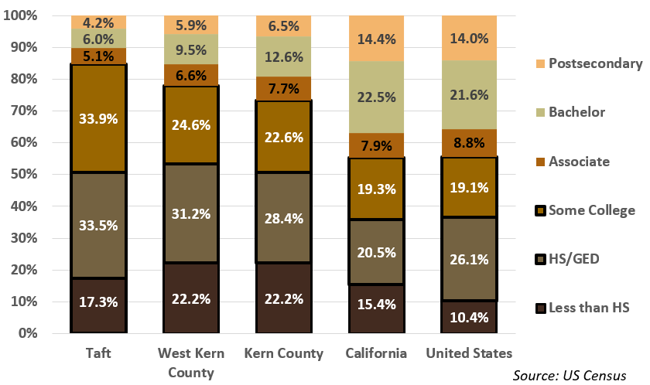
Kern County, West Kern County, and Taft have lower educational attainment levels than the state or the nation.
Of all these areas, Taft shows the lowest educational attainment levels. Those with less than an Associate Degree:
- Taft 84.7%
- West Kern County 78.0%
- Kern County 73.2%
- California 55.2%
- United States 55.6%

Note: “Some College” can include certificate earners.

Kern County K-12 Trends
Kern County K-12 Enrollment Trends
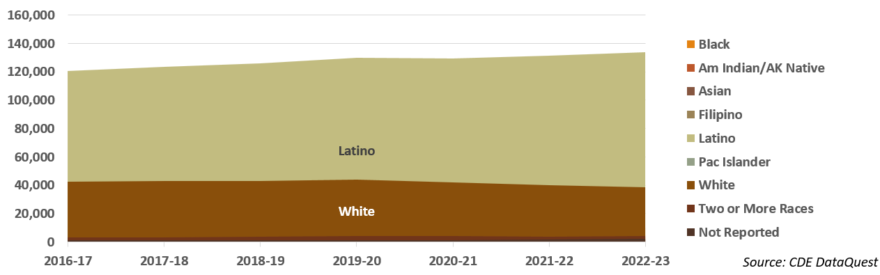
Source: CDE DataQuest.
Enrollment in County public schools increased 6% from 2016-2017 to 2022-2023, from 18,236 to 197,042 with the growth coming primarily from Latino students.
In the same time period, K-12 enrollment statewide decreased 6%, from 6.2 million to 5.8 million.
Kern County K-12 English Language Learners by Language
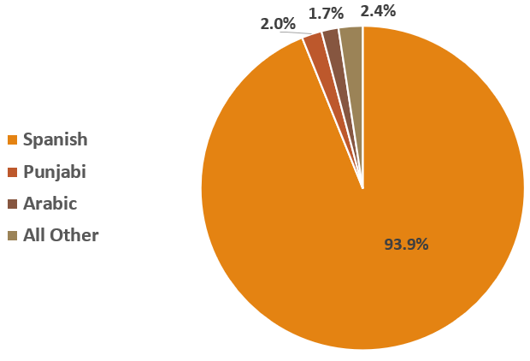
Source: CDE DataQuest.
There are 53 different first languages reported for students enrolled in English Language (EL) programs in Kern County Schools.
The vast majority (93.9%) speak Spanish, followed distantly by Punjabi (2.0%) and Arabic (1.7%). All other languages represent less than 1% of EL students.
According to US Census data (presented previously), 19.7% of Kern County residents are foreign-born, and 44.8% report speaking a language other than English at home.
Kern County Twelfth Grade Enrollment (Including Charters)

Source: CDE DataQuest.
Enrollment in twelfth grade in Kern County increased 12% from 2016-2017 to 2022-2023, from 13,676 to 15,275.
Kern County Twelfth Grade Enrollment by Ethnicity
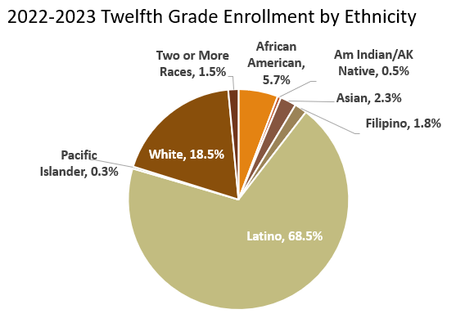
Source: CDE DataQuest.
Over two-thirds (68.5%) of county seniors in 2022-2023 were Latino, while less than one-fifth (18.5%) were White.
Kern County Graduation Rates, Compared

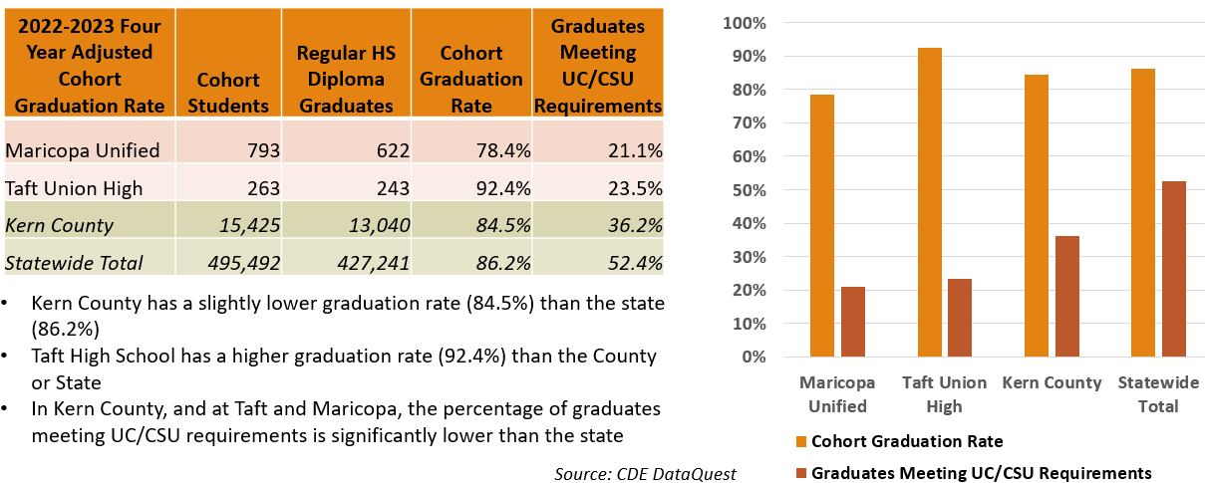
Kern County College-Going Rates, by Ethnicity
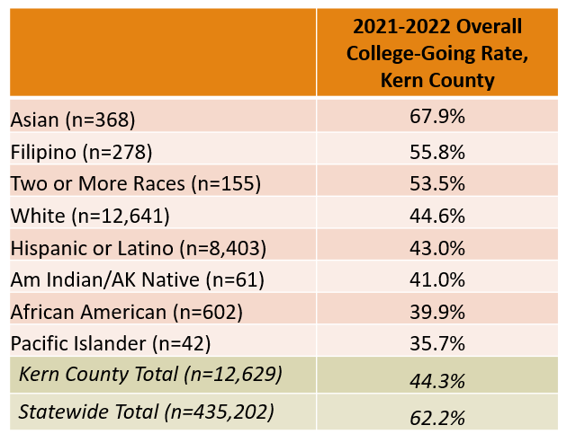
Source: CDE DataQuest.
Less than half (44.3%) of Kern County high school completers enroll in a postsecondary institution within 12 months, which is significantly lower than the statewide average of 62.2%.
Rates vary by ethnicity, with Asian, Filipino, multiracial, and White students having the highest college going rates.
Statewide (51.3%) and in Kern County (52.1%), half of high school seniors who attend college choose a California Community College.
Source: CDE DataQuest
Kern County College-Going Rates, by District

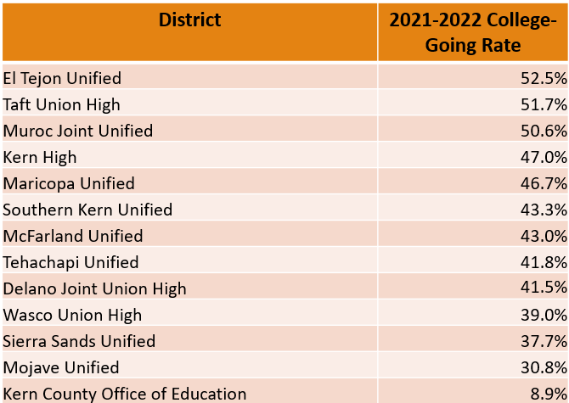
Source: CDE DataQuest.
College-going rates vary by district within Kern County. Over half of El Tejon (52.5%), Taft (51.7%), and Muroc (50.6%) twelfth grade completers enroll in college within twelve months.
The same is true for less than half of completing seniors from other county high schools.
According to CDE data (presented previously), the state college-going rate is 62.2%, higher than for any district in Kern County.

Labor Market Information
Top Occupations in the Central Valley/Mother Lode, 2023
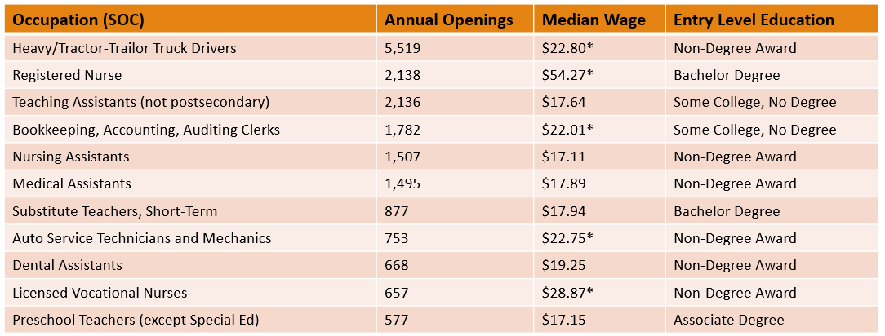
Source: COE/Lightcast Datarun 2022.4.
*Indicates at or above living wage for 1 adult 0 children ($21.44 in February 2024, MIT Living Wage Calculator, Kern County)
Eight of the top occupations are in the fields of Health or Education.
The region under consideration includes the Central Valley (from Stockton to Taft) and the Mother Lode region to the east of the Central Valley.
For a list of the Top 50 Occupations in Central Valley/Mother Load Region, see the full report.
Gap Analysis, South Central Valley/Southern Mother Lode, 2023
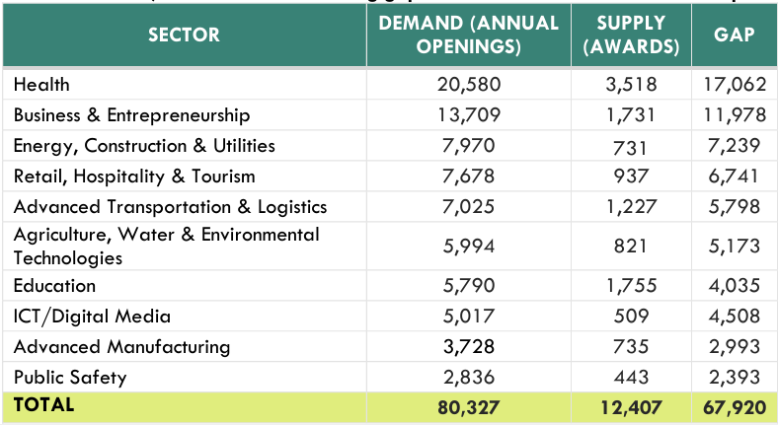
Source: COE/LightCast 2023.
This chart shows the undersupply of trained workers in the South-Central Valley/Southern Mother Lode Region (the comparison between workforce demand (annual job openings) and postsecondary supply (average annual awards) for each sector showing gaps in the number of workers to fill openings). The jobs under consideration all require more than a high school diploma but less than a Bachelor degree. The region under consideration includes the following Colleges: Clovis Community College, Fresno City College, Reedley College, College of the Sequoias, West Hills Colleges, Porterville College, Bakersfield College, and Taft College.
The three sectors with the greatest number of annual openings also have the largest potential gaps in workforce supply in the region:
- Health, a shortage of 17,062 workers
- Business and Entrepreneurship, a shortage of 11,978 workers
- Energy, Construction and Utilities, a shortage of 7,239 workers

Note: For more detailed information about the ten highlighted sectors and associated occupations, which are expected to offer eighty thousand job openings annually in the region, access the full report: Subregional Labor Market Overview: South Central Valley/Southern Mother Lode, 2023

In-Demand Occupations, South Central Valley/Southern Mother Lode, 2023
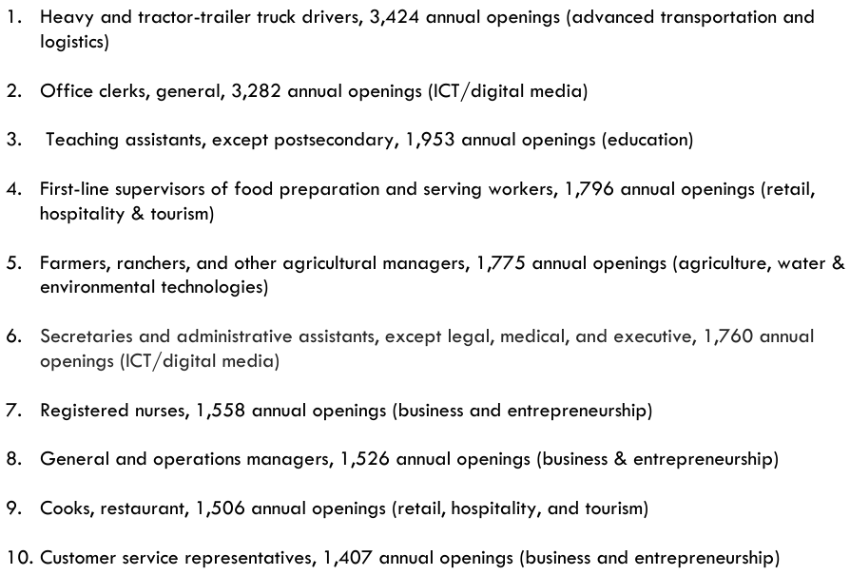
Source: COE/LightCast 2023.
The ten occupations with the most annual openings across all sectors in the South-Central Valley/Southern Mother Lode region are listed above. These highly in-demand jobs can provide a promising entry-point for students transitioning to the workforce.
Well-Paid Occupations, South Central Valley/Southern Mother Lode, 2023
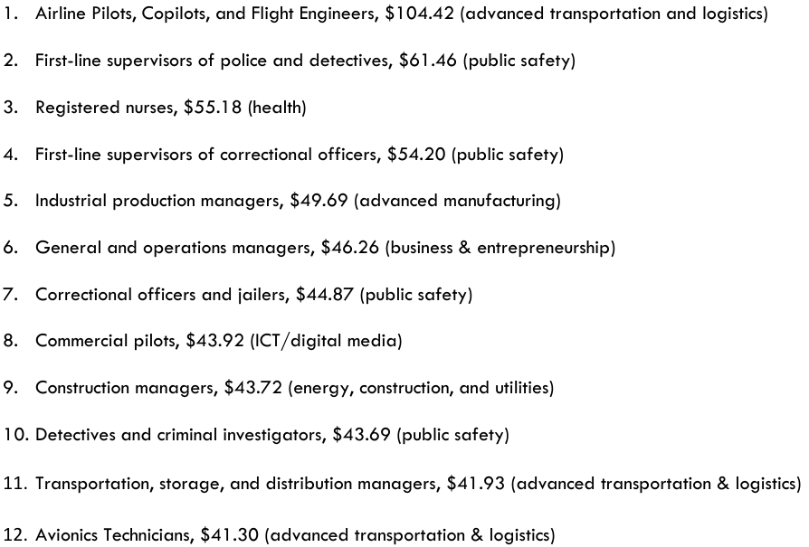
Source: COE/LightCast 2023.
The list above shows the 12 occupations in the Southern Central Valley/South Mother Lode region that pay median wages above $40/hour and that have more than 50 annual openings. Programs training for these occupations would provide students with the opportunity to advance economically. Many of these occupations are supervisory/managerial and multiple are in the Public Safety and Advanced Transportation & Logistics sectors.

Remote Jobs
The COVID-19 pandemic caused both work and school to shift to online platforms. Since then, work and school have maintained more of an online presence than before the Pandemic.
Citing census data and the US Bureau of Labor Statistics and other sources, Forbes Advisor (updated June 12, 2023) identified the following key remote work statistics:
- One in five workers nationally is working remotely
- 16% of companies are fully remote, operating without a physical office
- The highest percentage of remote workers are aged 24 to 35 – within this age group, 39% work remotely full-time and 25% do so part time
Source: https://www.forbes.com/advisor/business/remote-work-statistics/#sources_section.

Top Industries for Remote Work in 2024 | Top Remote Job Titles
- Computer & IT | - Accountant
- Accounting and Finance | - Executive Assistant
- Marketing | - Financial Analyst
- Medical & Health | - Product Manager
- Project Management | - Customer Service Rep
- Customer Service | - Software Engineer
- Sales | - Customer Success Manager
- Administrative | - Accounting Manager
- HR & Recruiting | - Product Designer
- Operations | - Writer
Source: Quoted in Forbes
Original Source: https://www.flexjobs.com/blog/post/100-top-companies-with-remote-jobs-in-2024/

Appendix B: Internal Scan

Enrollment
Taft College Historic Enrollment

Source: CCCCO DataMart.
Taft College enrollment, including WESTEC, has trended upward with a dramatic peak of over 12,000 students in 2008. Enrollment stabilized at 4,000-5,000 between 2011 and 2023. As with other colleges, enrollment dropped in 2020 due to the COVID-19 pandemic but began to rebound in 2022.
In the 1990s, the majority of Taft College students were White. From 2010 on, the majority of Taft College students have been Latino.

Enrollment Trends, Fall 2024
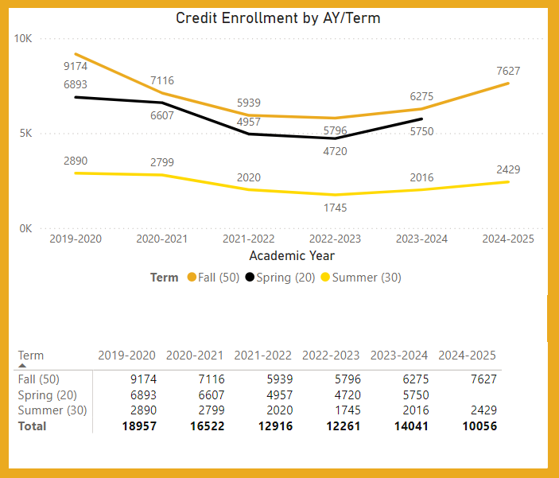
Taft campus

WESTEC

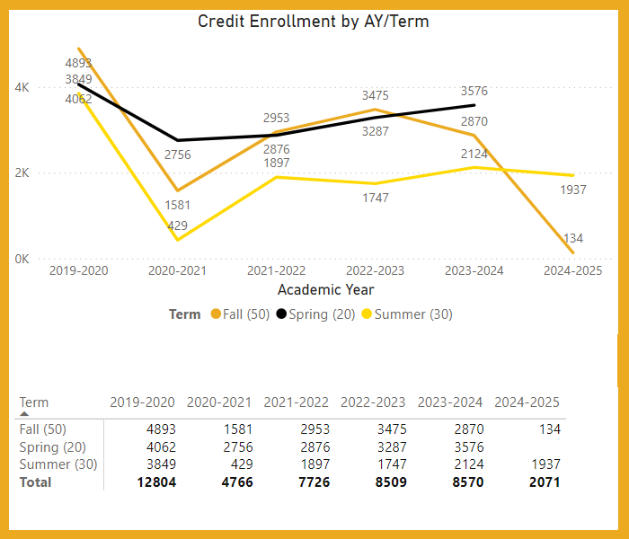

Source: Taft College Daily Enrollment dashboard, extracted 9/25/2024.
Enrollment at both the Taft campus and WESTEC has been rebounding since the COVID-19 pandemic, nearly reaching pre-pandemic levels.
Note: enrollment numbers are not finalized until end of term due to short-term courses taught throughout the semester.

Historic Headcount
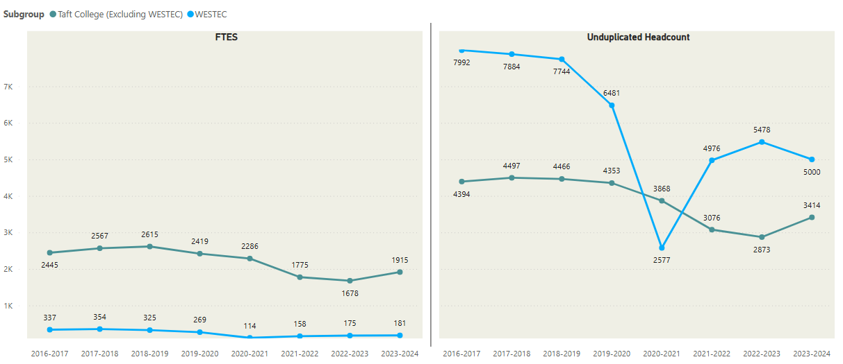

Source: Taft College Office of Institutional Research and Planning
Note: The scale is different for each chart.

At both campuses, enrollment was fairly stable until it dropped during the COVID-19 pandemic.
Prior to the Pandemic, nearly 4,500 students were enrolled annually at the Taft campus, and nearly 8,000 at WESTEC.
In most years, WESTEC accounts for approximately 60% of Taft College students.

Source: Taft College Office of Institutional Research and Planning.

Historic FTES

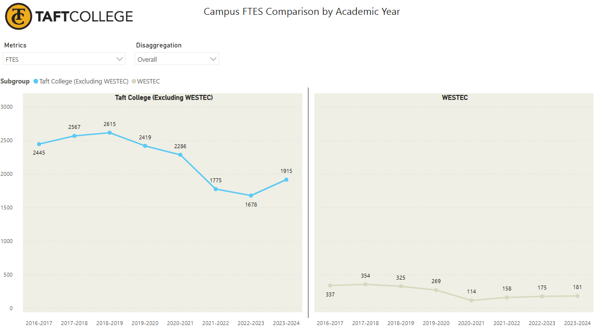
Source: Taft College Office of Institutional Research and Planning.
Note: The scale is different for each chart.

At both campuses, FTES was fairly stable until it dropped (along with headcount) during the COVID-19 pandemic.
Prior to the Pandemic, FTES at the Taft campus hovered around 2,500 while it was closer to 325 at WESTEC.
In most years, WESTEC accounts for approximately 10% of Taft FTES.

Enrollments by Modality

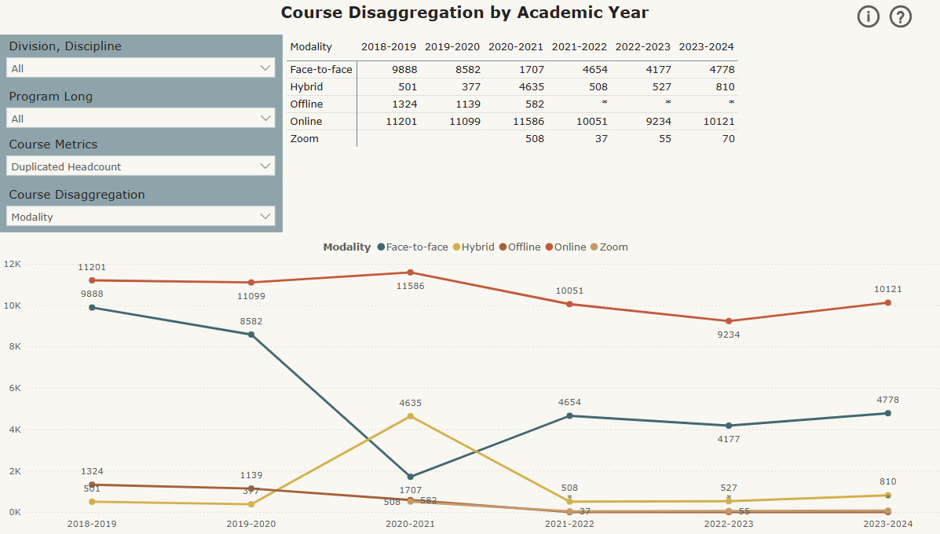
Source: Taft College Office of Institutional Research and Planning.
Note: Offline courses are correspondence; Zoom are specific time online courses; not all WESTEC enrollments are included.

Even prior to the COVID-19 pandemic, Taft College had higher online enrollments than face-to-face.

During the peak of the Pandemic, enrollments in hybrid courses increased and face-to-face decreased, with more enrollments online.

Post-pandemic, hybrid enrollments subsided to pre-pandemic levels, and face-to-face enrollments rebounded but had not yet reached pre-pandemic levels in 2023-2024.

Success Rate by Modality

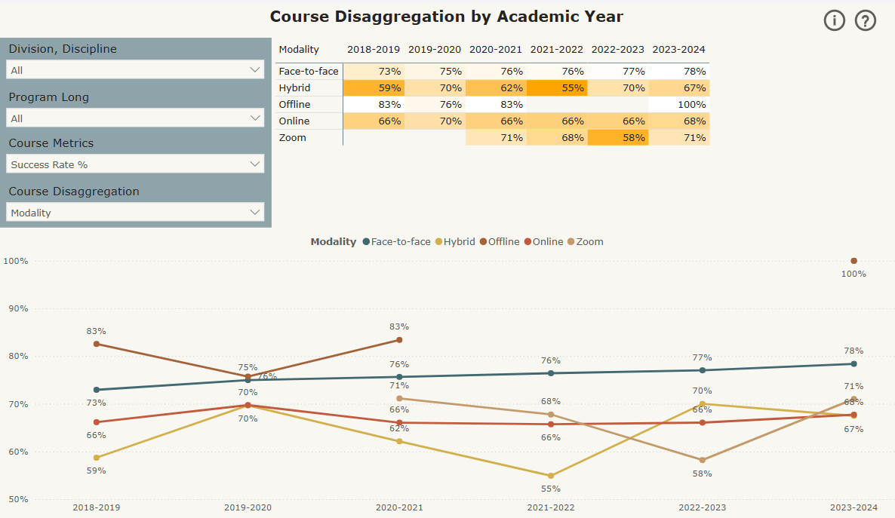
Source: Taft College Office of Institutional Research and Planning.
Note: Not all WESTEC enrollments are included.

Over the past several years, success rates have been highest in face-to-face classes, at 79% in 2023-2024.
Over time, success rates are lower in Online and Hybrid courses (68% and 67%, respectively, in 2023-2024).

Students
Educational Goal

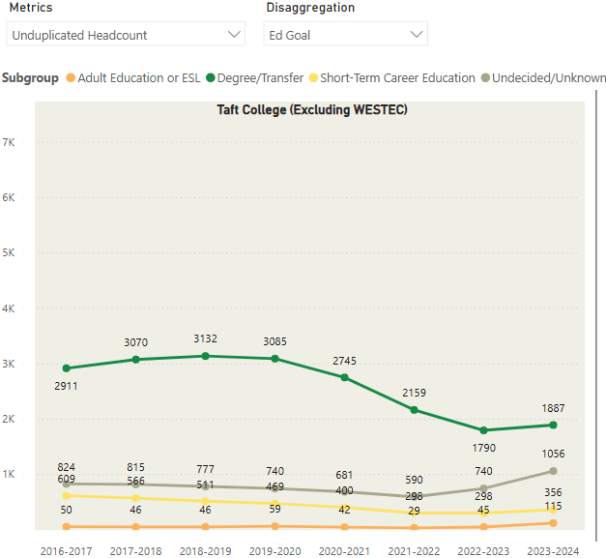
Source: Taft College Office of Institutional Research and Planning.

The majority of students at the Taft campus have Degree/Transfer as their educational goal, followed by Undecided/Unknown, Short-Term Career Education, and Adult Education.

Gender

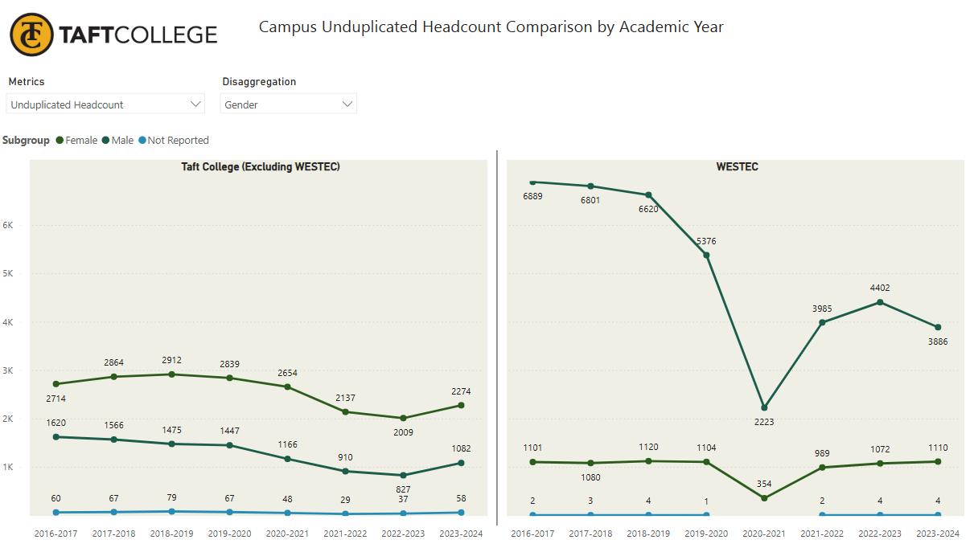
Source: Taft College Office of Institutional Research and Planning.
Note: The scale is different for each chart.

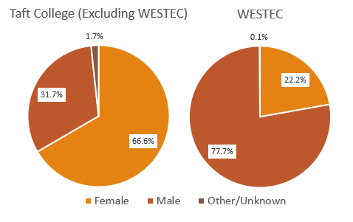

At the Taft campus, the majority of students are female, about 2:1.
At WESTEC, the majority of students are male, about 4:1.

Ethnicity

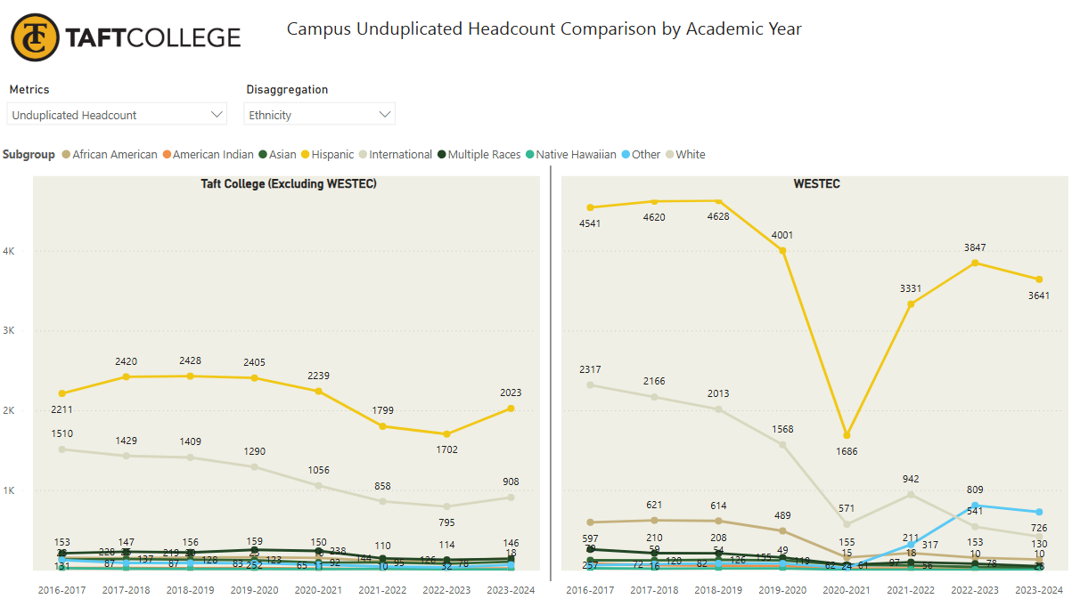
Source: Taft College Office of Institutional Research and Planning.
Note: The scale is different for each chart.

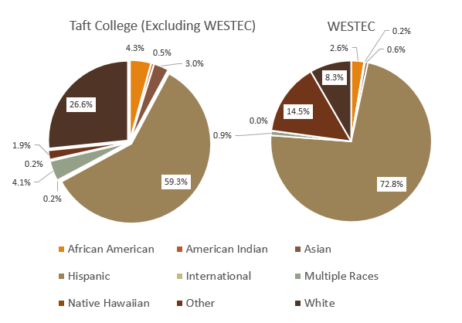

At both the Taft campus and WESTEC, the majority of students are Latino, followed by Whites.

Age

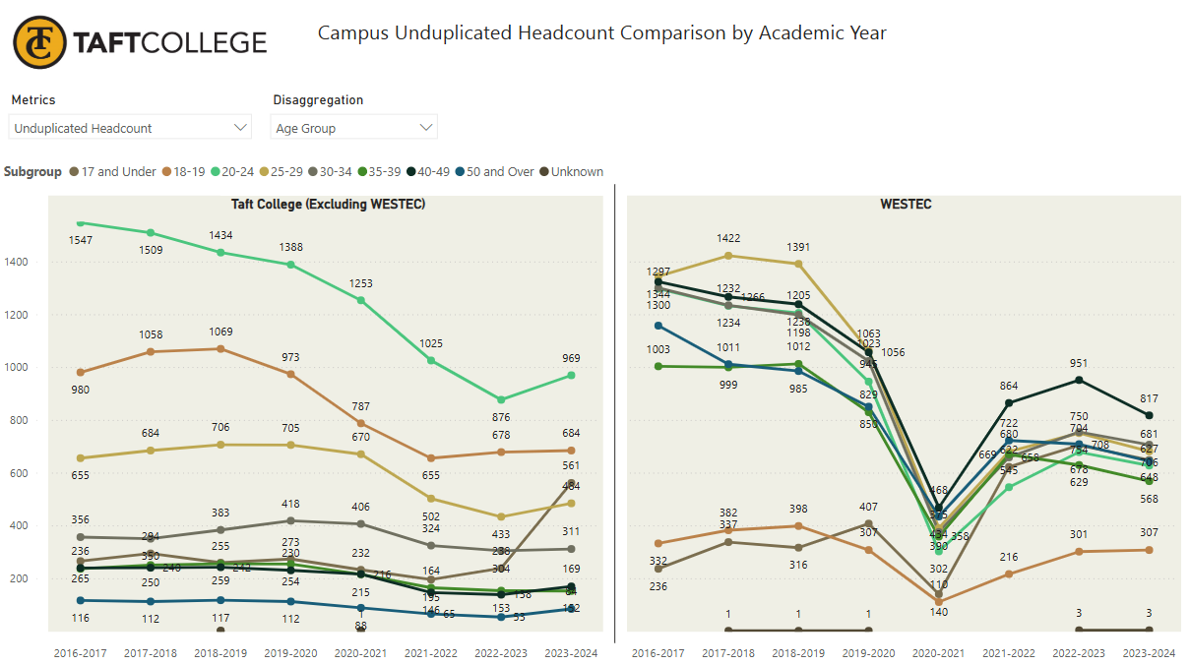
Source: Taft College Office of Institutional Research and Planning.
Note: The scale is different for each chart.

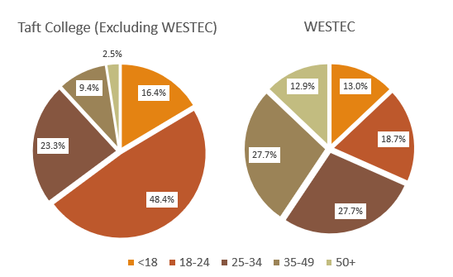

At the Taft campus, the student population is younger and is more traditionally college-aged (24 and under).
At WESTEC, the student population is older, with the majority being 25 and older.

Special Admit

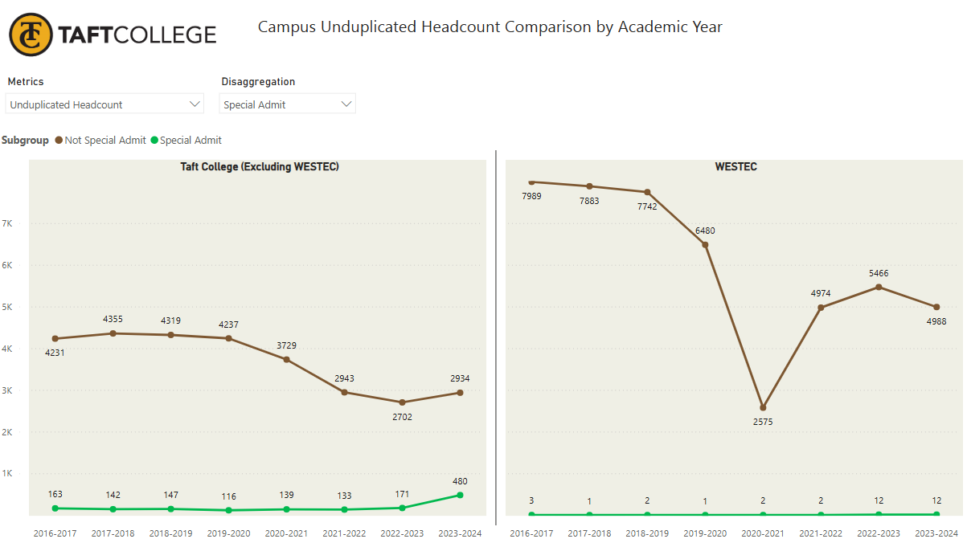
Source: Taft College Office of Institutional Research and Planning.
Note: The scale is different for each chart.

The vast majority of Taft College students who are “Special Admit” are enrolled at the Taft campus.

The number of Special Admit students has tripled since before the Pandemic, from 163 in 2016-2017 to 480 in 2023-2024.

In 2023-2024, Special Admit students accounted for 14% of headcount at the Taft campus (and 5% of FTES, which is not shown on this chart).

Student Type (excludes WESTEC)

Fall 2023 Enrollment Status | Taft campus | CCCs
First-Time Student | 18.2% | 17.5%
First-Time Transfer Student | 16.8% | 7.9%
Returning Student | 13.0% | 12.1%
Continuing Student | 41.0% | 51.2%
Special Admit Student | 10.9% | 11.2%
Total Number | 2,376 | 1,449,392
Source: Taft College Office of Institutional Research and Planning for Taft numbers, CCCCO DataMart for statewide numbers.
Note: Comparable data for WESTEC is currently not available.

There is twice the proportion of First-Time Transfer Students at Taft College than statewide at all CCCs.

Proportionally, there are fewer continuing students at Taft than statewide.

Declared Majors (excludes WESTEC)

Top Declared Majors | 2019/20 | 2020/21 | 2021/22 | 2022/23 | 2023/24
Liberal Arts Allied Health | 543 | 583 | 491 | 486 | 539
Business Administration 2.0 | 0 | 0 | 3 | 131 | 246
Psychology for Transfer | 280 | 281 | 239 | 210 | 222
Engineering | 188 | 164 | 156 | 142 | 188
Early Care Educ for Transfer | 255 | 231 | 183 | 179 | 186
Biology for Transfer | 224 | 176 | 142 | 124 | 159
Elementary Teacher Ed | 0 | 3 | 70 | 116 | 150
Life Science | 235 | 178 | 120 | 100 | 126
Kinesiology for Transfer | 102 | 97 | 66 | 75 | 109
Business Administration | 116 | 95 | 63 | 71 | 105
Admin of Justice for Transfer | 177 | 131 | 98 | 76 | 89
General Business | 236 | 139 | 56 | 74 | 88
Early Care Ed & Family Studies | 158 | 146 | 100 | 66 | 79
Liberal Arts Communication | 139 | 111 | 95 | 72 | 68
Sociology for Transfer | 128 | 128 | 101 | 66 | 67
Source: Taft College Office of Institutional Research and Planning.

Over the past five years, Liberal Arts for Allied Health has remained the most popular major for Taft College students.

Business Administration 2.0 and Elementary Teacher Ed gained popularity quickly after being introduced.

Total Awards

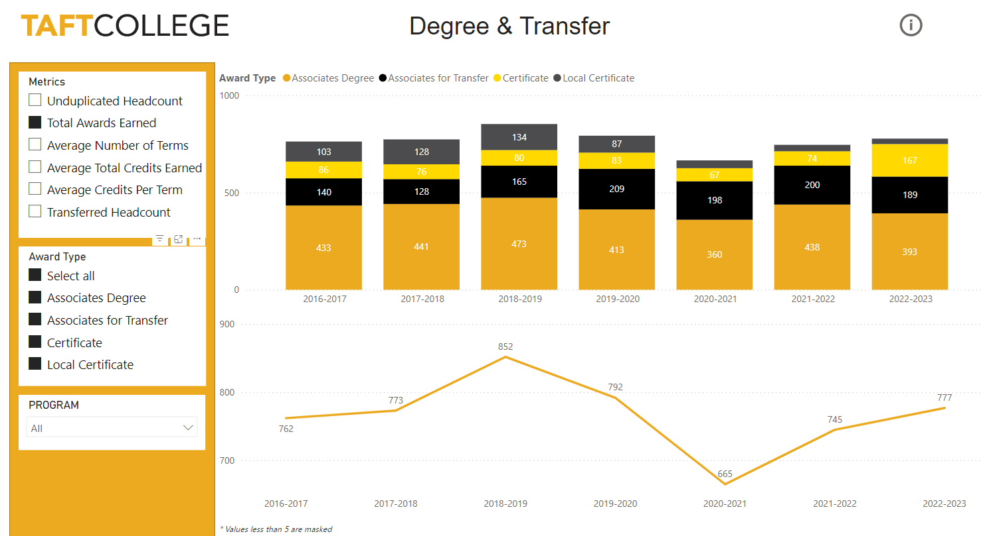
Source: Taft College Office of Institutional Research and Planning.

In 2022-2023, 777 have been awarded (to date).

Taft College has awarded between 665 and 852 degrees and certificates annually over the past 7 years, with lower numbers occurring during the COVID-19 pandemic.

The majority of awards are Associate degrees and Associate degrees for Transfer.

The number of certificates (non-local) awarded increased notably in 2022-23.

Unduplicated Student Awards

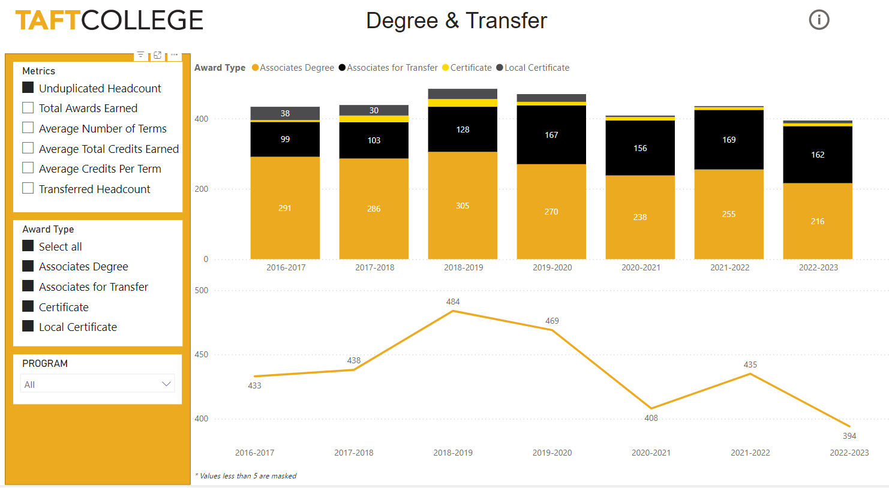
Source: Taft College Office of Institutional Research and Planning.
Note: In 2022-2023, 777 awards were bestowed on 394 students, for an average of 2 awards per student.

Between 394 and 484 Taft College students have earned one or more awards annually in recent years, with many earning more than one award.

While more degree-earning students are receiving local Associate degrees, over the past years an increasing number are earning Associate Degrees for Transfer.

Top Awards, 2023-2024

Award | #
Certificate in CSU GE | 151
AA Liberal Arts Math & Science | 70
AA Liberal Arts Allied Health | 64
AS Life Science | 44
AA Liberal Arts Communication | 41
ADT-Psychology for Transfer | 30
Business Administration 2.0 | 19
AA Liberal Arts Business Technology | 18
AS Criminal Justice Admin | 18
ADT-Sociology for Transfer | 17
AA Liberal Arts Natural Life Sci | 17
AS Dental Hygiene | 15
AS General Business | 15
CC in Child Development Assistant Teacher | 15
CA in Associate Teacher ECEF | 14
Source: Taft College Office of Institutional Research and Planning.

The most frequently bestowed Taft College award in the 2023-2024 Academic Year was the “Certificate in CSU General Education.”

The most popular Associate of Arts degree majors are in the Liberal Arts (Math & Science, Allied Health, Communication Business).

The most popular Associate of Science degree majors are Life Sciences, Criminal Justice, and Dental Hygiene.

Notably, there are two popular Associate Degree for Transfer majors, Psychology and Sociology.

Location Origins, 2023-2024 (excludes WESTEC)

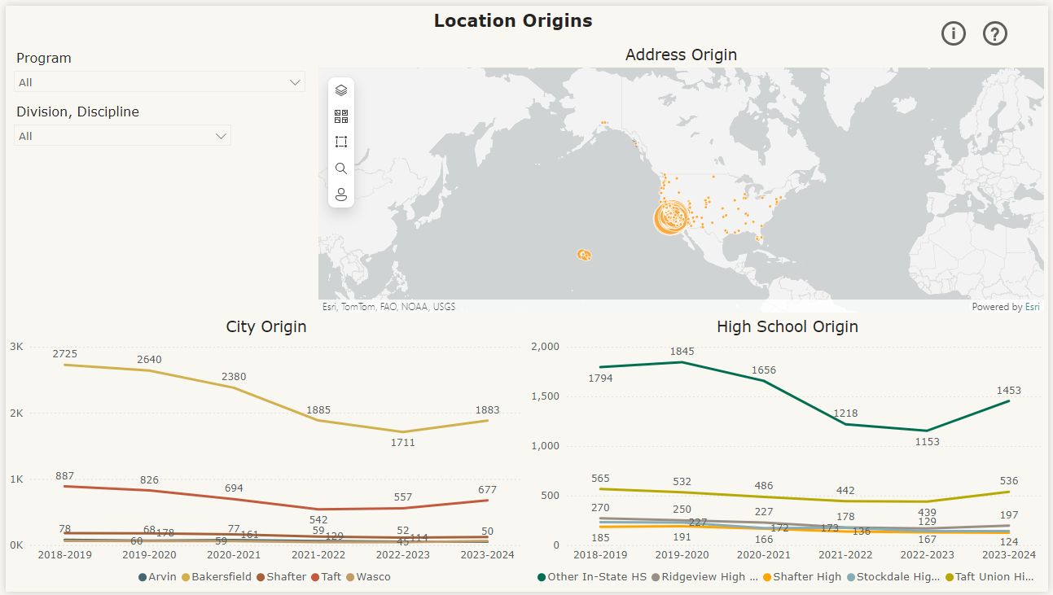
Source: Taft College Office of Institutional Research and Planning.

The preponderance of Taft students are from Bakersfield.

The second largest student group by the town is from Taft, followed by Shafter, Wasco, and Arvin.

The high school sending the greatest number of students to Taft College is Taft High School, followed by Ridgeview, Stockdale and Shafter high schools.

Enrollment by ZIP Code (excludes WESTEC)

Location (based on ZIP code of residence) | % of Headcount in AY 2023-2024
Bakersfield | 55.0%
Taft | 19.8%
17 other regional towns | 17.1%
Other California | 6.0%
Out of State | 1.6%
Unknown | 0.4%
Source: Taft College Office of Institutional Research and Planning, Location&Modality_Final+1.xls

Over half of Taft College students (excluding WESTEC) have residential ZIP codes in Bakersfield – this proportion has decreased; in recent years it was 60-61%.

One-fifth of Taft College students live in Taft – this proportion has been stable over the past few years.

Nearly another fifth of students are from regional towns, including Shafter (3.5%), Lompoc (2.7%), Wasco (1.8%), Arvin (1.5%), Santa Maria (1.4%) and Lamont (1.2%).

Taft College “Special Populations”

Special Characteristic, Fall 2023 | Head Count | % Headcount | Credit FTES
First Generation | 1,175 | 29.6% | 420.28
Special Admit | 657 | 16.5% | 54.64
Received Services/Support through Basic Needs Center | 580 | 14.6% | 302.63
EOPS - Extended Opportunity Programs & Services | 251 | 6.3% | 125.37
DSPS - Disabled Students Programs & Services | 114 | 2.9% | 35.48
Foster Youth | 82 | 2.1% | 26.87
Veteran | 25 | 0.6% | 7.6
CalWORKs - California Work Opportunity & Responsibility to Kids | 10 | 0.3% | 4.42
Homeless | 10 | 0.3% | 2.97
Military (Active Duty, Active Reserve, National Guard) | 7 | 0.2% | 2.64
CARE - Cooperative Agencies Resources for Education | 6 | 0.2% | 2.48
CAFYES - Cooperating Agencies Foster Youth Educational Support | 5 | 0.1% | 2.4
Source: CCCCO DataMart.
Nearly one-third (29.6%) of Taft College students, including WESTEC, are First Generation college students, meaning neither parent/guardian earned a Bachelor degree.
One in six (16.5%) Taft College students are Special Admit, meaning they are concurrently enrolled in high school.
One in seven (14.6%) Taft College students received Basic Needs support.
Smaller proportions of students are in other special populations, as indicated in the above chart.

Taft College CPG, Pell, and AB540 Students

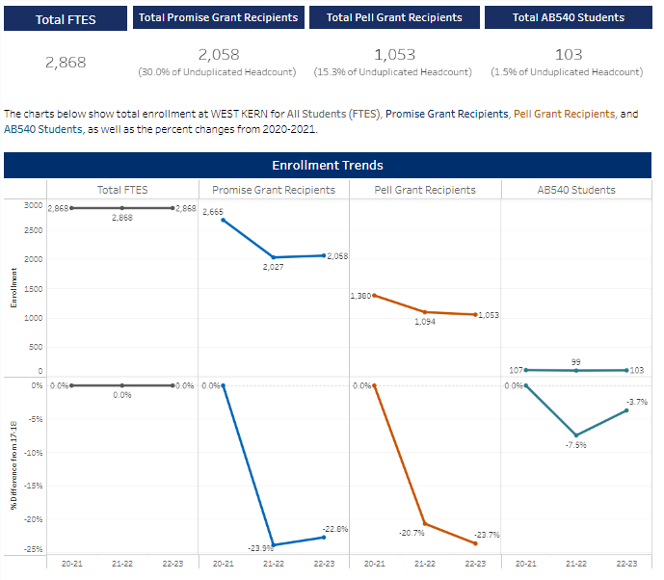
Source: CCCCO SCFF Dashboard.
Statewide and Taft Compared, 2023-2024
 | CCCs | Taft College
Promise Grant Recipients | 36.7% | 30.0%
Pell Grant Recipients | 19.3% | 15.3%
AB540 Students | 2.3% | 1.5%
Source: CCCCO SCFF Dashboard.

As enrollment decreased at Taft College (including WESTEC) in the early 2020s due to the COVID-19 pandemic, so did the number of students receiving Promise and Pell grants, and the number of undocumented students afforded in-state status for tuition purposes. As colleges receive additional funding for these categories of students, especially if they achieve identified outcomes, it is important for the College to ensure eligible students apply and are awarded.
Compared to all California Community Colleges, Taft has slightly lower rates of Promise and Pell grants awarded, and slightly fewer AB540 students.

Student Outcomes: Educational Journey
Student Outcomes: Students by Educational Journey, CCCCO DataVista 2022-2023

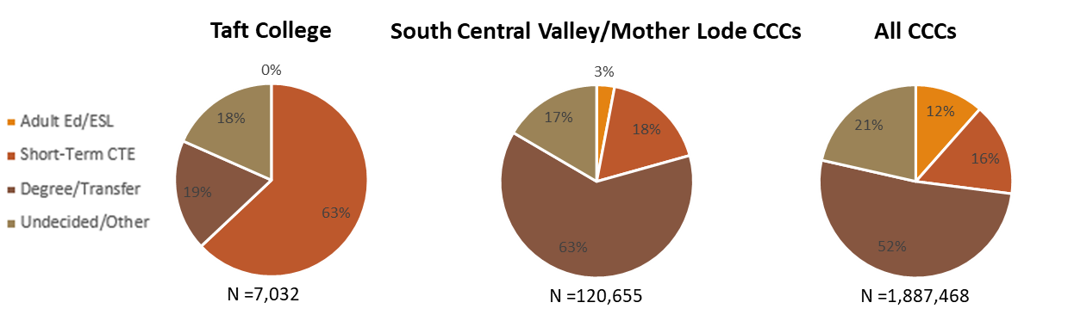
Source: CCCCO DataVista.
Compared to regional community colleges and all CCCs statewide, Taft has a much larger proportion of short-term CTE and much smaller proportions of Degree/Transfer, Undecided/Other, and Adult Education. This is likely due to the relatively large population of short-term CTE students served at the WESTEC facility.
For this reason, it is important to consider Taft students (including WESTEC) by educational journey when assessing outcomes. The following charts present outcomes data by student journey.
In the CCCCO DataVista, the regional comparison group for Taft College includes Clovis Community College, Fresno City College, Reedley College, College of the Sequoias, West Hills Colleges, Porterville College, and Bakersfield College.

Student Outcomes: Degree/Transfer Students (primarily Taft campus)
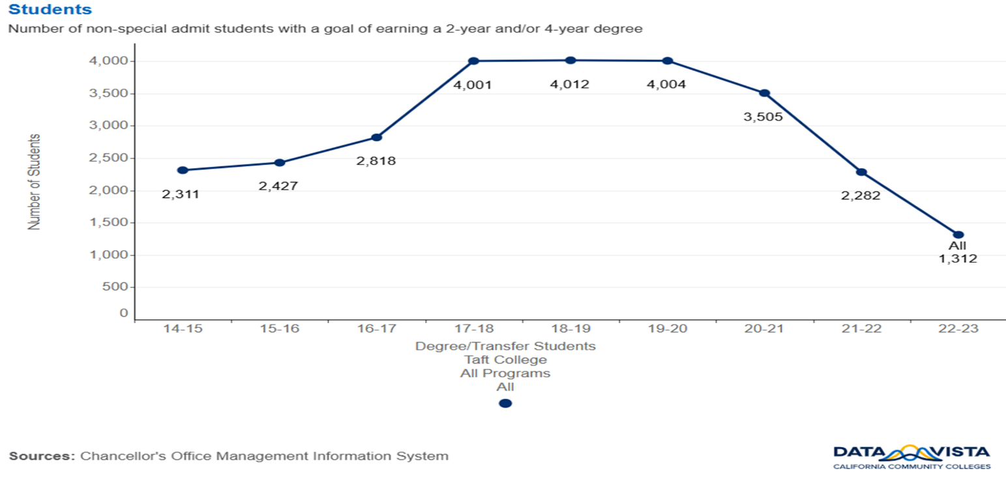
Source: CCCCO DatVista..
This population should not include WESTEC students unless they indicated degree/transfer as their educational goal. This population should represent the majority of students taking classes at Taft College, not at WESTEC. It is most likely WESTEC students have the educational goal of short-term CTE training, as that is what the WESTEC campus provides.
The number of Taft students with the educational goal of degree/transfer has fluctuated over the past seven years, peaking between 2017 and 2020 at about 4,000.
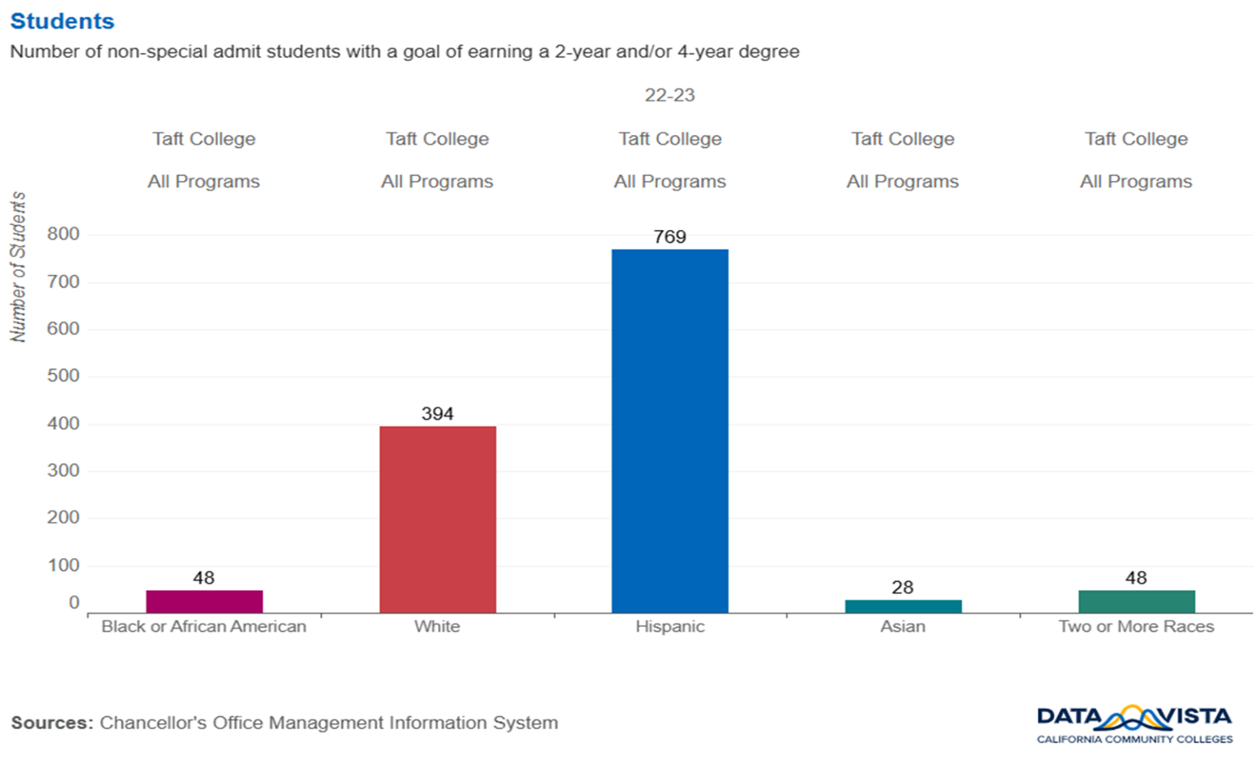

Source: CCCCO DataVista.
The majority of Degree/Transfer students, primarily at the Taft campus, are Latino, followed by White, and smaller proportions of other ethnic groups.
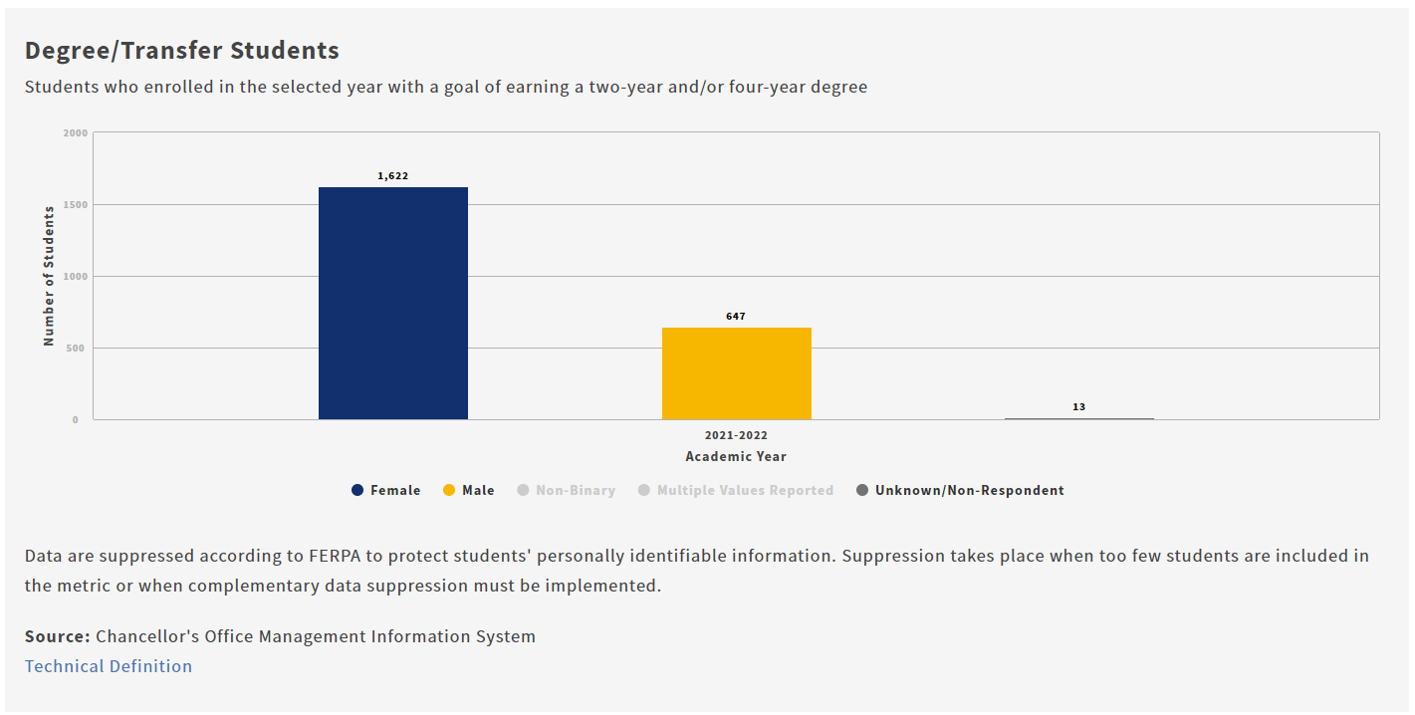
Source: CCCCO DataVista.
The majority of Degree/Transfer students, primarily at the Taft campus, are female.
Learning Progress, Degree/Transfer Students
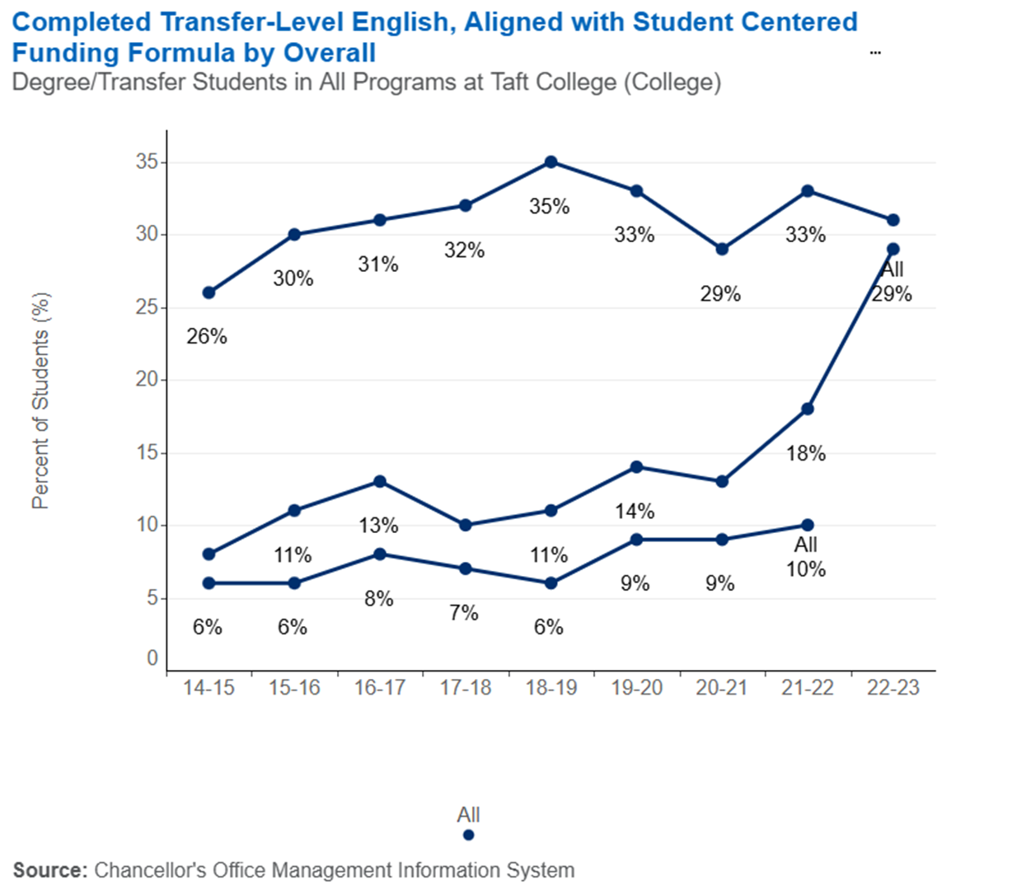
Top Line: Completed Transfer Level English in First Year
Middle Line: Completed Transfer Level Math in the First Year
Bottom Line: Completed Transfer Level Math and English in the First Year
Source: CCCCO DataVista.
Completing Transfer-Level Math and English in a student’s first year is an evidenced-based strategy promoting completion and transfer for students desiring to earn a degree and/or transfer to a 4-year institution.
At Taft College, the Math and English completion rates have trended slightly upward to where they are in the most recent data, for 2021-2022, where the completion rates are 33% for English, 18% for Math, and 10% for both.

Learning Progress, Degree/Transfer Students Compared

Compared to the Southern Central Valley/South Mother Lode region and the state, Taft College Degree/Transfer students post higher levels of math completion rates. For English, Taft rates are on par with the region but lower than the state.

Source: CCCCO DataVista.
Persistence, Degree/Transfer Students
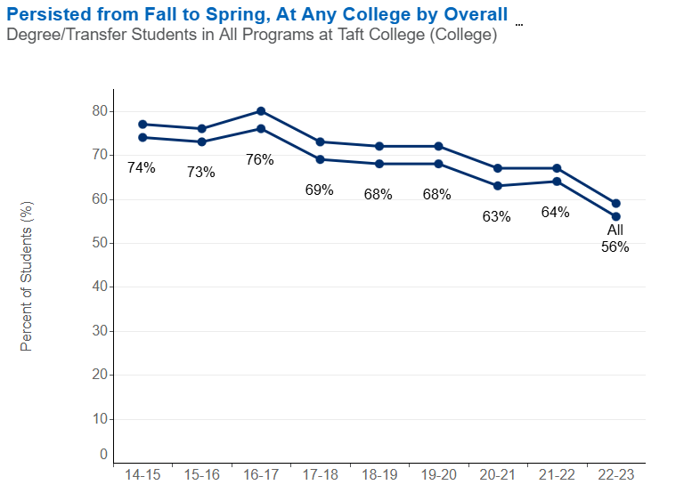
Top Line: Persistence from Fall to Spring at Any Community College
Bottom Line: Persistence from Fall to Spring at the Same College
Source: CCCCO DataVista.
The percent of Taft College students persisting from Fall to Spring has decreased over time, from about 75% in 2014-2015 to about 65% in 2021-2022. The pattern holds for persistence at the same college (Taft) and persistence at any California Community College.
Persistence, Degree/Transfer Students Compared

Compared to the Southern Central Valley/South Mother Lode region and the state, Taft College Degree/Transfer students posted lower levels of Fall to Spring Persistence.

Source: CCCCO DataVista.
Completion, Degree/Transfer Students Over Time

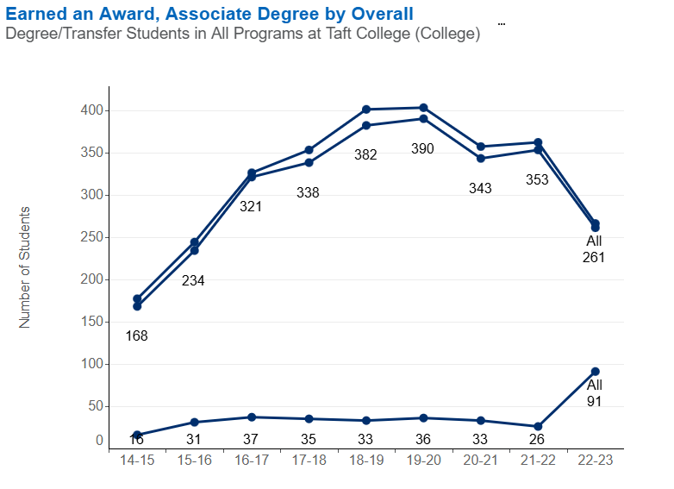
Top Line: Earned and Award, Vision Goal Completion Definition
Middle line: Earned an Award, Associate Degree
Bottom Line: Earned a Chancellor’s Office Approved Credit Certificate

Source: CCCCO DataVista.
Even though there have been enrollment fluctuations, the number of Taft College students with the goal of degree and/or transfer who have earned a degree or attained the Vision Goal of Completion (degree, transfer, certificate, apprenticeship) has trended upward to 10% in 2021-2022 but decreased in 2022-2023. The percentage of degree/transfer students earning a Chancellor’s Office-approved certificate has remained relatively flat, at 1%, which is not a surprise as this student group has the goal of earning a degree and/or transfer, not earning a certificate.

Completion, Degree/Transfer Students Compared

Compared to the Southern Central Valley/South Mother Lode region and the state, Taft College Degree/Transfer students posted higher levels of degree completion, and Vision for Success Goal Completion. Taft’s Chancellor’s Office approved certificate completion rate is lower, which makes sense given this student population has the goal of degree and/or transfer.

Source: CCCCO DataVista.
Units Accumulated Upon Degree Completion, Degree/Transfer Students
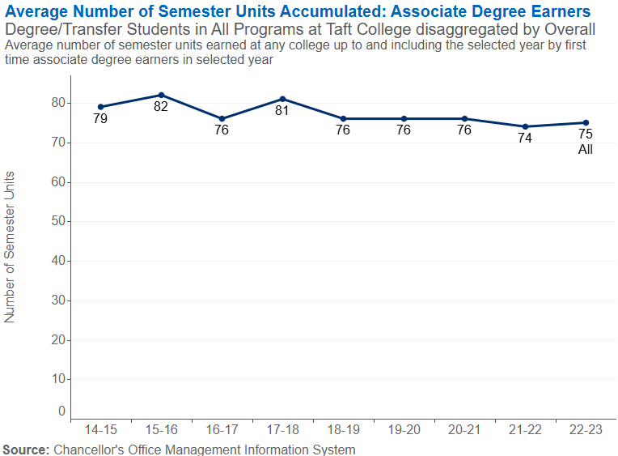
Source: CCCCO DataVista.
For Degree/Transfer students who earn an Associate Degree at Taft College, the total number of units accumulated has decreased from a high of 80 to a low of 74 in 2021-2022. Technically, an Associate Degree requires only 60 units, and excess unit accumulation can impact financial aid eligibility after transfer.

Units Accumulated Upon Degree Completion, Degree/Transfer Students Compared

Compared to the Southern Central Valley/South Mother Lode region and the state, Taft College Degree/Transfer students amassed fewer units upon conferral of first Associate degree, which improves student eligibility for future financial aid.

Source: CCCCO DtaVista.
Transfer, Degree/Transfer Students
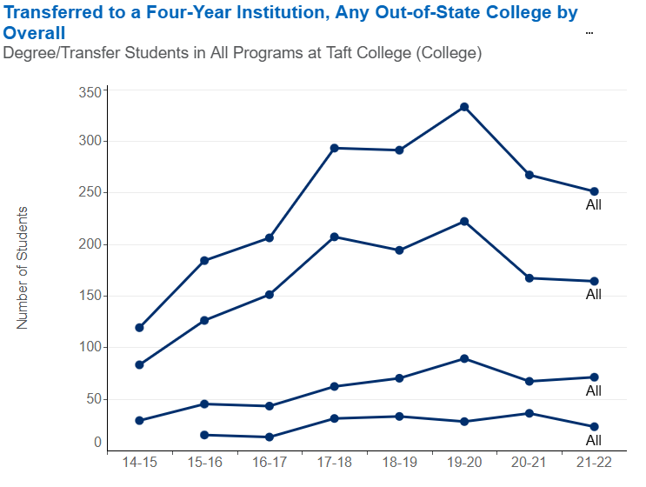
Source: CCCCO DataVista.
The number of Taft College students with the educational goal of earning a degree and/or transfer to a four-year institution has been trending upward over the past four years, with a modest dip in 2020-2021. The majority of these transfer students attend a CSU or UC.

Transfer, Degree/Transfer Students Compared

Compared to the Southern Central Valley/South Mother Lode region and the state, a higher percentage of Taft students with the goal of degree and/or transfer actually transferred in 2021-2022.

Source: CCCCO DataVista.
Transfer Rate

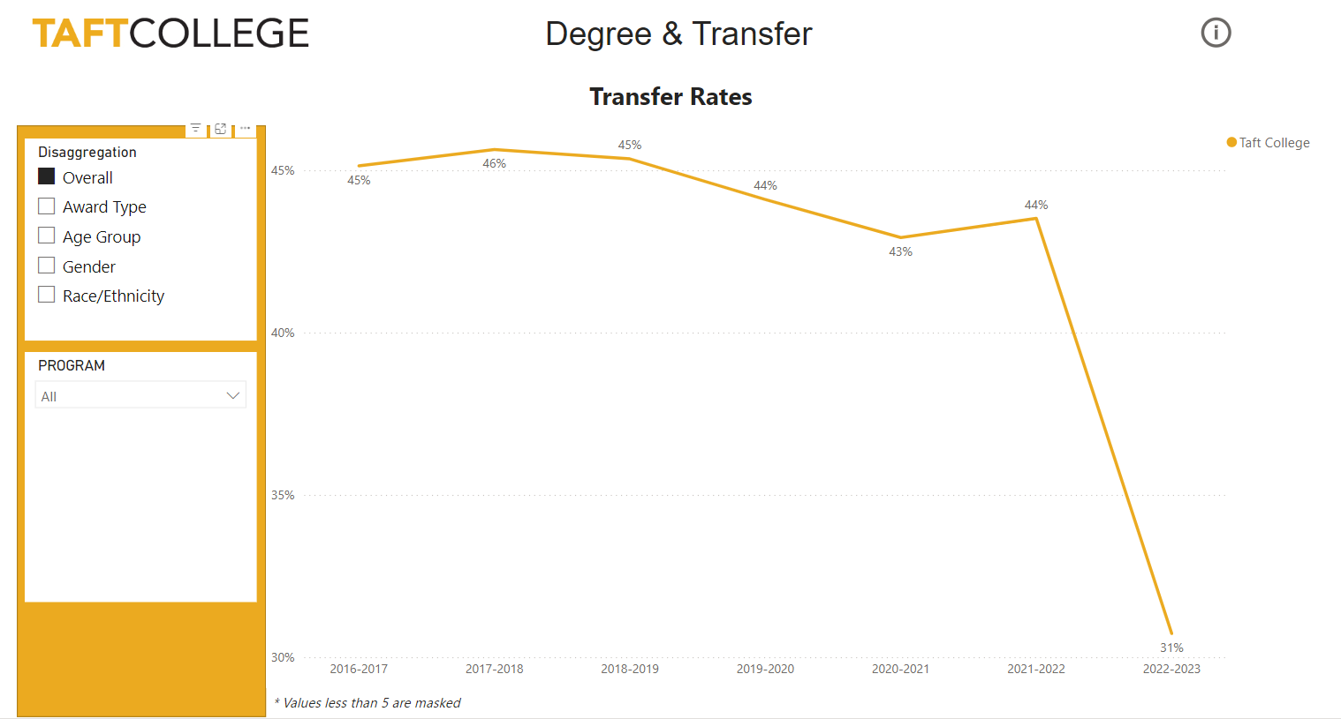

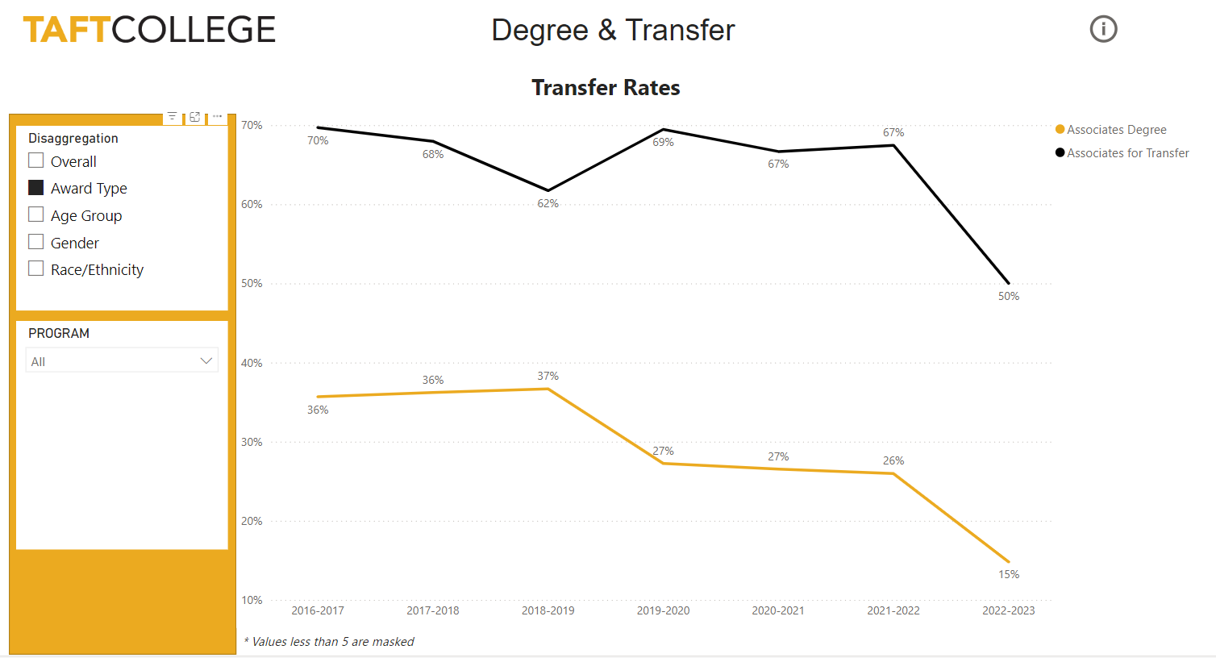
Source: Taft College Office of Institutional Research and Planning.
Note: there is a time lag in confirming transfer data; the numbers for 2022-2023 will likely increase.

Taft College locally defines transfer rate as the percentage of degree earners who transfer to a 4-year college or university the following Fall. The transfer rate was fairly stable until it decreased noticeably in 2022-2023, perhaps because the data are incomplete.

While more Taft students earn local Associate degrees than ADTs, the transfer rate for ADT earners is significantly higher.

Top University Transfer Destinations

Institution Name | 5-Year Total Students Transferred (16/17-22/23)
CALIFORNIA STATE UNIVERSITY - BAKERSFIELD | 505
CALIFORNIA STATE UNIVERSITY - FRESNO | 20
ARIZONA STATE UNIVERSITY | 20
FRESNO PACIFIC UNIVERSITY | 20
WESTERN GOVERNORS UNIVERSITY | 17
UNIVERSITY OF PHOENIX | 16
CALIFORNIA STATE UNIVERSITY - LONG BEACH | 14
POINT LOMA NAZARENE UNIVERSITY | 13
NATIONAL UNIVERSITY | 13
GRAND CANYON UNIVERSITY | 13
CALIFORNIA STATE UNIVERSITY- NORTHRIDGE | 13
SAN DIEGO STATE UNIVERSITY | 10
SOUTHERN NEW HAMPSHIRE- 09WEEK | 10
Source: Taft College Office of Institutional Research and Planning.
Note: about half of these 4-year colleges and universities are fully online, or have substantial online degree completion programs.

By far, the top transfer destination for Taft College transfer students in California State University, Bakersfield. Tied for a distant second are CSU Fresno, Arizona State University, and Fresno Pacific College.
UC and CSU Acceptance and Enrollment Rates Compared

Fall 2023 UC and CSU Rates
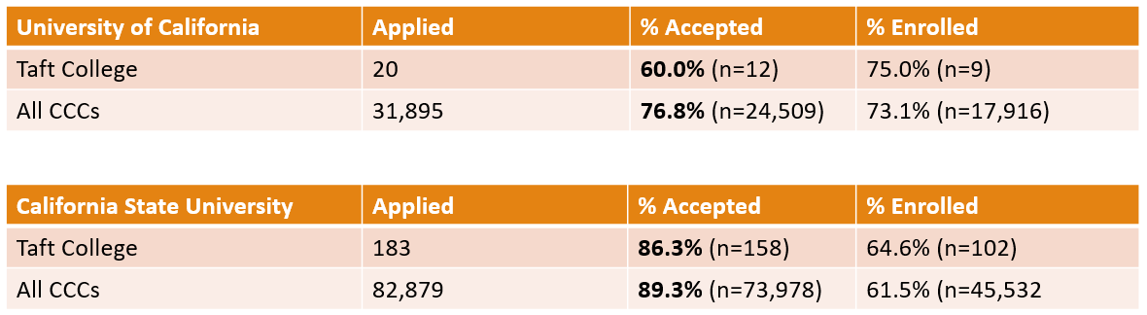
Source: UCOP Info Center, and CSU Data Analytics.
Taft College students post lower acceptance rates to the University of California and to the California State University System, but higher enrollment rates. In other words, fewer Taft College students are accepted to a UC or CSU, but of those who are accepted, a higher proportion actually enroll, as compared to statewide CCC averages.

Student Outcomes: Short-Term Career Students (primarily WESTEC)

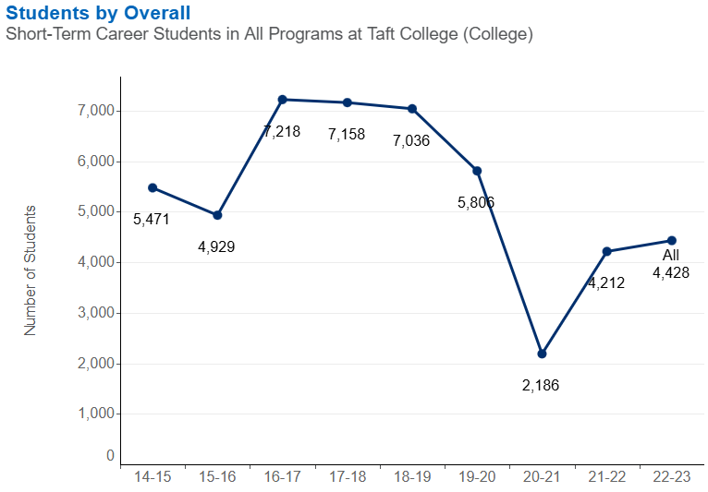
Source: Source: CCCCO DataVista.
Taft College students with the goal of Short-Term Career likely represent all students enrolled at the WESTEC site, and possibly some students enrolled at Taft College who share that specific educational goal.
The number of Taft College students (likely mostly WESTEC students) with the goal of building skills to advance their careers has varied over the past years, with a noticeable dip during the COVID-19 pandemic between 2019 and 2021, when course offerings at WESTEC also dipped due to restrictions on in-person instruction.
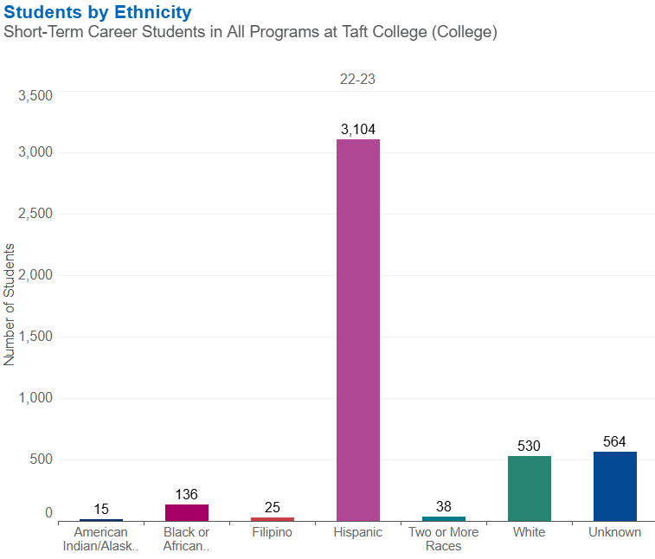
Source: CCCCO DataVista.
The majority of Short-Term CTE students (likely mostly WESTEC students) are Latino.
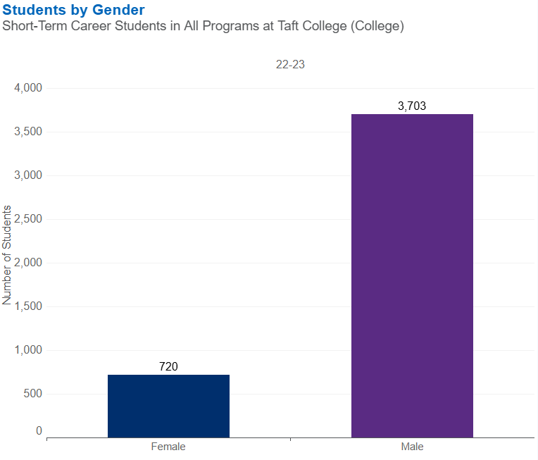
Source: CCCCO DataVista.
The majority of Short-Term CTE students (likely WESTEC students) are male.
Course Success Rate, Short-Term Career Students
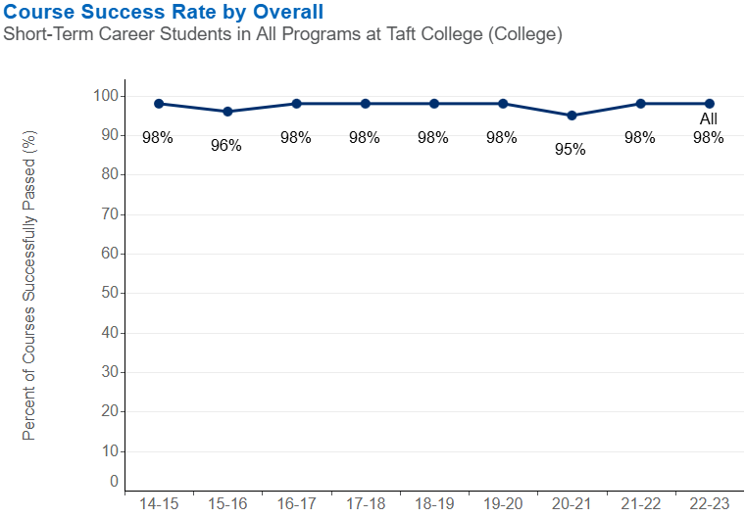
Source: CCCCO DataVista.

Taft course completion rates for Short-Term CTE (likely WESTEC students) have remained high in recent years, between 96% and 98%.

Taft course completion rates for Short-Term CTE (likely mostly WESTEC students) are higher than the regional and state averages.

Source: CCCCO DataVista.
Median Change in Earnings, Short-Term Career Students
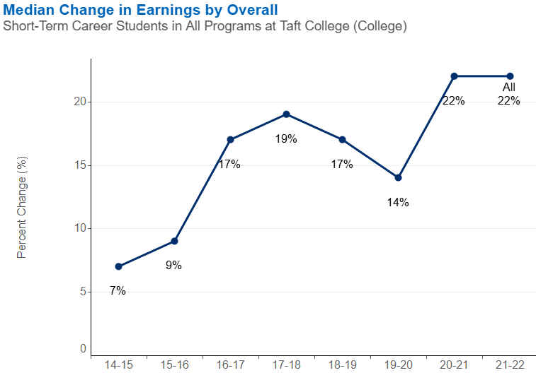
Source: CCCCO DataVista.
Participating in Short-Term Career Education training has had positive economic outcomes for Taft College students who show increasing gains in earnings over the past six years.

Median Change in Earnings, Short-Term Career Students Compared

Compared to the Southern Central Valley/South Mother Lode region and the state, Taft College Short-Term Career students (likely enrolled at WESTEC) posted lower levels of increased earnings after their training.

Source: CCCCO DataVista.
Attained the Living Wage, Short-Term Career Students

Source: Source: CCCCO DataVista.slightly lower levels
Participating in Short-Term Career Training has had positive economic outcomes for Taft College students, who show increasing levels of attaining the living wage over the past six years.

Attained the Living Wage, Short-Term Career Students Compared

Compared to the Southern Central Valley/South Mother Lode region and the state, Taft College Short-Term Career students (likely enrolled at WESTEC) posted slightly lower levels of attaining the regional living wage after their training.

Source: CCCCO DataVista.
Career Education Employment Outcomes Compared, 2023

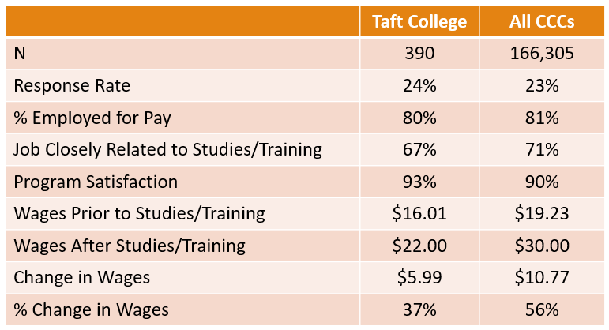
Source: California Community Colleges Career & Technical Education Employment Outcomes Survey (CTEOS).

Taft College students, and CCC students statewide, show an increase in earnings after participating in career education programs and training.
The increase in wages brings Taft College students, on average, above the regional living wage ($21.44 for 1 adult 0 children, February 2024, Living Wage Calculator, Kern County California).

Career Education Wage Outcomes by Program

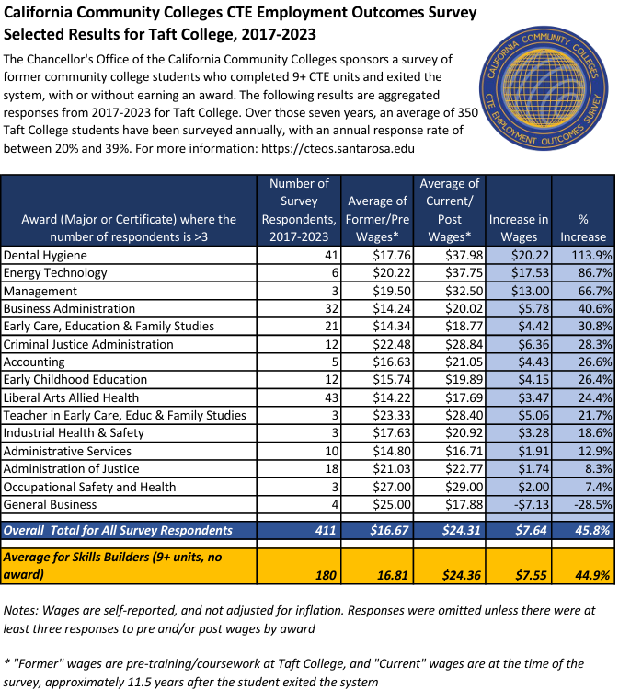
The above table shows the increase in wages for aggregated Taft College students by local program of study, 2017-2023, ranked from highest increase to lowest. Dental Hygiene, Energy Technology, Management, and Business Administration post the largest increases in wage gains over the past six years.

Student Outcomes: Undecided/Other Students
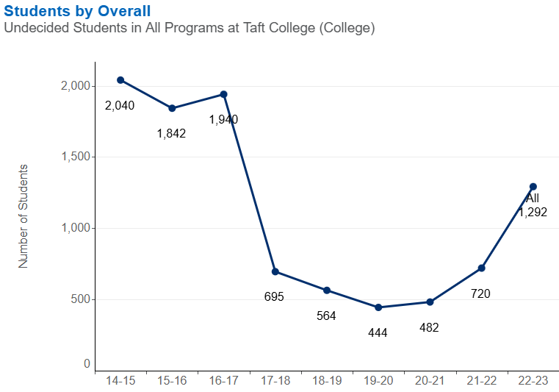
Source: CCCCO DataVista.
The number of Taft College students who are undecided on their educational goal, or who fall into one of the lower-enrolled categories of Life-long learning or currently enrolled at a 4-year institution, has been decreasing. Other colleges with a similar trend have attributed it to better collection of educational goals data from students upon matriculation. In any event, the numbers have decreased at Taft, and it is not possible to know what the true educational goal of these students is, so assessing outcomes without a stated goal makes no sense.

Student Surveys
In addition to the student voices captured in the listening sessions, which are reported in the next section of this document, student feedback provided through surveys were also analyzed to capture a broader range of the student experience and help inform the Educational Master Plan. The two student surveys analyzed were the 2024 Community College Survey of Student Engagement (CCSSE) and the 2023 Taft College Student Survey. Findings from those analyses are provided in the sections that follow.
Community College Survey of Student Engagement (CCSSE), 2024
In Spring 2024, the CCSSE was administered to Taft College students; 274 students answered the survey for a participation rate of approximately 13%. Key findings included the following:
- Taft College students are generally more satisfied with their college experience than the students at similar small community colleges, and more satisfied than the average for all community college students responding to the survey nationally.

- Taft College students report higher levels of interaction with instructors, and higher levels of accessing and being satisfied with student support services, specifically library resources, tutoring and skills labs, counseling, and specialized programs such as services for veterans and students with disabilities.
- Students highlighted the following as important: zero textbook cost classes, transfer/career counseling and job placement, tutoring/skills labs, student organizations, library resources and services, and specialized support programs such as veterans and disability resources.
- Compared to national averages, Taft College students reported significantly higher levels of support for student learners and lower levels of academic challenge/rigor (fewer readings and written assignments).

On the CCSSE benchmark of "Support for Learners," Taft College scored above the average for the top 10% of the national cohort, which is remarkable.
Taft College Student Survey, 2023
Each Fall semester, Taft College administers an internally developed survey to current students. In Fall 2023, 477 students answered the survey for a response rate of approximately 20%. Key findings included the following:
- Students choose Taft College due to its "good reputation" (50.3%), "programs I wanted” (46.1%), and schedule, resources for students, and location (approximately 39% each).

- Challenges cited to remaining enrolled at Taft College include transportation issues (20.4%), personal issues (14.8%), schedule conflict (10.0%), family issues (8.8%), and cost of college fees and "not doing well in classes" (8.0% each).
- For students who considered leaving Taft College but decided to stay, their reasons were: quality of classes (54.7%), resources to help me (46.9%), class sizes (41.7%), college location and connections with instructor (34.9% each), and the Promise Program (21.9%).
- 88.7% of Taft College students report using Taft College resources to be successful in their classes. The highest areas cited were: library resources (63.8%), library check-outs (44.0%), instructor's office hours (42.6%), Basic Needs/Resource Center (40.9%), Learning Center (29.9%), EOPS/CARECalWORKS (28.0%), and distance education website or call desk (20.7%).
- For the 45.3% of students who indicate they have obstacles outside of Taft College affecting their success, the most frequently cited challenges were: mental health issues (44.9%), transportation (42.2%), unemployment (36.8%), food (28.7%), and housing (27.0%).
- Over three-quarters of Taft College students (79.5%) report being on track to complete their educational goal within two years, 85.5% report having met with a counselor to build an educational plan, and 87.4% report having completed a Taft College orientation.
- Over one-fifth (22.3%) of students indicate they have been unable to get into a Taft College class required for their degree, with the most common reasons being: classes were full before my priority registration (47.5%), class time did not fit my schedule (36.9%), classes were not offered (27.9%), and class time conflicted with another class (21.3%).
- Nearly one-eighth (11.8%) of Taft College students report having to take classes at another college because Taft College did not offer what they needed.
- Over half (54.5%) of Taft College students report preferring face-to-face courses, and nearly three quarters (73.2%) prefer online courses, which sounds contradictory, but of those students preferring online, 22.0% prefer hybrid (the class has both in-person and online hours).

Listening Sessions and Emergent Themes
Introduction
During the Discovery Phase, listening sessions were held with individuals and groups of internal and external stakeholders of Taft College, including students. Participants provided a great deal of perspective regarding the College’s future. A summary of these sessions is provided below.

INTERNAL STAKEHOLDER LISTENING SESSIONS
Session  Categories | Individuals and Groups |  | # Sessions | Approx. # Participants
TC Internal Stakeholders | - President and Cabinet Members  - Administrative Services  - Instruction and Library Services  - Student Services  - HR and Campus Security  - Cal School Employees Association (CSEA)  - Academic Senate  - Governance Council (GC) | - GC Subcommittee Representatives  - Special Programs (e.g., CTE, MESA, Distance Ed, EOPS, DSPS)  - Transition to Independent Living, Athletics, Dental Hygiene, CDC, WESTEC  - Two Open Sessions | 13 | 83
Student groups | - Associated Student Organization (ASO) |  | 1 | 4
Total Number of Internal Listening Sessions and Participants |  |  | 14 | 87
EXTERNAL STAKEHOLDER LISTENING SESSIONS
Session  Categories | Individuals and Groups |  | # Sessions | Approx. # Participants
Foundation, Business, Industry | - Foundation/Community, Business, Industry |  | 1 | 7
Government & Community Partners | - Workforce, Economic Development, City Officials, Chamber of Commerce |  | 1 | 4
Educational Partners | - K-12 Schools  - Universities |  | 1 | 2
Total Number of External Listening Sessions and Participants |  |  | 3 | 13
TOTAL NUMBER OF INTERNAL AND EXTERNAL LISTENING SESSIONS AND PARTICIPANTS |  |  | 17 | 100
Emergent Themes
Overall, the perception of the College by internal and external stakeholders and students was very positive among the emergent themes, and there were also areas identified for further exploration. This qualitative input, combined with the trends and planning assumptions from the Data Profile, is valuable for the College as it highlights challenges and opportunities for Taft College, which is discussed later in this document. As displayed below, six themes and 20 sub-themes emerged from the listening sessions.

Emergent Themes and Subthemes

Highlights of Stakeholder Insights from Listening Sessions
Stakeholders at Taft College emphasized the institution’s unique appeal, characterized by its small campus size, personalized atmosphere, and strong relationships between faculty, staff, and students. The welcoming environment and easy campus navigation are significant advantages for prospective students, and the college’s small class sizes foster meaningful relationships between students and instructors. Many students choose Taft College based on positive family experiences and a strong sense of community. Compared to larger institutions like Bakersfield College, students noted a preference for Taft due to individualized support. Direct access to faculty, free parking, and tutoring services further enhances the student experience, making Taft an attractive option for those seeking a supportive and intimate educational environment.
Despite these positive observations, stakeholders highlighted factors impacting the college, with declining enrollment a significant concern. Stakeholders emphasized the importance of understanding and addressing student experiences, particularly academic programming and scheduling issues. Demographic shifts, particularly within the local Latino population, highlight the need to address language barriers that impact educational access and success. Maintaining strong faculty-student relationships is becoming more complex, and there is a strong focus on recruiting students from outside the immediate area. The use of athletic programs and student engagement opportunities as recruitment tools was emphasized. Concerns regarding academic counseling were noted, as students faced inconsistencies in advising that led to delays in their educational program progress. The importance of establishing more consistent and meaningful connections with counselors, alongside support for non-traditional career paths, was also emphasized. Additionally, problems related to course registration and a need for more awareness about orientation programs were noted.
Looking forward, strengthening community and economic partnerships and making strategic infrastructure improvements were viewed as vital to ensuring Taft College’s sustained growth and relevance in the region. Stakeholders emphasized the importance of Taft College adapting to demographic shifts and changes in the regional economy and workforce. Additionally, the expansion of credit and noncredit Career and Technical Education (CTE) programs and the exploration of new workforce training opportunities were considered essential for meeting the changing demands of the industry. Further investments in dual enrollment and strengthened partnerships with local high schools and universities were also mentioned as important to create clear academic pathways for students. Innovative class scheduling and diverse delivery methods were further identified as essential to meet the needs of both traditional and non-traditional students. Stakeholders also underscored the significance of prioritizing professional development for faculty, diversifying program offerings, and pursuing new funding opportunities to maintain the infrastructure and for financial stability.
Challenges and Opportunities
A high-level Strengths, Opportunities, Aspirations, and Results (SOAR) analysis of the findings from Phases I and II revealed challenges and opportunities for Taft College to consider in developing its next ten-year Educational Master Plan. High-priority challenges, opportunities, and efforts already underway are highlighted in the section that follows.
Taft College is uniquely positioned to leverage its strengths and opportunities in West Kern County, a region with a rich history and a growing potential for transformation. While the area is sparsely populated, experiencing an ongoing population decline, and facing both demographic shifts and changes in the economy and workforce, the College is committed to addressing these challenges through innovative solutions. The college-going rate in Kern County is lower than the state average, presenting an opportunity for Taft College to be a key player in increasing educational access and fostering success in this community. Though the region has faced economic challenges, particularly with the decline of the oil industry, these shifts open new opportunities for Taft College to pivot towards emerging sectors like renewable energy and technology, which are essential to the region's future.
Similar to the West Kern County region, the College is experiencing many transitions as well. Instability in executive leadership, high staff turnover, and the many changes at the State level have challenged the College to take a fresh look at its approach in serving students and the region. Limited space, aging buildings, and outdated athletic facilities restrict the College’s ability to attract and recruit students effectively. Additionally, state funding formula uncertainties and the possibility of reduced future funding, along with enrollment decline with a slow recovery compared to peer institutions, pose serious risks to financial stability.
While space, facilities, and fiscal resources may be constrained, these challenges present a clear path for modernization, technology solutions, strategic enrollment management, innovation, and growth. Taft College is exploring ways to enhance its athletic, CTE, and student spaces to better serve the changing needs of today’s students and improve recruitment and retention. The need for technological upgrades is also recognized as a key opportunity, and the college is committed to modernizing its systems to improve online learning platforms and keep pace with innovations like California Virtual Campus (CVC) badging, high-flex courses, and fully online programs. These updates will enhance student access and support enrollment growth, particularly as the college adapts to the increasing demand for flexible and innovative learning options for both traditional students and non-traditional adult learners.
Despite its designation as a Hispanic-Serving Institution (HSI), the College’s ability to adapt to changing demographics and fully embrace Diversity, Equity, Inclusion, and Anti-Racism (DEIAA) remains challenging. Taft College is dedicated to addressing the evolving demographics of the region and is working to better integrate these initiatives into all aspects of campus life and academic programming, ensuring that all students are supported and empowered. Increased competition from nearby colleges and the rural location of the College present further enrollment challenges, but they also inspire the College to refine its marketing strategies, expand outreach, and further strengthen connections with local schools, industries, and community organizations for a collective approach in meeting local higher education, workforce, and training needs. These efforts will be key to attracting students and engaging the community, particularly with 55% of the student population coming from the nearby city of Bakersfield, poised for modest growth in the coming years.
To address course scheduling and support the needs of working adult students, Taft College is committed to offering more flexible learning options, including fully online, hybrid, and hybrid-flexible (hyflex) courses and programs. This aligns with the fact that a significant portion (73%) of the adult population in Kern County has some college education but no degree, creating a substantial pool of potential students who could benefit from tailored programs. Furthermore, expanding career and technical education (CTE) and non-credit programs, including dual enrollment, English as a second language (ESL), and Vocational ESL, will provide essential “on-ramp” opportunities for students and help meet local workforce needs, including remote job opportunities in fields like renewable energy and technology.
The College is also focused on expanding its academic and student support services. Enhanced mental health services, academic counseling, and financial aid will be integral to ensuring that students not only enroll but succeed. By strengthening partnerships with local government, industry, and the community, Taft College can foster a collaborative approach that supports economic development, expands DEIA efforts, and ultimately boosts enrollment. Additionally, improving the college’s digital infrastructure — such as introducing Open Educational Resources (OER), implementing zero textbook initiatives, expanding CVC course badging, creating micro credentials and expanding stackable credentials, and reducing time to degree and degree units — will further reduce costs and increase access, success and completion for students.
To align with future workforce needs, Taft College plans to integrate cutting-edge curricula, including remote and AI-related courses, and offer more experiential learning opportunities, such as internships and apprenticeships. These opportunities will better prepare students for the evolving job market. Using data to inform decision making around program development, enrollment management strategies, and institutional planning will ensure that Taft College remains responsive and agile in its approach to student success. Collaboration across departments and between instruction and student services via full implementation of the guided pathways initiative can increase completion of college-level mathematics and English in the first year, support streamlined and innovative curriculum, marketing and recruitment, academic and student support services, retention and persistence, and completion and transfer rates. These collaborative efforts, together with an eye on securing strategic grants to support workforce development, renewable energy programs, and facility improvements, can position Taft College to transform itself to grow in new and exciting ways.
The support of the State Chancellor and collaboration with local industry leaders will be vital as Taft College continues to build upon its strengths. By remaining adaptable to changes in enrollment patterns and the local economy, Taft College can thrive in an ever-changing landscape, positioning itself for sustainable growth and long-term success.

