
Admissions and Records

International Student Application

INTERNATIONAL CHECKLIST OF REQUIRED MATERIALS

I HAVE COMPLETED AND SUBMITTED THE FOLLOWING:
All forms, information, documentation and fees must be submitted before your application will be evalu-ated. All documentation must be submitted in English. Please check off each box when the task is com-pleted and return checklist with the required forms.

INTERNATIONAL STUDENT APPLICATION
$100.00 APPLICATION FEE (PAYABLE TO TAFT COLLEGE) * NON-REFUNDABLE
RESIDENCE HALL (DORM) APPLICATION (GOES TO THE ATHLETIC DEPARTMENT)
$150.00 RESIDENCE HALL SECURITY DEPOSIT (PAYABLE TO TAFT COLLEGE)contact Cashier's Desk
HIGH SCHOOL TRANSCRIPT (INDICATING DATE OF GRADUATION AND GPA)
OFFICIAL COLLEGE TRANSCRIPTS (IF APPLICABLE)
FINANCIAL ASSURANCE FORM (MUST ATTACH VERIFICATION OF FUNDS AVAILABLE)(In English)
PROOF OF IMMUNIZATIONS (PLEASE INCLUDE COPY OF VACCINATION RECORDS)
PROOF OF ENGLISH PROFICIENCY (FOR NON-ENGLISH NATIVE SPEAKERS)
OFFICIAL TOEFL SCORE REPORT INCLUDED (IF APPLICABLE)
OFFICIAL DUOLINGO SCORE REPORT INCLUDED (IF APPLICABLE)
MEDICAL INSURANCE AFFIDAVIT
PROOF OF HEALTH INSURANCE
OR
I WILL PURCHASE INSURANCE UPON ARRIVAL (If you need medical insurance speak DSO.)
COLORED COPY OF PASSPORT



Admissions and Records

International Student Application

APPLICATION TERM:
Fall 2025 Admission (Deadline: June 1st, 2025) Spring 2026 Admission (Deadline: November 1st,
2025)
STUDENT DEMOGRAPHICS (Taft College Student ID Number: )

Name: Date of Birth:
Last/Family First Middle Month /Day/Year
Citizen of: Country of Birth: City of Birth: U.S. Security No:
Include only if you already have one
Gender: Male Female Other
Married: Yes No If Yes, will your spouse accompany you to the U.S.?:
Permanent Foreign Address: Phone Number: Email: Language spoken at home: Official language of your country?:

LOCAL—UNITED STATES INFORMATION
If you are currently in the United States, please provide the following:
Address: Phone Number: Date of Entry into the United States: Type of Visa at entry to the U.S.: Type of Visa you now hold: Visa Expiration Date:

If you have an F-1 visa, what institution issued the Immigration Form I-20 to you?
Name: Address: Have you attended that institution? Yes No Was this for English Classes only? Yes No Number of Units Completed? Dates Attended: Indicate where you want the I-20 Sent? Foreign Address United States Address

Admissions and Records

International Student Application

SUMMARY OF YOUR EDUCATIONAL EXPERIENCE (Show High School and College if applicable)

Date Attended | Name of School | Location  (City and Country) | Certificate, Degree or Diploma Received | Graduation Date

SUMMARY OF EDUCATIONAL EXPERIENCE (cont.)
Year of formal study of the English language: Give Dates: Do you have a high school diploma?: (Yes or No) Date of high school graduation: Have you taken the TOEFL?: (Yes or No) Date of Test: Score on test:
Have you taken DUOLINGO?: (Yes or No) Date of Test: Score on test:
** TOEFL AND DUOLINGO SCORES ARE FOR ADMISSION ONLY. Upon arrival, students must meet with an academic counselor to determine placement in appropriate courses.

ACADEMIC INTENT
What is your intended field of study (Major)?: Do you wish to enroll in courses which prepare you for transfer to a 4-year college or university? To which 4-year college or university do you plan to transfer?
RELEASE OF INFORMATION (OPTIONAL)
I hereby give permission to Taft College to release information concerning my student status to the following
person(s).

Father…… | Name:
Mother…. | Name:
Sponsor… | Name:
Other……. | Name:

Signature of Student: | Date:

CERTIFYING STATEMENT
I hereby certify that all information provided on this application is true and correct. I understand the presen-tation of false information or failure to comply with Taft College Admissions and Registration procedure may result in my dismissal without a refund of fees paid.
Signature of Student: Date:

ONLY APPLICATIONS WITH THE $100.00 NON-REFUNDABLE ADMISSIONS APPLICATION FEE WILL BE REVIEWED FOR ADMISSION TO TAFT COLLEGE.

FINANCIAL ASSURANCE FORM
To be admitted as an F-1 Student, documentation must be provided indicating that there
are sufficient funds (a minimum of $29,714.00 U.S. dollars) available to cover your expenses.

 |  | Off-Campus Housing | On-Campus Housing
Non-resident tuition fee | 30 units X $400.00 | $12,000.00 | $12,000.00
Enrollment and related fees | 30 units x $46.00 per unit | $1,380.00 | $1,380.00
Associate Student Body card and  Student representation Fee | Cost per academic year | $34.00 | $34.00
Housing (Off-Campus) | $5,000.00 per semester | $10,000.00 | $0.00
Meals (Off-Campus) | $900.00 per month | $1,800.00 | $0.00
Housing (On-Campus) plus meals | $3,849.00 per semester | $0.00 | $7,698.00
Textbooks and Supplies | $500.00 per semester | $500.00 | $500.00
Transportation | Cost per semester | $1,000.00 | $350.00
Health Insurance | $500.00 per semester | $1,000.00 | $1,000.00
Miscellaneous/Personal Expense | Cost per month | $2,000.00 | $2,000.00
Estimated Total: |  | $29,714.00 | $24,962.00

The annual total is estimated at $29, 714.00. ALL NON-RESIDENT TUITION AND ENROLLMENT FEES ARE DUE AT THE TIME OF REGISTRATION. International students must be full time students carrying a minimum of 12+ units per semester. International students can only take one on-line course per semester. Students must complete 30 units per year in order to graduate in two years. Freshmen students under the age of 21 may be required to live in the dorms and participate in the meal programs. Dorms fees must be paid upon arrival. No Exceptions.* Enrollment fees are subject to change.

FINANCIAL ASSURANCE FORM (cont.)
Please show the amount of funds available to attend Taft College. Consider exchange rates and report the funds in terms of U.S. dollars. FUNDS MUST BE EQUAL TO OR GREATER THAN THE ESTIMATED TOTAL OF
$29,714.00. By signing this document I understand the fees that I must pay and when I must pay them.

 |  |  | First Year
Source: | A. From Family…………………………………………………………………………………. | $
 | B. From Own Savings………………………………………………………………………... | $
 | C. From Government………………………………………………………………………... | $
 | D. From Sponsor………………………………………………………………………………. | $
 | Sponsor Name Signature
 | Sponsor Address
 | E. From Scholarship (not Taft College)……………………………………………... | $
 | Scholarship Name
 | F. From Other Sources……………………………………………………………………... | $
 | Other Sources Name
 | Total:

Do you have finances to pay for your travel to and from the United States? | Yes | No

MEDICAL INSURANCE AFFIDAVIT
All international students are required to purchase medical insurance. Failure to do so may result in dismissal from the college.

PLEASE CHOOSE ONE OF THE FOLLOWING

 I hereby submit the attached evidence of my health and medical insurance. This insurance will cover the usual and normal costs that might incur due to accident and / or illness while in attendance at Taft College.

Name of Insurance Carrier:
Policy Number of Identification:
Policy Expiration Date:
Address of Insurance Carrier:
(PLEASE ATTACH A COPY OF YOUR MEDICAL CARD OR POLICY)

 I hereby agree to purchase health and medical insurance before the end of the second week of clas-
ses and maintain medical coverage during my entire period of attendance at Taft College. I will pre-sent evidence of continuous coverage to the Admissions Office.

Students Name: (PLEASE PRINT)
Students Signature:
Date:

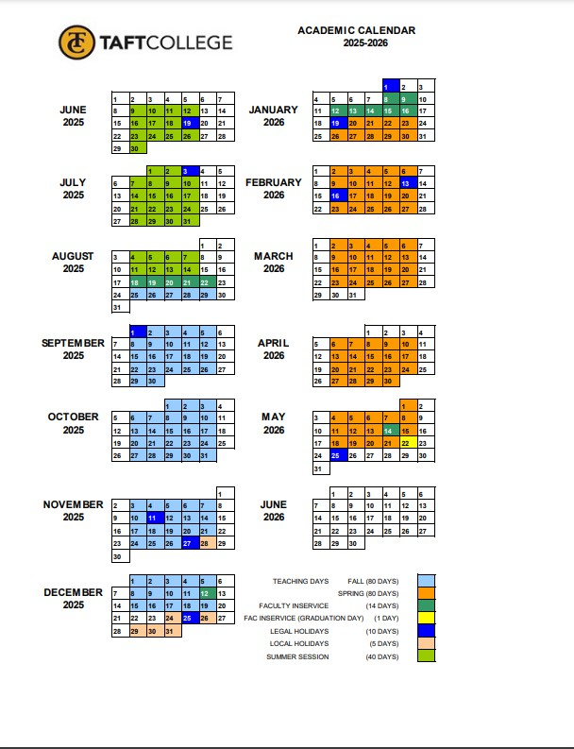
INFORMATIONAL ONLY

