
Accreditation Steering Task Force
Thursday, January 15, 2026
8:10 a.m. to 9:00 a.m.
Cougar Room

Present: Xiaohong Li, Rashitta Brown-Elize, Greg Bormann, Mike Giacomini, Vicki Jacobi, Adam Bledsoe, Amar Abbott, Jennifer Altenhofel, Heather Cash, Susan Groveman, Terri Smith, Seth Rowland,
Justin Madding, Greg Hawkins, and Candace Duron

Guest: Jessica White and Trudi Blanco Secretary: Brandy Rowson

Absent: Leslie Minor, Heather del Rosario and Jaime Lopez

Approve ISER Timeline - The timeline was reviewed and has been approved by the Governance Council and the Academic Senate. Any modifications to the timeline will need to be approved by those two groups.
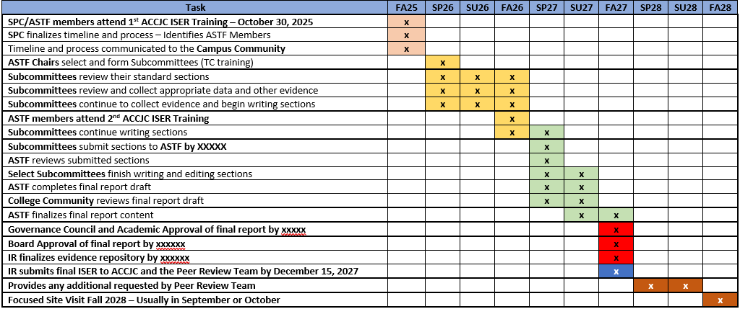

Institutional Self Evaluation Process
Xiaohong gave a presentation on the Self Evaluation process. Major steps outlined:

- Determine Timeline  - Determine leaders/ASTF members and subcommittee chairs  - Call for volunteers  - Review documents/handbooks needed for ISER/Midterm/ISS  - Gather evidence  - Track progress on trouble spots | - Draft sections  - Compile the report  - Share with constituencies. Review and revise the report  - Share again?  - Edit and finalize report  - Get AS, GC and the Board approval  - Submit  - Prepare for the ISER Peer team review

ISER Template Overview
Xiaohong shared the report template provided by ACCJC. The report template has been streamlined and shortened. The new format will make it very easy to provide narratives and evidence. The entire report could be less than 100 pages. Tables embedded in the report will make it very easy to provide documentation in an organized manner.

ACCJC Liasson Workshop PPT Overview
A brief refresher on the October 30, 2025, Self Evaluation workshop PPT was given. ASTF members are encouraged to review the PPT which is housed internally in the MyTC Employee Resources.

Subcommittee Chair Role and Responsibility
A handout was shared listing the role and responsibilities of Subcommittee Chairs:

Area | Responsibilities
Leadership | Lead the subcommittee assigned to one ACCJC Standard; coordinate faculty, staff, and administrators contributing to the ISER.
ISER Development | Draft, revise, and finalize the ISER narrative for the assigned Standard, ensuring compliance with ACCJC 2024 Standards and evidence-based analysis.
Evidence & Data | Identify, collect, and validate supporting evidence; ensure documentation is current, accessible, and clearly mapped to Standard components.
Alignment & Integration | Ensure alignment with institutional planning, governance processes, and other ISER Standards; participate in cross-standard reviews for consistency.
Communication | Provide regular progress updates; respond to feedback and revision requests from the Accreditation Steering Committee or Task Force leadership.
Site Visit Support | Serve as a content expert for the assigned Standard during ISER review cycles and the ACCJC site visit.

Next Meeting
ASTF meetings will be held quarterly for the first year of the ISER development. The next meeting will be scheduled in early April 2026. Training will be scheduled for Subcommittee Chairs in February 2026. Chairs have been asked to have subcommittees established by February 14th.

Respectfully submitted by Brandy Rowson, ASTF Secretary

