**How to Enter Grades in Banner 9 Faculty Services (Cougar Tracks)**

1. Log into MyTC (upper right-hand corner of the TC homepage). If you need to reset your password, please contact A&R at 7741.

1. Click on the Faculty Services (Cougar Tracks) icon

1. Click on “Faculty Grade Entry”

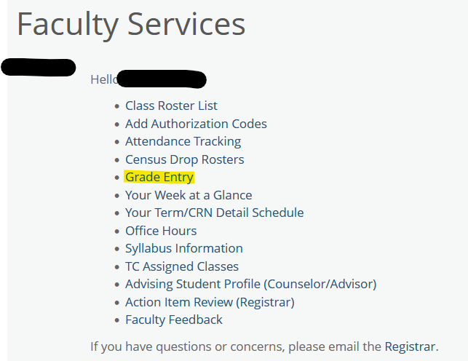

1. Click on the course you are wishing to enter grades for and the students will populate below.

1. Select the appropriate grade from the drop-down menu for each student. The last date of attendance is required for each “FW” grade you enter.

Other helpful grading tips:

* If your students are showing up on multiple pages, change the drop-down menu in the bottom right-hand corner to display all students. This will ensure you don’t miss a page of students or navigate between pages without saving.

* If you are issuing an **Incomplete**, you need to submit the [Incomplete Grade Assignment](https://ct-prod-wp.taftcollege.edu/forms/admissions/incomplete-grade-assignment/) form online. This can be found under the Faculty Resources page.
* If you see **Pass/No Pass** as grading options for a student that typically has letter grade options displayed, they submitted a Request for Pass/No Pass grading to our office. If the student’s letter grade would have been A, B, or C then you would issue a Pass. If their letter grade would have been a D, F, or FW then you would issue a No Pass. Confirm that the student elected this grading option by calling our office at 7741.
* If your course is an **Arranged Hours** course, you will need to enter the hours when you submit the grades as well as the attendance tracking.
* **“W” Grades** cannot be assigned on a final grade roster. If the “W” is not appearing then the student did not drop the course and you are required to assign the grade the student earned.
* **“FW” Grades** are to be used when a student is failing a course due to non-attendance and/or non-participation. The last date of attendance is required for each “FW” grade you enter.