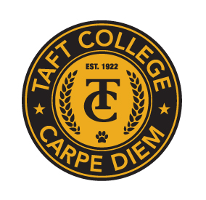**TAFT COLLEGE**

**Governance Council**

May 9, 2024

10:10 am Cougar Room

# AGENDA

Facilitator: Damon Bell

Timekeeper: Leslie Minor

Recorder/Minutes: Trudi Blanco

1. Approval of Minutes from March 15, 2024 and April 12, 2024 Meetings 5 Minutes

1. Committee Reports (Brief Updates) 40 Minutes
   1. SEMCOM Committee (Damon Bell/Leslie Minor)
   2. Budget Committee (Todd Hampton)
   3. Strategic Planning Committee (Xiaohong Li)
   4. Campus Safety and Security (Heather del Rosario)
   5. Information Technology (Xiaohong Li)
   6. DEIAA Committee (Damon Bell)
   7. Academic Senate (Candace Duron)
2. Action - 2024-25 Governance Council Dates (McMurray/Duron) 5 Minutes

1. Action – ISS (Institutional Set Standard) 2024-25 Goals (Li) 15 Minutes
2. Action – One-Year Extension for Current Strategic Action Plan (Li) 5 Minutes
3. Action – 3-Year Program Review Rotation List and 2024-25 Contact List (Li) 10 Minutes
4. Information – GC Ranking for Program Review Goal Submissions (Li) 10 Minutes
5. Action – One-Year Extension for Current Technology Education Master Plan (Li) 5 Minutes
6. Information – Leading from the Middle Project (Li) 5 Minutes
7. Information – OER: What’s in it for You? (OER Team) 5 Minutes

1. Other 5 Minutes

Next Meeting - Facilitator: Timekeeper:

Next Meeting: TBD in the Cougar Room