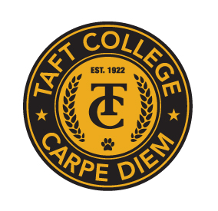**TAFT COLLEGE**

**Governance Council**

December 8, 2023

10:10 am Cougar Room

# AGENDA

Facilitator:

Timekeeper: Tina Mendoza

Recorder/Minutes: Sarah Criss

1. Approval of Minutes from November 17, 2023 Meeting 5 Minutes

1. Committee Reports (Brief Updates) 40 Minutes
   1. SEMCOM Committee (Damon Bell/Leslie Minor)
   2. Budget Committee (Todd Hampton)
   3. Strategic Planning Committee (Xiaohong Li)
   4. Campus Safety and Security (Heather del Rosario)
   5. Information Technology (Xiaohong Li)
   6. DEIAA Committee (Damon Bell)
   7. Academic Senate (Candace Duron)
2. Committee Self-Evaluation 15 Minutes
   1. DEIAA (Damon Bell)
3. Committee Charter 10 Minutes
   1. DEIAA (Damon Bell)
4. Educational Master Plan 15 Minutes
5. Other 5 Minutes

Next Meeting - Facilitator: Timekeeper:

Next Meeting: January 19th, 10:10 am in a room TBD