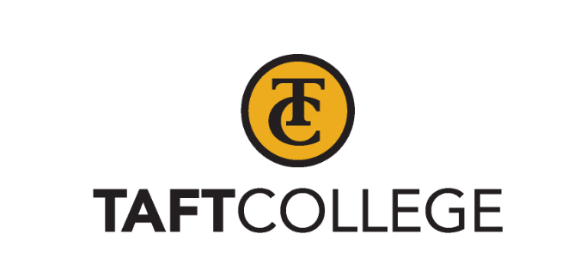

Midterm Report

(Final Draft for Approval– October 2025)

Submitted by
Taft College
29 Cougar Ct. Taft, CA 93268

to

Accrediting Commission for Community and Junior Colleges

October 2025

Certification

To: Accrediting Commission for Community and Junior Colleges

From: Dr. Leslie Minor, Interim Superintendent/President
Taft College
29 Cougar Ct. Taft, CA 93268

This Midterm Report is submitted to the ACCJC for the purposes of 1) highlighting recent improvements or innovations and 2) providing an update on institutional performance regarding student outcomes since the last comprehensive peer review. The Midterm Report reflects the nature and substance of this institution, as well as its best efforts to align with ACCJC Standards and policies, and was developed with appropriate participation and review by the campus community.

Signatures:

Leslie Minor, Ph.D.  Interim Superintendent/President | Date
Kathy Orrin, Ph.D.  President, Board of Trustees | Date
Candace Duron  President, Academic Senate | Date
Xiaohong Li, Ed.D.  Vice President of Information and Institutional Effectiveness, ALO | Date

Contents
A. Reflections on Continuous Improvement Since Last Comprehensive Review 1
B. Reflections on Institution-Set Standards and Other Metrics of Student Achievement 4
C. Reflections on Assessments of Student Learning 7
D. Looking Ahead to the Next Self-Evaluation and Comprehensive Review 12

Reflections on Continuous Improvement Since Last Comprehensive Review
Provide brief responses to the prompts below, referring to the Peer Review Team Report for the last comprehensive peer review. Suggested length for Section A is 3 pages.

1. Briefly describe major improvements or innovations since the time of the last comprehensive peer review, focusing on areas where your institution is excelling or showing significant improvement with regard to equitable student outcomes, educational quality, and/or mission fulfillment.

Since the last comprehensive peer review, Taft College has made substantial progress in advancing student success, enhancing educational quality, and reinforcing its mission to serve a diverse community of learners. These improvements are reflected in a range of strategic initiatives designed to foster a supportive, inclusive, and high-impact learning environment. By aligning practices with its strategic priorities, the College continues to create pathways to success for all students, especially those from historically underserved backgrounds. Taft College’s ongoing commitment to student achievement is demonstrated through innovative programs that enhance educational opportunities, address equity gaps, and strengthen community engagement. In support of effective and transparent governance, the College provides training and professional development on participatory governance, Administrative Procedures, Board Policies, the 10+1 framework, and related processes for administrators, faculty, staff, and students (Participatory Governance Handout.pdf) (Participatory Governance - Workshop Minutes.docx).

Taft College MESA: Advancing STEM Access and Student Success
Launched in 2023, the Taft College Mathematics, Engineering, Science Achievement (MESA) program has quickly become a high-impact initiative supporting underrepresented students in Science, Technology, Engineering, and Mathematics (STEM). MESA reflects the College’s commitment to expanding access to higher education and fostering inclusive student success. Through academic support, leadership development, and career exploration, the program helps students build confidence, community, and professional readiness in high-demand STEM fields.

MESA (MESA Program | Taft College) Notable Achievements:
- Professional Exposure: Students attended national STEM conferences including Society of Hispanic Professional Engineers (SHPE) (SHPE National Conference 2024.pdf), Society for Advancement of Chicanos/Hispanics and Native Americans in Science (SACNAS)( 2024 conference by the numbers_final.pdf), Disney Imagination Campus (Science & Technology | Our Curriculum | Disney Imagination Campus ); and visited universities including University of California Santa Barbara (UCSB), California State University Fullerton, and California Polytechnic State University (Cal Poly).
- Student Leadership and Engagement: MESA in Taft launched a SHPE chapter, hosted leadership retreats, and held student-centered events such as banquets and camping trips.
- STEM Pipeline Development: MESA led “Taft College Takeover” outreach events at local high schools to inspire future STEM students.
- Innovative Projects: Students completed hands-on tech projects (e.g., personal computer builds, racing simulator) and launched a student-led social media campaign.
- Institutional Collaboration: Staff and students hosted a college district Board of Trustees tour of the MESA Center, conducted student worker interviews to gather feedback on their experiences and the impact of the program, and participated in statewide MESA leadership meetings (MESA Student Leadership Retreat.)

Baccalaureate Degree
In 2024, Taft College reached a major milestone with the approval of its first Bachelor’s degree program in Dental Hygiene Administration, approved by the California Community Colleges Chancellor’s Office (CCCCO), and accredited by the Accrediting Commission for Community and Junior Colleges (ACCJC), and the Dental Hygiene Board of California (DHBC). This program represents a significant advancement, showcasing the College’s commitment to providing high-quality, career-focused educational opportunities. Designed to equip students with advanced leadership skills in the dental hygiene field, this degree offers a pathway for career advancement in high-demand professions such as college instruction, research, public policy, and public health. By offering this bachelor’s program, Taft College expands access to higher education and provides students with specialized knowledge, helping to meet evolving workforce needs while maintaining academic rigor and excellence.

Innovations in Academic Programs
Since the last comprehensive peer review, Taft College has made significant strides in advancing student success and enriching its academic offerings. Notably, the College successfully launched the Elementary Teacher Education program in 2022, providing students with valuable career pathways and addressing a teacher shortage in the region. In addition, the College has significantly increased degree and certificate offerings, adding 29 new programs, including the Graphic Design Certificate, Law, Public Policy, and Society Degree for Transfer, Computer Science, Paramedic and Medical Assistant. Moreover, the English Writing Lab, staffed by two full-time faculty members who regularly dedicate time to meet with students, continues to play a vital role in supporting student learning, particularly in English C1000 (formerly English 1500, Composition and Reading). The department remains committed to providing supplemental academic support following the elimination of English 1000 (Interactive Writing and Grammar) and other remedial courses, in alignment with recent changes in California State law.

In response to AB1705, the department introduced English 1501 (C1000E), a four-unit course designed to provide additional support for students struggling with English C1000. This innovation will be fully assessed in the next comprehensive program review. Additionally, a new course, English 1502, was developed to support non-native English speakers, which is particularly beneficial given the College’s designation as a Hispanic-Serving Institution. Committed to diversity and equity, the department has incorporated multicultural perspectives into its curriculum, including integrating The 1619 Project. These efforts reflect Taft College’s proactive approach to improving academic outcomes and addressing the needs of diverse student populations.

Further demonstrating the English Department’s academic leadership and spirit of professional collaboration, the department has played a central role in organizing the Kern County Building Bridges Conference (Building Bridges Conference - 2025 TC) - an annual event uniting CSUB, county high schools, and local community colleges for a day of professional sharing and collaboration. English faculty have actively participated in the event over the years, presenting on topics such as best practices for online education and dual enrollment initiatives. The department takes great pride in this ongoing, 25-year initiative and its role in fostering educational partnerships that benefit students throughout the region.

Advancing Campus Accessibility and Compliance
Taft College has also taken meaningful steps to improve accessibility across campus and online platforms. The College established an Accessibility Taskforce dedicated to identifying and addressing accessibility needs. In collaboration with the California Community Colleges (CCC) Accessibility Center, faculty and staff participated in accessible documents training to ensure compliance and inclusivity (Accessible-training-flyer_04252025). As part of this effort, each department was assigned specific documents to review and update for accessibility on the college website (Accessibility-Assignment-Progress Report), demonstrating a campus-wide commitment to creating an equitable learning environment for all students.

Enhancement of Efficiency through Technology Upgrades
Since the last comprehensive peer review, Taft College has undertaken substantial efforts to strengthen its technological infrastructure to support equitable student outcomes and improve overall campus operations. A key initiative has been the implementation of a digital communication system, Diligent, for use by our Board of Trustees (Digital Board system Portal), which streamlines communication, reduces paper usage, and improves information sharing in real-time. Additionally, the College has upgraded all classroom computers (Board Agenda Page 13 - Classroom Computer Purchase) , ensuring that students and faculty have access to modern, high-performance technology that supports a variety of academic needs. To further improve the learning experience, Taft College replaced all campus network switches (Board Memo Page 52 - Network Switch Replacement) and access points Board Memo Page 42 - Network Access Point Replacement, resulting in faster, more reliable internet connectivity across the campus. These technological improvements not only enhance the quality of education by providing students and faculty with the necessary tools to succeed but also contribute to a more efficient and equitable educational environment. Currently, a new five-year Technology Master Plan is in development (Information Technology Committee Minutes: Technology Strategic Plan Discussion), with a focus on enhancing cybersecurity and improving digital accessibility. These continued improvements support student success, improve operational efficiency, and help advance the College’s mission to provide high-quality, accessible education.

2. Briefly describe actions taken in response to any recommendations for improving institutional effectiveness or feedback noted in the Peer Review Team Report for the last comprehensive peer review.

In the most recent comprehensive peer review, Taft College did not receive formal recommendations related to institutional effectiveness. However, the College remains deeply committed to continuous self-assessment and improvement. Reflecting this commitment, Taft College proactively identified opportunities for growth and implemented focused actions in response.

One major action has been the revision of the program review process. Based on internal feedback and strategic planning discussions, the College shifted from an annual review cycle to a more comprehensive three-year cycle. This change, piloted in 2022–23 and fully adopted by 2025–26, was endorsed by the Strategic Planning Committee (Strategic Planning Committee Minutes: Strengthening the Comprehensive Program Review Process), Academic Senate (Academic Senate Minutes: Approval of Comprehensive Program Review New Process), and Governance Council (Governance Council Minutes: Approval of Comprehensive Program Review New Process). It is designed to improve long-term planning, better alignment with strategic goals, and more meaningful assessment of academic and service programs.

The revised process also strengthened structured two-way communication between program review faculty leads and College leadership. While still being fully implemented, the new structure encourages dialogue by creating opportunities for faculty to share program accomplishments, justify resource needs, and propose initiatives. In response, area Vice Presidents or Division Chairs provide formal feedback, helping align program goals with institutional priorities. This approach promotes transparency, shared responsibility, and more informed decision-making to support student success and continuous improvement.

3. How are the actions described above helping your institution deepen its practices for continuous improvement and transformation in relation to the 2024 Accreditation Standards?

Taft College’s shift to a three-year comprehensive program review cycle has strengthened its ability to engage in long-term, reflective planning and align program goals with institutional priorities—key principles emphasized in the 2024 Accreditation Standards. This change encourages faculty and staff to evaluate trends over time, use disaggregated data to assess student outcomes, and focus on sustained improvements rather than short-term fixes.

By shifting from an annual to a three-year comprehensive program review cycle, the College has created a more reflective and strategic approach to evaluation. This longer cycle allows academic and service programs to analyze multi-year trends in enrollment, success rates, resource use, and program impact, rather than reacting to short-term fluctuations. Programs are encouraged to assess progress toward long-term goals, identify systemic challenges, and develop actionable strategies that are aligned with both divisional and institutional priorities. This extended timeline not only increases the quality and depth of reflection but also strengthens the connection between program-level planning and institutional resource allocation.

Program Review has been embedded in broader planning and budgeting processes, and the College is fostering a culture of evidence-based decision-making and continuous improvement. These practices support institutional transformation by ensuring the College remains responsive to evolving student needs, equity goals, and workforce demands—core elements of the 2024 Accreditation Standards.

Reflections on Institution-Set Standards and Other Metrics of Student Achievement
Provide a brief response to each question below, referring to Standards 1.3 and 2.9 for additional context. You may insert graphs, charts, or other similar visuals as needed to support your narrative. Suggested length for Section B (not counting any visuals) is 3 pages.

- Review the most recent ACCJC Annual Report and other meaningful metrics of student achievement. Has the institution met its floor standards? Exceeded its stretch goals? Describe any patterns or trends you see in performance against your institution-set standards and other metrics of student achievement.

Taft College established its Institutional Set Standards (ISS) baseline floor and stretch goals over a decade ago as part of its ongoing commitment to student achievement and institutional effectiveness. Each year, the Strategic Planning Committee (SPC) conducts a comprehensive review of the data from the previous seven years (Strategic Planning Committee Minutes: New ISS Goal Proposal Discussion). Below is a sample from this year’s review.

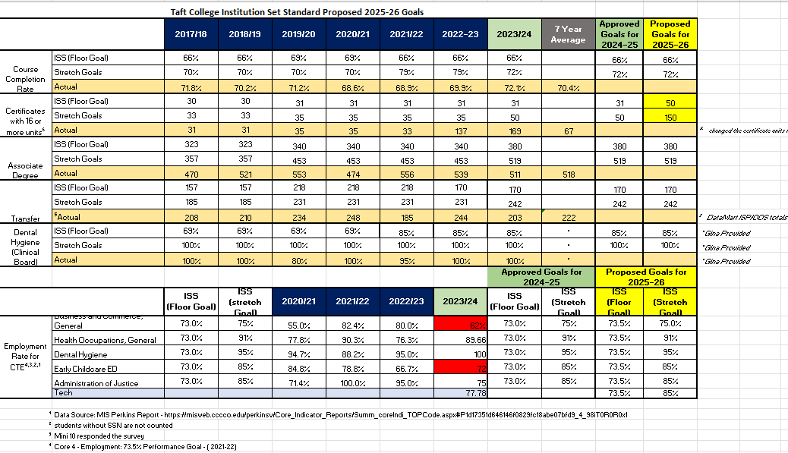

The SPC carefully analyzed each metric, comparing actual performance to the established floor and stretch goals to identify emerging trends, strengths, and areas for improvement. Notably, Taft College has consistently met or exceeded its institution-set floor standards in key metrics such as course completion rates, certificates, and associate degree awards, demonstrating a strong track record of student success. The ISS baselines are, albeit rarely, revised upward when longitudinal data indicates that a higher floor is appropriate.

For example, Taft College has demonstrated consistent strength in key performance areas. Over the past six years, course completion rates have ranged from 68.6% to 72.1%, exceeding the floor goal of 66%. Similarly, the College has seen steady gains in certificate and associate degree awards, often meeting or surpassing stretch targets. One standout success is the Dental Hygiene program, which achieved a 100% pass rate on the licensing exam for the past two years—underscoring the effectiveness of its specialized training and academic preparation.

While overall trends have been positive, the number of students transferring to four-year universities has presented a challenge over the past six years. Specifically, transfer goals were not met in two instances, largely due to significant enrollment declines during the 2020–21 academic year caused by the COVID-19 pandemic. As a result, fewer students completed their community college coursework, leading to a decline in transfer numbers over the following two years. This external disruption had a notable impact on overall transfer outcomes.

In response, the College has proactively implemented strategies to increase the number of students transferring. These efforts include expanding transfer pathways, enhancing counseling services, implementing Program Pathways Mapper, conducting targeted outreach to students who have completed 40 units but not yet earned their transfer degrees, and strengthening collaborations with four-year institutions. Additionally, the College is investigating other contributing factors to ensure its transfer initiatives are data-informed and sustainable.

Taft College’s commitment to continuous improvement is reflected not just in its outcomes, but in the strategic planning processes that drive them. While specific metrics like course completion and credential attainment show consistent progress, the broader trend underscores the institution’s ability to respond to changing conditions—such as the impacts of COVID-19—while maintaining a clear focus on student achievement and institutional effectiveness. The College’s approach remains data-informed, goal-oriented, and adaptive to evolving student needs.

- When you disaggregate the data for the institution-set standards and other meaningful metrics of student achievement, what do you see related to equitable student achievement outcomes (i.e., equity gaps)? What patterns or trends excite you? What patterns or trends concern you?

Taft College’s Comprehensive Program Review Dashboard and Student Equity Plan Dashboard presents disaggregated data related to institution-set standards and other student achievement metrics. Some equity gaps exist, particularly as the Hispanic student population has grown from 50% in 2018 to over 65% in fall 2024. Hispanic students have been disproportionately impacted across three key student outcome metrics: course success rate, retention rate, and degree attainment. The College is actively addressing these gaps. For example, Table 1 below (extracted from the Comprehensive Program Review Dashboard) shows that course success rates for African American and Hispanic students have been slightly lower compared to other racial and ethnic groups. However, the College has made significant strides in addressing this concern. Over the past seven years, the course success rate for Hispanic students has consistently increased from 65% to 69%, effectively narrowing the equity gap. In fall 2024, the course success rate for Hispanic students reached 69%, aligning with the overall rate and demonstrating the College’s commitment to equity and student success.

Table 1 Course Success Rate by Ethnicity from Fall 2018 to Fall 2024
 | Fall 2018 | Fall 2019 | Fall 2020 | Fall 2021 | Fall 2022 | Fall 2023 | Fall 2024
African American | 62% | 58% | 60% | 62% | 54% | 61% | 53%
American Indian | 58% | 63% | 68% | 74% | 81% | 75% | 67%
Asian | 79% | 72% | 74% | 82% | 76% | 73% | 74%
Hispanic | 65% | 64% | 60% | 66% | 66% | 67% | 69%
International | 100% | 72% | 100% | 100% | 100% | 100% | 100%
Multiple Races | 70% | 73% | 68% | 67% | 76% | 79% | 72%
Native Hawaiian | 71% | 51% | 68% | 77% | 65% | 95% | 83%
Other | 65% | 57% | 75% | 81% | 73% | 70% | 73%
White | 72% | 71% | 74% | 70% | 68% | 72% | 69%
Overall | 68% | 67% | 65% | 68% | 67% | 69% | 69%

In addition to these improvements, there are other positive trends: Hispanic students in the EOPS program consistently outperform other groups in course success rates, and dual enrollment students continue to show strong achievement outcomes, highlighting the effectiveness of these initiatives. To further support this progress, the College is expanding resources for online learning, increasing outreach to underserved groups, and enhancing support for programs like EOPS. Taft College remains committed to closing equity gaps through data-driven strategies and continuous efforts to ensure all students have the resources they need to succeed.

3. What actions has your institution taken/is your institution taking in response to the patterns and trends discussed above? How will you monitor the results of these actions in order to inform future improvements and innovations in support of equitable student achievement?

Taft College continues to prioritize the use of disaggregated data to identify and address equity gaps in student achievement. In response to the trends observed—particularly among Hispanic students—the College has implemented several targeted initiatives. These include the annual Latinx Graduation Celebration, which promotes engagement by featuring culturally relevant speakers and success stories, as well as “Communication Cafe” (Communication Cafe.pdf) sessions held over lunch to provide students with an informal setting in which to practice English speaking skills.

In addition, the College is expanding professional development opportunities for faculty and staff, with a focus on culturally responsive teaching and equity-minded practices (Fall 2024 Inservice - inclusive Teaching Practices.xlsx). These efforts aim to foster more inclusive classrooms and improve educational experiences for disproportionately impacted students.

To evaluate the effectiveness of these initiatives, the College monitors student outcome data—including course completion, retention, and degree attainment—while also collecting student feedback on their academic experience to guide improvements and better support student success. For example, the Strategic Enrollment Management Committee (SEMCOM) conducts an annual student survey, and the results are shared with faculty, staff, and college leadership (Survey Results - Findings Presentation). The SPC and SEMCOM regularly review disaggregated student outcome data and share findings with the Academic Senate and other campus governance groups to ensure broad institutional engagement (Strategic Action Plan Data Updates). In addition, the College’s Strategic Action Plan incorporates these data insights and presents outcomes to the Board of Trustees, reinforcing transparency and accountability (Board Meeting Minutes - Strategic Action Plan Data Update) . These continuous review processes help ensure that Taft College’s equity-driven strategies remain responsive, data-informed, and aligned with institutional goals for student success.

Reflections on Assessments of Student Learning
Provide a brief response to each question below, referring to Standards 1.3, 2.1, 2.2, and 2.9 for additional context. You may insert graphs, charts, or other similar visuals as needed to support your narrative. Suggested length for Section C (not counting any visuals) is 3 pages.

- Review the results of learning outcomes assessment. Describe any patterns or trends related to attainment of learning outcomes observable in these data that may be relevant as you implement improvements and innovations in the design and delivery of academic programs?

In recent years, Taft College’s ongoing efforts to consistently assess Student Learning Outcomes (SLOs) and gather assessment results for analysis and evaluation have faced challenges due to the COVID-19 pandemic and the inconsistent use of eLumen. Every year during the fall in-service faculty are given time to enter SLO data into eLumen. Faculty have often cited that there is a disconnect to entering data after the course has concluded and have asked for a way to enter the data into Canvas as the assessment is being graded. The SLO Coordinator and administrators have responded to that feedback and started the process of transitioning the College from eLumen to Insights by eLumen which is embedded within Canvas course shells and available outside of Canvas as well.

Implementing Insights by eLumen at Taft College will empower faculty with the tools they need to enhance their teaching, align their courses with institutional goals, and ultimately improve student outcomes. By replacing the current eLumen platform with Insights by eLumen, faculty will be able to enter and track Student Learning Outcomes directly in Canvas as they are grading their assessments. This will ensure a more data-driven and cohesive approach to education, benefiting both instructors and students. Non-Canvas users and departments will still be able to utilize Insights by eLumen to track Student Learning Outcomes as well.

While it is too early to observe meaningful patterns and trends in these results, the College is taking active steps toward having sufficient data for review by the fall 2025 semester. In fall of 2024 the SLO Coordinator completed the Insights by training and worked with the Information Technology and Distance Education departments to integrate Insights into Canvas. In the spring of 2025, the SLO Coordinator trained a pilot group of users to begin using Insights. A training has been completed for fall 2025 in-service to train all Taft College faculty on how to use Insights (Fall 2025 Inservice Schedule - General Overview -SLO Insights and Accessibility Training.xlsx). After that time the College will have completed the transition from eLumen to Insights.

- How (i.e., for what subpopulations, modalities, etc.) does your institution disaggregate its assessment results? When you review disaggregated assessment results, what patterns or trends do you see related to equitable attainment of student learning? What patterns or trends excite you? What patterns or trends concern you?

Taft College is dedicated to disaggregating SLO assessment results by race/ethnicity, gender, and other student demographics to uncover and address equity gaps. This practice is a vital component of promoting educational equity and implementing equity-minded teaching, both of which are integral to the College’s mission, vision, and core values. We are currently able to run reports in eLumen to access the data. Below are sections of an example report pulled for PSLO: History AA - T Program:

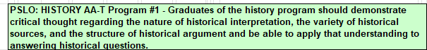
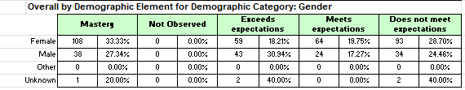
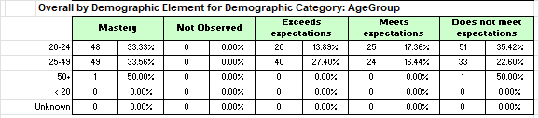
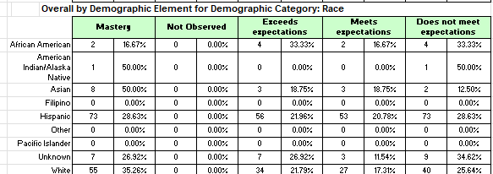
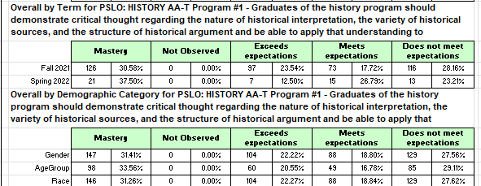

Our use of eLumen has enabled a structured and consistent method for collecting and disaggregating SLO assessment data. While eLumen enables departments to disaggregate data by student demographics—such as race/ethnicity, gender, and age—at the program and institutional levels (PSLO and ISLO), it currently does not support disaggregation at the course level (CSLO). Only having data available at the PSLO and ISLO level has made it difficult to collect meaningful data. eLumen recommends “mapping” CSLOs to PSLOs, which allows departments to access some disaggregated data, though it is based on program-level outcomes. As part of the transition from eLumen to Insights, we began working on the mapping process during fall in-service 2024. Each division received printouts of their programs, courses, and learning outcomes from the SLO Coordinator to allow the divisions to properly map each CSLO to PSLOs and ISLOs. The SLO Coordinator then collected the handouts and is implementing the mapping into Insights.

Although it is still early to identify patterns or trends, due to lower than desired participation rates of entering data into eLumen and the anticipated adoption of Insights - which enables the generation of disaggregated data at the course SLO level - the College is confident it will be able to begin collecting meaningful disaggregated data starting in fall 2025.

- What actions has your institution taken/is your institution taking in response to the patterns and trends discussed above? How will you monitor the results of these actions in order to inform future improvements and innovations in support of equitable student learning?
As noted earlier, the College has modified the collection process of collecting SLO assessment results and anticipates having sufficient data—including disaggregated data by student demographics—for meaningful analysis of patterns and trends starting in fall 2025. To support this effort, the College is taking several steps to ease the data collection process for departments, particularly through the adoption of eLumen’s Insights tool, while also providing faculty with guidance and support in analyzing SLO data to enhance equitable student learning.
In addition to offering training and resources to help faculty plan, collect, and review SLO assessment results, the College is committed to institutionalizing the full SLO Assessment Cycle as a consistent, collegewide practice. With the ease of assessing directly in Canvas with Insights, our anticipation is that participation rates of faculty reporting SLO data will climb significantly. Faculty will also be able to see their own personalized dashboard of SLO data in Insights. This means using assessment data not only in formal program reviews—where departments analyze results and make curriculum and pedagogical recommendations—but also more routinely, such as in semester and annual department planning.
Furthermore, the College will carefully monitor how departments respond to identified trends in SLO data through the program review process. As part of this process, departments complete the assessment cycle by analyzing their data and proposing improvements.
For the past three years, we have overhauled our Annual Program Review process. During the transition from an annual program review to a three-year comprehensive program review cycle, we added equity specific sections to encourage equity driven goals based off the internal disaggregated data dashboards (Comprehensive Program Review Templates). The data provided to each instructional and non-instructional program is at least a five-year trend or greater with additional custom data provided upon request. The disaggregated dashboards also show trends and will be updated annually. The SLO and SAO data are posted on the Taft College website, while the Comprehensive Program review data and disaggregated data trends and dashboards are posted on an employee access only site. This data and program review process allows our institution to track and monitor our progress internally against our institutional planning documents.
Two custom survey questions were added to the CCSSE survey by our Office of Instruction regarding how “Zero Textbook Cost” options affect students when registering for courses and what “Low-Cost Textbook” would look like to them. This information supported our discussions on defining and implementing the 'Low-Cost Textbook' designation for the California Community College Chancellor’s Office mandate—specifically for the Management Information System XB report, Data Element #2 - while also encouraging the expansion of 'Zero Textbook Cost' options across more disciplines.

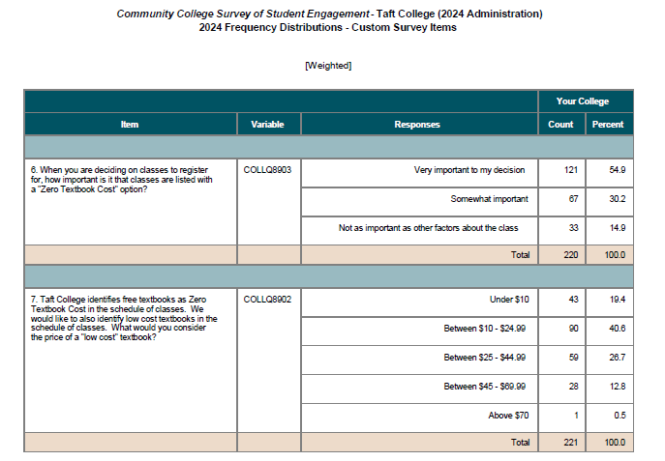

Looking Ahead to the Next Self-Evaluation and Comprehensive Review
Provide a brief response to the question below. Suggested length for Section D is 2 pages.

Your institution will begin its next comprehensive self-evaluation in 1-2 years. What opportunities, changes, or other internal or external factors do you see on the horizon that are likely to affect the context of your self-evaluation and/or comprehensive peer review?

As Taft College prepares for its next comprehensive self-evaluation, the institution anticipates a range of internal and external factors that will shape the context of the review. Central to this process is the College’s ongoing commitment to continuous improvement, guided by the strategic goals outlined in the newly developed Educational Master Plan (EMP) (Taft College Planning Documents: Educational Master Plan) . This plan emphasizes increasing student enrollment, improving retention and success rates, diversifying instructional programs, and fostering partnerships that support workforce development. These goals will serve as a framework for evaluating institutional progress in student success, academic innovation, and long-term sustainability.

Several focused programs and strategic initiatives are expected to significantly influence the self-evaluation process:

Dual Enrollment:
Expanding dual enrollment continues to be a key strategy for increasing access and enrollment. Taft College has been able to collaborate with our primary feeder high school, Taft Union, to establish a College and Career Access Pathways (CCAP) agreement. The agreement builds on longstanding collaborations establishing a pathway to provide access for Taft Union High School students to complete their general education while in high school. Building on successful partnerships with local high schools, the College aims to create clearer pathways for high school students to engage in college-level coursework. Additionally, Taft College is exploring dual enrollment opportunities to strengthen alignment between its offerings and the West Kern Adult Education Network (WKAEN), particularly in career-focused areas, to better serve adult learners. These efforts are designed to reduce time to degree, bridge educational attainment gaps, and create more seamless transitions to higher education.

Adult Learning
Expanding opportunities for adult learners is a critical component of the College’s equity and access agenda. Taft College is committed to increasing educational pathways for adult students through partnerships, flexible course formats, and programs tailored to adult learning needs. These efforts are designed to support individuals re-entering education after time away, seeking new career opportunities, or balancing education with work and family responsibilities.

Non-Credit Programs:
Taft College is also investing in the development of non-credit programs that provide low-barrier entry points into higher education, and has provided faculty workshops to delve into the process as well as college needs and student interests for non-credit classes. These programs are particularly effective in supporting career exploration, basic skills development, and workforce training. By offering non-credit options aligned with regional workforce needs, the College is working to support both economic development and lifelong learning across its service area.

Credit for Prior Learning (CPL):
A major area of improvement and focus for Taft College is expanding its Credit for Prior Learning offerings. By recognizing the value of students' previous learning experiences—whether through military service, workforce training, or other non-traditional educational settings—the College will provide a more equitable path to degree completion. Taft College is seeking to participate in the Mapping Articulated Pathways (MAP) Initiative aimed at developing the capacity and procedures to award up to a year of college credit in recognition of the mastery acquired through prior learning, training, and experience. This initiative aligns with the College's broader mission of serving diverse student populations and meeting the needs of a constantly evolving job market.

Competency Based Education (CBE):
Taft College will continue to develop the infrastructure to advance CBE, offering students a personalized, flexible option to continue learning. We are in the beginning stages of CBE but see the benefits of students taking more ownership of their learning leading to increased engagement and enhancing learning outcomes.

Short-Term Career and Technical Education (CTE) Pathways:
Taft College will continue to develop and expand short-term CTE pathways aimed at preparing students for immediate employment opportunities and supporting meeting the occupational needs of the region. By focusing on high-demand fields, such as healthcare, the College is responding to the needs of students who seek rapid entry into the workforce, as well as regional industries seeking a well-trained labor force. Taft College remains committed to meeting local industry needs and has developed various programs including Paramedic and Medical Assisting to support those efforts. Additional programs being developed include Speech Pathology Aide and Environmental Health and Safety. These pathways will be closely aligned with labor market trends and community needs, ensuring that students are equipped with relevant, up-to-date skills.

ZTC (Zero Textbook Cost) Program
We continue to expand the availability of ZTC (Zero Textbook Cost) textbooks, to reduce financial barriers and make courses more accessible and attractive to a wider student audience. Taft College has secured several grants aimed at supporting the expansion of Open Educational Resources (OER) at TC leading to more ZTC courses. To support those efforts, our campus has leveraged grant funding to develop a ZTC Implementation plan, providing our campus with a faculty-lead blueprint to expand ZTC courses. Additionally, to promote the plan and other available resources to students and staff, Taft College has created an Open Educational Resources website.

Strengthening Planning and Sustainability Through Review and Resource Monitoring
We have just completed the pilot of our three-year comprehensive program review process, with full implementation now underway. This shift promotes long-term planning, deeper reflection, and stronger alignment with institutional goals. Additionally, the College has implemented an Expenditure Dashboard to help monitor budgets, support informed decision-making, and sustain institutional efforts. Together, these tools strengthen our ability to align resources with priorities and enhance continuous improvement.

Through these focused programs and initiatives, Taft College is positioning itself to continue making strides in providing equitable access to higher education while fostering an environment of academic excellence, workforce readiness, and sustainable growth. As the College approaches its next comprehensive self-evaluation, these efforts will provide a solid foundation for assessing its progress toward meeting institutional goals and addressing the needs of its diverse student population.

External Factors:
One external factor facing the college is population decline. Taft College is located in the city of Taft, California, located 35 miles west of Bakersfield. The total population of Taft in 2025 is 6,621. This is a decline of about 11% from the recorded population of 7,471 recorded in the 2020 census. A consistent decline of about 2.5% has been occurring annually in recent years (Taft Population). Population decline means fewer potential students. In addition, Bakersfield College’s new Arvin Center, located near our district, may draw students who previously attended our college, negatively impacting enrollment.

The second external factor is the decline and economic instability of the oil and gas industry. The city of Taft, and the college itself, only exist due to the predominant oil and gas economy over the past 100 years. While legislation was very recently passed to support in-state oil production, the economic benefits will not occur immediately, likely delayed by at least a year. In the past, access to jobs in well-paying oil industry also reduced college enrollment, as many potential students chose immediate employment over higher education. As technology changes rapidly, we will need to respond.

The third external factor is instability in federal immigration policies impacting higher education in our region. As an Hispanic Serving Institution, impacts to the college enrollment numbers are uncertain.

The fourth external factor currently vague in its impacts is the advent of AI across all of our programs and processes. While we are currently developing AI policies for the college and for faculty, the full effects remain unforeseen.

Finally, fluctuations in the state's budget, along with an enrollment that has not recovered from the pandemic, have created potential obstacles for funding. All of these external factors place increased emphasis on our enrollment strategies as described above: dual enrollment, CTE programs, adult learner emphasis, non-credit, CBE, CPL, and updated technology. We continue to strive toward student success in our daily work and in our long-term planning.

