The purpose of this guide is to assist faculty in completing the Course Record of Outline (COR) for courses that have an assigned Common Course Number (CCN). An example of a successful COR with CCN, HIST C1002, is provided. The COR document is presented first, and the instructions are written below the original content.

Step 1:

Contact the Curriculum Technician in the Office of Instruction (OoI), instruction@taftcolllege.edu, or ext. 7981, to request the most recent COR. The COR is a MS Word document. The document will be emailed to you as an attachment with Track Changes enabled.

Save the COR to your device. Use strike through to remove old information, and use red font for all new information.

Suggested tutorials on using Track Changes:

Track Changes in Word

Track Changes in Word: A Step-by-Step tutorial

How to Use Track Changes

Review the COR, paying attention to the listed C-ID number noted at the end of the Catalog Description.

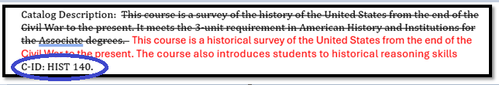

Step 2:

Go to Course Identification Numbering System C-ID website.

On the C-ID page, use the drop-down menu to select the appropriate discipline.
Example is History, which has 6 individual courses.
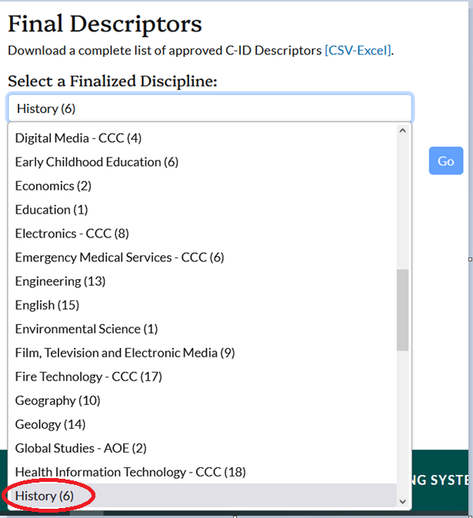

Select the Descriptor that matches the C-ID listed in the Catalog Description, click Go.
Example shows HIST 140: United States History from 1865.

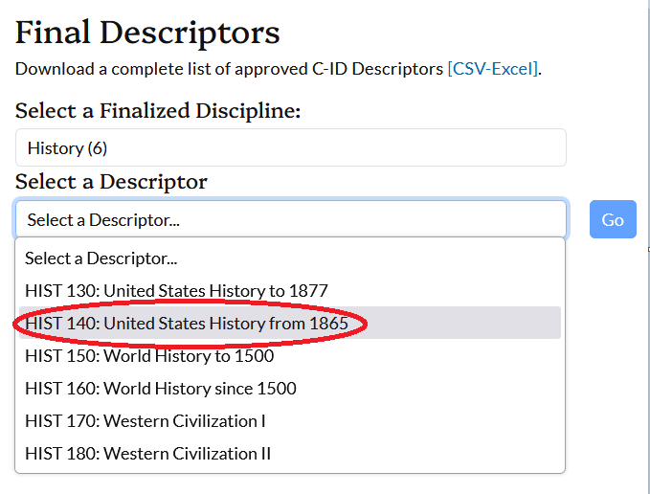

On the View Descriptor page, choose Export PDF:

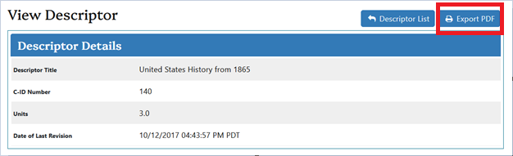

Open the file > Verify the course information.

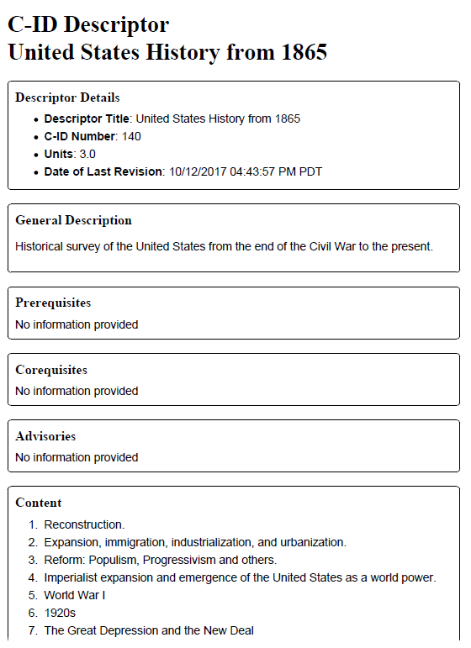

Refer to this information as you work through changing the COR. Look for information that is NOT on the CCN.
Step 3:

Go to Course Outline of Records Submission to access the Common Course Numbering Templates.

We are currently in Phase II (B). Select Standard Templates.

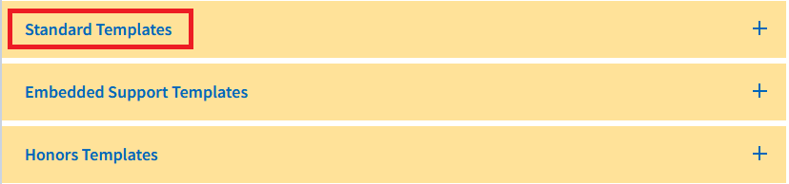
Locate the appropriate course. Click the title to open the document.
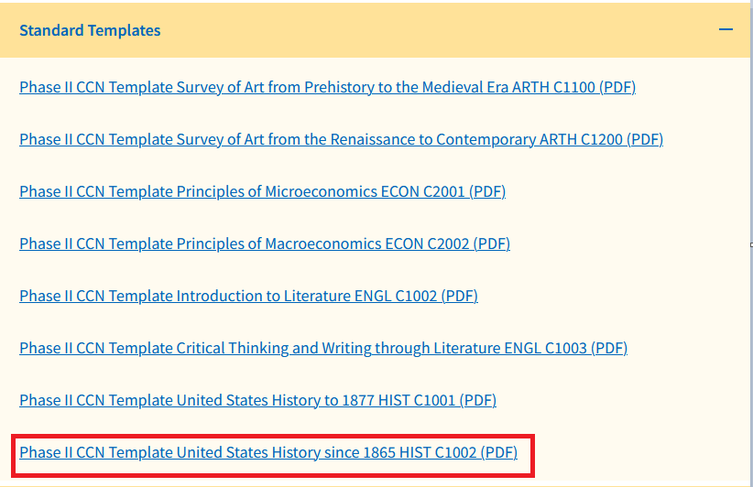

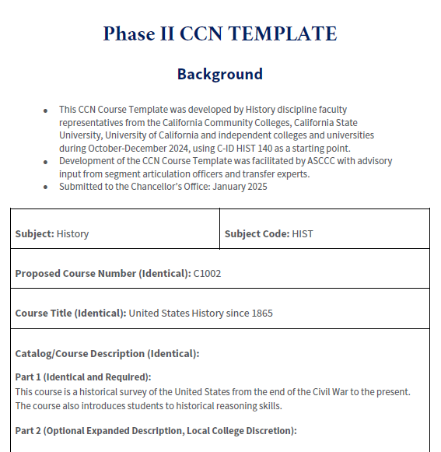

You have three documents open:
COR (MS Word)
C-ID (PDF)
CCN template (PDF)

TIPS:
If possible, have the COR on one screen and the CCN template on another screen so you can navigate each document accordingly. The two documents have the same information on them, but the section titles are different, and the sections are not in the same order. Use the COR format as your primary document and scroll the CCN template.

The CCN includes Part 1 and Part 2 for each section. Part 1 is (Required and Identical). Part 2 is (Optional Expanded Description). Copy and Paste CCN Part 1 content into the COR document. Look on the C-ID document for additional information that is not included in the CCN. Add information from the C-ID to Part 2 ONLY if it is not included in Part 1. Do NOT duplicate Part 1 in Part 2.
Step 4:

Below is a recent COR (HIST C1002) as an example. The document is broken down by each line/section. Instructions are in blue font directly below the original content. Begin editing in the upper right corner.

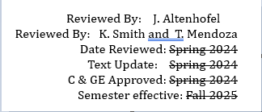

Reviewed By:
List all faculty who participate in reviewing, updating, and editing the document using first initial and last name.

In the example above, there are three reviewers listed on two lines. It is preferred that each reviewer be listed on a separate line. This example was accepted as correct; however, listing each faculty member on separate lines is preferred:

Reviewed By: J. Althenhofel
Reviewed By: K. Smith
Reviewed By: T. Mendoza

Date Reviewed: Spring 2026

Date Reviewed:
Enter the date COR is reviewed

Date Reviewed: Spring 2026

Do NOT complete the other dates. The Curriculum Technician will enter the dates as the COR is processed.

Step 5:

History (HIST) 2232 C1002 History of the United States Since 1865 1877 (3 Units) CSU: UC
[formerly History 17B, History 2232]

Course Name and Number:
On the COR
Edit the information to match the CCN document.
Strike through the old information.
Use red font to add new information.
Include all ‘formerly’ courses including the most recent TC course name and number.

Advisory: Successful completion of English 1500, ENGL C1000, C1000E, and 1502 strongly recommended

Advisory:
Confirm name and course information recommended on the CCN, e.g. ENGL C1000
Add courses as appropriate using new and/or old course names and numbers
Strike through old information
Use red font for new information

Total Hours: 48 hours lecture. 96 Outside of class hours. (144 Total Student Learning Hours)

Total Hours:
Do NOT enter information—Curriculum technician enters this information.

Catalog Description: This course is a survey of the history of the United States from the end of the Civil War to the present. It meets the 3-unit requirement in American History and Institutions for the Associate degrees. This course is a historical survey of the United States from the end of the Civil War to the present. The course also introduces students to historical reasoning skills
C-ID: HIST 140.

Catalog Description:

On the COR, it is titled Catalog Description.
On the CCN, it is titled Catalog/Course Description.
There is Part 1 and Part 2.
Part 1(Identical and Required):

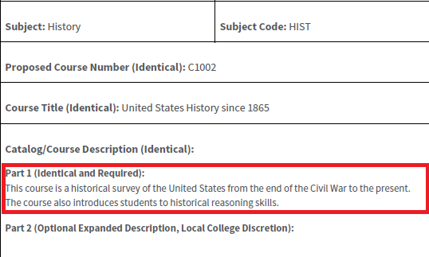
Add the words /Course to Catalog Description using red font, e.g.,
Add Part 1: using red font below the title.

Catalog/Course Description

Part 1:

Strike through all old content.
Copy and paste the text from Part 1 on the CCN into the Catalog/Course Description on the COR.

Part 2 (Optional Expanded Description, Local College Discretion):
There is no template for Part 2.

Add the words Part 2 to the COR using red font.
Add the C-ID number under Part 2 IF the C-ID is on the exiting COR. If it is not listed on the COR, do NOT add it.
Add information from the C-ID if it is not included in Part 1.
Add further information describing the course content that a student would use to determine whether the course meets their needs. Be clear and concise.
Leave it BLANK if there is no additional information.

Part 2:

C-ID: HIST 140

Type of Class/Course: Degree Credit

Type of Class/Course:
Do not add information: leave as is on the existing template.

Representative Texts: Corbett, Scott P., et al. U.S. History. OpenStax, 2024, U.S. History, https://openstax.org/details/books/us-history.

Instructor discretion to choose scholarly and primary sources that enable an academic interrogation of history.
Types of Course Materials: textbook; classics; document reader; scholarly articles; and/or monograph
Representative Texts:
- Carnes, Mark C. and John A. Garraty. 2021. The American Nation. Pearson.
- Corbett, P. Scott, Janssen Volker, John Lund “U.S. History. OpenStax Free Textbooks Online.” (OER). 2024.
- Faragher, John Mack, Mari Jo Buhle, et al. 2021. Out of Many: A History of the American People. Pearson.
- Foner, Eric, Kathleen DuVal, and Lisa McGirr. 2022. Give Me Liberty! W.W. Norton Company.
- Goldfield, David, Carol Abbott, et al. 2021. The American Journey. Pearson.
- Kamensky, Jane, Carol Sheriff, et al. 2017. A People and a Nation: A History of the United States. Cengage.
- Kennedy, David M. and Lizabeth Cohen. 2024. The American Pageant. Cengage Learning.
- Locke, John and Ben Wright. American Yawp (OER). Stanford University Press.
- Murrin, John, Pekka Hämäläinen, et al. 2019. Liberty, Equality, Power. Cengage Learning.
- Nash, Gary, Julie Roy, et al. 2023. The American People: Creating a Nation and a Society. Pearson.
- Roark, James L., Michael P. Johnson , et al. 2022. The American Promise. Bedford/St. Martin’s.
- Tindall, George Brown and David E. Shi 2022. America: A Narrative History. W.W. Norton & Company.
- U.S. History Open Stax. Supplemental Options:
- Calloway, Colin G. 2024. First Peoples: A Documentary Survey of Native American History. Bedford/St. Martin's.
- Brown, Leslie, Jacqueline Castledine, et al. 2017. U.S. Women’s History: Untangling the Threads of Sisterhood. Rutgers University Press.

DuBois, Ellen and Lynn Dumenil. 2024. Through Women’s Eyes, Combined Volume: An American History with Documents. Macmillan Learning.
- White, Deborah Gray, Mia Bay, et al. 2020. Freedom on My Mind: A History of African Americans, with Documents. Macmillan Learning.
- Kendi, Ibram X. Christopher Dontrell Piper, et al. 2017. Stamped from the Beginning: The Definitive History of Racist Ideas in America. Bold Type Books.
- Choy, Catherine Ceniza, Cindy Kay, et al. 2023. Asian American Histories of the United States.
Beacon Press.
- Ling, Huping. 2023. Asian American History. Rutgers University Press.
- Gonzales, Manuel G. 2019. Mexicanos, Third Edition: A History of Mexicans in the United States. Indiana University Press.

Representative Texts:

On the COR, the next section is titled Representative Texts.
Scroll through the CCN Template to the section titled Representative Texts, Manuals, OER, and Other Support Materials.
There is Part 1 and Part 2.
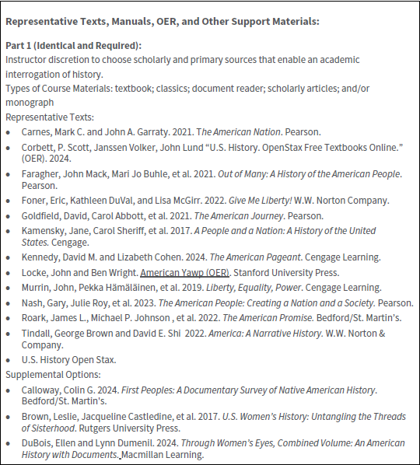
Part 1: Representative Texts, Manuals, OER, and Other Support Materials

Add the words Part 1: Representative Texts, Manuals, OER, and Other Support Materials to the COR Template using red font, e.g.,

Part 1: Representative Texts, Manuals, OER, and Other Support Materials

Strike through all old texts.
Copy and Paste from CCN Part 1 beginning with the narrative to the COR. Be sure to copy and paste ALL texts including the Supplemental Options.
NOTE: The list of texts may be on two pages.

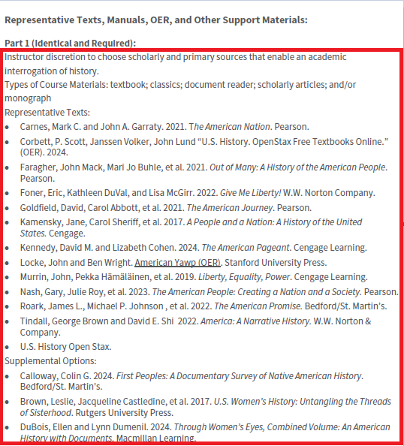

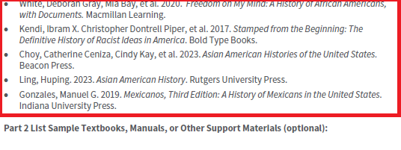

Additional Instructional Materials: None

On the COR, the section is titled Additional Instructional Materials.
On the CCN, the section is titled Part 2: List Sample Textbooks, Manuals, or Other Support Materials (Optional):
Scroll through the CCN Template to Part 2.

On the COR:
Strike through Additional Instructional Materials: None
Add to the COR in red font Part 2: List Sample Textbooks, Manuals, or Other Support Materials (Optional):, e.g.,

Additional Instructional Materials: None
Part 2: List Sample Textbooks, Manuals, or Other Support Materials (Optional):

Add additional required texts as a citation in MLA format in red font. For assistance with MLA format, see the TC Library Guide MLA Style > Works Cited Examples
Add additional required materials, such as paintbrushes, calculators, kits, etc., in red font.
Be specific.
Leave this BLANK if there are no additional materials.
Do NOT duplicate texts that are included in Part 1.

Course Objectives:

By the end of the course, a successful student will be able to

1. demonstrate a general but clear understanding of the genesis and development of our
cultural, social, and economic heritage,
2. demonstrate the ability to interpret primary and secondary sources and to compose an argument which uses them, as appropriate, for support,
3. demonstrate an understanding of U.S. History through multiple analytical categories such as race, class, gender, and ethnicity,
4. demonstrate an understanding of America’s growth in a global context,
5. explain the major political trends, attitudes, conflicts, and events—including both mainstream and reform efforts—and explain their historical significance,
6. explain the major social and cultural developments, their causes and effects, and their historical significance,
7. explain the major economic; technological and scientific developments; and their historical significance, and
8. analyze the relevancy of history in today’s world.
- Demonstrate the ability to interpret primary and secondary sources and to compose an argument which uses supportive evidence.
- Demonstrate an understanding of U.S. History through analytical categories such as race, class, gender, sexuality, and ethnicity.
- Analyze economic, political, and cultural developments as well as social movements and assess their historical significance
- Analyze the relevance of Modern American History to the present day.

Course Objectives
On the COR, the section is titled Course Objectives.
On the CCN template, the section is titled Course Objectives/Outcomes. There is Part 1 and Part 2.

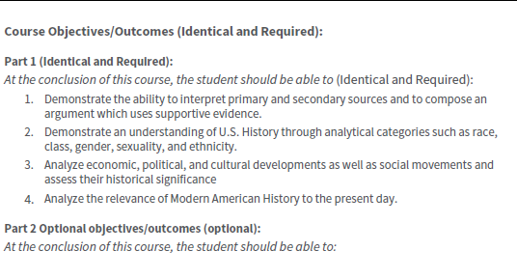
Part 1:
Scroll to Course Objectives/Outcomes on the CCN.
Add /Outcomes in red font to the COR if it is not there.
Strike through the statement, ‘By the end of the course, a successful student will be able to’ if it is on the COR.
Add the statement from the CCN as written in the CCN using red font.
NOTE: Delete unnecessary characters, such as the number 5 from the COR. Review the document for typos and other errors and clean up the issues.

Course Objectives/Outcomes
By the end of the course, a successful student will be able to
At the conclusion of this course, the student should be able to

Strike through all old course objectives on the COR.
Copy and paste all of PART 1: (Identical and Required) from the CCN template to the COR.
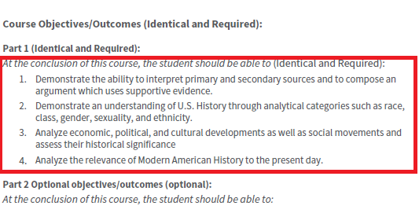

Part 2 Optional objectives/outcomes (optional):
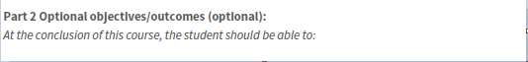

On the COR
Add the words Part 2 to the COR using red font.
Add the approved CSLOs using red font.
Strike through old CSLOs
Do NOT add PSLOs

Part 2
Course Level Student Learning Outcomes

Demonstrate the ability to interpret primary and secondary sources and to compose an argument which explains their historical significance in reference to any of the following: race, class, gender, and ethnicity; America's growth in a global context; economic, technological and scientific developments; political trends, attitudes, conflicts, and events; and, social and cultural developments from 1865 to the present.

Demonstrate an understanding of America's growth in a global context through major economic, technological, and scientific developments and their historical significance since 1865

NOTE:
If you are changing your CSLOs, your Division Chair must submit a copy of this completed COR to the SLO Coordinator (Adam Bledsoe) via email PRIOR to submission to Tech Review. The SLO Committee will review the new SLOs and the coordinator will contact your Division Chair regarding the status of the change request. If approved, the Division Chair will forward the COR to the Curriculum Technician.

Local Level General Education Learning Outcomes
- Demonstrate an understanding of the rights and obligations of individual citizens in the political system established under the U.S. Constitution

2. Analyze the influence of major social, cultural, economic, and political forces on human behavior and institutions using the major concepts, models, and concerns developed through the social sciences in contemporary as well as historical settings and in a variety of cultural contexts.
3. Apply research methodologies employed in social scientific inquiry.
4. Demonstrate the principles, concepts, models of value systems, and ethics framework employed in social scientific inquiry.

Local Level General Education Learning Outcomes:
(NOTE: this is part of Part 2)

On the COR, if applicable
Add GESLOs.

Course Scope and Content:

Unit I The Era of Reconstruction, 1865-1877
- Restoring the Union
- Congress and the Remaking of the South, 1865-1866
- Radical Reconstruction, 1867-1872
- The Collapse of Reconstruction

Unit II Go West Young Man! Westward Expansion, 1840-1900
- The Westward Spirit
- Homesteading: Dreams and Realities
- Making a Living in Gold and Cattle
- The Loss of American Indian Life and Culture
- The Impact of Expansion on Chinese Immigrants and Hispanic Citizens
Unit III Industrialization and the Rise of Big Business, 1870-1900
- Inventors of the Age
- From Invention to Industrial Growth
- Building Industrial America on the Backs of Labor
- A New American Consumer Culture

Unit IV The Growing Pains of Urbanization, 1870-1900
- Urbanization and Its Challenges
- The African American "Great Migration" and New European Immigration
- Relief from the Chaos of Urban Life
- Change Reflected in Thought and Writing

Unit V Politics in the Gilded Age, 1870-1900
- Political Corruption in Postbellum America
- The Key Political Issues: Patronage, Tariffs, and Gold
- Farmers Revolt in the Populist Era
- Social and Labor Unrest in the 1890s

Unit VI Leading the Way: The Progressive Movement, 1890-1920
- The Origins of the Progressive Spirit in America
- Progressivism at the Grassroots Level
- New Voices for Women and African Americans
- Progressivism in the White House

Unit VII Age of Empire: American Foreign Policy, 1890-1914
- Turner, Mahan, and the Roots of Empire
- The Spanish-American War and Overseas Empire
- Economic Imperialism in East Asia
- Roosevelt's "Big Stick" Foreign Policy
- Taft's "Dollar Diplomacy"

Unit VIII Americans and the Great War, 1914-1919
- American Isolationism and the European Origins of War
- The United States Prepares for War
- A New Home Front
- From War to Peace
- Demobilization and Its Difficult Aftermath

Unit IX The Jazz Age: Redefining the Nation, 1919-1929
- Prosperity and the Production of Popular Entertainment
- Transformation and Backlash
- A New Generation
- Republican Ascendancy: Politics in the 1920s

Unit X Brother, Can You Spare a Dime? The Great Depression, 1929-1932
- The Stock Market Crash of 1929
- President Hoover's Response
- The Depths of the Great Depression
- Assessing the Hoover Years on the Eve of the New Deal

Unit XI Franklin Roosevelt and the New Deal, 1932-1941
- The Rise of Franklin Roosevelt
- The First New Deal
- The Second New Deal

Unit XII Fighting the Good Fight in World War II, 1941-1945
- The Origins of War: Europe, Asia, and the United States
- The Home Front
- Victory in the European Theater
- The Pacific Theater and the Atomic Bomb

Unit XIII Post-War Prosperity and Cold War Fears, 1945-1960
- The Challenges of Peacetime
- The Cold War
- The American Dream
- Popular Culture and Mass Media
- The African American Struggle for Civil Rights

Unit IX Contesting Futures: America in the 1960s
- The Kennedy Promise
- Lyndon Johnson and the Great Society
- The Civil Rights Movement Marches On
- Challenging the Status Quo

Unit X Political Storms at Home and Abroad, 1968-1980
- Identity Politics in a Fractured Society
- Coming Apart, Coming Together
- Vietnam: The Downward Spiral
- Watergate: Nixon's Domestic Nightmare
- Jimmy Carter in the Aftermath of the Storm

Unit XI From Cold War to Culture Wars, 1980-2000
- The Reagan Revolution
- Political and Cultural Fusions
- A New World Order
- Bill Clinton and the New Economy

Unit XII The Challenges of the Twenty-First Century
- The War on Terror
- The Domestic Mission
- New Century, Old Disputes
- Hope and Change
Course Scope and Content:
On COR this is titled Course Scope and Content:
On the CCN Template, this is titled Course Content with Part 1 and Part 2.
Scroll to Course Content: Part 1: Required Topics (Identical) on CCN Template

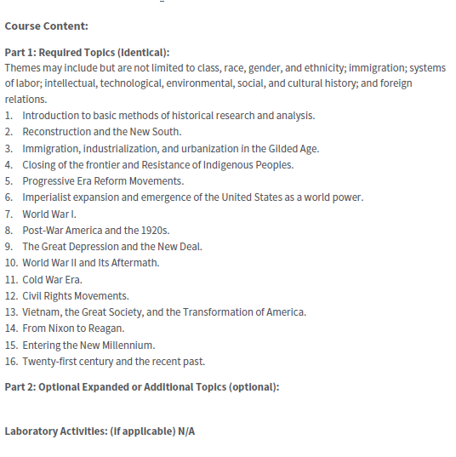

Strike through Scope and on the COR
Strike through all old content on the COR

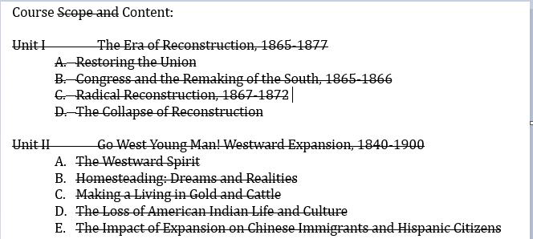

Copy and paste all content from the CCN Template Part 1: Required Topics (Identical): to COR Course Scope and Content using red font.

Themes may include but are not limited to class, race, gender, and ethnicity; immigration; systems of labor; intellectual, technological, environmental, social, and cultural history; and foreign relations.
- Introduction to basic methods of historical research and analysis.
- Reconstruction and the New South.
- Immigration, industrialization, and urbanization in the Gilded Age.
- Closing of the frontier and Resistance of Indigenous Peoples.
- Progressive Era Reform Movements.
- Imperialist expansion and emergence of the United States as a world power.
- World War I.
- Post-War America and the 1920s.
- The Great Depression and the New Deal.
- World War II and Its Aftermath.
- Cold War Era.
- Civil Rights Movements.
- Vietnam, the Great Society, and the Transformation of America.
- From Nixon to Reagan.
- Entering the New Millennium.
- Twenty-first century and the recent past.

Part 2: Optional Expanded or Additional Topics (optional):
Add topics not included in Part 1.
Add any content that is included in the C-ID descriptor to Part 2. For example, The Frontier Movement 1865-1900 is added to Part 2.
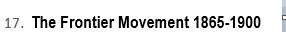

NOTE: Check the document for any unnecessary lines, characters, punctation, etc. Use strike though as needed.

Learning Activities Required Outside of Class:

There is no equivalent section on the CCN.
On the COR, edit, modify, or add to this section.
Do NOT delete all the content.

The students in this class will spend a minimum of 6 hours per week outside of the regular class time doing the following:

- Studying
- Completing required reading
- Written work

ADD the words Example of Reading Assignment to the COR and provide a description of a reading assignment using red font. Keep the description under 250 words, e.g.,

Example of Reading Assignment:
Carefully read the text and supplemental readings and practice the analysis of primary source materials to discuss cultural and historical readings and videos, including a wide variety of United States cultures.

Add the words Example of Writing Assignment to the COR and provide a description of a writing assignment using red font. Keep the description under 250 words, e.g.,

Example of Writing Assignment:
ESSAY (Includes "blue book" exams and any written assignment of sufficient length and complexity to require students to select and organize ideas, to explain and support the ideas, and to demonstrate critical thinking skills.)

Methods of Instruction:

On the COR, the section is titled Methods of Instruction.
On the CCN, there is no equivalent section.
Do NOT delete or leave this section BLANK.
Add methods not included on existing COR if appropriate.

1. Assigned readings from text and collateral reading
2. Current reading from news magazines and newspapers
3. Discussion of current problems
4. A research paper on a theme suggested by the instructor
5. Lectures and presentations

Methods of Evaluation will include:

On the COR, this section titled Methods of Evaluation will include:
On the CCN, this section is titled Methods of Evaluation: (Identical and Required) and includes Part 1 and Part 2.

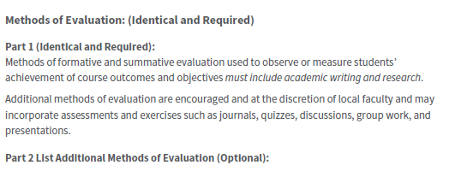

Strike through will include: on the COR.
Add Part 1: using red font.
Strike through all old content.
Copy and paste from the CCN template to the COR all content using red font.

Methods of Evaluation will include: Part 1:
Methods of formative and summative evaluation used to observe or measure students’ achievement of course outcomes and objectives must include academic writing and research.
Additional methods of evaluation are encouraged and at the discretion of local faculty and may incorporate assessments and exercises such as journals, quizzes, discussions, group work, and presentations

1. Substantial writing assignments, including:
a. reading reports
b. written essays and/or research projects
c. essay exams

2. Other evaluation can include:
a. multiple choice exams
b. classroom discussions that include primary and secondary sources
c. classroom projects and presentations

On the COR,
Add the words Part 2 using red font.

Part 2

Add additional methods of evaluation is appropriate.
Leave BLANK if no new methods are appropriate.

Supplemental Data:

TOP Code: | 220500: History
SAM Priority Code: | E: Non-Occupational
Distance Education: | Online, Offline
Funding Agency: | Y: Not Applicable (funds not used)
Program Status: | 1: Program Applicable
Noncredit Category: | Y: Not Applicable, Credit Course
Special Class Status: | N: Course is not a special class
Basic Skills Status: | N: Course is not a basic skills course
Prior to College Level: | Y: Not applicable
Cooperative Work Experience: | N: Is not part of a cooperative
Eligible for Credit by Exam: | E: Credit By Exam
Eligible for Pass/No Pass: | C: Pass/No Pass
Taft College General Education: | CSC2: CSU Area C2  IG3B: IGETC Area 3B  IG4F: IGETC Area 4F  LAHI: Local Course American History  LES: Local Ethnic Studies  LSBS: Local GE Social/Behavioral Sci  CSU Area D6  Cal-GETC Areas 3B, 4
Discipline | History

