

Taft College

Institutional Self-Evaluation Report (ISER) Training January 25, 2019

Gohar Momjian Vice President, ACCJC

Kristina Allende

Faculty, Mt. San Antonio College

## Greetings! A training conversation…

* Introductions – who’s in the house
* Purpose of conversation today:
  + Learn from each other - Q & A
  + Share information on recent ACCJC changes
  + Answer your questions and support you

### Training Outcomes

* Start the self evaluation process with the right frame of mind
* Interpret the standards & discuss their application to Taft
* Apply qualities of effective report writing
* Be confident in your ability to produce a meaningful report



Discuss:

### Activity 1

1. What do you hope your college will gain from the accreditation process (from self-evaluation to Commission decision)?
2. What do you hope to gain from today’s workshop?
3. What questions/concerns do you have regarding the self-evaluation process or accreditation in general?

### ACCJC 101

* 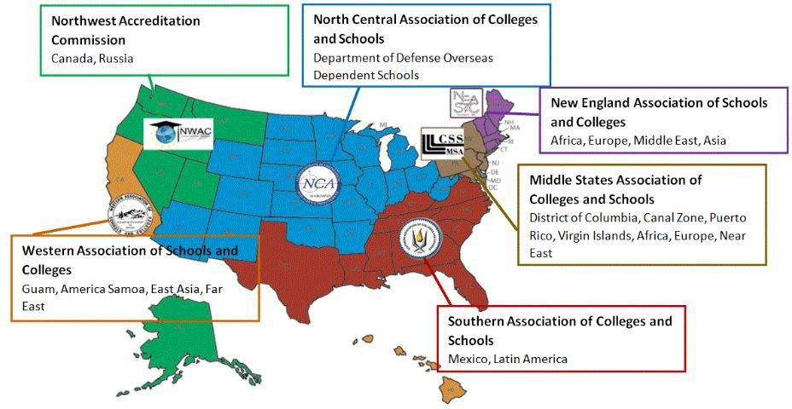What is the ACCJC?
  + Regional Accreditor (1 of 7)
  + 1 Region, 2 Agencies
* Why do we exist?
  + Quality Assurance
  + Recognition for transfer
  + Gatekeepers to Federal

Financial Aid (Title IV)

### Our Purpose

* **Mission:** The Accrediting Commission for Community and Junior Colleges works with its **member institutions to advance educational quality and student learning and achievement**. This collaboration fosters institutional excellence and continuous improvement through innovation, self-analysis, peer review, and application of standards.
* **ACCJC Core Values**: Integrity; Quality Assurance; Institutional Improvement; Peer Review; Student Learning and Achievement; Collegiality
* **Strategic Plan & Goals**

### ACCJC: More Effective, More Responsive

* ACCJC New Directions
  + Vice Presidents and the Portfolio Model
  + Advanced ISER Training, Improved Resources
  + Responsiveness to the needs of the field and more transparent engagement in its own continuous quality improvement (e.g. planning and evaluation)

### ACCJC: More Effective, More Responsive

* Approach to Peer Review - The Right Frame of Mind
  + Dual purpose of compliance and improvement
  + Mission centered
  + Celebrate the College, Support the College, Help the College



# Institutional Self Evaluation Process

ACCJC.ORG

### Accreditation Process – This is the beginning…

* Institutional Self Evaluation (internal)
* Institutional Self Evaluation Report (ISER)
* Peer Review Team (a.k.a. the Visiting Team)
* Commission Review and Action
  + Recommendations (for improvement or for compliance)
  + Commendations
  + Action levels

### Major Steps: Institutional Self Evaluation Process

Possible Steps of the Process:

1. Determine leaders.
2. Plan backward.
3. Invite others.
4. Discuss Standards Assign teams.
5. Gather evidence. Make changes.
6. Draft sections.
7. Compile the report.
8. Share with constituencies. Review and revise the report.
9. Share again?
10. Edit and finalize the report.
11. Get Board approval.
12. Submit.
13. Prepare for the Visit.

### Key ingredients for a successful Institutional Self Evaluation Process

* + Make sure you have the right people on your workgroups.
  + Work existing committee structures into the process.
  + Start with understanding the standards.
  + **Gather evidence first!** Then write…
  + Make changes early if identify need to strengthen alignment.
  + Build cushion in your timeline.



# Interpreting Standards

ACCJC.ORG

### Part 1: What you should know about the Standards

* + Why must we have Standards?
  + What is their purpose?
  + Who developed them?
  + How were they developed?

### The Standards

* + Standard I: Mission, Academic Quality and Institutional Effectiveness,

and Integrity

* + 1. Mission (4)
    2. Assuring Academic Quality and Institutional Effectiveness (9)
    3. Institutional Integrity (14)
  + Standard II: Student Learning Programs and Support Services
    1. Instructional Programs (16)
    2. Library and Learning Support Services (4)
    3. Student Support Services (8)

### The Standards

* + Standard III: Resources
    1. Human Resources (15)
    2. Physical Resources (4)
    3. Technology Resources (5)
    4. Financial Resources (16)
  + Standard IV: Leadership and Governance
    1. Decision-Making Roles and Processes (7)
    2. Chief Executive Officer (6)
    3. Governing Board (13)
    4. Multi-College Districts or Systems (7)

### Primary Resource

[*Guide to Institutional Self Evaluation and Peer Review*](https://accjc.org/wp-content/uploads/Guide-to-Institutional-Self-Evaluation-Improvement-and-Peer-Review.pdf) *(September 2018)*

### Part 2: How Does One Interpret a Standard?

**Standard II.A.2**: Faculty, including full time, part time, and adjunct faculty, regularly engage in ensuring that the content and methods of instruction meet generally accepted academic and professional standards and expectations.

In exercising collective ownership over the design and improvement of the learning experience, faculty conduct systematic and inclusive program review, using student achievement data, in order to continuously improve instructional courses and programs, thereby ensuring program currency, improving teaching and learning strategies, and promoting student success.

## C:\Users\Janet\AppData\Local\Microsoft\Windows\INetCache\IE\HX1345QC\clipart-illustration-orange-man-holding-question-mark[1].jpgActivity 2: Using the Guide , Interpreting Standard, Identifying Evidence

#### PURPOSE

1. To provide opportunity to discuss varying perspectives on the standard
2. To identify differences among standards which are related
3. To identify 1-2 pieces of evidence at Taft College which would demonstrate

alignment

1. To provide opportunity to norm Taft College’s interpretation and expectation to demonstrate alignment

## C:\Users\Janet\AppData\Local\Microsoft\Windows\INetCache\IE\HX1345QC\clipart-illustration-orange-man-holding-question-mark[1].jpgActivity 2: Using the Guide , Interpreting Standard, Identifying Evidence

#### INSTRUCTIONS

1. Break into 4 groups.
2. Read the Standards that have been assigned to your group.
3. Discuss the accompanying questions. (20 minutes)
4. Be prepared to share your findings with the crowd. (5 minutes)

Note: please feel free to use the table to record your responses.

### Standard I group: Let’s Discuss

**I.A.2** (*Mission*)**:** The institution **uses data** to determine how effectively it is **accomplishing its mission**, and whether the mission directs institutional priorities in meeting the educational needs of students.

**I.B.4** (*Assuring Academic Quality and Institutional Effectiveness/Academic Quality*)**:** The institution **uses assessment data** and organizes its institutional processes to support student learning and student achievement.

**I.B.5** (*Assuring Academic Quality and Institutional Effectiveness/Institutional Effectiveness*)**:** The institution **assesses accomplishment of its mission** through program review and evaluation of goals and objectives, student learning outcomes, and student achievement. Quantitative and qualitative **data** are disaggregated for analysis by program type and mode of delivery.

### Standard II group: Let’s Discuss

**I.B.2** (*Assuring Academic Quality and Institutional Effectiveness/Academic Quality*)**: The institution defines and assesses student learning outcomes** for all instructional programs and student and learning support services.

**II.A.3** (*Instructional Programs*)**: The institution identifies and regularly assesses learning outcomes** for courses, programs, certificates and degrees using established institutional procedures. The institution has officially approved and current course outlines that include student learning outcomes. In every class section students receive a course syllabus that includes learning outcomes from the institution’s officially approved course outline.

**II.C.2** (*Student Support Services*)**: The institution identifies and assesses learning support outcomes** for its student population and provides appropriate student support services and programs to achieve those outcomes. The institution uses assessment data to continuously improve student support programs and services

### Standard III group: Let’s Discuss

**I.C.8** (*Institutional Integrity*)**:** The institution establishes and publishes **clear policies** and procedures that promote **honesty, responsibility and academic integrity**. These policies apply to **all constituencies** and include specifics relative to each, including student behavior, academic honesty **and the consequences for dishonesty**.

**III.A.13** (*Human Resources*): The institution upholds **a written code of professional ethics for all of its personnel**, **including consequences for violation**.

**IV.C.11** (*Governing Board*)**:** The governing board upholds **a code of ethics** and conflict of interest policy, and individual board members adhere to the code. The board has a **clearly defined policy** for **dealing with behavior that violates its code** and implements it when necessary. A majority of the board members have no employment, family, ownership, or other personal financial interest in the institution. Board member interests are disclosed and do not interfere with the impartiality of governing body members or outweigh the greater duty to secure and ensure the academic and fiscal integrity of the institution.

### Standard IV group: Let’s Discuss

**I.C.5** (*Institutional Integrity*)**:** The institution **regularly reviews** institutional **policies**, procedures, and publications to assure integrity in all representations of its mission, programs, and services.

**IV.C.7** (*Governing Board*)**:** The governing board acts in a manner consistent with its policies and bylaws. The board **regularly assesses** its **policies** and bylaws for their effectiveness in fulfilling the college/district/system mission and revises them as necessary.

Activity 2:Using the Guide , Interpreting Standard, Identifying Evidence

# Reflections and Feedback



The Institutional Self Evaluation Report

**(The ISER)**

ACCJC.ORG

### Compliance and Quality Improvement

* Sections related to Compliance
  + Five ERs
  + Commission Policies (federal regulations)
  + 127 Standards and 17 more ERs
  + “Evidence of meeting” and “Analysis and evaluation”
  + Improvement plans (to align with Standards)
* Sections related to Quality Improvement
  + “Moving the needle” on student achievement and student learning
  + Student Achievement data
  + Quality Focus Essay

1. Title page

### Structure of the Report

8. Compliance with ERs 1-5

1. Certification page/signatures
2. Table of Contents
3. Introduction
4. Student achievement data and institution-set standards
5. Organization of the self- evaluation process
6. Organizational information
7. Compliance with Commission policies
8. Analysis of Standards
   1. “Evidence of Meeting the

Standard”127

* 1. “Analysis and Evaluation”127
  2. (Conclusion13 or 14)

1. Quality Focus Essay

### From Evidence to Draft

* “Evidence of Meeting the Standard”: Try to use language like this:
  + “Document X shows that the College . . .” does something. Use the language of the Standard in your descriptions.
  + Document X shows that the College . . . does something.
  + Document X is the College’s policy on . . . .
  + Document X describes the College’s procedure for . . . .
  + Page 21 of Document X presents the College’s . . . .
  + The minutes of XX meeting capture dialogue on . . . .
  + Document X demonstrates that the College . . . .
  + Document X is an example of the College’s . . . .

### Moving from evidence into “Analysis and Evaluation”

Analysis = Describe the policy or practice in more detail— what it is or how it works.

Evaluation = Judge the policy or practice—does it work or not? Is it effective or not? How do you know? Is it satisfactory, or does it need improving? If needs improving, what are your plans for that? Timeline?

### Quality Focus Essay – Proposed Projects

* Improvement component
* Connect to student learning and achievement
* What doing to move the needle?
* Long-term projects with clear demarcation line
* Peer Review team provides constructive feedback
* Report on QFE projects in Mid-term report (4 years out from start)

### Length of ISER, Evidence, & Action Plans

* Focus on language in Standard
* Relevant evidence & be concise
* Consider your audience & format as electronic doc
* Don’t overdo it!
* Action plans (improvement & compliance)

### Format of the Report

* Simple, focused, concise, neat, professional, business style
* Use template
* Electronic, on USB drive
  + A separate USB for each team member
  + One USB for ACCJC staff
* Links to evidentiary documents
  + Frozen snapshots in time (PDF or Word)



# What Happens Next?

ACCJC.ORG

### Expectations of Peer Reviewers

* + Have a working knowledge of ACCJC Eligibility Requirements, policies, and Standards, and relevant federal regulations
  + Review the college in the context of its mission
    - Remain objective, flexible, and refrain from imposing personal

opinions and beliefs

* + Represent the Commission and the peer review process
    - Relationships with college personnel – take the fear out of the process
  + Communicate clearly and concisely, orally and in writing
  + Work as part of a team with positive frame of mind

### What happens after this training?

* Advanced ISER Training
* ACCJC and your CEO select a date for the visit.
* ACCJC staff recruit your Peer Review Team (peers).
* You send the report and evidence to the Team on USB.
* The Team attends training and completes a desk review.
* The VISIT!
* The Team completes its “External Evaluation Report.”
* Your CEO checks for errors of fact.
* The Commission (peers) reviews everything and takes action.
* And life goes on….

## Thoughts and Remaining Questions??

***

Don’t forget: Save the Date, ACCJC Conference April 30 – May 3, 2019

Consider becoming a Peer Reviewer – complete form online