**Taft College**

**Planning Guide**

**Manual of Institutional Plans**

**West Kern Community College District**

Taft College

29 Cougar Court

Taft CA 93268

**Contents**

Introduction 3

Taft College Mission Statement 3

Overview 4

I. Mission 6

II. Educational Master Plan 7

Process for Developing the Educational Master Plan 8

III. Strategic Action Plan 9

Process for Developing the Strategic Action Plan 9

IV. Institutional Area Plans 10

Technology Master Plan 10

Process for Developing the Technology Master Plan 10

Facilities Master Plan 11

Process for Developing the Facilities Master Plan 11

Student Equity Plan 12

Process for Developing Student Equity Plan 13

V. Program-Level Planning 14

Program Review Update and Planning 14

Diagram Depicting Program-Level Planning Cycles 15

Process for Program Review 16

VI. Planning Documents at a Glance 18

# Introduction

### Taft College Mission Statement

**Our Vision**

Taft College instills a passion for learning, leading to success for all.

**Our Mission**

Taft College is committed to creating a community of learners by enriching the lives of all students we serve through career technical education, transfer programs, foundational programs, baccalaureate programs, and student support services. Taft College provides an equitable learning environment defined by applied knowledge leading to students’ achievement of their educational goals.

**Our Values**

* + Students and their success.
  + A learning community with teaching excellence.
  + An environment conducive to learning, fairness, dialogue, and continuous improvement.
  + A communicative, collaborative, collegial, and respectful culture.
  + A partnership of students, faculty, support services, and community.
  + Innovation, diversity, creativity, and critical thinking.
  + Academic, financial, personal, and professional integrity.
  + Employees and their professional development.
  + A transparent, accessible, participative governance structure.

Best practices for educational institutions and accreditation standards require integrated planning. Taft College uses best practices as a means of accomplishing the mission of the college. Integration of plans and activities throughout the college requires an intentional process of communication, evaluation, and improvement. This document provides a record of how Taft College achieves integrated planning.

The Taft College *Responsibilities and Schedule of Plans* documents the schedule, responsible entity, and institutional areas involved in maintaining currency for institutional-wide planning at Taft College.

The manual begins with an overview of the planning process. Subsequent sections provide detailed descriptions of the elements used throughout the process along with specific information to develop the individual plans.

# Overview

Taft College integrated planning uses a multi-layered system of plans. Plan development works from the top down for institution level plans and from the bottom up for unit level plans. In this manner, both institution level plans and unit level plans work in conjunction to direct activities at all levels of the College.

Institution level plans consist of the Educational Master Plan (EMP) and the Strategic Action Plan (SAP). The EMP defines the long-term goals and direction for the College while the SAP documents broad efforts to achieve the goals through movement in the identified direction. The institution level plans are supplemented by four area plans specific to broad areas within the College:

* Technology Master Plan (Standard III)
* Facilities Master Plan (Standard III)
* Student Equity and Achievement -- Program Plan (Standard II)

Each of the area plans link to elements of the SAP. The institutional area plans include details intended to move subcomponents of the college forward in line with the EMP. Information from program and unit reviews drives the creation of these plans. The plans include area specific data including budgetary components. Thus, these plans provide broad operational goals and actions for the College and units within the College.

Area plans are evaluated for usefulness and value added over time. Addition or deletion of area plans occurs as needed, making this list responsive to the needs of the College. For example, current committee discussions include the value of adding an Enrollment Master Plan.

Action plans derive from programs reviews. These plans document actions to increase or sustain the effectiveness of the programs. Action plans include requests for resources. Information derived from program reviews move through committee structures and provide a bottom-up element to the planning mechanism.

# I. Mission

Taft College’s Mission Statement defines the overall purpose of the institution and identifies the community served by the College. The Mission Statement also includes a Vision Statement, which sets the context for the Mission Statement by stating a singular vision for the entire college, and a set of values, or guiding principles, which employees of the College hold as they go about their daily business. The college’s mission, vision, and values are the starting point for integrated planning at Taft College.

The Accrediting Commission for Community and Junior Colleges standards most relevant to the development and review of a district mission statement is:

*Standard 1.1 - The institution has established a clearly defined mission that appropriately reflects its character, values, structure, and unique student demographics. The institution’s mission articulates its commitment to ensuring equitable educational opportunities and outcomes for all students. Accreditation Standards - June 2024*

**Process for Mission Statement Review/Revision**

|  |  |
| --- | --- |
| Mission reviewed once in an accreditation review cycle. Last completed in April 2019 | |
| Step 1 | College community including staff and students reviews the Mission of the college for currency. |
| Step 2 | Data from reviews are sent to the GC (Governance Council) and GC reviews the results.  If changes are suggested, the draft is sent to the college community and Board of Trustee (BOT) for review and input. |
| Step 3 | Governance Council makes recommendation of changes, if any, to Superintendent/President |
| Step 4 | S/P recommends changes, if any, to Board of Trustees |
| Step 5 | After BOT approval, if changes were made, publications are updated. |

# II. Educational Master Plan

The Educational Master Plan (EMP) is the primary vehicle of Institutional-Level planning at Taft College. The Educational Master Plan is a broad, comprehensive plan covering all aspects of campus functioning. Taft College’s 2014-2024 Educational Master Plan makes general recommendations for the next ten years that address the needs of the college, its students, and the community it serves. The EMP reflects the data from internal and external environmental scans and follows the Western Association of Schools and Colleges Commission’s standards. The plan identifies the needs of the College and the students and community it serves and then provides broad recommendations for the College for the next ten years. The EMP provides the foundation for other long-range master plans and is the central reference point for program plans and reviews, student learning outcomes, and resource allocation. All College planning efforts are informed by, and link back to, the College Educational Master Plan. The EMP addresses the five broad areas of Student Learning and Success, Access, Business, Industry, and Community, Facilities and Infrastructure, and Institutional Planning and Effectiveness.

The Accrediting Commission for Community and Junior Colleges standards most relevant to the development of planning is:

*Standard 1.2 - The institution establishes meaningful and ambitious goals for institutional improvement, innovation, and equitable student outcomes. Accreditation Standards – June 2024*

### Process for Developing the Current Educational Master Plan

|  |  |
| --- | --- |
| Timeline – every 7 to 10 years | Action – last completed in AY 2013-2014 |
| September | Formation of the Educational Master Plan Committee (EMPC). Membership includes faculty, classified staff, educational administrators, and management representatives.  Board approves consultant firm |
| October | Consulting agency - Internal and external scans, growth forecasts, future academic space needs, and other space needs |
| November | Consulting agency - Survey college community. |
| December – January | Consulting agency - Interviews with members of the Taft College community, including faculty, classified staff, managers, administrators, students, members of the Board of Trustees, and community resident leaders |
| February | EMPC – develops consensus on planning assumptions, prioritizes needs, develops broad planning recommendations, develops recommendations in the areas of:   * Student Learning/Success * Access * Business/Industry/Community * Facilities and Infrastructure * Institutional Planning/Effectiveness   IR - Posts draft version for comment by the college community  GC - reviews draft of EMP  Academic Senate - review draft EMP |
| March – April | EMCP – revises EMP based on comments. Finalizes recommendations  Consulting agency – edits and formats final version |
| May | EMPC – approves EMP final draft  GC - approves EMP final draft; recommendation to Superintendent/President |
| June – July | Superintendent/President – recommendation to Board of Trustees  Board of Trustees - adoption |

# III. Strategic Action Plan

As noted in the overview earlier, Taft College’s Strategic Action Plan (SAP) presents prioritized recommendations from the EMP and, for each recommendation in the SAP, lists objectives, actions to be taken, timelines, and expected outcomes. The SAP is a shorter 3-year implementation plan of selected, prioritized recommendations from the EMP. Whereas the EMP presents a broader, long-term, more global perspective of recommendations, the SAP presents specific details meant to move the recommendations in the EMP forward.

The Accrediting Commission for Community and Junior Colleges standards most relevant to the development of planning are:

*Standard 1.3 - The institution holds itself accountable for achieving its mission and goals and regularly reviews relevant, meaningfully disaggregated data to evaluate its progress and inform plans for continued improvement and innovation. (ER 3, ER 11)  
Accreditation Standards – January 2024*

### Process for Developing the Current Strategic Action Plan

|  |  |
| --- | --- |
| Timeline – every 3 years | Action – last completed in AY 2021 |
| September-November | SPC – presents overview of the SAP development process to GC |
| December - April | SPC –workshops:   * Identify and prioritize EMP recommendations to be addressed in the next three years * Draft specific actions to be implemented year by year * Identify measurable outcomes * Identify “champions” to facilitate the actions and collect data on the outcomes * Write SAP draft   IR – SAP draft posted for public comment, comments compiled for SPC |
| May – Summer | SPC – final revisions of SAP  GC – recommend SAP approval to Superintendent/President |

# IV. Institutional Area Plans

Area plans link to elements of the SAP. The institutional area plans include details intended to move the college forward in line with the EMP. Information from the EMP, SAP, and program and unit reviews drives the creation of these plans. The plans include area specific data including budgetary components. Thus, these plans provide broad operational goals and actions for the College and units within the College.

## Technology Master Plan

The Technology Master Plan details the institution-wide plan to achieve and maintain the technology and technology support across all college activities.

The Accrediting Commission for Community and Junior Colleges standards most relevant to the development of planning is:

*Standard 3.9 - The institution implements, enhances, and secures its technology resources to support and sustain educational services and operational functions. The institution clearly communicates requirements for the safe and appropriate use of technology to students and employees and employs effective protocols for network and data security. Accreditation Standards – January 2024*

### Process for Developing the Technology Master Plan

|  |  |
| --- | --- |
| Timeline – 5 years | Action – last completed in AY 2019-2020 updated every 2 years |
| September | Superintendent/President – Notifies VP Information and Institutional Effectiveness to initiate planning process  VP Information and Institutional Effectiveness - Forms stakeholder groups consisting of stakeholders knowledgeable about student/faculty/system needs. |
| October - January | VP Information and Institutional Effectiveness – works with stakeholder group to:   * Identify and prioritize technology needs to be addressed in the next 5 years * Draft specific actions to be implemented year by year * Identify measurable outcomes * Write Technology Plan draft |
| February - April | ITC and Stakeholders– review Technology Plan draft |
| May | VP Information and Institutional Effectiveness – presents Technology Plan to GC as information item |
| June | VP Information and Institutional Effectiveness – presents Technology Plan to Board of Trustees |

## Facilities Master Plan

The Facilities Master Plan (FMP) details the institution-wide plan to achieve and maintain the facilities needs to support all college activities.

The Accrediting Commission for Community and Junior Colleges standards most relevant to the development of planning are:

*Standard 3.8 - The institution constructs and maintains physical resources to support and sustain educational services and operational functions. The institution ensures safe and effective physical resources at all locations where it offers instruction, student services, and/or learning supports. Accreditation Standards – January 2024*

### Process for Developing the Facilities Master Plan

|  |  |
| --- | --- |
| Timeline – up to 20 years | Action – last completed in AY 2020-2021 |
| May | Superintendent/President - Initiates planning process  VP of Administrative Services – identifies consulting agency  Facilities Committee (FC) – reviews planning process, identifies and prioritizes EMP recommendations |
| June - August | Consulting Agency – Drafts specific actions to be implemented year by year |
| August - November | FC – Identifies measurable outcomes and “champions” to facilitate the actions and report on outcomes, reviews Facilities Plan draft |
| December | FC – final revisions of Facilities Plan  GC – recommend plan approval to Superintendent/President  Board of Trustees – approval of plan |

## Student Equity Plan

The Taft College Student Equity Plan (SEP) is designed to advance the College’s mission of providing excellent comprehensive educational programs and services that promote student learning and success in collaboration with our diverse communities. Our goal is to provide diverse student groups with the tools and opportunities they need to achieve their goals which is fundamental to our mission. The Student Equity Plan serves to provide basic skills completion, degree and certificate completion, career and technical education and transfer opportunities for all our students. This plan helps us provide the necessary tools to ensure all our diverse students have the same opportunity to achieve their goals.

The Accrediting Commission for Community and Junior Colleges standards most relevant to the development of planning are:

*Standard 1.2 - The institution establishes meaningful and ambitious goals for institutional improvement, innovation,*

*and equitable student outcomes.*

*Standard 2.7 - The institution designs and delivers equitable and effective services and programs that support students in their unique educational journeys, address academic and non-academic needs, and maximize their potential for success. Such services include library and learning resources, academic counseling and support, and other services the institution identifies as appropriate for its mission and student needs. (ER 15, ER 17) Accreditation Standards – January 2024*

### Process for Developing Student Equity Plan (SPC)

|  |  |
| --- | --- |
| Timeline – 3 years | Action – Every three years with Annual Reporting |
| November | VP of Student Services and VP of Instruction - Initiates planning process |
| Dec -Feb | IR – data analysis  Student Success sub-Committee – review processes and outcomes |
| February - March | Student Success sub-Committee   * Identify and prioritize Equity plan recommendations to be addressed in the next 3 years * Draft specific actions to be implemented year by year * Identify measurable outcomes * Draft specific actions to be implemented year by year * Identify measurable outcomes * Write Equity Plan draft |
| April - May | Student Enrollment Management Committee – presentation to stakeholder groups for comment  Presentation to Governance Council  Presentation to Academic Senate Council and Academic Senate  Presentation/Information item to Board of Trustees |
| June | Board of Trustees – 1st reading; approval of SEP |

# V. Program-Level Planning

## Program Review Update and Planning

Program reviews are conducted by all programs on campus. Each Program Review Report contains among other things a summary of major findings, an update on the previous year's program goals, and a set of new goals based on empirical data. The Taft College program review processes involves members of all programs. Program review is integrated into strategic planning processes and is tightly linked to budgeting and resource allocation.

The Accrediting Commission for Community and Junior Colleges standards most relevant to Institutional Program Planning and Reviews are:

*Standard 1.4 - The institution’s mission directs resource allocation, innovation, and continuous quality improvement through ongoing systematic planning and evaluation of programs and services. (ER 19)*

*Standard 2.9 - The institution conducts systematic review and assessment to ensure the quality of its academic, learning support, and student services programs and implement improvements and innovations in support of equitable student achievement. (ER 11, ER 14)*

*Accreditation Standards – January 2024*

### Diagram Depicting Program-Level Planning Cycles

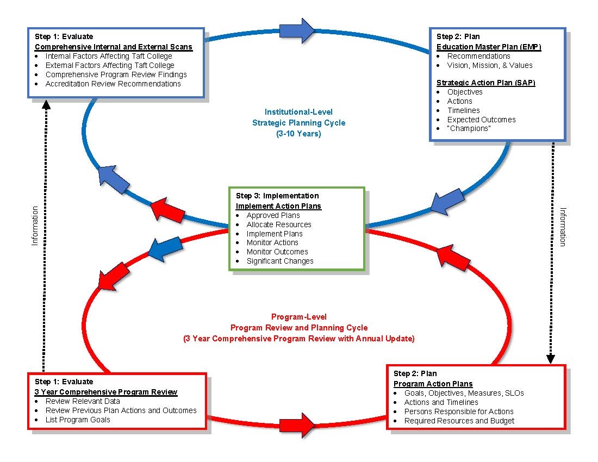

### Process for Program Review

|  |  |
| --- | --- |
| Timeline –Annual Updates and Comprehensive 3-Year | Action – Current |
| August | IR – program review website updated with current cycle documents and data Program Review Overview during in-service Programs begin updating/drafting reports and goal forms |
| August – January | Program contacts – guide program review analysis and writing process; submit Program Review Reports, and Program Goals; submit evaluation of the program review process |
| February | Budget Committee review potential funding sources for non personal resource allocation  SPC (Strategic Planning Committee) review the comprehensive program review reports and provide feedback  IR – compile program review goals, and distribute prioritization worksheet to GC members |
| March | GC – Review & Rank non-personnel goals  Classified Committee: Review & Rank classified staff goals |
| May | GC – Review list of programs for accuracy in preparation for next Program Review cycle  Superintendent/president receives final rankings of program review goals |
| April - July | IR – edits based on the feedback and posts program reviews on IR website  goals and sends to appropriate committees: GC, AC, Budget Committee, CSEA |

Prioritization of Goals and Allocation of Resources

Annual Program Goals requiring allocation of additional resources may result from the program review process. Resource requests are filtered into the institutional planning process each spring semester (see Timeline on next page).

# VI. Planning Documents at a Glance

|  |  |  |  |
| --- | --- | --- | --- |
| **Taft College Planning Documents at a Glance** | | | |
| **Document Title** | **Last Update** | **Cycle** | **Next Update** |
| Taft College Mission Statement | April 2022 | 7 Years ( | —Nov. 2026 |
| Educational Master Plan | AY 2013/14 | 7-10 Years | AY 2023/24 |
| Strategic Action Plan | AY 2020/21 | 3 Years *Extended 1-Year | AY 2024/25 |
| Technology Master Plan | AY 2019/20 | 5 Years *Extended 1-Year | AY 2024/25 |
| Facilities Master Plan | AY 2019/20 | 5 Years | AY 2025/26 |
| Student Equity and Achievement Plan | AY 2022/25 | 3 Years with Annual Report | AY 2027/28 |

*Planning Guide to Be Reviewed and Approved by SPC – Spring 2025*