

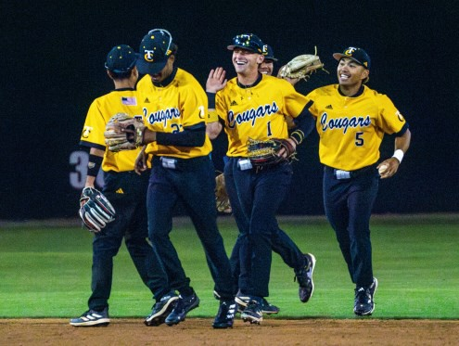

The Taft College Athletic Department is dedicated to helping our student athletes achieve success both academically and athletically.

Highlights from the previous year include four of the sports

programs making it into playoffs, Women’s Volleyball, Women’s Basketball, Baseball and a Women’s Golfer.

Academically, four of the teams had in-season GPA’s

above a 3.0.

Taft College is a member of the Central Valley Conference and participates

in the following intercollegiate sports:

Service Area 767 Square Miles

Campus Size 39 Acres

Date Founded 1922

**Taft College**

**Quick Statsf 2024**

**29 Cougar Court**

**Taft, CA 93268**

**(661) 763-7700**

**Tuition and Fees 2024-2025 Enrollment Fee** $46/unit

**Credit by Exam Fee** $46/unit

**Class Audit Fee** $15/unit

**Nonresident Tuition Fees** (in addition to $46 per unit enrollment fee and credit by exam fee)

0 thru 14 units $406/unit

15 units or more $6,090/semester

**International Student**

Admissions application fee $100

**Textbook Rental Fees**

Rental fee w/paid ASO fee Average 30% of

new book price

**Associated Student Organization (ASO) Fee** $30/year

**Residence Hall Room & Board** $3,665/semester (Board includes 19 meals per week)

**Financial Aid 2023-2024**

Total number of students receiving an award: 3,388 Total dollar amount of aid awarded: $10,236,039.00

|  |  |
| --- | --- |
| **Sport** | **Team GPA** |
| Baseball | 3.00 |
| Men’s Soccer | 3.02 |
| Women’s Volleyball | 3.38 |
| Women’s Basketball | 3.58 |

|  |  |
| --- | --- |
| Men’s Baseball  Men’s Golf  Men’s Soccer  Women’s Basketball | Women’s Golf Women’s Soccer Women’s Softball Women’s Volleyball |

Quick Stats 2024 prepared by

Full Time Faculty 60

Adjunct Faculty 77

Classified Staff 107

Confidential Staff 13

Administrators 34

**Dr. Todd Hampton,**

**Acting Superintendent/President**

**West Kern Community College District Board of Trustees**

*Billy White, President Dawn Cole, Trustee*

*Michael Eveland, Trustee Jeremy Gregory, Trustee Dr. Kathy Orrin, Secretary*

|  |  |  |
| --- | --- | --- |
| **Project** | **Cost** | **Status** |
| Administration, Student  Services & Library Remodel for Efficiency | $19,266,624 | Complete |
| Science Modernization | $5,060,414 | Complete |
| Child Development Center | $4,159,800 | Complete |
| M&O Facility | $3,218,006 | Complete |
| Tech Arts Modernization | $5,776,151 | Complete |
| Technology Upgrades | $4,150,000 | Complete |
| Transition to Independent  Living | $15,062,894 | Complete |
| Dorm Modernization | $3,138,348 | Complete |
| Student Center (Bookstore,  Café) | $17,616,519 | Complete |

Institutional Research & Planning Office (661) 763-7944

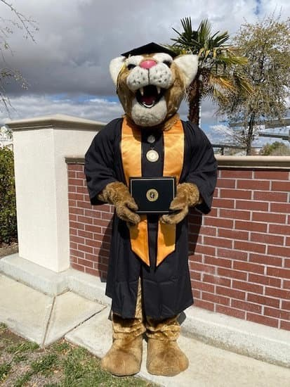

* Admin of Justice
* Administrative Services
* Advanced Technology & Management Certificate
* Art
* Art History
* Biology
* Business Administration
* Court Reporting
* Criminal Justice Admin.
* Dental Hygiene
* Dental Hygiene Admin. Bachelor of Science
* Direct Support Education
* Disability Services
* Early Care, Education, & Family Studies
* Early Childhood Education
* Economics
* Elementary Teacher

Education

* Energy Technology
* Engineering
* English
* General Business
* History
* Industrial Electronics
* Kinesiology
* Kinesiology Sport Management
* Law, Public Policy & Society
* Liberal Arts with an Area of Emphasis:
  + *Allied Health*
  + *Arts & Humanities*
  + *Business & Technology*
  + *Communication*
  + *Health & PE*
  + *Math & Science*
  + *Natural & Life Science*
  + *Natural & Physical*

*Science*

* Life Science
* Management
* Mathematics
* Occupational Safety &

Petroleum Technology

* Physical Education
* Physical Science
* Psychology
* Sociology
* Spanish
* Studio Art
* Welding
* CSU GE Breadth: Certificate of Achievement
* Intersegmental GE Transfer Curriculum: Certificate of

Achievement

Health

•

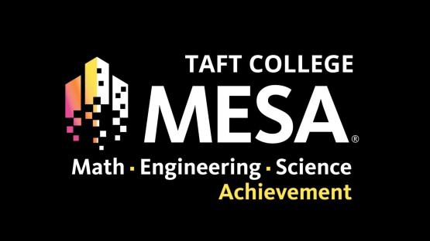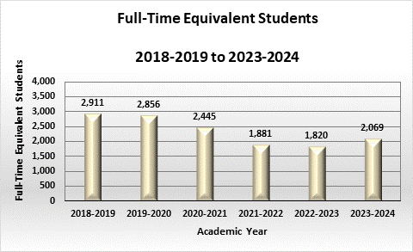

**Top 5 Certificates for 2023-2024**

1. CSU GE Certificate
2. Associate Teacher ECEF
3. Teacher in ECEF
4. Structural Code Welding
5. IGETC Certificate

**Top 5 Degrees for 2023-2024**

1. Liberal Arts Math & Science AA
2. Liberal Arts Allied Health AA
3. Life Science AS
4. Liberal Arts Communication AA
5. Psychology For Transfer ADT

FTES 2,069

Average Class Size** 15

Race

Asian 1%

African-American 4%

Filipino 1%

Hispanic 66%

Pacific Islander 2%

Native American 0%

White Non-Hispanic 18%

Multi-Ethnicity 2%

Other/Unknown 10%

Gender

Female 59%

Male 41%

Not Identified 0%

*includes WESTEC students ** On-Campus students

**Data Source: CCCCO Data Mart**

|  |  |
| --- | --- |
|  | |
| **E**stablished in 1991, the California Community College segment of Mathematics, Engineering, Science Achievement (MESA) programs, began working in partnership with the University of  California Office of the President MESA statewide. This intersegmental collaboration supports underserved and underrepresented students pursuing calculus-based Science, Technology,  Engineering and Mathematics (STEM) bachelor’s degree yielding a seamless matriculation of students into and out of postsecondary educational systems. MESA’s comprehensive support system for underserved and underrepresented students includes academic advising, tutoring, and hands-on learning opportunities from college prep programs (middle and high schools) to community college and onto four-year colleges/universities. The holistic approach of the MESA program segment maintains data integrity and program efficacy as students succeed in challenging STEM fields and compete for  highly competitive | |
|  | STEM careers.  The Taft College MESA program just completed its first full academic year in  Spring 2024. The |
| program served 45 students majoring in calculus-based STEM degrees by providing a dedicated student center, located in the ETEC building, tutoring services, academic counseling, field trips, college tours, community service opportunities, and the best espresso on campus! MESA students were able to attend student conferences in Utah and Texas and visited  ten different CSUs and UCs. The MESA program has even spread to local high schools by sponsoring student STEM clubs at Taft Union High School and Ridgeview High School. | |