2020/21-2025/26 FACILITIES MASTER PLAN
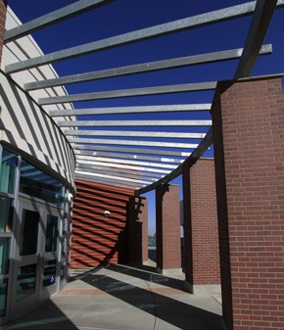
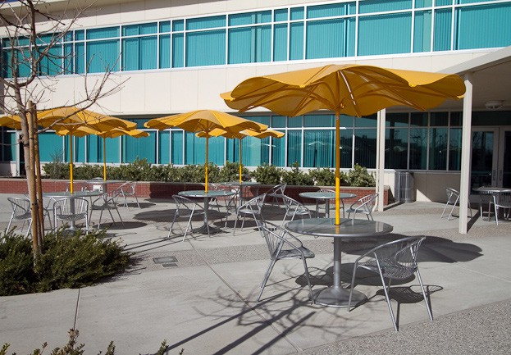
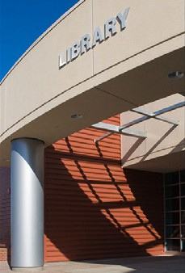

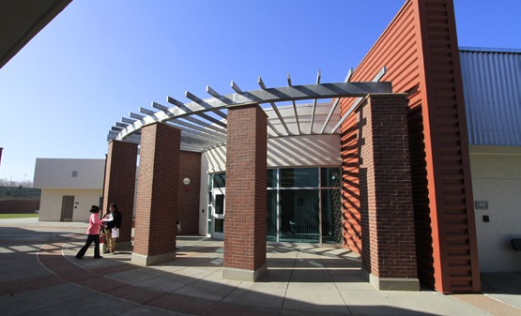
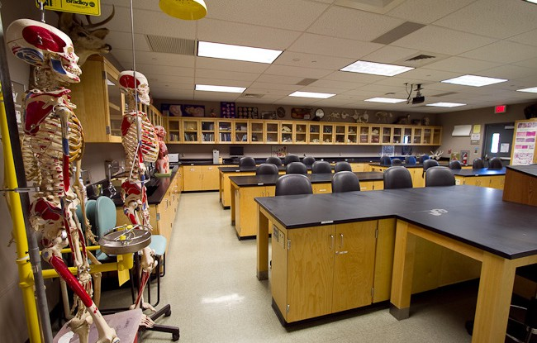
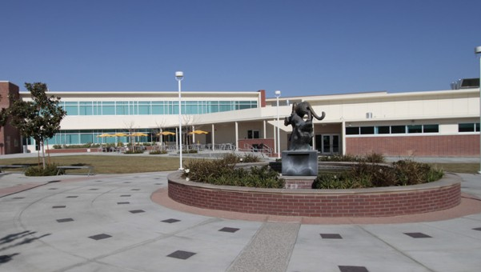
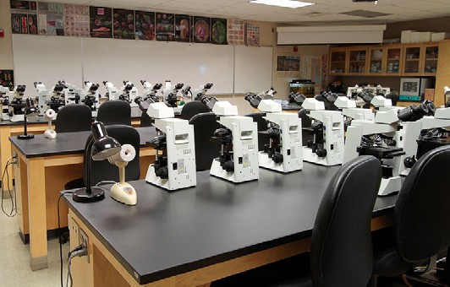
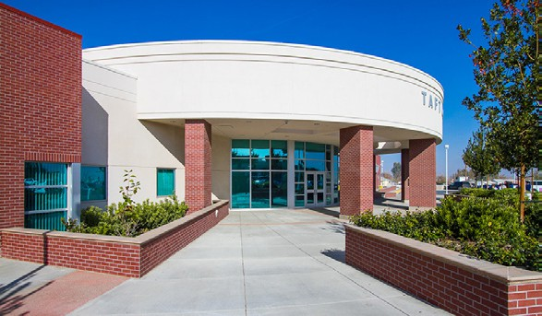
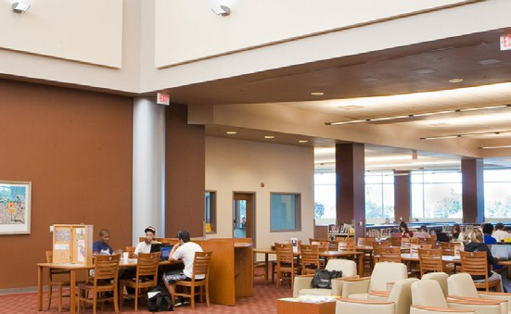

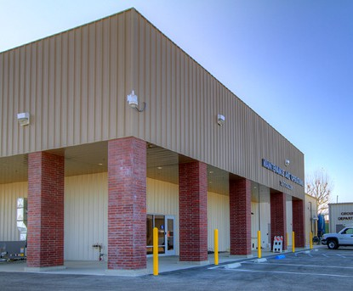
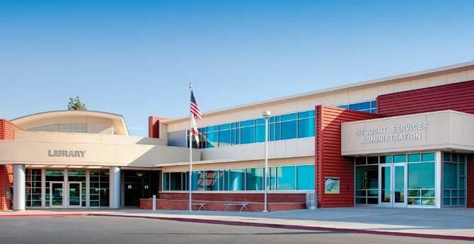
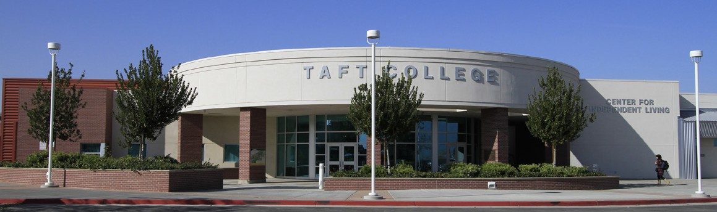
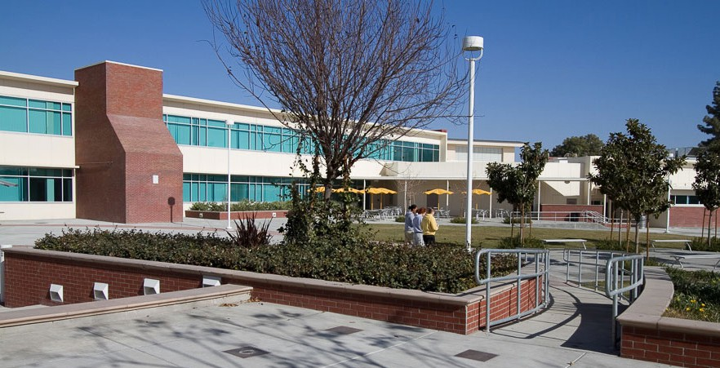

29 Cougar Court, Taft, CA 93268 661-763-7700 www.taftcollege.edu prepared by AP Architects

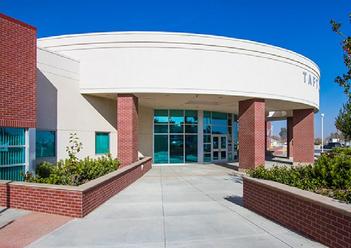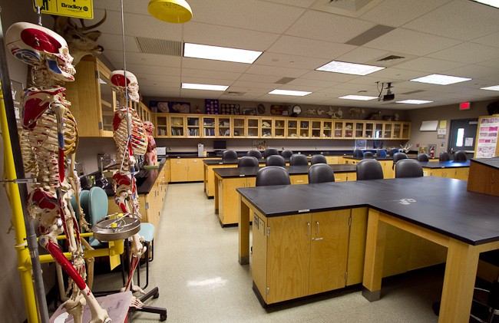

3

Table of Contents

- Executive Summary 5
- Background 7
  - Regional Data 7
  - Campus History 10
  - Campus Information 11
  - Geology and Hydrology 13
- Planning Considerations 15
  - Educational Master Plan 15
  - Enrollment Projections 18
  - Land Use 19
  - Vehicular Circulation 20
  - Pedestrian Circulation 21
  - Campus Life 22
- Outcomes and Solutions 23
  - Instructional Space 23
  - Non-Instructional and
Support Space 27
  - Land Use 32
  - Vehicular Circulation 33
  - Pedestrian Circulation 34
  - Campus Life 35
- Funding Requirements 37
- Continuing Items 39
- Appendix A—Existing Site Plan 41
- Appendix B—Proposed Master Plan 43

5

Executive Summary

West Kern Community College District is nearing the completion of a successful Capital Im- provement Plan. Measure A, a local Proposition 39 Bond, was passed in 2004. It’s value was
$39.8 million, and through leveraging funds, a total investment of over $100 million is being implemented at Taft College.
This plan is the next phase of growth of the campus. As successful as the previous bond was, the list of needs far exceeds available funding. A long range strategy and planning outlook has been completed. After closely coordinating with the Educational Master Plan, the Col- lege has extended the Facilities Master Plan out further.
Since a Campus Facilities Master Plan is a reflection of the academic and campus life endeav- ors of the institution, it is based on a series of assumptions and guiding principles. The plan illustrates that the College’s needs go far beyond what the 2004 Measure A bond is capable of producing. The College will continue to seek State funding as well as donations.
Many key indicators have been analyzed and when taken as a whole they become the Plan- ning Considerations that drive the decision making process. The campus community has been involved in the development of this Facilities Master Plan.

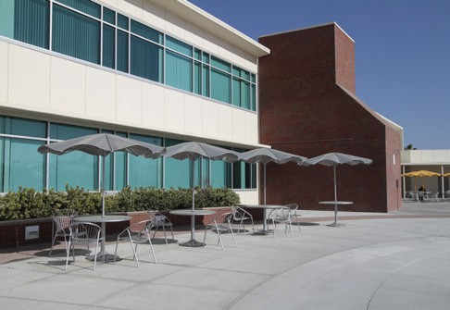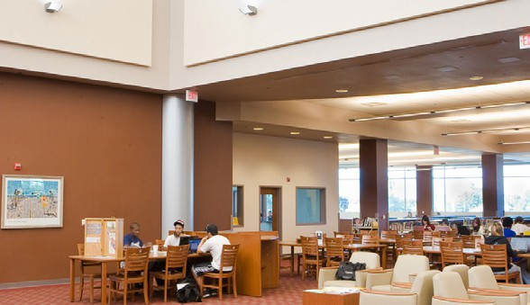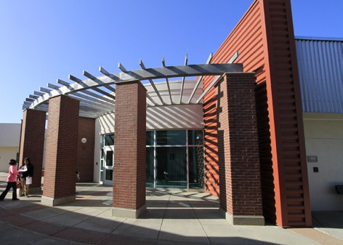

7

Background

Regional Data

City of Taft—Regional Context
Taft is a city in the foothills at the southwestern edge of the San Joaquin Valley, in Kern County, Cali- fornia. Taft is located 30 miles west-southwest of Bakersfield, at an elevation of 955 feet. The population was 9,327 at the 2010 census. According to the United States Census Bureau, the city has a total area of
15.1 square miles.
Most of the traffic traveling to Taft is along Highway 119. Highway 119 connects Bakersfield to Taft and also provides the connection to Taft from Interstate 5.
Taft is situated in a major petroleum and natural gas mining region in California. A large system of oil pipelines and drilling surrounds the town.

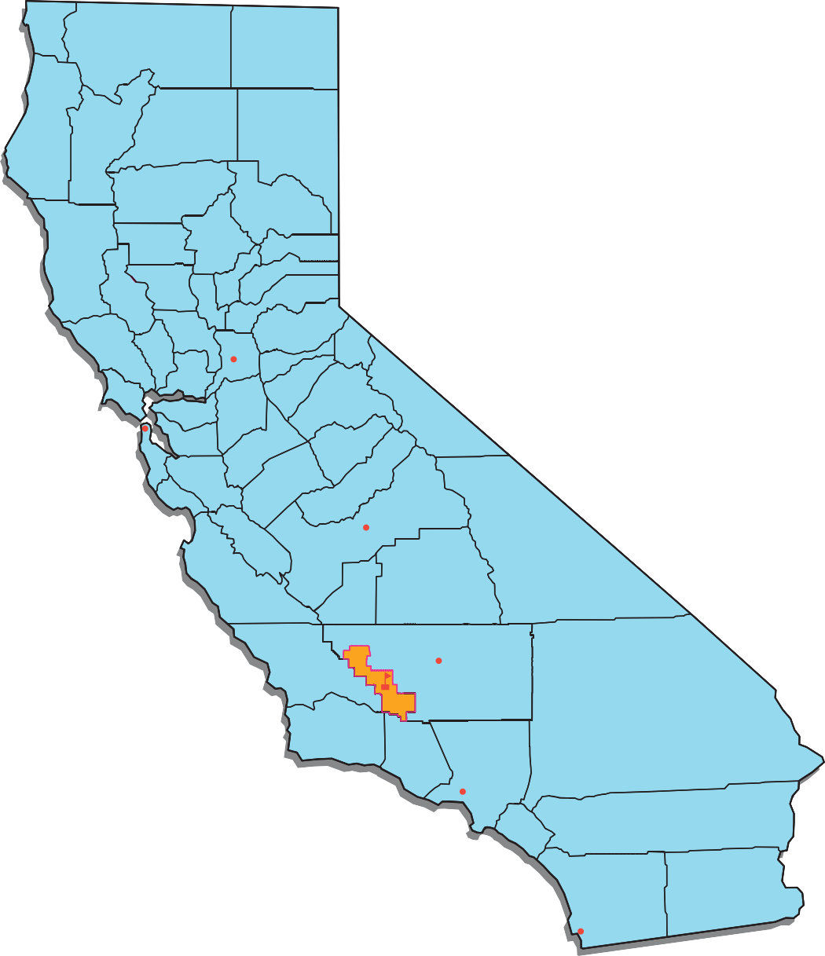

8 Facilities Master Plan Background

Sacramento

San Francisco

Fresno

Bakersfield

Taft College

Los Angeles

San Diego
@ College District Location in California

Background Facilities Master Plan 9

Taft College Area
Taft College is located in the western Kern County community of Taft and unincorporated Kern County with a population of 17,000. The surrounding area brings the total population to about 21,000. The com- munity is in the heart of the Midway-Sunset oilfield, one of the nation’s best producing fields. While oil is the leading industry, the area also is rich in agriculture, light industry, and recreation.
Taft College is located in the City of Taft. The dis- trict contains 735 square miles and is composed of the Taft City, Midway, McKittrick, Elk Hills
46

Lost Hills

33
46
Wasco

5

99

Shafter
elementary school districts Taft Union High School District and the Maricopa Unified Dis- trict.

KERN COUNTY
State Route 58
58
State Route 58
58
58

BAKERSFIELD
State Route 58

SAN LUIS OBISPO
5

33 119

TAFT COLLEGE

119
99

Lamont Arvin
State Route 99

Maricopa
5
99
Interstate Route 5
166



166

5

SANTA BARBARA COUNTY

VENTURA COUNTY
@ Regional Map

10 Facilities Master Plan Background

Campus History

History of Taft College
Taft Junior College was established August 30, 1922 as part of the Taft Union High School District. Classes were held on the high school campus. The school title officially became Taft College on July 1, 1954 and in September of 1956 a separate campus opened on Emmons Park Drive adjacent to the high school.
The West Kern Junior College District was formed in an election on June 19, 1962, and became opera- tive on July 1, 1963. Two years later the Maricopa Unified District was annexed to the West Kern Junior College District, and on July 1, 1971, the district’s name was changed to the West Kern Community College District.
Taft Community College is surrounded in property by a Taft Elementary School and Taft High School making the area a central teaching and learning hub for the community. The area also includes a Coun- ty Library, along with coffee shops and neighborhood shopping areas. The Historic Fort to the west of the Campus offers the neighborhood views reminding the area of Taft’s rich history.
The West Kern Community College District encompasses a 767-square-mile district in western Kern County. The Taft College campus is located at 29 Cougar Court and serves more than 2,400 full-time equivalent students on its campus. Campus buildings are considered excellent structures with adequate space provided for physical education, recreation and athletics.

Background Facilities Master Plan 11

Campus Information
The campus was built in 1956 and originally included classrooms, a library, student union, and admin- istrative offices, marking the first step in separating the college from the high school. A physical educa- tion building was completed in 1956, but was converted in the Student Services Center in early 1977 to centralize all student personnel services in one location. The science building was completed in 1966, the technical arts facility a year later, and the vocational and technical education center in 1969.
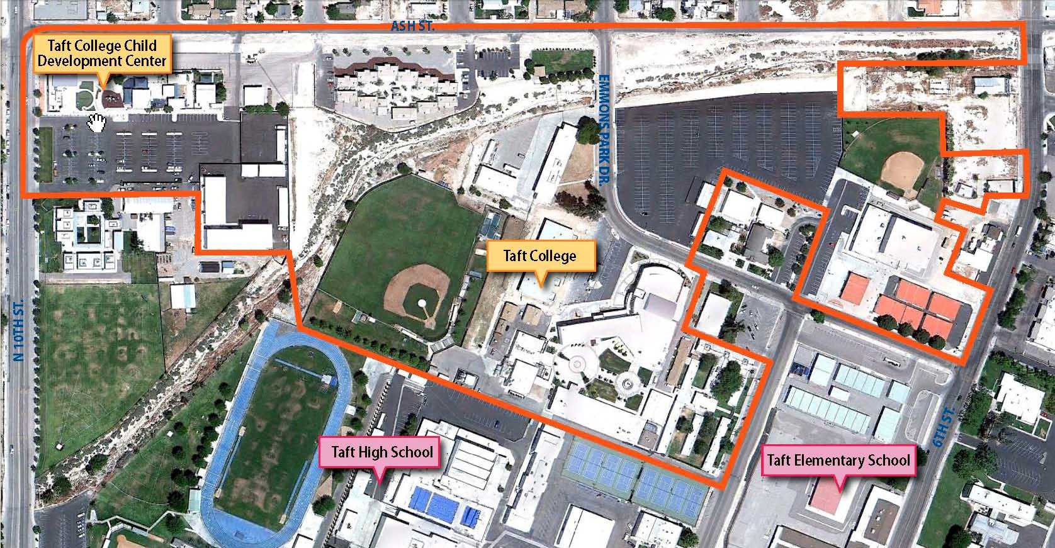

12 Facilities Master Plan Background

A 36-student addition to the campus residence halls, lighted tennis courts, and a women’s softball field were added in 1978. Three years later a sports center designed to accommodate physical education classes, athletics, and community services programs was finished. An 80-student residence hall opened in 1983 and brought the total campus capacity to housing 200 students.
Many of the college’s occupational programs are headquartered in an off-campus training center called North Kern Training Center conducted by WESTEC (Westside Energy Services Training and Educa- tion). The facility is headquarters for a nonprofit corporation established to work with the college in providing a variety of services to the oil industry in Kern County and the western United States. The Center at WESTEC expanded during 2001 when the college purchased a vacated elementary school north of Bakersfield. This expansion saw the college partner with Bakersfield College to provide in- creased offerings in petroleum technology as well as the growing correctional officer training program.
The Child Development Center was completed in April of 1991 to meet the needs of college students with young children, and to provide a community children’s center. In 2007 a new Child Development Center Facility was completed with the help of Measure A and General Obligation Bonds replacing many of the dated modular trailers. The Child Development Center has grown to become one of the largest child development centers in the region.
A 6,500-square foot dental hygiene complex that includes offices, classrooms, and a clinic was com- pleted in 1993 when the college launched what has become one of the most highly regarded dental hygiene programs in the state.

Background Facilities Master Plan 13

Geology and Hydrology
The existing campus is located on an area of local geology comprised of collapsible soil. Due to the prox- imity of Sandy Creek, the drainage creek along the northern area of campus, there are several issues to be mitigated. These can be summarized in two main areas. First is a low structural capacity of existing soil to accept structural footing loads. Second is that any water contact with the soil decreases its load carrying capacity.
Differential settlement, which is uneven and unpredictable movement of random building components, is always present in soil conditions such as this. This can be seen as above-normal cracking both in
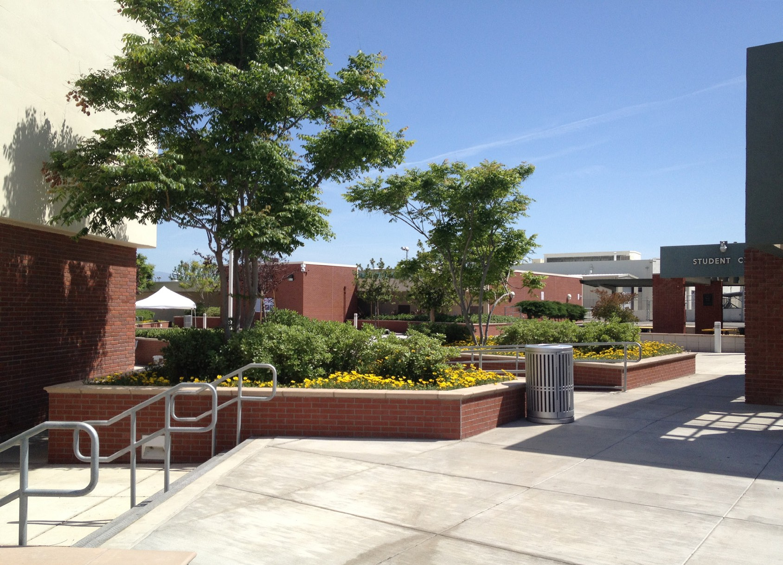
buildings and site improvements as different parts of building and site work settle at different rates and in different directions.
The only effective mitigation for these soil con- ditions is to eliminate water intrusion to the soil. This is very costly and can be unattractive if not considered carefully. Work done during the Measure A program determined campus stan- dards in regards to special piping and drainage around buildings. Also completed at this time was the architectural development of campus landscaping and site improvements to contain water and divert what minimal irrigation water is done.

15

Planning Considerations

Educational Master Plan
The Facilities Master Plan draws directly from the Educational Master Plan and the college’s integrated planning process. Overall drivers are not only the Space Needs Forecast section, but also the general direction and fullness of campus life, together with the Taft College Vision, Mission and Values. The following are general needs and recommendations that directly or indirectly relate to facilities and are taken straight from the Educational Master Plan:

Priority Needs:
- Better public transportation between Bakersfield and Taft.
- More property for Taft College—land locked.
- Explore expanding the cohort model for more programs.
- Block scheduling with 2-year plan, with MW, TTh standard time blocks.
- Facilities: event space, large assembly room.

16 Facilities Master Plan Planning Considerations

Additional Needs:
- More parking at Taft College.
- Internet access / infrastructure.

Recommendations—Facilities and Infrastructure
- Analyze current facilities usage for efficiency and maximize use of existing space.
- Overcome lack of physical space and land:
  - Explore purchasing / donation of land (off campus) to support educational programs.
  - Explore concept of shared space with educational / business partners.
  - Explore with business and industry, opportunities to partner on development of facilities and equipment to support educational programs.
- Ensure Facilities and Technology Master Plans are informed by the Educational Master Plan.

The following general recommendations were generated by the Educational Master Plan and are con- tinuously being implemented by Facilities Planning:

Lecture / Laboratory Differentiation
Some campus spaces are, by nature, multi-purpose and will be used as lecture classrooms AND for laboratory sections. The College should however, avoid using specialty laboratories for lecture classes. A wet lab, for example, should not be used for the lecture portion of a class. These labs are quite expensive to build and should be used as much as possible for what they were designed for.

Quality of Academic Space
This analysis provides only a quantitative look (total square footage) at campus space in each cat- egory. It does not consider the quality of the spaces. The design, layout and condition of the campus facilities are of equal importance. When updating the Taft College Facilities Master Plan, careful consideration should be given to these questions.

Planning Considerations Facilities Master Plan 17

For example, modular buildings being used for classrooms, laboratories and offices might not pro- vide the ideal teaching/learning environment. These buildings should be considered for removal and replacement. Appropriate room sizing should be analyzed as well to ensure the most efficient use of the facilities. The College currently lacks a large lecture hall and adequate meeting spaces. The next Facilities Master Plan update should also consider room equipment, furnishings and other finishes that have a significant impact on student learning.

Space Inventory
Taft College conducts a full update of its Space Inventory Report annually. This is a report that is filed with the State Chancellor’s Office, that lists all of the campus facilities space with appropriate space category coding. This report is used by the Chancellor’s Office to determine if a College has sufficient space or has some additional needs. This determination has a major impact on awarding State facilities funding.

Room Utilization
The College should undertake a room utilization study to determine how efficiently its classrooms and laboratories are being used. This study would analyze how many hours the rooms are used throughout the week, as well as what percentage of the rooms’ capacity is being filled.

18 Facilities Master Plan Planning Considerations

Enrollment Projections
Enrollment data is not only provided by the State Chancellor’s Office Long-Range Enrollment Fore- cast but also adjusted by locally available data. Generally, the long-range outlook is that the college is growing steadily. For the purposes of facility planning however, it is not the actual, precise target that is important but rather the overall trend. It is not important that either the exact number of students or correct year that growth will hit but only that the college is prepared both academically and physi- cally to respond to the need; trying to predict an actual amount and time would be impossible. It is much better to expect a range of possible outcomes and be prepared to react to actual data. Refer to the following chart from the Educational Master Plan to see the overall growth direction and ranges of possibility (Chart 1):
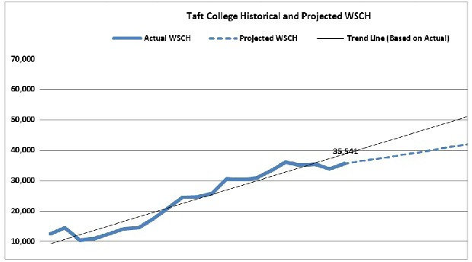
These enrollment projections are directly related to the campus eligibility for future projects. They are compared to the space that exists on campus to determine a ratio between existing space and needed
Taft College Historical and Projected WSCH
60,000
50,000
40,000
30,000
20,000
10,000
0
YEARS
Actual WSCH
Projected WSCH
Linear (Actual WSCH)

Chart 1
WSCH
1988
1989
1990
1991
1992
1993
1994
1995
1996
1997
1998
1999
2000
2001
2002
2003
2004
2005
2006
2007
2008
2009
2010
2011
2012
2013
2014
2015
2016
2017
2018
2019
2020
2021
2022
2023
2024
2025
2026
2027
space. This is called a Capacity / Load Ratio and is used as a filter for possible state fund- ing. Numbers below 100% show that additional space is needed; numbers over 100% indicate an overbuilt condition and that no space is needed. Currently the campus has a need in most all cat- egories but again, a precise snapshot is not as helpful as is the fact that the campus is growing.

Planning Considerations Facilities Master Plan 19

Land Use
In general terms, other than specific instructional related program data, most facility related comments from the Educational Master Plan are related to Land Use. Land use comments may be split between one of two categories, either parking related or acquiring additional property for educational development.
Parking is the most easily understood of the land use comments. Any visit to Taft College will demon- strate the need for additional parking. Most recently, the growth of the college has spilled vehicles into neighboring areas. Parking is difficult to model and predict for an adult student population such as a college. Much of the flow is dependent on both duration and timing. These can not only be problematic to predict but are also changing seasonally and annually. Students are a mix of full-time and part-time which impacts their duration on campus as well as their arrival and departure schedules. For example, many students will take only one on-campus class each semester yet will still consume a single parking spot; conversely a full-time student might take 15 or more units but only require the same single parking spot. After taking historical data and blends into consideration, a parking forecast indicates that addi- tional parking is required on campus.
Additional property for campus expansion of operations is also obvious. Growth in either building space or physical education outdoor space cannot be accommodated within the existing campus foot- print. However, both of these uses are in need of additional space which also triggers increases in sup- port space such as even more parking.
Land Acquisition Analysis
Item (*) | Name
1 | Field Sports
2 | Student Housing
3 | Offsite Industry
4 | Student Services Exp.
5 | Library Expansion
6 | Parking Expansion

(*) Not priority list

20 Facilities Master Plan Planning Considerations

Vehicular Circulation
Previously, Emmons Park Drive was a city through street that divided the campus longitudinally. It has recently been intentionally closed and renamed Cougar Court. It is now the main campus entrance from the east and opens into an institutional circle drive. The opposite, north-west, end has been ter- minated into a parking entrance directly from the north. These changes have eliminated through traffic and made a much safer separation of vehicles and pedestrians. Other campus uses have individual ac- cess points from perimeter streets and drives.
On campus vehicle circulation is not available to the public. There are portions of fire lane access drives
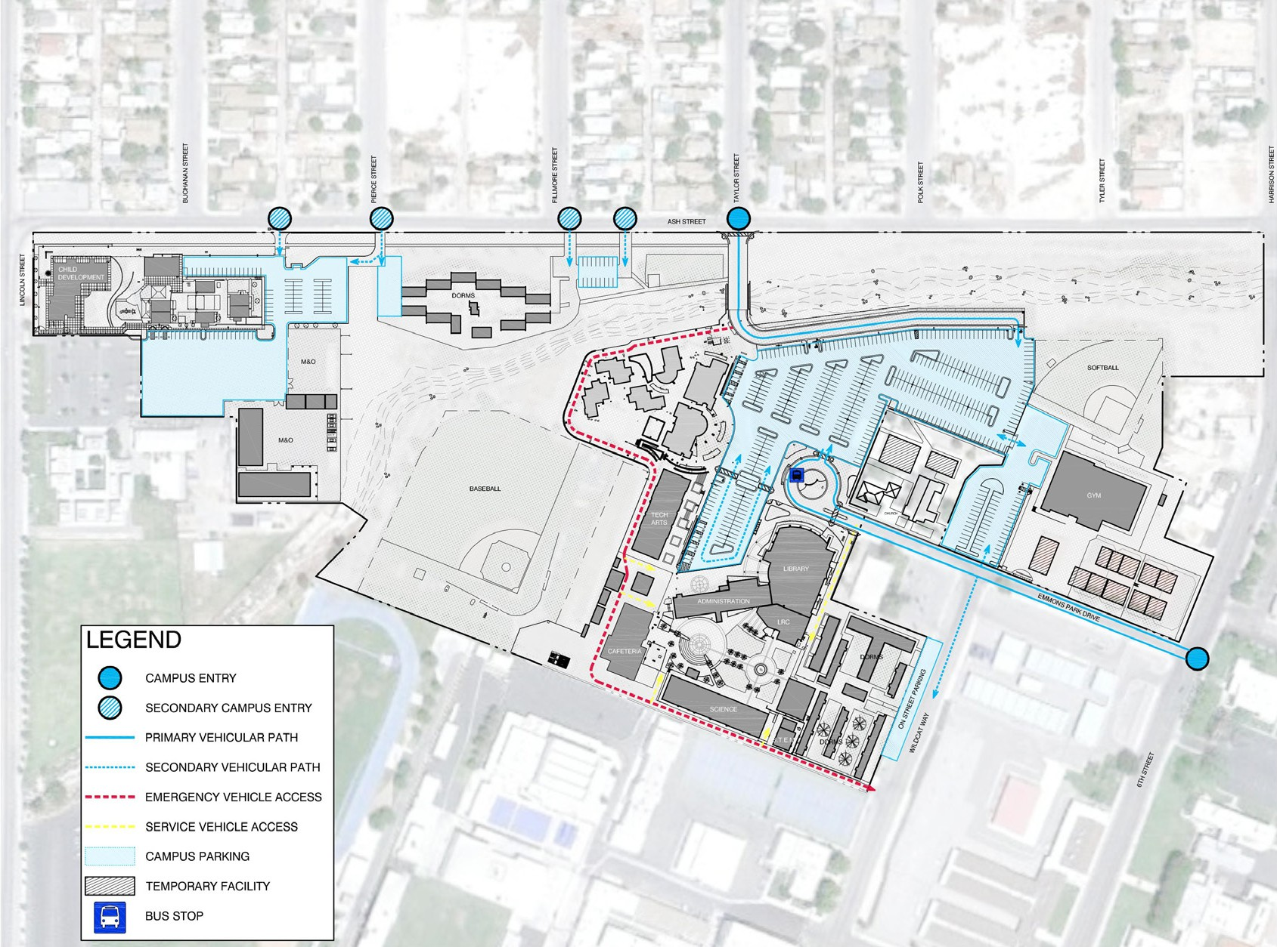
that are only shared by emergency use and campus maintenance vehicles as well as short term deliveries. There are several other specific parking areas that serve individual uses such as Child Development, Maintenance / Operation and student housing spaces.
There does not yet exist any connection from these areas back to the central portion of the campus. In fact, they are divided by a drainage creek that generally runs from east to south- west along the northern portion of the cam- pus. Campus operation would be much more efficient with a vehicular connector from these areas back to the main portion of campus.

Planning Considerations Facilities Master Plan 21

Pedestrian Circulation
Due to the existing geology and soil subsidence issues on campus, there is minimal green lawn spaces. These are traditionally the main areas on a higher education campus to designate open and free student surfaces. However, due both to local and state-wide water restrictions, a drastic reduction in green spaces, such as lawns, is now becoming the norm.
At Taft College, pedestrian spaces take on a more prominent role in encouraging campus life. Many spaces have been created in and around the campus to encourage a student friendly atmosphere. These
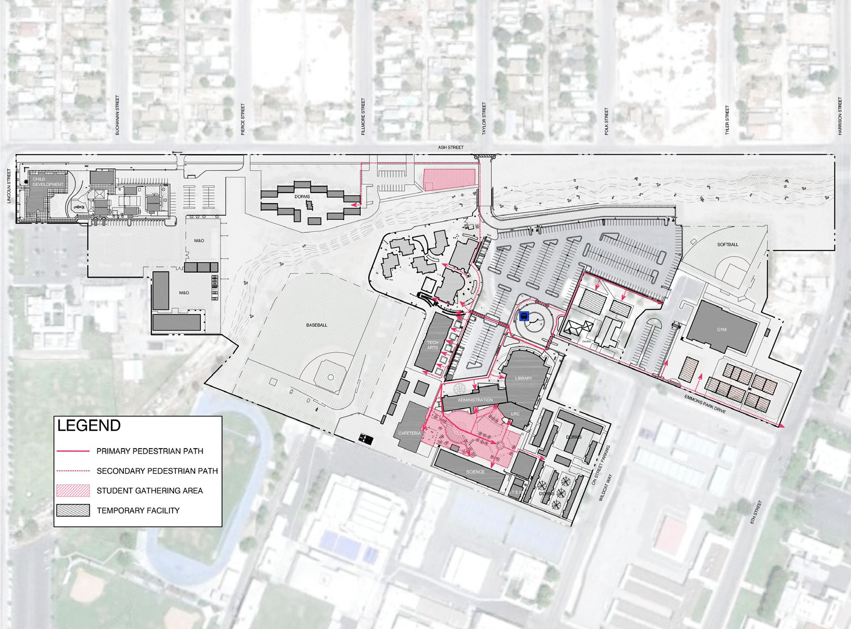
have incorporated both raised and submerged planters, differing heights of built improvements and intentional layout and development of ar- eas that would not otherwise have been given the attention or the importance. As the campus continues to develop, special attention should be given to not only continuing the existing pedes- trian spaces but to search out additional oppor- tunities for expansion.
Pedestrian circulation around the campus has well defined, accessible paths of travel to most areas. Since there are several access points around the campus, care should be given to consolidating the pedestrian identity and usage of them. As of now, there is not a path across the creek. However, as consideration is being given to vehicular connections across the cam- pus, pedestrian links should be expanded also. Improvements to these routes should be done at appropriate intervals within the overall schedule for campus maintenance and development.

22 Facilities Master Plan Planning Considerations

Campus Life
Taft College has a vibrant learning and support setting for students enrolled at the campus. There is a spirited campus life enjoyed through athletics, student leadership and various student groups to name just a few of the many extracurricular activities available to students. There is a higher education atmosphere that is felt through a balance of open and intimate spaces throughout the campus. A major contributor to this feel is the fact that Taft College has residential students in on-campus housing. This creates an ownership feel of the campus as well as 24 hour presence to campus life.
A main consideration when developing a Facility Master Plan is to not only maintain a campus culture that encourages and invites learning, but to enhance the out of classroom learning opportunities for students as they pursue their higher education goals. The look and feel of the campus facilities are important components of the higher education environment and play a key role in complementing a student’s collegiate experience.

23

Outcomes and Solutions

Instructional Space

Vocational Center, Technology Center, Instructional Center
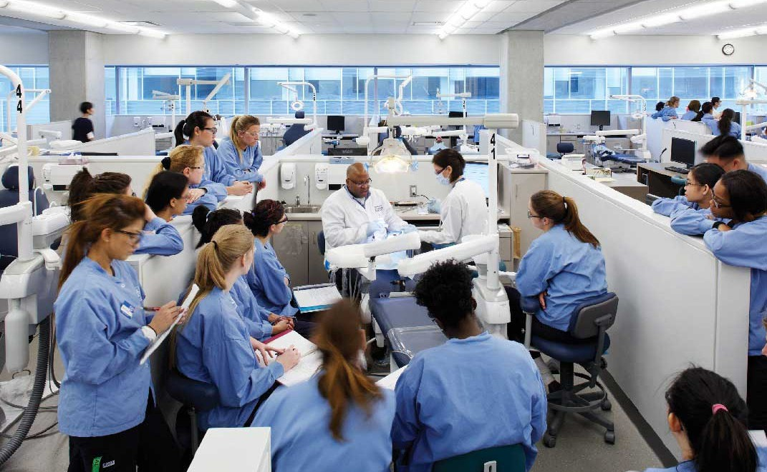
These purely instruction related buildings will be entirely new construction and respond to the needs of additional lecture and teaching laboratory spaces. Each project will be similar in that they will contain a mixture of classrooms, labs and related office and support spaces.

‚ Representative view of planned space.

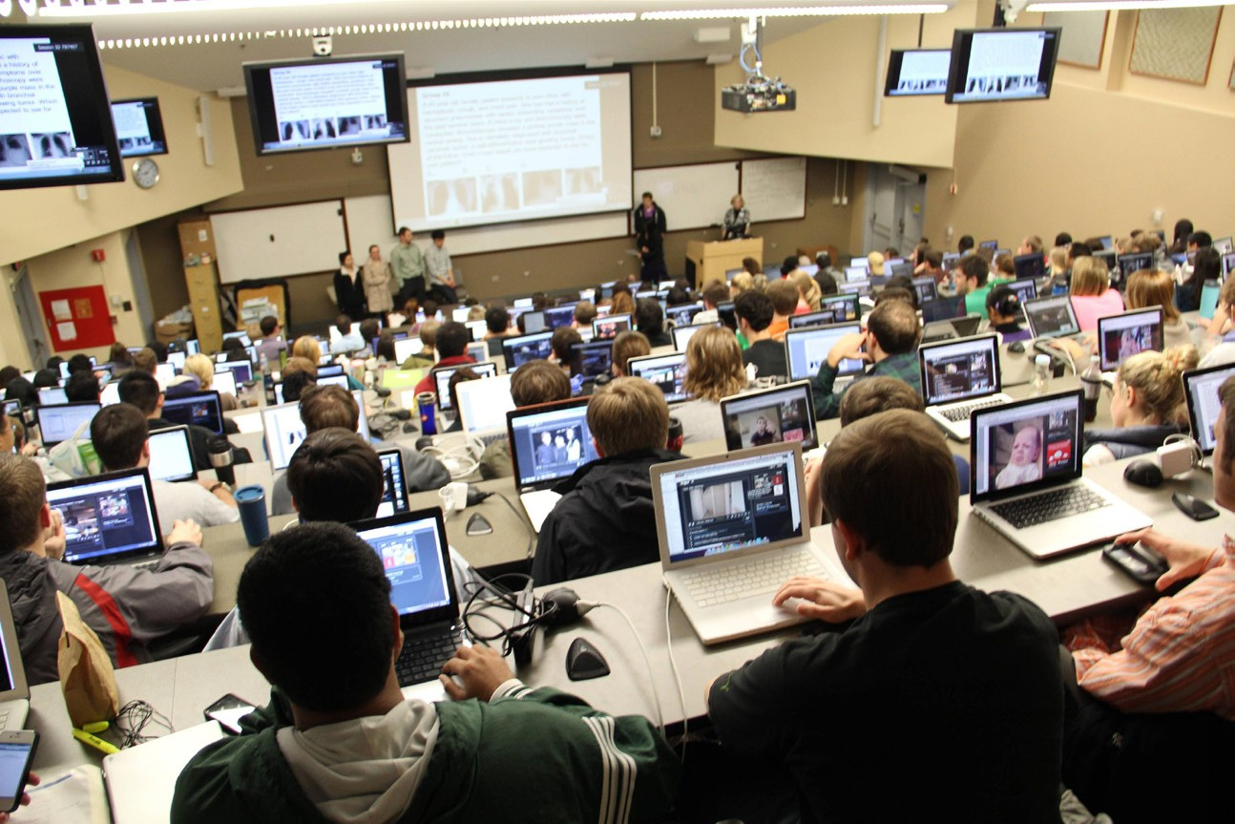
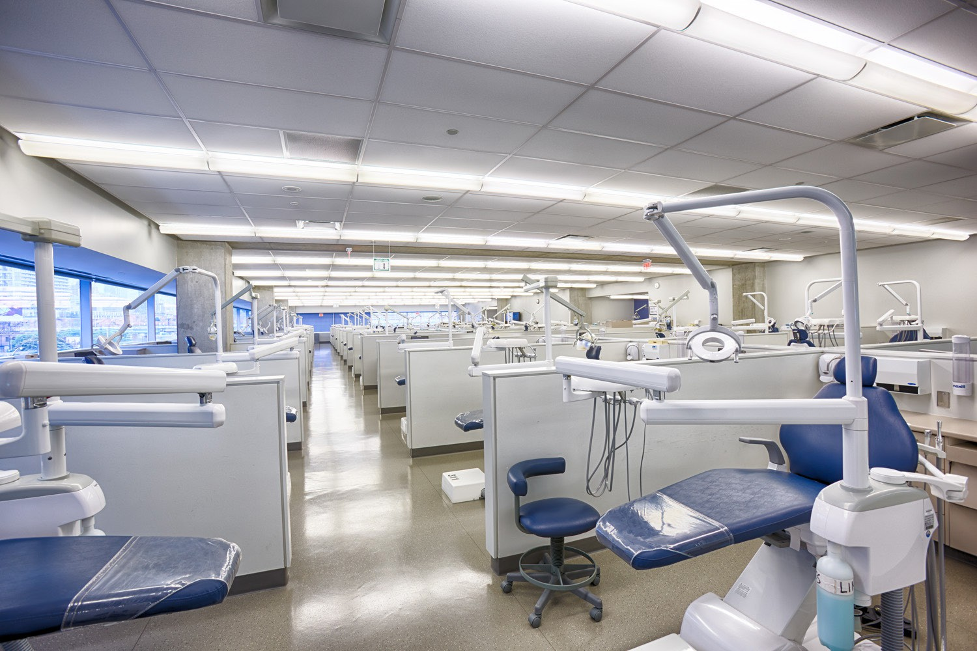
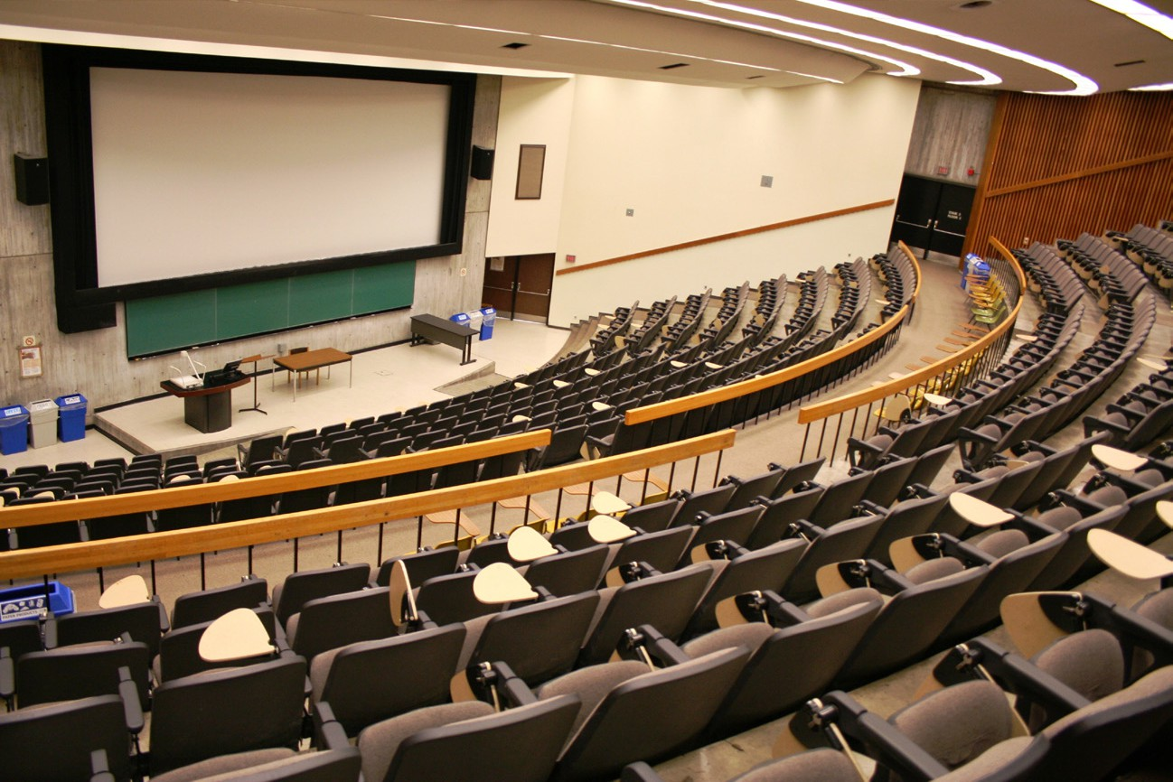

24 Facilities Master Plan Outcomes and Solutions

Their final square footage size and content will be determined by the funding eligibility and amount of space that the college will qualify for. Initial uses will be to eliminate the last remaining temporary spaces that exist on campus; for example, Dental Hygiene. The proj- ects will be staggered in their development to allow for scoring to be maximized as the campus continues to grow.

‚ Representative views of planned spaces.

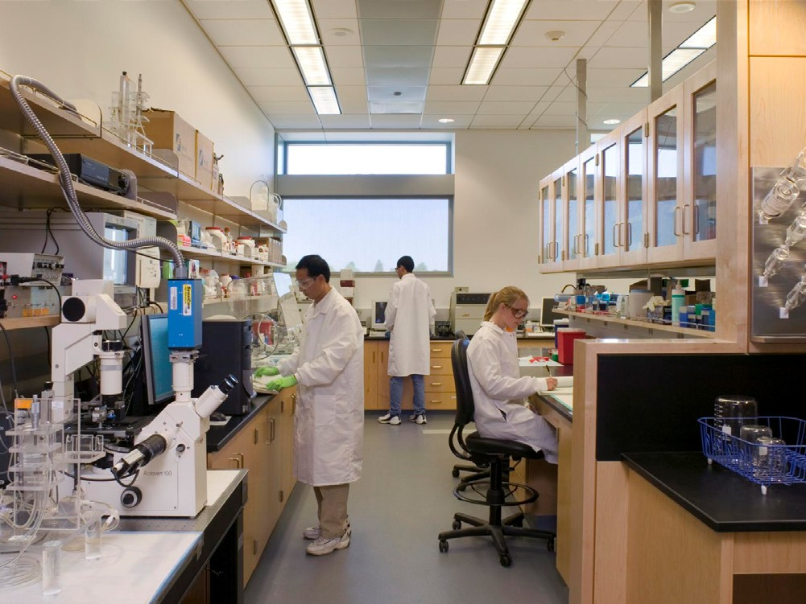


Outcomes and Solutions Facilities Master Plan 25

Science Expansion, Community Science Center
These science-related teaching laboratory buildings will be entirely new construction and add space to the existing STEM (Science, Technology, Engineering, Math) pro- grams on campus.
‚ Representative views of planned spaces.

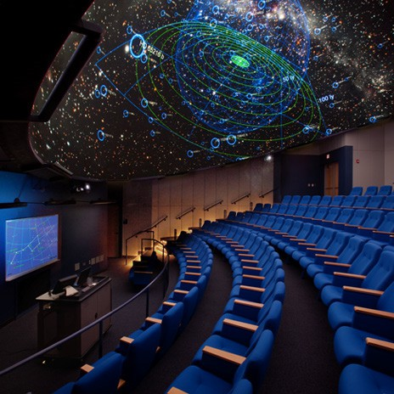
A key component of the Community Science Center will be public and children special events. Several ideas are being considered including a planetarium or other such space.

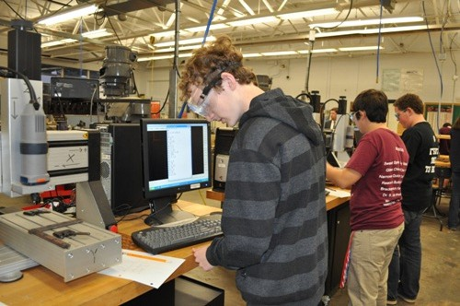
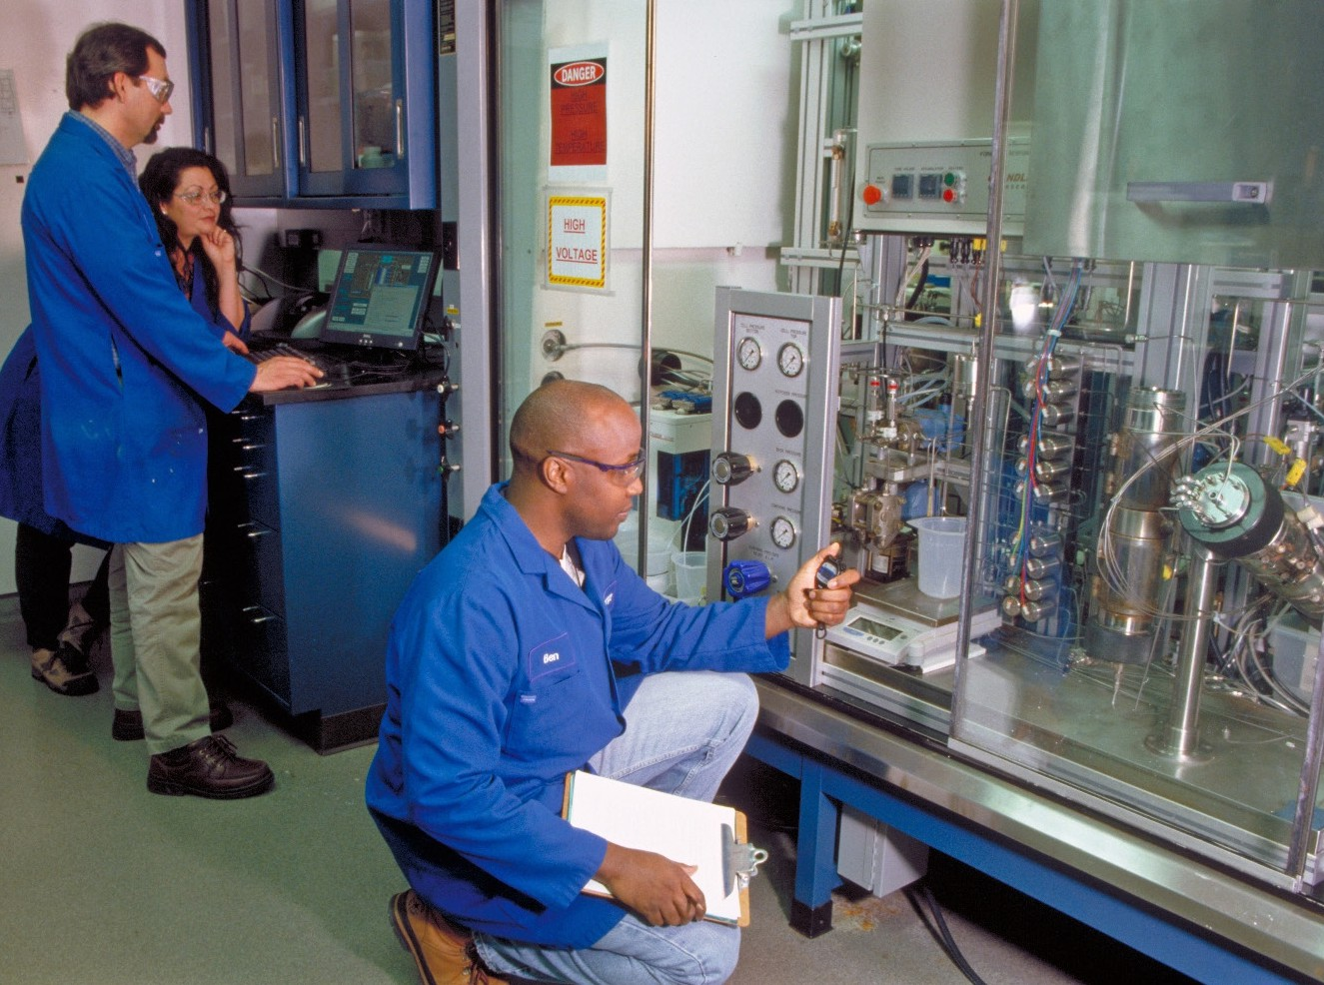
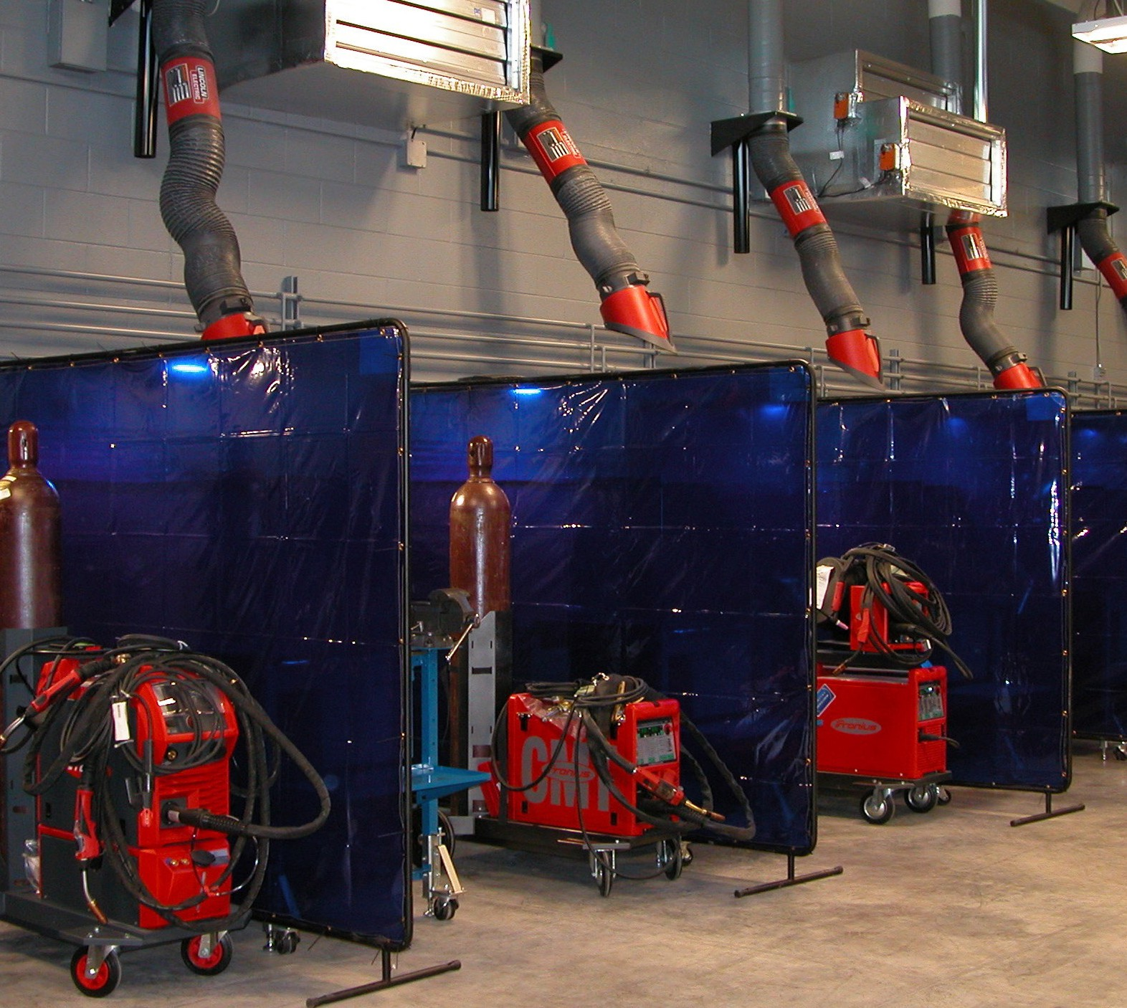

26 Facilities Master Plan Outcomes and Solutions

Offsite Industry Education Center
This project will replace and grow existing spaces that are career technology oriented and also provide safety training. Currently, the programs are delivered in spaces that are offsite but in buildings that are not ideal for instruction.

‚ Representative views of planned spaces.

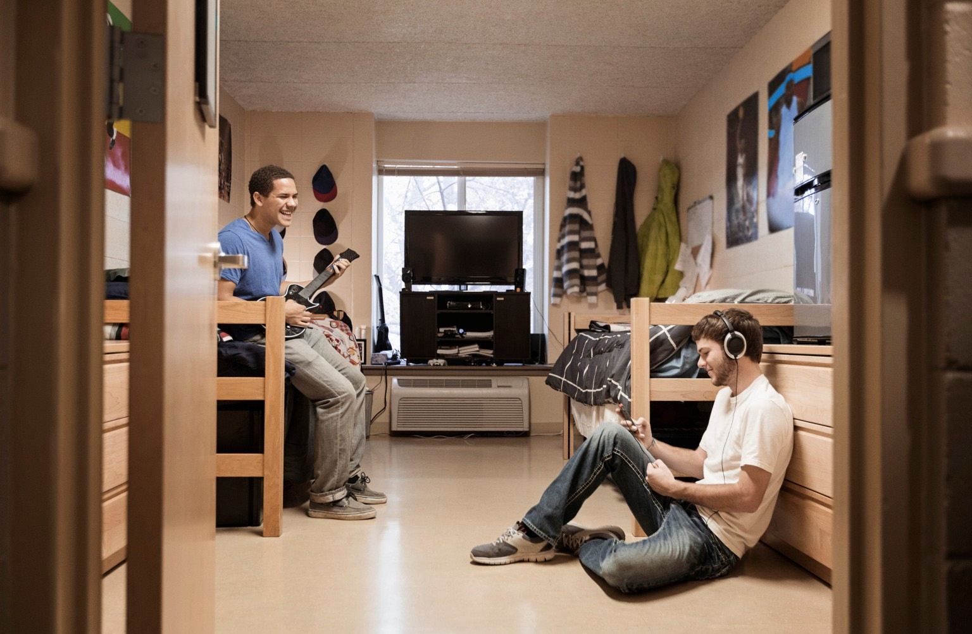
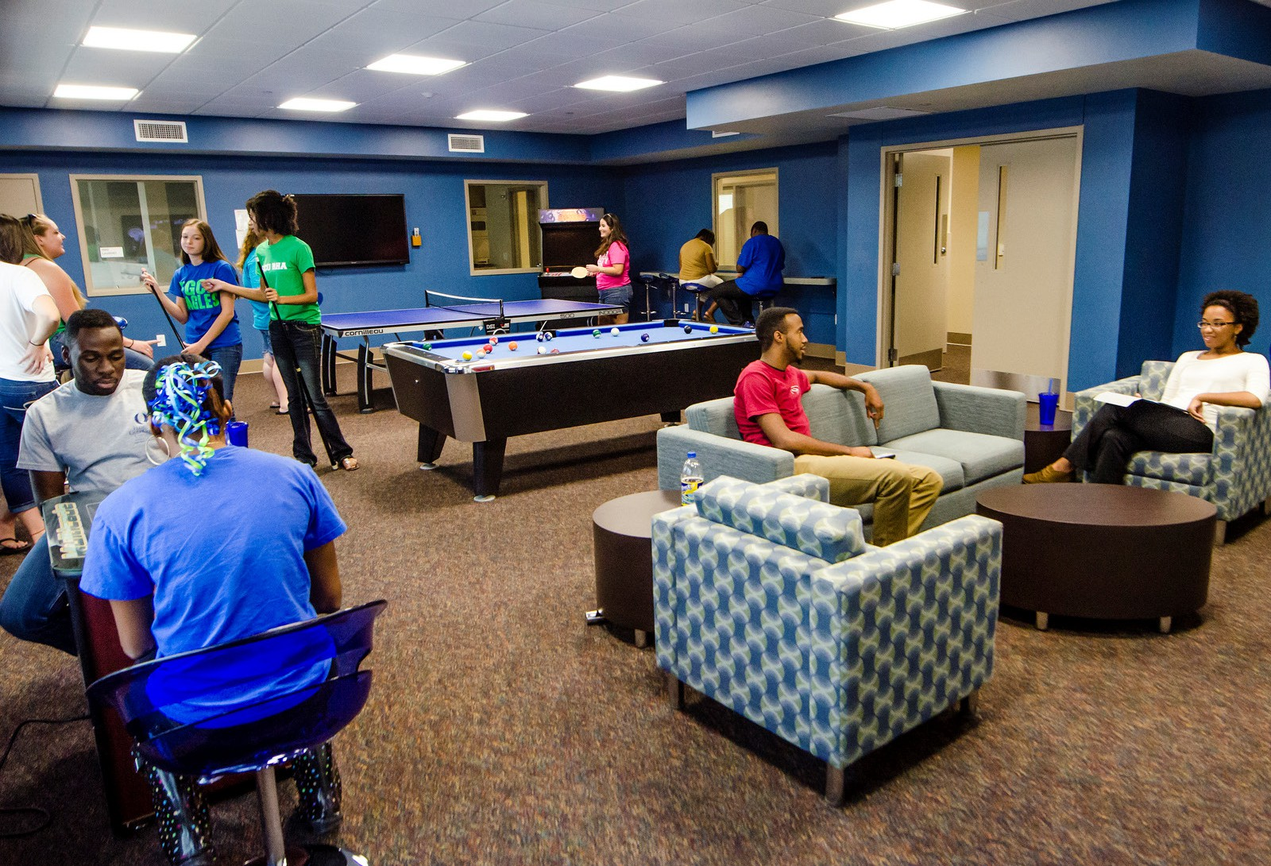
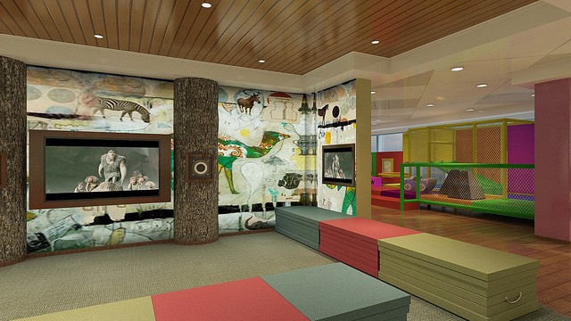
Outcomes and Solutions Facilities Master Plan 27

Non-Instruction and Support Space

Student Housing
This project will replace the existing student housing spaces at an off- site location adjacent to the campus. Parking will be added to support the housing units and circulation connecting back to the campus will be strengthened. The facility will be sensitive to the existing residential neighborhood.

‚ Representative views of planned spaces.

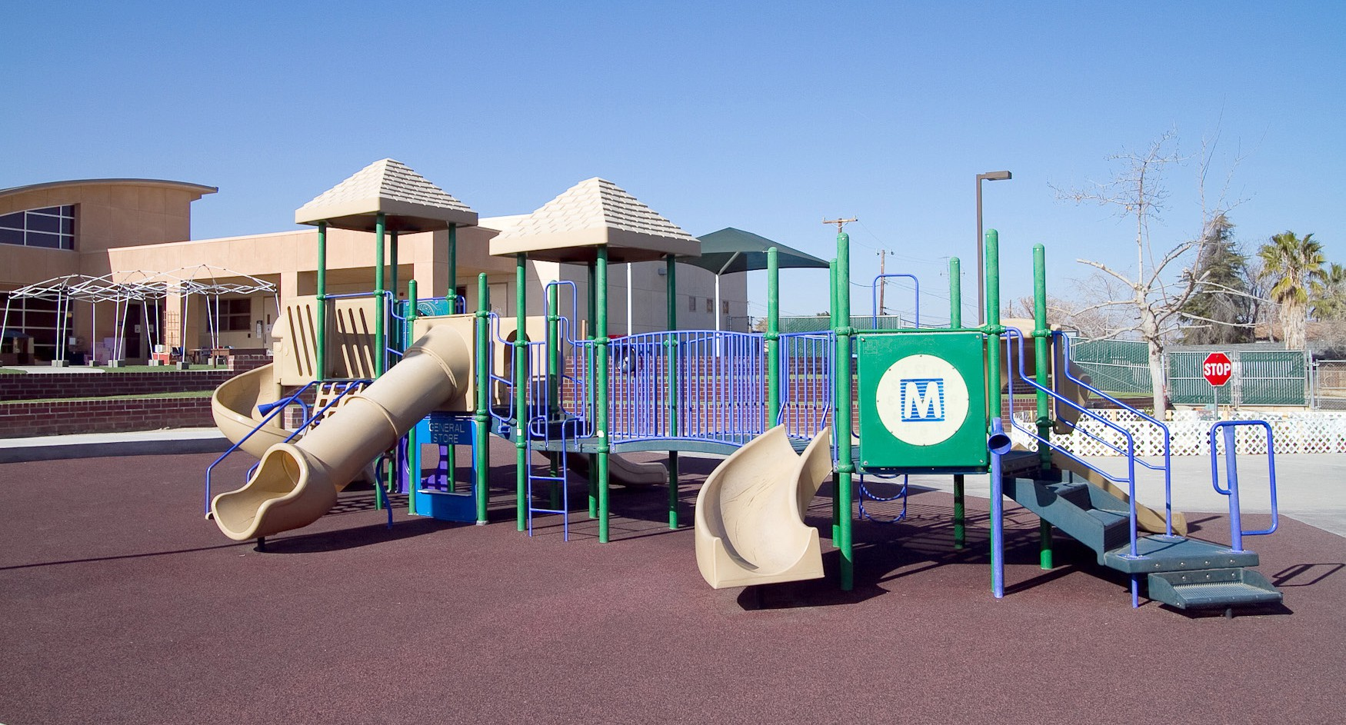
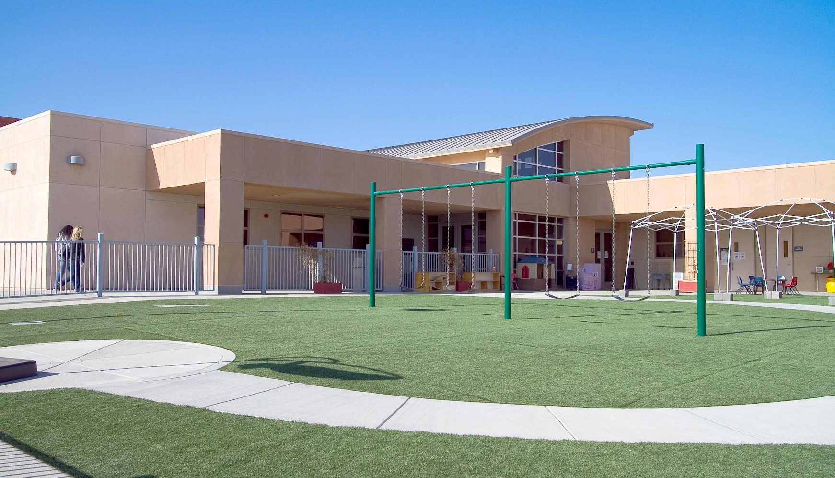
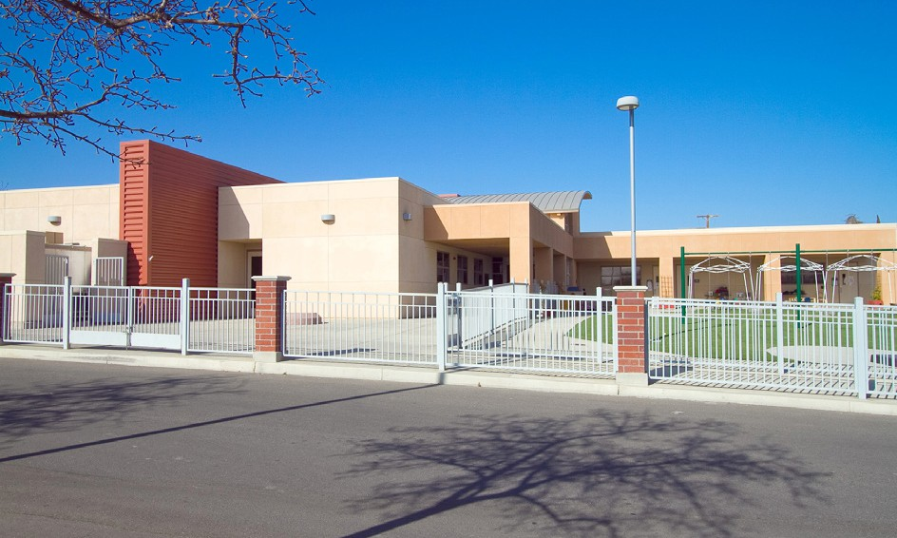
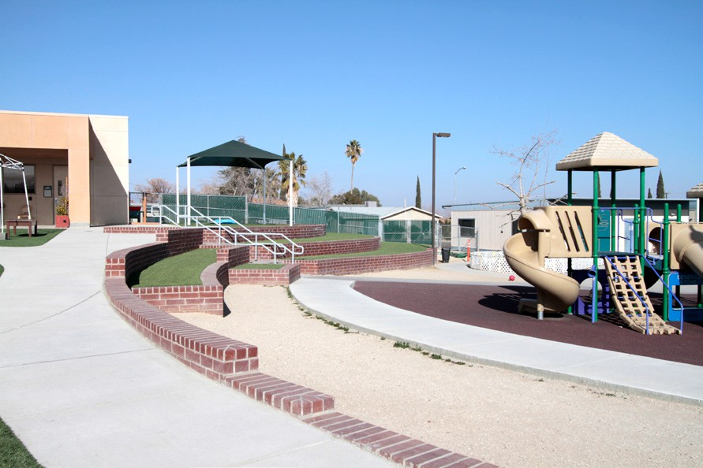
28 Facilities Master Plan Outcomes and Solutions

Child Development Center:
This project will replace the last remaining temporary facilities at the existing Child Development Cen- ter (CDC). In 2007, approximately half of the temporary buildings were replaced with the initial con- struction of the main permanent building and related playground outdoor space.

‚ Photos from existing TC Child Development Center.

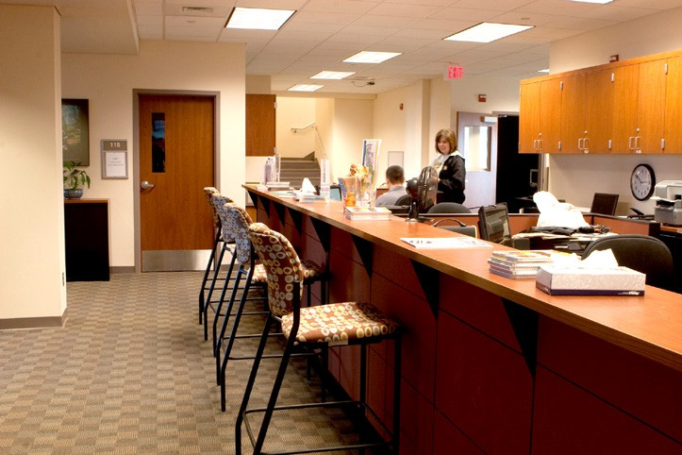
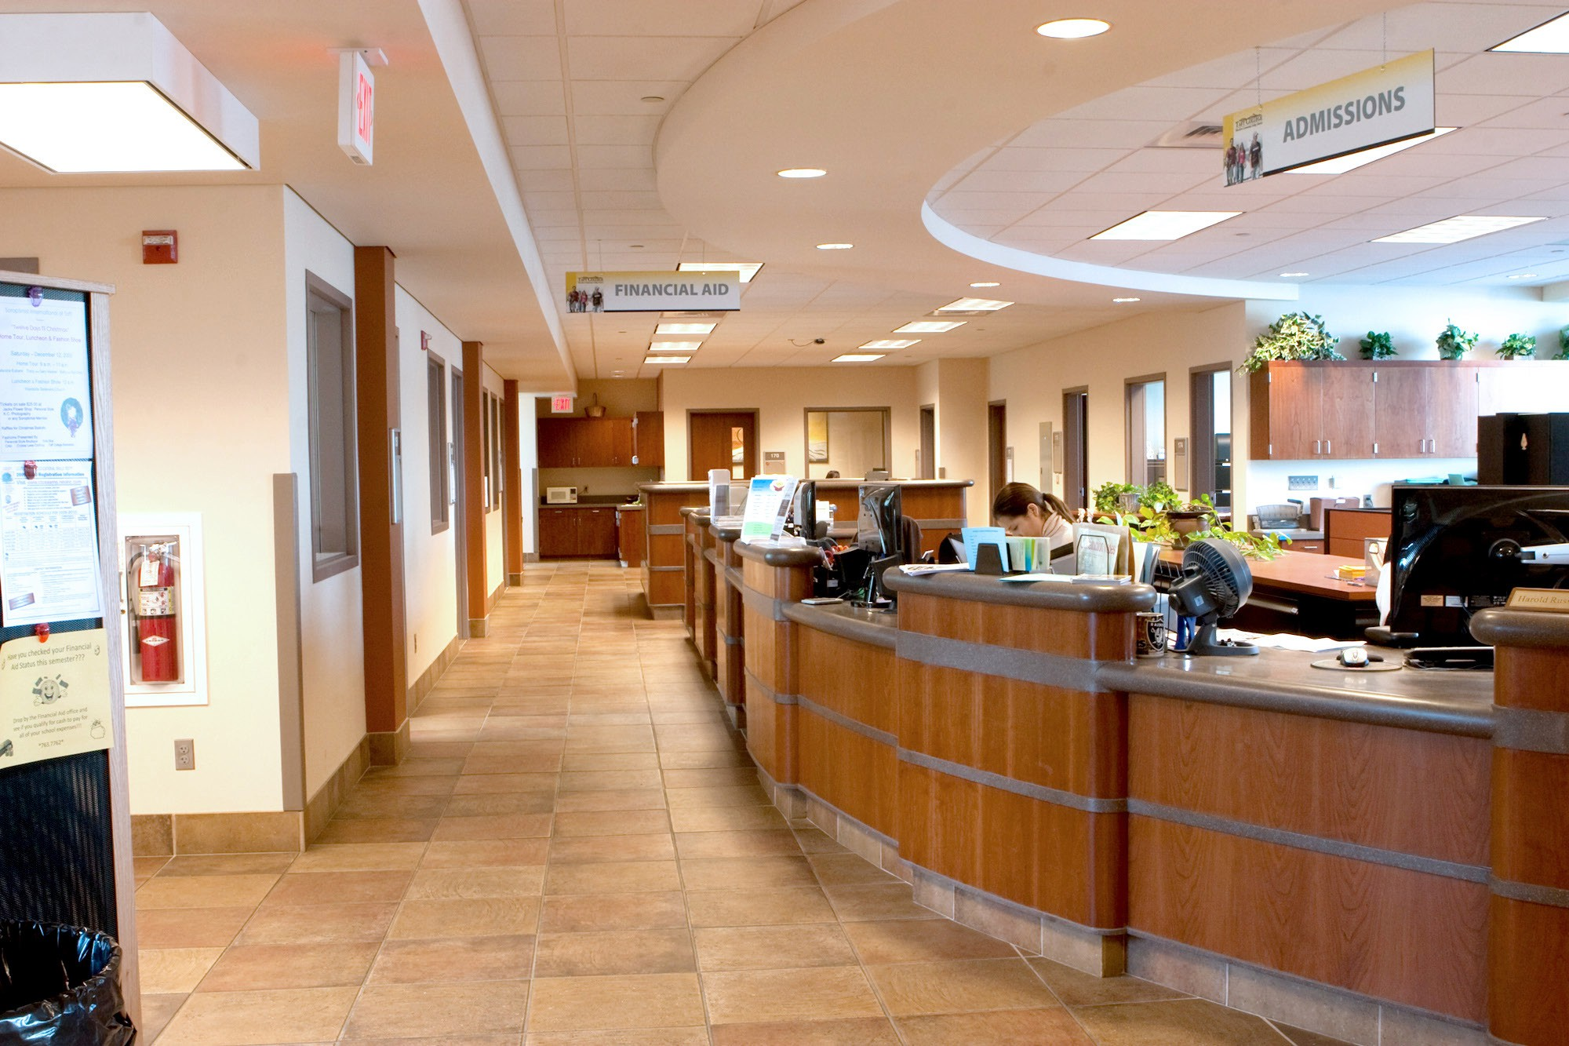
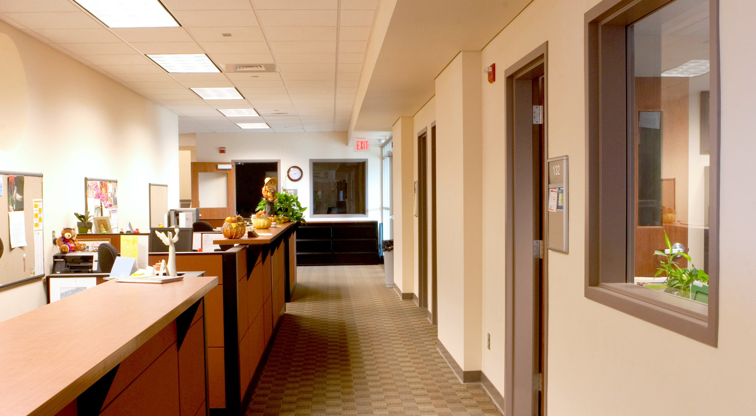
Outcomes and Solutions Facilities Master Plan 29

Student Services Expansion
This project will expand the existing Student Services spaces on campus. The first phase of Student Ser- vices consolidated and centralized the various programs into the first floor of the main building. Con- tinued growth of the campus has increased the programs far beyond the original solutions. This project will either consolidate programs into the entire main building and relocate other uses elsewhere or move Student Services out of the main building into their own space.

‚ Photos from existing TC Student Services.

30 Facilities Master Plan Outcomes and Solutions

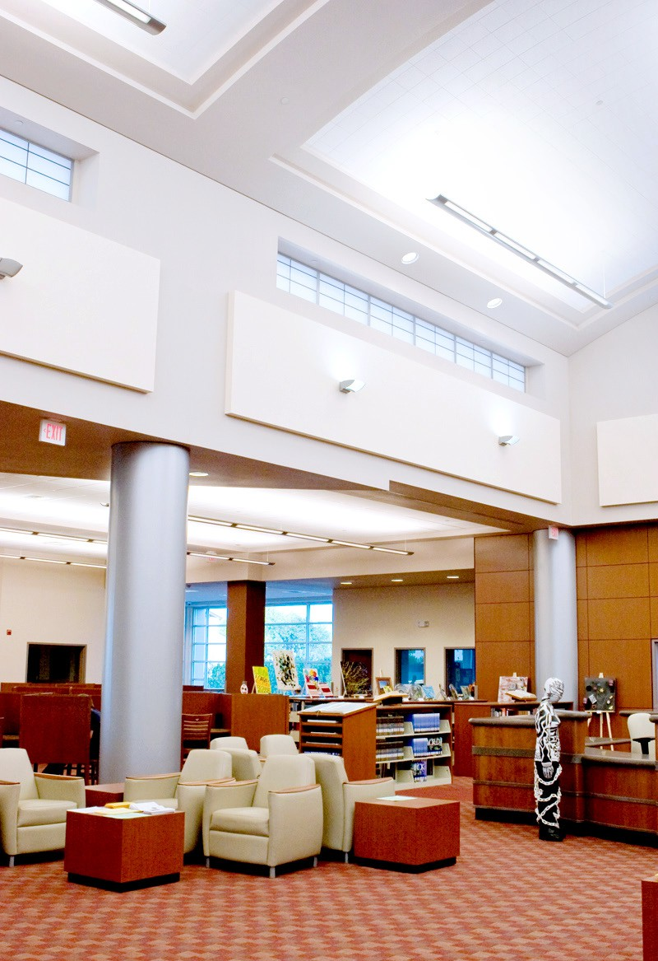
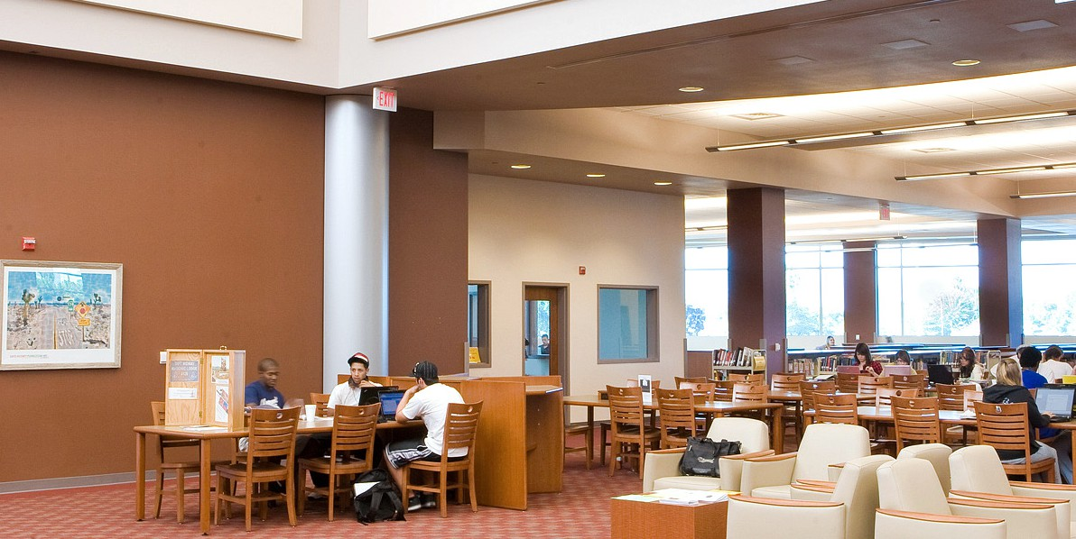

‚ Photos from existing TC Library.

Library Expansion
This project will expand the existing Library spaces on campus. As one of the early Measure A projects, Library functions were consolidated into the east addition of the Main Building. Being a state funded project meant that the Library size was limited to a specific capacity. Continued growth of the campus has increased the programs far beyond the original solutions. This project will either consolidate programs into the remainder of the main building and relocate other uses else- where or move Library out of the main building into its own space.
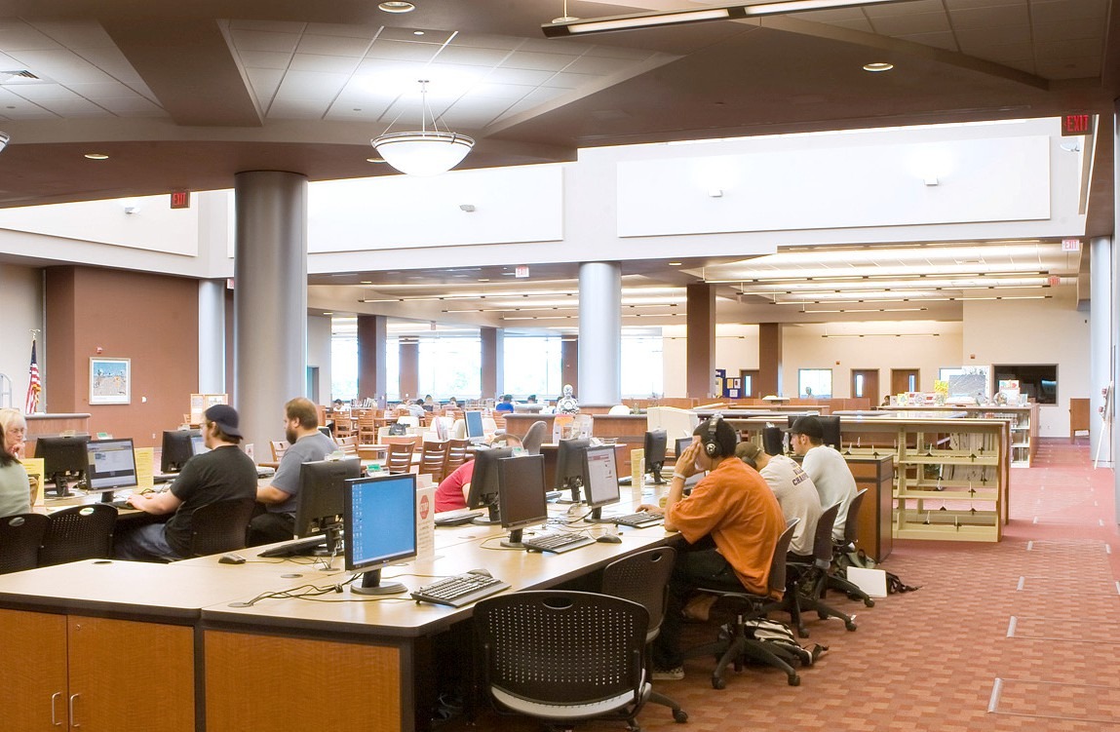

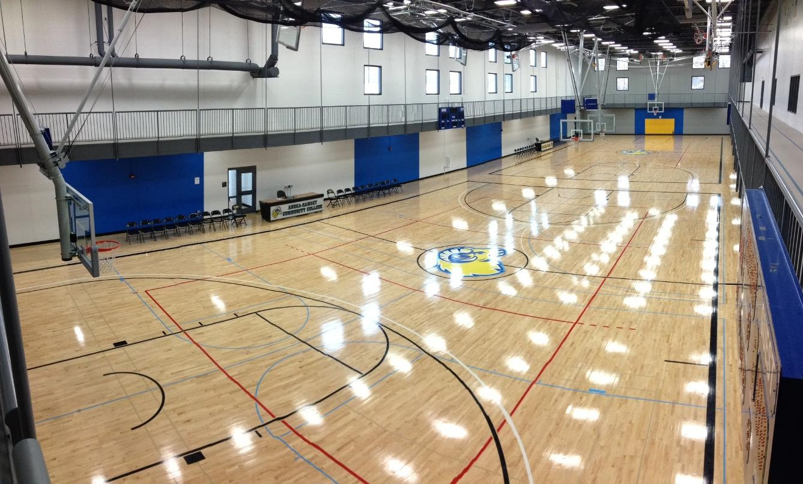
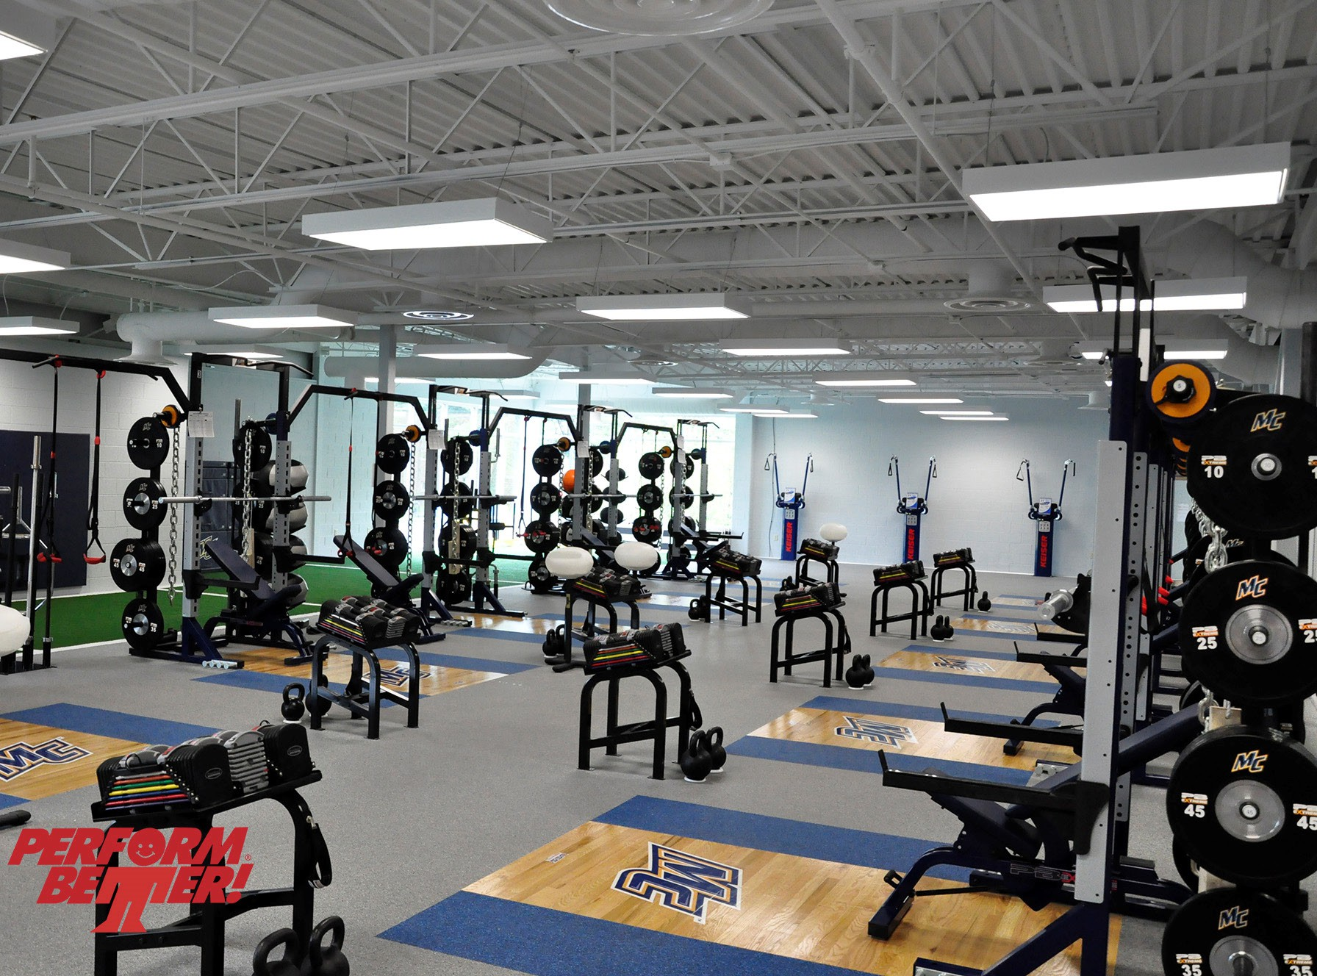
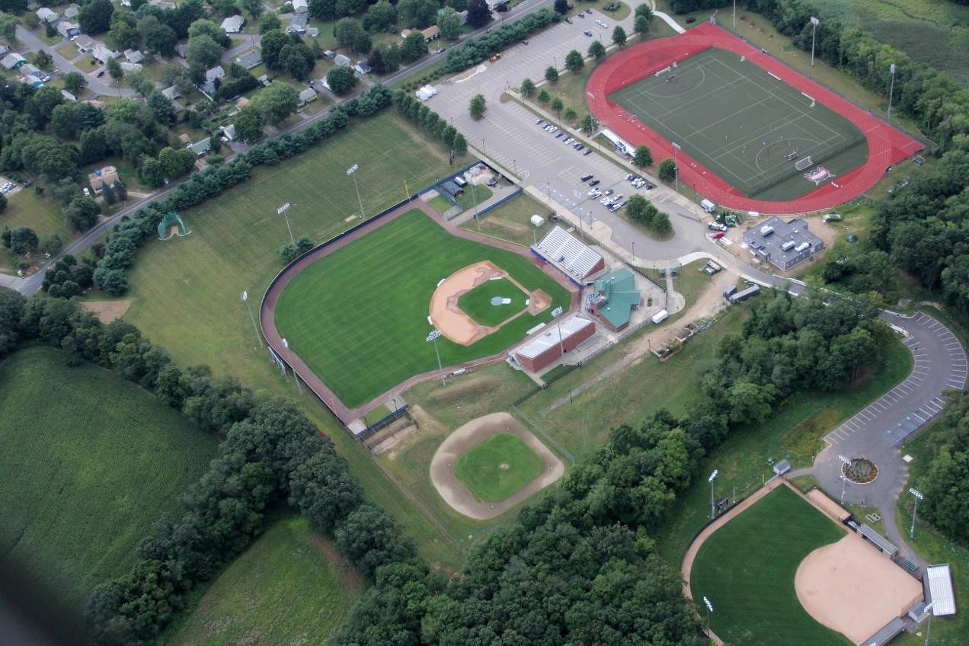
Outcomes and Solutions Facilities Master Plan 31

Physical Education Building and Field Sports Complex:
This project will centralize the entire Physical Education program to one complex at an unidentified location. It will provide full field sports access and a replacement Gymnasium / Locker Room / Wellness / Fitness building at a single location.

‚ Representative views of planned spaces.

32 Facilities Master Plan Outcomes and Solutions

Land Use
Additional parking is proposed at various locations around the campus as development increases. Off- site parking is even proposed to assist with peak times. Parking is included with each development to mitigate traffic and vehicular circulation.
There will likely be several different solutions to the acquisition of property for various expansion proj- ects. Property close to the campus is preferred for some uses while other distinct uses may be provided by being further away. It is proposed that Physical Education programs be centralized but it is not expected to remain necessarily adjacent to the campus; due to the large amount of acreage required.

Land Acquisition Analysis

Item (*) | Name | Acres |  | Count EA | Size in SF
 |  | Required Size | Calculated size | Parking | Building | Parking | Improvement | Landscape | Misc
1 | Field Sports | 20-35 | 23.3 | 300 | 32,000 | 300,000 | 540,600 | 130,680 | 10,000
2 | Student Housing | 4-8 | 4.3 | 130 | 24,000 | 130,000 | 15,000 | 12,000 | 8,000
3 | Offsite Industry | 10-15 | 9.3 | 192 | 42,000 | 192,000 | 150,680 | 12,000 | 8,000
4 | Student Services Exp. | 3-4 | 2.6 | 75 | 15,000 | 75,000 | 12,000 | 8,000 | 5,000
5 | Library Expansion | 3-4 | 2.8 | 80 | 17,500 | 80,000 | 12,000 | 8,000 | 5,000
6 | Parking Expansion | 6-10 | 6.2 | 250 | - | 250,000 | - | 9,000 | 10,000
(*) Not priority list

Outcomes and Solutions Facilities Master Plan 33

Vehicular Circulation
Much of the improvements to vehicular circulation have been completed. However, a major connec- tor needs to be added to the campus which takes the form of bridges over the creek. If you refer to the Master Plan it will become apparent that there are three additional bridge connectors across the creek and a replacement of the one existing bridge. These will be required to withstand the loading of emer- gency vehicles and while not all of them are proposed to be for public access, they all require the same planning. These bridges and related traffic improvements will enable the campus to become much more integrated, rather than the separate areas that exist now.
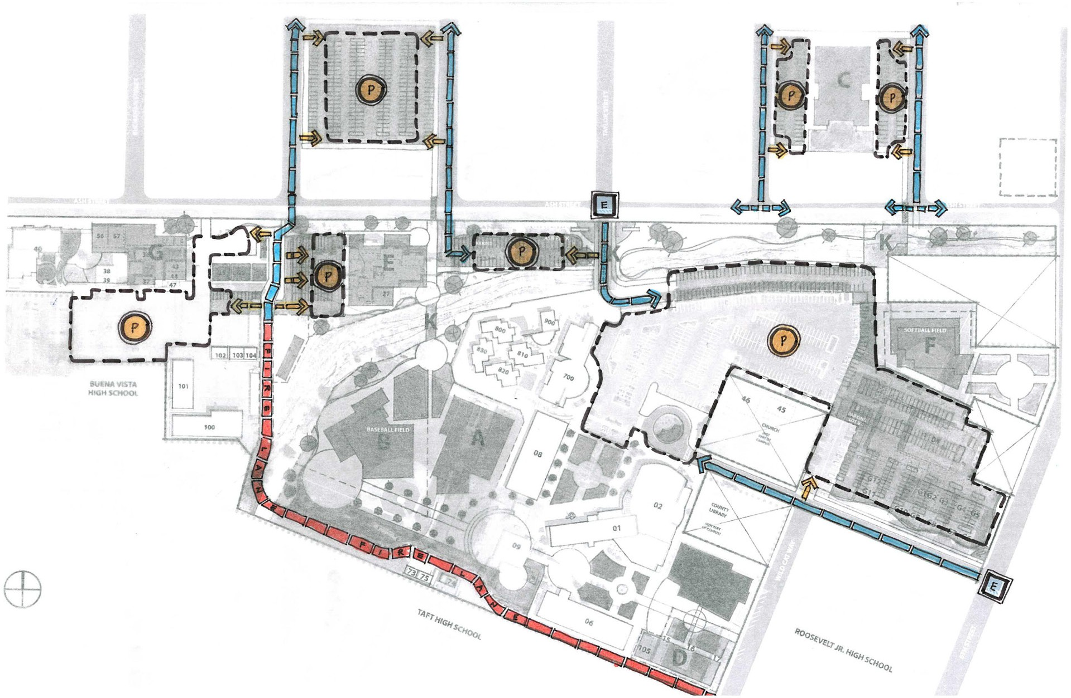
There will also need to be atten- tion to the flow of traffic and ve- hicles to and from various offsite locations. One Educational Mas- ter Plan recommendation was to increase public transportation. Obviously this recommendation is beyond the scope of this Facilities Master Plan; however, it will have impacts to the final solutions to several of these vehicular circula- tion concerns.

34 Facilities Master Plan Outcomes and Solutions

Pedestrian Circulation
The Master Plan features pedestrian friendly paths of travel through a hierarchy of walkways and de- fined outdoor spaces throughout the campus.
Vehicular circulation remains in parking areas along the campus perimeter as much as possible and allows pedestrians to filter into the campus core. It is important for these paths to provide direct acces- sibility for pedestrians to primary destinations and focal points on campus.
A variety of pedestrian walks within the developed campus are strategically located and sized to provide students and staff with a direct connection between buildings.
Materials should be considered when constructing accessible pedestrian paths of travel. The Master
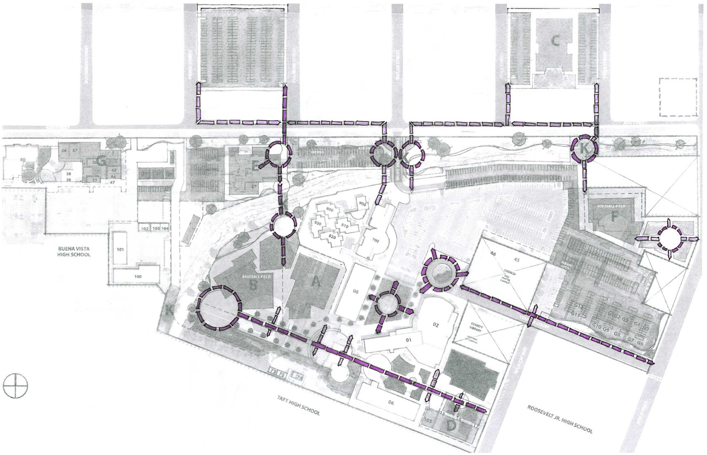
Plan reflects concrete walks throughout the campus; however, the use of natural-colored paver bricks, decomposed granite and/or textured concrete may contribute to the pe- destrian feel as well. Paths also assist with mitigating geology and soil subsidence is- sues and create numerous opportunities for beautification.
Vehicular paths should be constructed with a different material, such as asphalt paving, to differentiate their use.
By designating a new fire lane along the south and adding a bridge to Maintenance / Operations and isolating all vehicular traffic outside of the developed campus, the Master Plan establishes a clear separation between pedestrian and vehicular circulation.

Outcomes and Solutions Facilities Master Plan 35

Campus Life
The Master Plan is driven by the student experience. Working with the existing campus landscape, the strategic positioning of the proposed built environment and the relationship to outdoor spaces around them support the College’s vision of providing students with a vibrant learn- ing environment.
There are numerous student friendly spaces built into the new layout. There are courtyard spaces both north and south of the new buildings designed as A and B and connector spaces between them and new spaces in front of the Main Building. There are proposed expansions of the existing courtyard spaces on campus,
Each built project in the Master Plan incorporates these opportunities in and around the immediate zone of development. It is especially im- portant to include what we are calling campus life into the planning of the Student Housing plan.

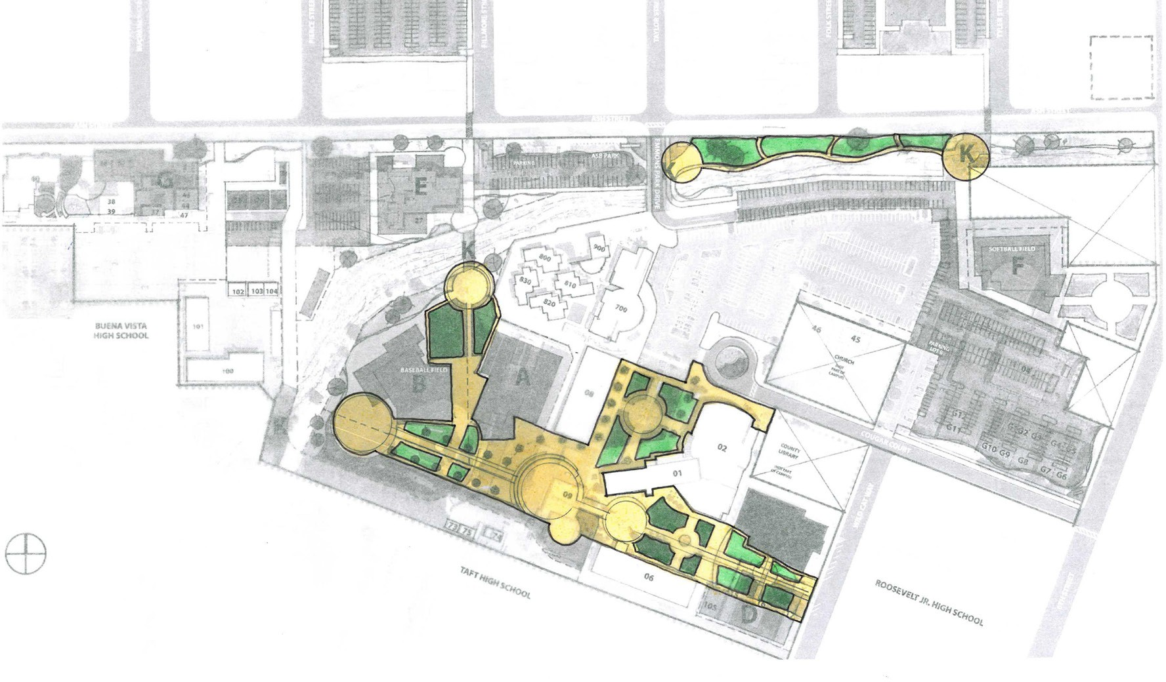
The relocation of Student Housing away from the campus core will have impacts on the campus life element. The housing site(s) will need to be sensitive to establish- ing their own campus life areas.
The new Physical Education offsite loca- tion will be farther away from campus, therefore it will require its own identity and attention to foster campus life.

37

Funding Requirements

A majority of the proposed projects in the Facilities Master Plan are eligible for state funding through the Capital Outlay Program. This program assists community college districts by providing state fund- ing for major capital projects, such as new construction or facility modernizations. The District is expected to contribute a share of the cost for each project. The projects included in the Master Plan are sized (in building area) and phased to achieve the highest scores when ranked by the State Chancellor’s Office for funding eligibility. Annual adjustments in scope and phasing should be expected to maintain scoring and eligibility.
Current Master Plan projects that are not eligible for state funding are Student Housing related projects.
Taft College does not currently have the funding resources required to implement the Master Plan and must identify additional funding sources.

39

Continuing Items

Items expected to revisit and develop as opportunities arise:
- Land usage and acquiring additional property
- Creek improvements and mitigation
- Scheduled maintenance of existing resources
- Funding sources for local contribution match

41

Appendix A

Existing Site Plan

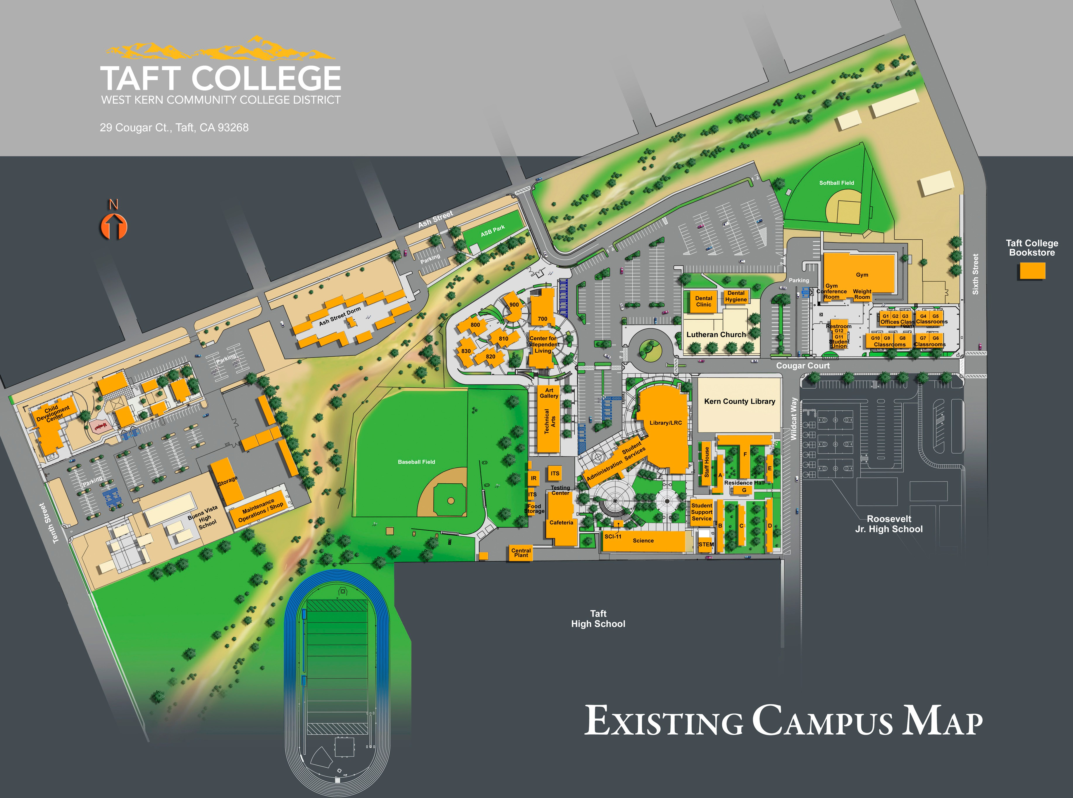

43

Appendix B

Proposed Site Plan

